

Opcenter Execution Pharma 2511

EBR [Electronic Batch Record] Design

Functional Specification

11/2025

**Guidelines**

This manual contains notes of varying importance that should be read with care; i.e.:

Important:

Highlights key information on handling the product, the product itself or to a particular part of the documentation. Note: Provides supplementary information regarding handling the product, the product itself or a specific part of the documentation.

**Trademarks**

All names identified by ® are registered trademarks of Siemens AG.

The remaining trademarks in this publication may be trademarks whose use by third parties for their own purposes could violate the rights of the owner.

**Disclaimer of Liability**

We have reviewed the contents of this publication to ensure consistency with the hardware and software   
described. Since variance cannot be precluded entirely, we cannot guarantee full consistency. However, the information in this publication is reviewed regularly and any necessary corrections are included in subsequent editions.

**Cybersecurity Information**

Siemens provides products and solutions with industrial cybersecurity functions that support the secure operation of plants, systems, machines and networks.

In order to protect plants, systems, machines and networks against cyber threats, it is necessary to implement -   
and continuously maintain - a holistic, state-of-the-art industrial cybersecurity concept. Siemens products and solutions constitute one element of such a concept.

Customers are responsible for preventing unauthorized access to their plants, systems, machines and networks. Such systems, machines and components should only be connected to an enterprise network or the internet if and to the extent such a connection is necessary and only when appropriate security measures (e.g. firewalls and/or network segmentation) are in place.

For additional information on industrial cybersecurity measures that may be implemented, please visit <https://www.siemens.com/cybersecurity-industry>.

Siemens products and solutions undergo continuous development to make them more secure. Siemens strongly recommends that product updates are applied as soon as they are available and that the latest product versions

are used. Use of product versions that are no longer supported, and failure to apply the latest updates may increase customer’s exposure to cyber threats.

To stay informed about product updates, subscribe to the Siemens Industrial Cybersecurity RSS feed under <https://www.siemens.com/cert>.

Siemens AG

Digital Industries

Postfach 48 48

90026 NÜRNBERG

GERMANY

Copyright © Siemens AG 2025

Technical data subject to change

Table of Contents

1

2

3

4

5

5.1

5.2

5.3

5.4

5.4.1

5.4.2

5.5

5.6

6

6.1

6.2

6.3

6.3.1

[6.3.1.1](http://6.3.1.1)

[6.3.1.2](http://6.3.1.2)

6.3.2

6.3.3

6.3.4

6.3.5

6.3.6

6.4

6.4.1

6.4.2

6.5

6.5.1

6.5.2

6.5.3

Revision History ...............................................................................................12

Initials and Acronyms ......................................................................................14

Preface..............................................................................................................16

Introduction .....................................................................................................17

Signature Path Management...........................................................................18

Signature Path Status ........................................................................................................18

Reference Paths..................................................................................................................18

List of Signature Paths .......................................................................................................19

Creating and Modifying a Signature Path .........................................................................19

Window description......................................................................................................................................20

Creating the Signature Path.........................................................................................................................21

Validating a Reference Path...............................................................................................21

Invalidating a Reference Path............................................................................................21

Parameter Management..................................................................................22

Introduction........................................................................................................................22

Parameter Lifecycle............................................................................................................22

Parameter Management ....................................................................................................23

Adding a Parameter......................................................................................................................................24

Window Description ...................................................................................................................................24

Checks .........................................................................................................................................................25

Modifying & Viewing a Parameter................................................................................................................25

Copying a Parameter....................................................................................................................................25

Revising a Parameter....................................................................................................................................25

Validating a Parameter.................................................................................................................................26

Deleting a Parameter....................................................................................................................................26

Managing the Notes of a Parameter..................................................................................27

Notes Properties...........................................................................................................................................27

Adding a Note ...............................................................................................................................................27

Managing Parameter Versions...........................................................................................28

Window Description .....................................................................................................................................28

Version Upgrade Rules .................................................................................................................................29

Traces............................................................................................................................................................29

Sp-EBRDesign-2511

iii

6.6

6.7

6.7.1

6.7.2

[6.7.2.1](http://6.7.2.1)

[6.7.2.2](http://6.7.2.2)

[6.7.2.3](http://6.7.2.3)

6.7.3

6.7.4

6.7.5

6.7.6

6.7.7

6.7.8

6.7.9

6.7.10

6.8

6.8.1

6.8.2

6.8.3

6.8.4

6.8.5

6.9

6.9.1

6.9.2

6.10

7

7.1

7.2

7.3

7.3.1

7.3.2

7.3.3

7.3.4

7.3.5

7.3.6

iv

Parameter Version History.................................................................................................30

Parameters Configuration .................................................................................................31

The Text Parameter ......................................................................................................................................32

The Numeric Parameter ...............................................................................................................................35

Window Description ...................................................................................................................................35

Unit management.......................................................................................................................................36

Initialization Methods.................................................................................................................................37

The Date Parameter .....................................................................................................................................38

The Time Parameter.....................................................................................................................................39

The Signature Parameter .............................................................................................................................39

The Function Parameter ..............................................................................................................................40

The Labelling Parameter..............................................................................................................................41

The Identification Parameter.......................................................................................................................43

The Barcode-Identification Parameter .......................................................................................................43

The Report parameter..................................................................................................................................45

DCS/PCS relevant parameters...........................................................................................49

Purpose .........................................................................................................................................................49

Master recipe upload....................................................................................................................................49

Configuration................................................................................................................................................49

New version upload for a recipe already configured..................................................................................53

DCS/PCS data upload...................................................................................................................................55

MBR relevant parameter ....................................................................................................56

Purpose .........................................................................................................................................................56

Configuration................................................................................................................................................56

Standard parameters.........................................................................................................56

Script Management..........................................................................................58

Introduction........................................................................................................................58

Script Lifecycle ...................................................................................................................58

Script Management............................................................................................................59

New, Modify, View, Copy, Revise, Validate, Delete, Version mgt................................................................60

Managing the versions of a script ................................................................................................................60

Rules for upgrading versions .......................................................................................................................62

History...........................................................................................................................................................62

Traces............................................................................................................................................................63

Standard scripts for PIs ................................................................................................................................63

Sp-EBRDesign-2511

8

8.1

8.1.1

8.1.2

[8.1.2.1](http://8.1.2.1)

[8.1.2.2](http://8.1.2.2)

[8.1.2.3](http://8.1.2.3)

8.1.3

8.2

8.2.1

8.2.2

8.2.3

[8.2.3.1](http://8.2.3.1)

[8.2.3.2](http://8.2.3.2)

[8.2.3.3](http://8.2.3.3)

[8.2.3.4](http://8.2.3.4)

[8.2.3.5](http://8.2.3.5)

[8.2.3.6](http://8.2.3.6)

[8.2.3.7](http://8.2.3.7)

8.2.4

[8.2.4.1](http://8.2.4.1)

[8.2.4.2](http://8.2.4.2)

[8.2.4.3](http://8.2.4.3)

[8.2.4.4](http://8.2.4.4)

[8.2.4.5](http://8.2.4.5)

[8.2.4.6](http://8.2.4.6)

[8.2.4.7](http://8.2.4.7)

[8.2.4.8](http://8.2.4.8)

[8.2.4.9](http://8.2.4.9)

[8.2.4.10](http://8.2.4.10)

[8.2.4.11](http://8.2.4.11)

[8.2.4.12](http://8.2.4.12)

[8.2.4.13](http://8.2.4.13)

[8.2.4.14](http://8.2.4.14)

[8.2.4.15](http://8.2.4.15)

[8.2.4.16](http://8.2.4.16)

Creating a PI .....................................................................................................64

The Header Tab ..................................................................................................................65

PI Characteristics (the More section)...........................................................................................................66

Characteristics of an Event PI (the Event PI section) ..................................................................................67

Field/button description ............................................................................................................................67

Definition ....................................................................................................................................................67

Configuration..............................................................................................................................................68

Items Linked to the PI (the Linked items list)..............................................................................................68

Editing the Workflow..........................................................................................................69

Calling the Workflow ....................................................................................................................................69

Accessibility Conditions & Workflow Opening Mode ..................................................................................69

Building a Workflow .....................................................................................................................................70

Main window...............................................................................................................................................70

Creation Tools.............................................................................................................................................70

Transitions ..................................................................................................................................................72

Looping .......................................................................................................................................................73

Returns, Breaks & Loops ............................................................................................................................74

Starting and Ending Simultaneous Sequences.........................................................................................74

Starting and Ending Sequence Selection..................................................................................................74

Types of Operations (Elements)...................................................................................................................75

Standard Configuration of the Elements ..................................................................................................75

The Weighing Element................................................................................................................................83

The Reconciliation Element .......................................................................................................................83

The Combination Element .........................................................................................................................84

The PI Element............................................................................................................................................85

The Script Element .....................................................................................................................................89

The Resource Allocation Element..............................................................................................................90

The Resource Release Element..................................................................................................................91

The Move Element ......................................................................................................................................92

The Transfer Element .................................................................................................................................94

The EPE Element.........................................................................................................................................96

The Wait Element......................................................................................................................................100

The PI Text element..................................................................................................................................101

The Requisition Element ..........................................................................................................................103

The Batch element ...................................................................................................................................105

The Step Element .....................................................................................................................................125

Sp-EBRDesign-2511

v

[8.2.4.17](http://8.2.4.17)

[8.2.4.18](http://8.2.4.18)

[8.2.4.19](http://8.2.4.19)

[8.2.4.20](http://8.2.4.20)

8.3

8.3.1

[8.3.1.1](http://8.3.1.1)

[8.3.1.2](http://8.3.1.2)

[8.3.1.3](http://8.3.1.3)

[8.3.1.4](http://8.3.1.4)

[8.3.1.5](http://8.3.1.5)

[8.3.1.6](http://8.3.1.6)

[8.3.1.7](http://8.3.1.7)

[8.3.1.8](http://8.3.1.8)

[8.3.1.9](http://8.3.1.9)

[8.3.1.10](http://8.3.1.10)

[8.3.1.11](http://8.3.1.11)

8.3.2

8.3.3

[8.3.3.1](http://8.3.3.1)

[8.3.3.2](http://8.3.3.2)

[8.3.3.3](http://8.3.3.3)

[8.3.3.4](http://8.3.3.4)

8.3.4

8.3.5

[8.3.5.1](http://8.3.5.1)

[8.3.5.2](http://8.3.5.2)

[8.3.5.3](http://8.3.5.3)

[8.3.5.4](http://8.3.5.4)

8.3.6

8.3.7

8.3.8

8.3.9

8.3.10

8.3.11

[8.3.11.1](http://8.3.11.1)

[8.3.11.2](http://8.3.11.2)

vi

The At-Line Testing Element....................................................................................................................125

The Cyclic Operation Element .................................................................................................................128

Printing the Graph ....................................................................................................................................139

Print Preview of the Graph .......................................................................................................................139

The PI Text Tab .................................................................................................................139

Writing the PI Text ......................................................................................................................................139

Formatting the Text and Paragraphs ......................................................................................................140

Contextual Menu when writing Text........................................................................................................142

Finding something through the Text.......................................................................................................142

Document Background Attributes...........................................................................................................142

Instructions...............................................................................................................................................143

Sections.....................................................................................................................................................145

Tables........................................................................................................................................................152

Hierarchic Organisation in PI Sub-parts..................................................................................................156

Page Breaks ..............................................................................................................................................157

Zoom .........................................................................................................................................................157

Style...........................................................................................................................................................158

The Detail panel..........................................................................................................................................161

Inserting Tags .............................................................................................................................................162

Introduction..............................................................................................................................................162

Tag Configuration.....................................................................................................................................163

Context Data Management ......................................................................................................................164

ACTION Context Data ...............................................................................................................................165

The Alert Tag...............................................................................................................................................166

The Batch parameter update Tag..............................................................................................................166

Batch Parameters configuration window ...............................................................................................167

Element identification section.................................................................................................................168

Parameters grid section ...........................................................................................................................172

Execution report .......................................................................................................................................173

The Combination Tag.................................................................................................................................173

The Date Tag ...............................................................................................................................................178

The Declaration-Adjustment Tag...............................................................................................................178

The Efficiency-Application Tag ..................................................................................................................179

The Electronic-Signature Tag ....................................................................................................................182

The E-mail tag.............................................................................................................................................184

Window description..................................................................................................................................184

Executing the tag ......................................................................................................................................185

Sp-EBRDesign-2511

[8.3.11.3](http://8.3.11.3)

8.3.12

8.3.13

[8.3.13.1](http://8.3.13.1)

[8.3.13.2](http://8.3.13.2)

[8.3.13.3](http://8.3.13.3)

[8.3.13.4](http://8.3.13.4)

8.3.14

8.3.15

8.3.16

[8.3.16.1](http://8.3.16.1)

[8.3.16.2](http://8.3.16.2)

[8.3.16.3](http://8.3.16.3)

[8.3.16.4](http://8.3.16.4)

8.3.17

8.3.18

8.3.19

8.3.20

8.3.21

8.3.22

8.3.23

8.3.24

[8.3.24.1](http://8.3.24.1)

[8.3.24.2](http://8.3.24.2)

[8.3.24.3](http://8.3.24.3)

8.3.25

[8.3.25.1](http://8.3.25.1)

8.3.26

8.3.27

8.3.28

8.3.29

8.3.30

8.3.31

[8.3.31.1](http://8.3.31.1)

[8.3.31.2](http://8.3.31.2)

8.3.32

8.3.33

Configuration............................................................................................................................................185

The EPE Tag ................................................................................................................................................185

The Equipment tags ...................................................................................................................................189

The Display Equipment Property tag ......................................................................................................189

The Equipment Property Modification tag..............................................................................................190

The List-Modification tag .........................................................................................................................192

The Read Equipment Property tag ..........................................................................................................194

The Hyperlink..............................................................................................................................................196

The Hypertext-Link Tag..............................................................................................................................197

The identification tags................................................................................................................................198

The Barcode-Identification Tag ...............................................................................................................198

The Container-Identification Tag ............................................................................................................199

The Equipment-Identification Tag ..........................................................................................................200

The Label-Identification Tag....................................................................................................................203

The Labelling Tag .......................................................................................................................................204

The List Tag.................................................................................................................................................208

The Manufacturing-Declaration Tag..........................................................................................................211

The Move Tag..............................................................................................................................................213

The Numeric Tag.........................................................................................................................................215

The Picture Tag...........................................................................................................................................216

The Re-labelling Tag...................................................................................................................................217

The Report Tag ...........................................................................................................................................218

Window description..................................................................................................................................219

Executing the tag ......................................................................................................................................221

Configuration............................................................................................................................................221

The Script Tag.............................................................................................................................................221

Use script tag as a checkbox ....................................................................................................................223

The Signature Tag.......................................................................................................................................223

The Splitting tag .........................................................................................................................................224

The Stock-Adjustment Tag.........................................................................................................................228

The Text Tag................................................................................................................................................229

The Time Tag ..............................................................................................................................................229

The Weighing Tag .......................................................................................................................................230

Declaring a Tag .........................................................................................................................................230

Using the Parameter.................................................................................................................................231

The WO Launch tag.....................................................................................................................................232

Labels & Conditions....................................................................................................................................233

Sp-EBRDesign-2511

vii

[8.3.33.1](http://8.3.33.1)

[8.3.33.2](http://8.3.33.2)

[8.3.33.3](http://8.3.33.3)

[8.3.33.4](http://8.3.33.4)

[8.3.33.5](http://8.3.33.5)

[8.3.33.6](http://8.3.33.6)

8.3.34

[8.3.34.1](http://8.3.34.1)

[8.3.34.2](http://8.3.34.2)

8.3.35

8.4

8.4.1

8.4.2

8.5

8.5.1

[8.5.1.1](http://8.5.1.1)

[8.5.1.2](http://8.5.1.2)

[8.5.1.3](http://8.5.1.3)

[8.5.1.4](http://8.5.1.4)

8.5.2

8.5.3

8.6

8.7

8.7.1

8.7.2

8.7.3

8.8

8.8.1

8.8.2

8.8.3

8.8.4

8.9

8.10

8.10.1

8.10.2

[8.10.2.1](http://8.10.2.1)

viii

Inserting Labels ........................................................................................................................................234

Creating a Condition.................................................................................................................................235

Delete a section labels..............................................................................................................................238

Edit section condition ..............................................................................................................................238

Delete a section condition .......................................................................................................................239

Rebind section label to section condition...............................................................................................239

Print Preview for a PI that is currently being written................................................................................241

Accessing the Functionality .....................................................................................................................241

Displaying the Preview .............................................................................................................................241

Printing a PI that is currently being written ..............................................................................................242

The Alerts Tab...................................................................................................................242

Aim...............................................................................................................................................................242

Configuring Alerts.......................................................................................................................................243

The Links Tab....................................................................................................................243

Version Links...............................................................................................................................................243

Window Description .................................................................................................................................244

Generating Links.......................................................................................................................................245

Selecting a Parameter ..............................................................................................................................245

Modifying a Link........................................................................................................................................247

PI Links ........................................................................................................................................................247

Script Links .................................................................................................................................................248

The Signatures Tab ..........................................................................................................250

The Notes Tab...................................................................................................................250

Window Description ...................................................................................................................................250

Notes Properties.........................................................................................................................................251

Adding Notes...............................................................................................................................................251

The Input output Tab .......................................................................................................252

Input Parameters........................................................................................................................................252

Output Parameters.....................................................................................................................................252

Configuration..............................................................................................................................................252

Modifying Parameters ................................................................................................................................254

The Review Tab ................................................................................................................255

PI Translation ...................................................................................................................256

PI Creation ..................................................................................................................................................256

PI Text translation ......................................................................................................................................256

Message translation management ..........................................................................................................258

Sp-EBRDesign-2511

[8.10.2.2](http://8.10.2.2)

8.10.3

8.10.4

8.10.5

8.10.6

9

9.1

9.2

9.3

10

10.1

10.1.1

10.1.2

10.1.3

10.1.4

10.1.5

10.1.6

10.1.7

10.1.8

10.1.9

10.2

10.2.1

10.2.2

10.2.3

10.2.4

[10.2.4.1](http://10.2.4.1)

[10.2.4.2](http://10.2.4.2)

[10.2.4.3](http://10.2.4.3)

[10.2.4.4](http://10.2.4.4)

[10.2.4.5](http://10.2.4.5)

[10.2.4.6](http://10.2.4.6)

[10.2.4.7](http://10.2.4.7)

[10.2.4.8](http://10.2.4.8)

[10.2.4.9](http://10.2.4.9)

[10.2.4.10](http://10.2.4.10)

10.2.5

PI text and translation consistency .........................................................................................................259

Workflow translation..................................................................................................................................260

Edit PI translations .....................................................................................................................................260

Copying a PI with translation.....................................................................................................................262

Revising a PI with translation.....................................................................................................................262

Managing <PI-Item> Links .............................................................................263

Definition ..........................................................................................................................263

Rules..................................................................................................................................263

Managing Links.................................................................................................................263

Tools to check PIs ..........................................................................................266

Coherence Analysis ..........................................................................................................266

Starting and Ending Elements ...................................................................................................................266

Transition Operations ................................................................................................................................266

Paths............................................................................................................................................................266

The PI-Text Element ...................................................................................................................................266

The Batch Element – with Batch Operating Text ......................................................................................266

PI Element...................................................................................................................................................267

Step element...............................................................................................................................................267

Element title ...............................................................................................................................................267

Report & Adjustment ..................................................................................................................................268

Detailed Documentation..................................................................................................268

Configuring how the Documentation is Generated ..................................................................................268

General Presentation .................................................................................................................................270

Introduction................................................................................................................................................271

Table of Contents .......................................................................................................................................271

Master Batch Record ................................................................................................................................271

Main...........................................................................................................................................................272

Validation..................................................................................................................................................273

Alerts Management...................................................................................................................................273

Signature Paths ........................................................................................................................................274

PI Text........................................................................................................................................................274

Tags ...........................................................................................................................................................275

Workflow Elements...................................................................................................................................275

Parameters................................................................................................................................................276

Scripts .......................................................................................................................................................276

PI Details .....................................................................................................................................................276

Sp-EBRDesign-2511

ix

10.2.6

10.3

10.3.1

10.3.2

10.3.3

10.3.4

10.3.5

10.3.6

10.4

10.4.1

10.4.2

10.4.3

10.4.4

10.5

10.5.1

10.5.2

10.5.3

10.6

10.7

10.8

11

11.1

11.2

11.3

11.4

11.4.1

11.4.2

11.4.3

11.4.4

11.5

11.5.1

11.5.2

11.6

11.7

x

Translation..................................................................................................................................................278

PI text Comparator...........................................................................................................278

Access..........................................................................................................................................................279

Comparator screen.....................................................................................................................................280

List of tag differences .................................................................................................................................280

PI text display..............................................................................................................................................281

List of properties.........................................................................................................................................282

Comparison algorithm ...............................................................................................................................282

Simulation ........................................................................................................................283

MBR selection .............................................................................................................................................284

Execution Rules ..........................................................................................................................................285

Operator's Actions......................................................................................................................................286

Colour Code ................................................................................................................................................286

Execution with a WO ........................................................................................................286

Accessing the Execution.............................................................................................................................287

Preparation Phase before Execution.........................................................................................................290

How the Test Execution is Processed ........................................................................................................290

Checking Links..................................................................................................................290

Checking Alerts.................................................................................................................290

Checking Input output .....................................................................................................290

PI Management ..............................................................................................292

PI Lifecycle ........................................................................................................................292

Accessing PIs.....................................................................................................................293

Copying PIs .......................................................................................................................294

Revising PIs.......................................................................................................................296

Introduction................................................................................................................................................296

The PI Revision Process..............................................................................................................................296

PI-Revision Attributes.................................................................................................................................297

Revision of a PI designed in version prior to 2205.0000.0000 (PIs not supporting instructions identification) .............................................................................................................................................297

Validating PIs ....................................................................................................................298

Signing PIs...................................................................................................................................................298

Rejecting PIs................................................................................................................................................300

Launching PIs ...................................................................................................................300

Modifying the Validity Dates of a PI .................................................................................302

Sp-EBRDesign-2511

11.8

11.9

11.10

12

12.1

12.2

12.3

13

13.1

13.2

14

Deleting PIs.......................................................................................................................302

Revision control of PIs......................................................................................................303

PI-Version History.............................................................................................................304

PI, Script, and Parameter Dependencies......................................................306

Introduction......................................................................................................................306

Accessing the Function ....................................................................................................306

Window Description .........................................................................................................307

Traces .............................................................................................................309

Accessing Traces ..............................................................................................................309

Traced Actions..................................................................................................................309

Known Issues .................................................................................................315

Sp-EBRDesign-2511

xi

*Revision History*

# 1

Revision History

**Rele** **ase**

2505

12

**Date**

May 2025

**Modifications**

Document created from v2411

Standard parameters: Add new EVENT_PI_CTX parameters

Managing links: Add a trace for each action on PI/Item links

Add warning in the chapter Configuring alerts regarding alerts created by ES

Add warning in the chapter Configuring alerts regarding Alert PIs output parameters

Managing links: Add a trace for each action on PI/Item links

Add warning in the chapter Configuring alerts regarding alerts created by ES

Add warning in the chapter Configuring alerts regarding Alert PIs output parameters

Standard parameters: Modified Cyclic operation Contextual Parameters

The Cyclic Operation Element : Modified chapter contents to add more details on CO configuration

The Cyclic Operation Element / Open PI Configuration-Windows description: Added a Remark

The Cyclic Operation Element: Removed note for limitation on changing Open PI Version

The Cyclic Operation Element: Added New Section for Cyclic Operation Pause Reason Management

Parameters Configuration-Numeric Parameter: Added Cyclic operation limitation

The Links Tab: PI Links: added limitation for cyclic operations element

The List tag: Adding a warning about an unauthorized character

Known Issues: Updated section

Add a chapter explaining how to use a script tag as a checkbox

The Numeric Parameter > Window description: add a warning about limitation of value recording for numeric parameter

The Cyclic Operation Element : Added description for Auto-link feature

The Cyclic Operation Element: Modified Detail documentation image and updated CO design images

The Cyclic Operation Element: Added a remark on Automatic Execution of CO task

Configuration: Updated screenshot for 'How to access the *DCS/PCS relevant parameter* *management* window'

The At-Line Testing Element: Updated the Instruction related to adding OpenSSL installation path.

The At-Line Testing Element: Updated the How to set up this element section for Configuration of the Execution Parameters.

 Sp-EBRDesign-2511

**Rele** **ase**

**Date**

*Revision History*

**Modifications**

2511

November 2025

The PI Text Tab: chapters related to tags design have been ordered (some chapters have been renamed)

The PI Text Tab > The Equipment tags > The Equipment Property Modification tag : fix typo and indentation in "The *Reference date* section"

Types of Operations - The Cyclic Operation Element

Updated Snapshot to reflect Automatic Activation of Cyclic Operation element design

Modified details related to Access Control tab for Workcenter and Access Right buttons

Added a note on limiting the numeric value for the configuration up to 9 digits.

Parameter Management - Adding a Parameter: Added a note on limitation of parameter

Sp-EBRDesign-2511 13

*Initials and Acronyms*

# 2

Initials and Acronyms

**Initials and acronyms**

ContID

DCS/PCS

EBR

Electronic Batch Record parameter

e.g.

EPE

GDI

i.e.

MBR

MES

N.B.

OPC

PI

PI/ PO

PP

ROP

RUP

14

**Meaning**

Container ID. Unique identifier of a container (RUP or ROP) in Batch System. For more details about its value, please refer to Batch_process_and_configuration document.

Distributed Control System / Process Control System

Electronic Batch Record

Parameter created in Opcenter Execution Pharma

Latin abbreviation - "exempli gratia" (means "for instance")

Equipment Procedural Element

Graphical Device Interface

Latin abbreviation - "id est" (means "that is to say")

Master Batch Record

Manufacturing Execution System

Latin abbreviation - "Nota Bene" (means "please note well")

Open Platform Communications

Process Instruction

Product Input/ Product Output

Process Parameter

Recipe Operation

Recipe Unit Procedure

 Sp-EBRDesign-2511

**Initials and acronyms**

RF

SGFG

SOC

SOP

*Initials and Acronyms*

**Meaning**

Radio Frequency

Start Gross Final Gross

Standard Operating Conditions

Standard Operating Procedure

TermID

WO

Sp-EBRDesign-2511

Terminal ID. Unique identifier of a terminal (RPH) in its container (RUP or ROP) in Batch System.

For more details about its value, please refer to Batch_process_and_configuration document.

Work Order

15

*Preface*

# 3 Preface

**Purpose**

This document describes Opcenter Execution Pharma Design module that enables the user to write reference Process Instructions that will be used during manufacturing and all the annexed elements that are essential for their utilisation. The PI edition and management stage enables the user to write, configure, and validate a PI before its actual use in production.

**Basic knowledge required**

This document is intended for Opcenter Execution Pharma users. To be able to understand the concepts and examples discussed in this document, the reader should at least have taken the Opcenter Execution Pharma Training and have general knowledge of Opcenter Execution Pharma and related technologies.

16 Sp-EBRDesign-2511

*Introduction*

# 4 Introduction

The Electronic Batch Record Design module enables the user to write reference Process Instructions that will be used during manufacturing and all the annexed elements that are essential for their utilization. The PI edition and management stage enables the user to write, configure, and validate a PI before its actual use in production.

PIs are sets of instructions to be followed in order to ensure the manufacturing of a product when associated with a WO. Writing a PI includes writing a workflow and a PI text.

**Writing a PI text** consists in:

writing the manufacturing instructions that will be displayed on the window during the execution of the PIs;

inserting tags which correspond to the different manufacturing data to record and to check. When monitoring the manufacturing of the product, they are displayed as fields to be filled in or actions to activate by clicking a button;

potentially inserting conditions into the text. These conditions enable, according to the value of a parameter, to request the execution of a specific section of PI text (loops, non-linear order, etc.);

potentially inserting hypertext links to other documents (e.g. in the Word, Excel, etc. format). When monitoring the manufacturing of the product, activating these links enables the operator to access the concerned documents;

formatting the text with the editor that belongs to the word-processor type (heading definition, insertion of pictures, text colour, etc.).

**Writing the workflow** consists in:

defining the different manufacturing operations, which may concern:

the execution of a specific PI text section (e.g. chapter);

a specific action called from the workflow (e.g. weighing a phase);

determining the conditions of execution of the various operations, with transition elements (according to the value of a parameter, etc.) which link the different operations.

The following basic data are required to write these PIs:

Parameters;   
 Signature paths.

The ***parameter*** notion enables to define all data that will be used when writing the PI. These data are merged according to their type (e.g. type: text parameter, numeric, etc.), but also according to more specific characteristics (definition of input formats, of authorised input units, etc.).

***Signature paths*** enable the user to validate the elements (e.g. PI) through successive users' signatures.

Sp-EBRDesign-2511 17

*Signature Path Management*

*Signature Path Status*

# 5 Signature Path Management

The Signature path function (i.e. "PIManagement.exe" > *PI Management* > *Signature path*) enables the user to access the signature path management. That functionality enables the user to create and validate reference signature paths, which will be used in PIs:

to validate the PI;

to review the record;

to validate alerts;

to sign the appended documents.

## 5.1 Signature Path Status

There are two possible statuses for a signature path:

***Created***

Status when the path is created. The path can be modified, deleted, or validated. When displaying the *Created*

status, a path cannot be associated with a PI.

***Validated***

The path can be associated with a PI, for its validation or the validation of its remarks and/or deviations. A path can

be invalidated only if it is not associated with a PI. A validated path cannot be deleted.

## 5.2

Reference Paths

18

Management rules:

A signature path is a well-ordered set of signature requests;

A signature path must include at least one signature level;   
 Each signature request refers to a user group;

A path needs to be validated to be used in a PI;

A validated path cannot be deleted;

When created, a path is initialised with the *Created* status;   
 A path used in a PI cannot be invalidated.

 Sp-EBRDesign-2511

## 5.3

*Signature Path Management*

*List of Signature Paths*

List of Signature Paths

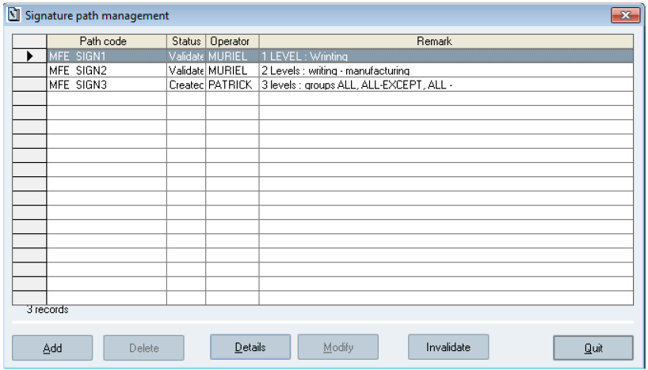

**The *Signature path management* window**

Clicking the *Add*, *Modify*, *Invalidate*, *Delete*, and *Details* buttons allows accessing the functions to handle signature paths management.

## 5.4

Creating and Modifying a Signature Path

Each new signature path is initialised with a default path which includes 4 signature levels. The writer can then modify it as s/he wants, as long as it has not been validated.

The access right 1850 (SIGNATURE PATHS MANAGEMENT) is required for that action.

Sp-EBRDesign-2511

19

*Signature Path Management*

*Creating and Modifying a Signature Path*

### 5.4.1 Window description

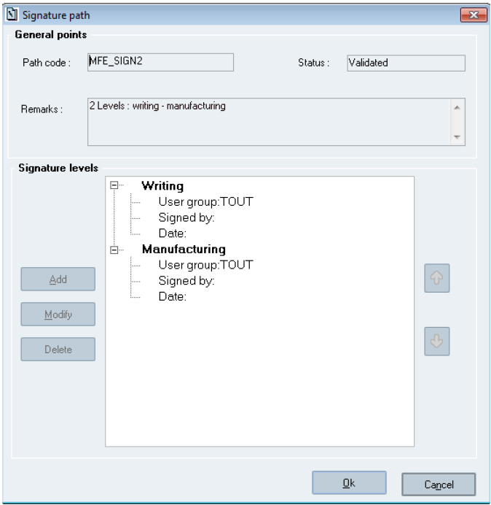

**The *Signature path* window**

**The *General points* section:**

***Path code*:** a unique code is required (type: 20-character alphanumeric field).

***Status*:** provides the status of the viewed path (*Created* or *Validated*).   
 ***Comments*:** inputting a comment is optional (255-character alphanumeric field).

**The *Signature levels* section:** the path is made up of levels. Each level is referred to by a description and is associated with a user group. The possible actions for all signature levels are the following:

***Add:*** adds a signature level.

***Modify:*** modifies the selected signature level.

About these two buttons: When **Adding/Modifying** a level, the following values are required:

Signature description: mandatory input of a description to refer to the signature.   
 Group: mandatory selection of an associated group from the list of groups.

***Delete:*** deletes the selected signature level. When **deleting** a level, the level is immediately deleted from the list.   
 ***Ok:*** allows the user to validate the selections is available only once both fields have been filled in.

When modifying data, the fields are pre-filled in with the properties of the selected level.

20 Sp-EBRDesign-2511

The

and

*Signature Path Management*

*Validating a Reference Path*

: allows updating the Row Order.

Since the list of levels is well-ordered, the operator can change the row order in the table by using the commands to make the rows going up and/or down.

and

### 5.4.2

Creating the Signature Path

To be allowed to confirm the creation of a signature path, the path must include at least one signature level, and all the defined signature levels must include a user group.

## 5.5 Validating a Reference Path

Validating a signature path enables the user to end the writing phase and to make the signature path available to the PI writers.

The access right 1851 (VALIDATE SIGNATORE PATHS) is required for that action.

## 5.6 Invalidating a Reference Path

Invalidating a signature path enables the user to make an already validated signature path modifiable. Invalidation is possible only if the path has not yet been used in a PI and if it is not configured in an MBR with a status different from *Withdrawn*.

The access right 1852 (INVALIDATE SIGNATURE PATHS) is required for that action.

Sp-EBRDesign-2511 21

*Parameter Management*

*Introduction*

# 6 Parameter Management

## 6.1 Introduction

A parameter enables the user to define all data that will be used when writing and tracking the manufacturing PI. These data are grouped together according to their type (e.g. type: text parameters, numeric, date, etc.), but also according to more specific characteristics (definition of input formats, input units, authorised values, etc.).

The various types of parameters are the following:

Text

Numeric

Date

Time

Signature

Function

Labelling   
 Identification

Barcode identification

Standard parameters can be used with Event PIs (see Standard parameters).

The created parameters will have a "non-standard" characteristic and will follow the lifecycle of parameters.

## 6.2 Parameter Lifecycle

Parameters have a lifecycle, described as follows:

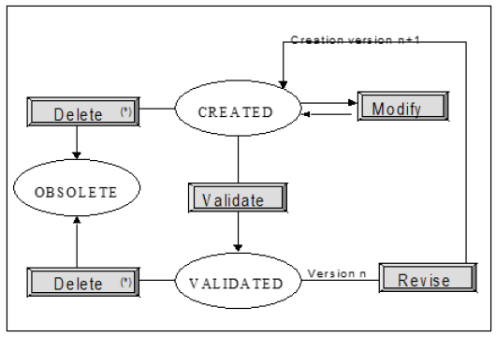

**The parameter lifecycle**

* Impossible if the parameter is referenced in a non-obsolete PI or parameter.

Parameters can display one of the following statuses:

***Created***: status displayed when the parameter is created. A parameter can be created by adding a new

parameter, or by copying an available parameter. A unique code is then allocated to it. Its creation index is 1. When a parameter is revised, it keeps the same code, but a new version is created. Revising version *n* triggers the creation of version n+1.

22 Sp-EBRDesign-2511

*Parameter Management*

*Parameter Management*

A parameter which displays the *Created* status can be:

Modified. In that case, it keeps the *Created* status.

Validated. In that case, the parameter status changes to *Validated*.

Deleted. That action is possible only if the parameter is not referenced in a non-obsolete PI or parameter.

***Validated***: status of the parameter once it has been validated.

All parameters referenced in a PI need to be validated to authorise the PI signature. Parameters can be validated from the list of parameters or when signing the PI. When validating a parameter, all the associated parameters also need to be validated (e.g. [PARAM1] initialised with [PARAM2]). If not, the system suggests validating them when validating the parameter.

A parameter which displays the *Validated* status can be:

Revised. Revision triggers the creation of index n+1 for the parameter which displays the *Created* status

(see Managing Parameter Versions for more information).

Deleted. That action is possible only if the parameter is not referenced in a non-obsolete PI or parameter.

***Obsolete***: the parameter cannot be used anymore. It is no longer referenced in parameters or ongoing PIs.

## 6.3

Parameter Management

The whole parameter management is included in the following screen, which is available from the Parameter management function:

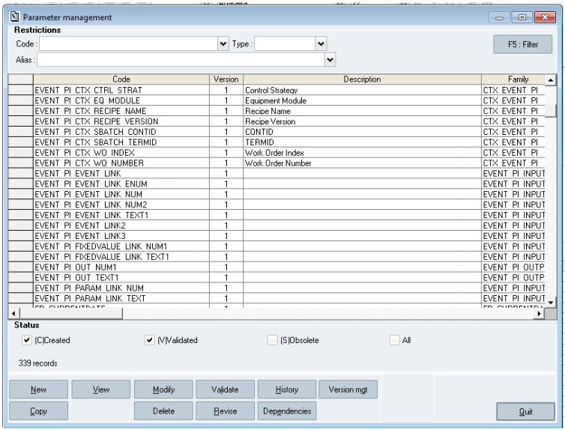

**The *Parameter management* window**

Sp-EBRDesign-2511

23

*Parameter Management*

*Parameter Management*

That list includes all parameters, which are identified by their unique alphanumeric code, their version, and their common characteristics.

**Window description**1**:**

***F5: Filter:*** allows creating the list of parameters that meet the specified criteria.

***View:*** allows displaying the window which enables the user to view the details that are specific to the selected type of parameter, in Read-only mode.

***Modify:*** allows displaying the window which enables the user to view the details that are specific to the selected type of parameter, in Modification mode.

***Validate:*** allows validating the selected parameter.

***History:*** allows accessing the history of the versions for a specific parameter.

***Version mgt*** (for "management")***:*** allows managing the versions of a parameter.

***Copy:*** allows copying the selected parameter.

***Delete:*** allows deleting the selected parameter if it is not referenced in a non-obsolete parameter or PI.

***Revise:*** allows creating a new version of the selected parameter when revising it.

***Dependencies:*** allows accessing the dependencies that are available between the selected parameter and the PIs.

***Quit:*** allows closing the *Parameter management* window without saving the modifications.

1N.B.: Some of the fields are not described (it is true for other window descriptions).

The following authorizations are defined:

The access right 1800 (PARAMETER CREATION).

The access right 1810 (VALIDATE PARAMETER).   
 The access right 1820 (REVISE PARAMETER).   
 The access right 1825 (DELETE PARAMETER).

### 6.3.1 Adding a Parameter

#### [6.3.1.1](http://6.3.1.1) Window Description

Clicking the *New* button in the *Parameter management* window displays the following screen:

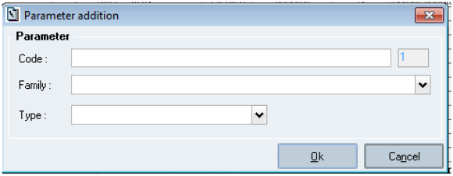

**The *Parameter addition* window**

**Window description:**   
**The *Parameter* section:**

***Code:*** code of the parameter that has to be created. Mandatory field, which cannot be modified once that window has been closed (type: 30-character alphanumeric field).

**Version** (next to the *Code* field)**:** the version is set to 1 and cannot be modified. That field cannot be modified (value: up to 999).

24 Sp-EBRDesign-2511

*Parameter Management*

*Parameter Management*

***Family:*** that optional field can be modified. It enables the user to select the family to associate with the new parameter from all families that are referenced by the system. Its default value corresponds to the parameter code that has been entered (type: 20-character alphanumeric field).

Should a new parameter linked to a non-available family be created, that family is added to the list of families that are referenced by the system.

***Type:*** that mandatory field enables the user to select the type of the parameter that s/he needs to create. The list cannot be modified and is pre-filled in with all possible types of parameters.

***Ok:*** allows validating the addition and displays the window which enables the user to define the characteristics of the added parameter (see The Date Parameter).

***Cancel:*** allows closing the window without saving the modifications.

It is advised to refrain from incorporating HTML special characters—specifically Less than (<): Entity: &lt, Greater than (>): Entity: &gt, Ampersand (&):Entity: &amp, Double quote ("):Entity: &quot, Single quote ('):Entity: &apos; or &#39   
—into parameter. The presence of these characters is prohibited as it can lead to critical system processing failures and integrity issues during documentation generation, particularly impacting the accuracy and display of detail documentation

#### [6.3.1.2](http://6.3.1.2) Checks

The system checks that all the mandatory fields have been filled in (Parameter & Type).

The system checks that the parameter code that the user entered is not available and that no forbidden character is part of that code (e.g. %, etc.).

### 6.3.2 Modifying & Viewing a Parameter

Both actions enable the user to directly access the details of a parameter, either to modify it (by clicking the *Modify* button) or to simply view it (by clicking the *View* button).

The windows that allow viewing the details of a parameter or modifying it include two or three tabs:

***Detail*:** displays a window which includes all parameter characteristics.

***Notes:*** displays a window which enables the user to freely associate the annotations with the parameter version (see Managing the Notes of a Parameter for more details).

***Alias (if applicable):*** displays a window which includes alias value.

### 6.3.3 Copying a Parameter

The window which is described below is identical to the window that is used to create a parameter:

The field that is used to enter the parameter code can be modified and is initialised with the code of the original

parameter.

The version is set to 1 and cannot be modified.

The type is initialised with the type of the original parameter and cannot be modified.   
 The family is initialised with the family of the original parameter and cannot be modified.   
 The notes of the original parameter are kept when copying.

The alias field (if applicable) is kept when copying.

### 6.3.4

Revising a Parameter

The rules inherent to the revision are the following:

Sp-EBRDesign-2511

25

*Parameter Management*

*Parameter Management*

Only parameters which display the *Validated* status can be revised.

Among all validated versions, only the last one can be revised.

A version cannot be revised if there is a higher parameter version which displays the *Created* status.

The parameter which has been created during revision has the same code as the original parameter. Its index corresponds to the highest available index (including obsolete parameters) incremented by 1, and its type corresponds to the type of the original parameter.

The notes are kept during revision.

The alias field (if applicable) is kept during revision.

During revision, all fields are pre-filled in with the values of the original parameter. All these fields (except the parameter code and version) can be modified.

### 6.3.5 Validating a Parameter

Several versions of the same parameter can display the *Validated* status at a given time.

Validating a parameter requires checking the validity of the parameters that are directly associated with the parameter. If there are associated parameters (or one parameter and its "dependencies"; see ***PI, Script, and Parameter Dependencies*** for further information), the list of these associated parameters is displayed with their validation status and the user can validate everything at the same time:

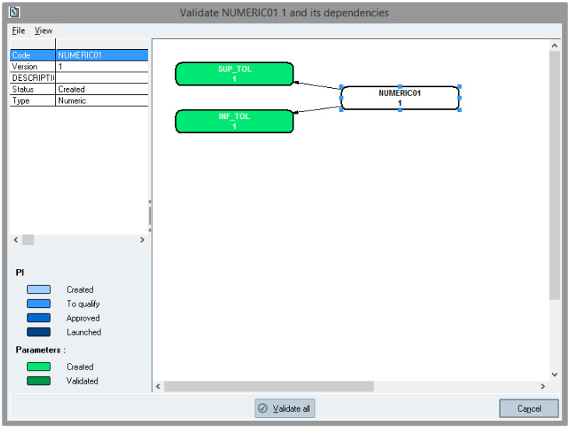

**The list of the associated parameters (dependencies) when validating a numeric parameter**

### 6.3.6 Deleting a Parameter

Deleting a parameter makes it definitively unusable as its status is changed to *Obsolete*. However, it is still displayed in the list of parameters. Any parameter version can be deleted (change it to *Obsolete*), except if it is referenced:

in a non-obsolete PI, or

26 Sp-EBRDesign-2511

*Parameter Management*

*Managing the Notes of a Parameter*

in another non-obsolete parameter.

## 6.4

Managing the Notes of a Parameter

For each type of parameter, a *Notes* tab allows viewing the annotations that have been attached to the parameter:

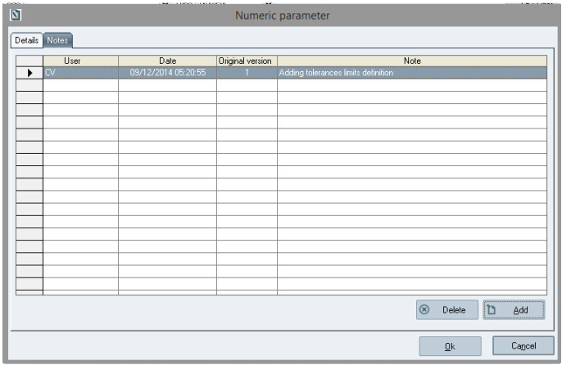

**The *Notes* tab**

That tab includes the exhaustive list of notes that have been entered for all the versions of the displayed parameter. For each note, the system can display:

The parameter version in which the note has been entered (and maybe the code);   
 All general information about its context;

The note text.

### 6.4.1 Notes Properties

The notes can be deleted after having been inserted, provided the user has been assigned the access right N°1355 - DELETE NOTE.

Notes are retrieved when copying and revising a parameter or a PI.

Notes can be added or deleted whatever the status of the annotated entity.

### 6.4.2

Adding a Note

Notes can be added by clicking the *Add button.*

The text entered:

Can include several lines;

Is limited to 4,000 characters.

Sp-EBRDesign-2511

27

*Parameter Management*

*Managing Parameter Versions*

## 6.5 Managing Parameter Versions

It is possible, from the list of parameters, to check the use of a parameter version from the PIs.

### 6.5.1 Window Description

Managing parameter versions is performed from the following window:

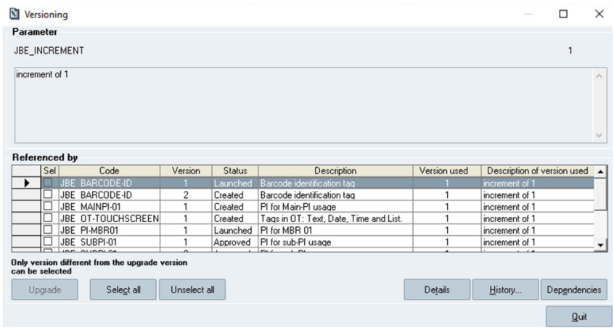

**The Versioning window**

That window lists all the non-obsolete PIs which use a version of the selected parameter.

The list displays:

The code/version of the PI using the parameter;

The status of that PI;

The description of that PI. The text is wrapped according to its length;

The parameter version that is used;

The description of that used version. The text is wrapped according to its length.

The window indicates that only version that are different from the used parameter version can be selected.   
 ***Upgrade*:** replaces the parameter version used by the PI with the version being viewed.

Sets of PIs can be upgraded by selecting several PIs from the list, by using check boxes. Upgrading parameters requires following rules that are described below:

When upgrading parameters, a window is displayed that sums up all the PIs for which an upgrade has been requested. For each of these PIs, the user can know if the upgrade will be performed or the reason why it cannot be performed (further to the upgrade rules). That window can be confirmed or cancelled. If confirmed, the upgrade is actually performed. If cancelled, the upgrade is not performed. In all cases, the selection is kept (i.e. the check boxes are still selected), and the *Versioning* window is updated according to the potential new used versions.

28 Sp-EBRDesign-2511

*Parameter Management*

*Managing Parameter Versions*

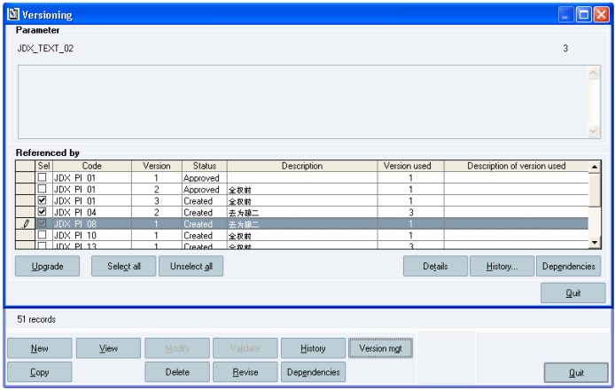

***Select all*:** selects the whole list.

***Unselect all*:** deselects the whole list.

***Details*:** allows accessing the details of the PI that the user selected from the list. These details correspond to a detailed documentation, which allows the user to quickly find the display occurrences of the parameter.   
 ***History…*:** allows accessing the history of the version of the selected parameter version.

***Dependencies*:** allows accessing the entire graph, which displays the use of the PIs and of their links, to help the user to better understand the impacts of the changes of version.

***Quit*:** allows closing the window.

### 6.5.2 Version Upgrade Rules

Upgrading parameters requires the access right 1826 (PARAMETER UPGRADE).   
These rules are the following:

If the parameter displays the *Created* status, only the PIs which display that status can be upgraded;   
 If the parameter displays the *Validated* status:

If the PI_VERSIONING_IMPACT parameter P is set to 1

All the non-obsolete PIs can be upgraded. The PI does not need to be revised.   
 If the PI_VERSIONING_IMPACT parameter P is set to 0

Only the PIs which display the *Created* status can be upgraded. Upgrading a parameter cannot be performed for PIs which display the *To qualify, Approved,* and *Launched* statuses. These PIs need to be revised. The upgrade is then applied to the new revision.

There is no impact on PIs that are being modified by another user.

**Case of new parameter configurations when inserting traces:** When a tag modifies the characteristics of the

parameter that it uses, changing the version of that parameter does not have any direct impact on that tag (e.g. a numeric tag, for which the limits of the parameter have been modified: changing the version of the used parameter does not modify the characteristics that have been modified during the tag insertion).

### 6.5.3

Traces

A trace is automatically generated each time a used version is modified (see Accessing Traces).

Sp-EBRDesign-2511

29

*Parameter Management*

*Parameter Version History*

## 6.6 Parameter Version History

The history of a parameter enables the user to view the progression of its versions:

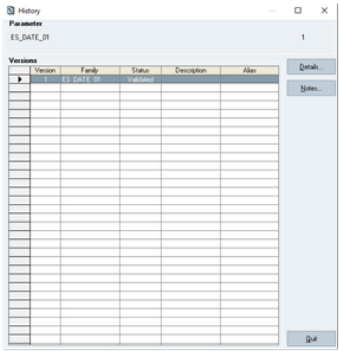

**The History window**

The history of a version is displayed as a list: that list is made up of all versions included between version 1 and the

last version of the parameter.

**Window description:**

***Details…:*** displays the details of the selected version, in Read-only mode. These details enable the user to see

all the parameter characteristics:

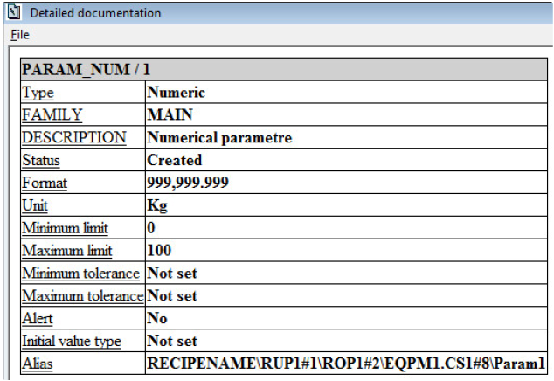

**The Detailed documentation window**

30 Sp-EBRDesign-2511

*Parameter Management*

*Parameters Configuration*

***Notes…:*** allows accessing the list of notes for that version, in Read-only mode:

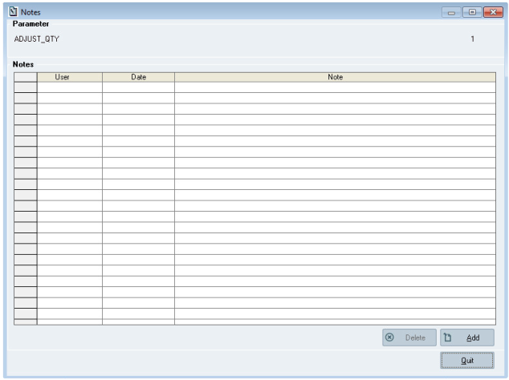

**The Notes window**

## 6.7

Parameters Configuration

When configuring a parameter, whatever its type:

The parameter code and version cannot be modified;

The description can be modified and is optional;   
 The family can be modified and is mandatory;

For text, numeric, date and time parameters an additional field is available in a dedicated tab: alias. The alias is a multi-line field. Its content is free, there are no checks performed on this field. The maximum number of characters is 640.

This field is used for the auto-link functionality available for batch element.

It can be modified; in this case the links already performed based on this field are not modified (in PI elements that do have the auto-link functionality).

Sp-EBRDesign-2511 31

*Parameter Management*

*Parameters Configuration*

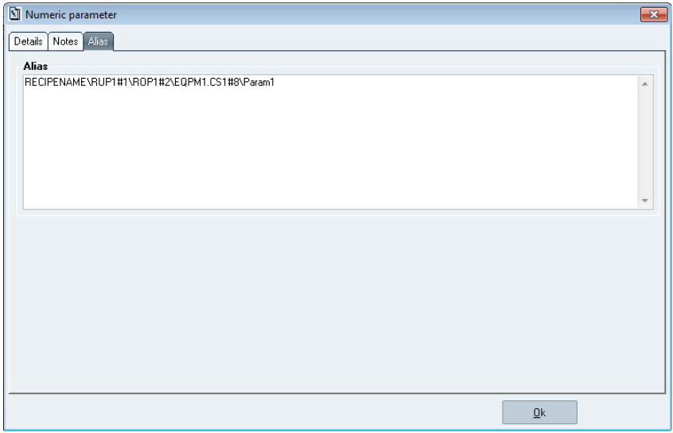

**Alias tab**

### 6.7.1

The Text Parameter

Text parameters enable the user to define text zones that can be manually entered or selected from a list of possible values defined when configuring parameters (see figure below to know how to configure text parameters):

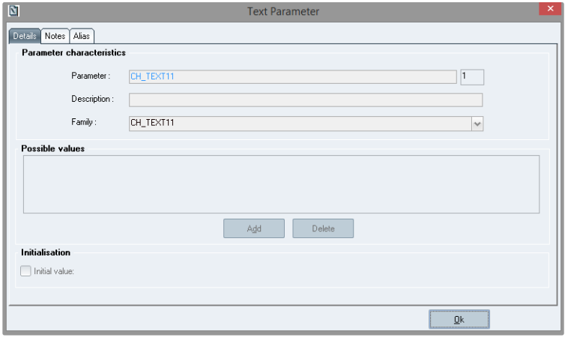

**The *Text Parameter* window**

**Window description:**

**The *Possible values* section:**

32 Sp-EBRDesign-2511

*Parameter Management*

*Parameters Configuration*

***Add*:** allows adding a value to the list. The system checks that the value is not stored in that list yet (50-character alphanumeric field).

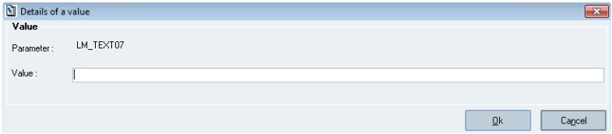

**The *Details of a value* window**

***Value:*** the user can enter a set of values possible for the parameter. That list will be sorted in alphabetical order. Optional input.

***Delete:*** allows deleting a value from the list. This button is shaded (i.e. not available) as long as the list of values is left blank.

**The *Initialisation* section:**

***Define*** or the ***Initial value*** check box (display the same window)***:*** allows defining an initialisation method for the

tag that will be associated with the parameter. That field is optional and can be modified:

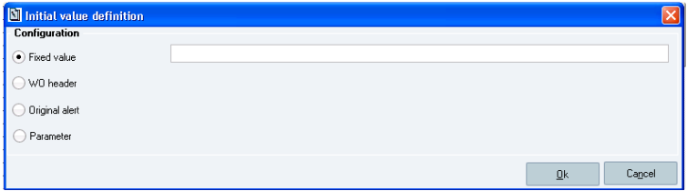

**The *Initial value definition* window – Text parameter**   
There are 4 methods to initialise a text parameter:

1. Selecting the *Fixed value* radio button will display an input field and allows performing the initialisation from a

fixed value;

2. Selecting the *WO header* radio button will display a drop-down list, from where the user will be able to choose a

value (i.e. *WO number*, *WO index*, *Product code*, *Lot number*, *Product description*, *WO unit*, *Reference code*, *Weight equivalent unit*, *Client reference code*) to perform the initialisation from a piece of information displayed in the WO header;

3. Selecting the *Original alert* radio button will display a drop-down list, from where the user will be able to choose

a value (i.e. *Numbers* (they correspond to the *Origin type*), *Status*, *Type*, *Origin*, *User*, *Workstation*, *Remark*, *Origin type*) to perform the initialisation from the original alert:

Types of Origin

Sp-EBRDesign-2511 33

*Parameter Management*

*Parameters Configuration*

**Origin type**

0

1

2

3

4

5

6

7

8

9

10

11

12

13

14

15

16

Others

**Origin (description)**

Forced tag

The limits of a numeric tag were exceeded

An alert was added to a tag

Filling in an alert tag

Unknown origin

Modifying a tag in Amend mode

Error while the script was executed

Forced task

Task was re-executed

An alert was added to a tag

Element was activated

Abort the execution of a task

Modifying a task-return parameters

Alert due to an electronic signature

Alert due to an electronic signature

Identification constraint was forced

Error while recording context data

Unknown origin

34

4. Selecting the *Parameter* radio button will display the *Parameter* button, from where the user will be able to choose a parameter to perform initialisation from a parameter.

 Sp-EBRDesign-2511

### 6.7.2

*Parameter Management*

*Parameters Configuration*

The Numeric Parameter

Numeric parameters enable the user to define digits which display a specific format and unit, and to assign values for the acceptable limits and the tolerance range.

#### [6.7.2.1](http://6.7.2.1) Window Description

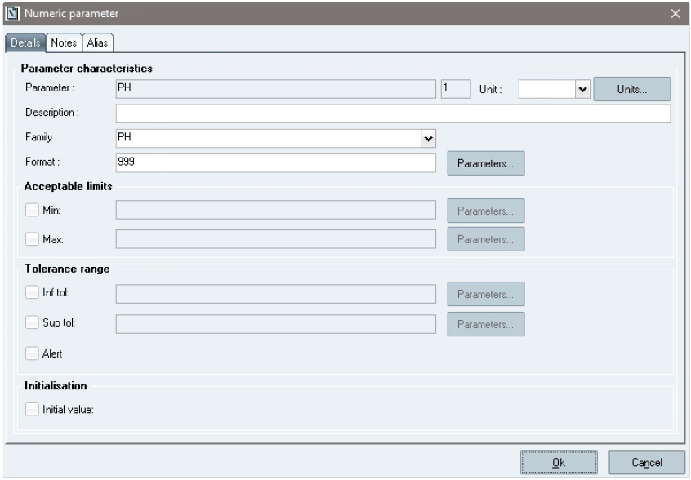

**The *Numeric parameter* window**

**The *Parameter characteristics* section:**

***Format:*** format of the numeric parameter. Definition of the number of figures expected for the integer part and

the decimal part. That field can be modified and is mandatory. The format value can either be defined by a value or by a text parameter (manually input or selected by the *Parameters…* button next to the field).

The format can be defined by a value as follows:

"**999**": the number of nines indicates the number of figures which is authorised for the integer part. In

that field, only nines will be displayed.

"**.**": indicates where the decimal separator is positioned and if there is any (optional, only once in the number).

"**99**": the number of nines indicates the number of figures which is authorised for the decimal part. In that field, only nines will be displayed.

***Unit:*** that field can be modified. The unit must be selected from the drop-down list, which includes all the units that are referenced by the system. Optional field. A button enables the user to manage all the units that are referenced in the system.

Sp-EBRDesign-2511 35

*Parameter Management*

*Parameters Configuration*

Please refer to ***Exploitation-i.pdf*** Technical document for more detail on the limitation of the length of the recording value

**The *Acceptable limits***

It enables the user to define the range of values that are allowed for this tag. Entering a value which is outside that range is impossible.

***Min:***

The field that is used to enter the minimum value and the associated button next to it (i.e. the *Parameters…* button)

are only available if the corresponding box is ticked. The minimum value can either be defined by value, which must respect the defined format (if defined by a value) and be inferior to the defined maximum value (negative values are authorised if the format allows it), or by another numeric parameter.

***Max:***

The field that is used to enter the maximum value and the associated button next to it (i.e. the *Parameters…*

button) are only available if the corresponding box is ticked. The maximum value can either be defined by value, which must respect the defined format (if defined by a value) and be superior to the defined minimum value (negative values are authorised if the format allows it), or by another numeric parameter.

**The *Tolerance range* section:**

It enables the user to define tolerance values directly on the value entered in the tag – or calculated by the system – and displayed in this same tag. If the value that the user wants to enter is outside that range, it is possible to enter a comment.

***Inf tol:***

It is the lower value (interval) of the tolerance range. The field that is used to enter the minimum value and the

associated button next to it (i.e. the *Parameters…* button) are only available if the corresponding box is ticked. The tolerance can either be defined by value, which must respect the defined format (if defined by a value) and be inferior to the maximum tolerance (negative values are authorised if the format allows it), or by another numeric parameter.

***Sup tol:***

It is the higher value (interval) of the tolerance range. The field that is used to enter the maximum value and the

associated button next to it (i.e. the *Parameters…* button) are only available if the corresponding box is ticked. The tolerance can either be defined by value, which must respect the defined format (if defined by a value) and be superior to the minimum tolerance (negative values are authorised if the format allows it), or by another numeric parameter.

**The *Initialisation* section:**

It enables the user to define an initialisation method for the tag that will be associated with the parameter. That field can be modified. **Optional input.**

#### [6.7.2.2](http://6.7.2.2) Unit management

The *Unit* *management* window enables the user to modify the list of units by adding or deleting values:

36 Sp-EBRDesign-2511

*Parameter Management*

*Parameters Configuration*

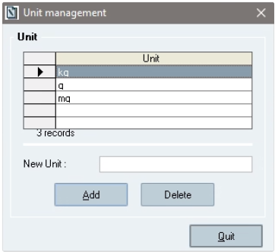

**The *Unit management* window**

**\Window description:**

**List of units:** list of units referenced by the system.

***New Unit:*** it is an input field which allows defining the unit. Its content will be considered when adding the unit. The unit length must be included between 1 and 10 characters.

***Add:*** allows adding the unit (that the user entered in the *New Unit* field) to the list of units.

***Delete:*** allows deleting the selected unit from the list. The button is shaded (i.e. not available) if the list is blank. A unit can be deleted only when it is not referenced in a parameter or in a piece of equipment (see the Equipment module, "Equipement.exe").

***Quit:*** allows closing the window without saving the modifications.

#### [6.7.2.3](http://6.7.2.3) Initialization Methods

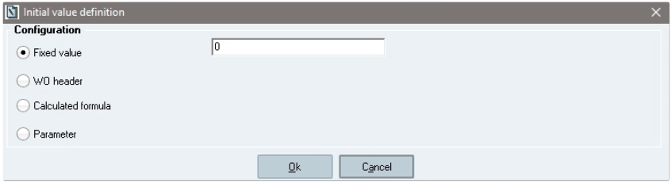

**The Initial value definition window – Numeric**   
There are 4 methods to initialise a text parameter:

1. Selecting the *Fixed value* radio button will display an input field to initialise all the tags that will use the

parameter, whatever the context;

2. Selecting the *WO header* radio button will display a drop-down list, from where the user will be able to choose a

value to initialise the tag linked to the parameter to it (i.e. *WO quantity*, *Weight equivalent*);   
Note: Initialization through WO header is not applicable for Cyclic operation element

3. Selecting the *Calculated formula* radio button will display a window, from where the user will be able to select a value from a list of parameters that display the "function" type. It allows the user to initialise the tag from the

result of a formula which is included in a function parameter;

Note: Initialization through Calculated formula is not supported for Cyclic operation element

Sp-EBRDesign-2511 37

*Parameter Management*

*Parameters Configuration*

4. Selecting the *Parameter* radio button will display the *Parameter* button. By clicking it, the *Parameter list* window

will become available and the user will be able to initialise the tag from the result of a parameter.

### 6.7.3 The Date Parameter

That parameter enables the user to define a date:

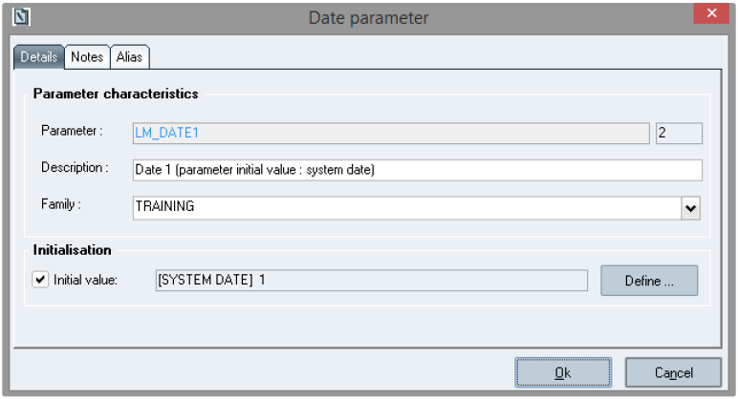

**The Date parameter window**

**Window description:**

**The *Initialization* section:**

Enables the user to define an initialisation method for the tag that will be associated with the parameter. Ticking the *Initial value* check box allows displaying the following window:

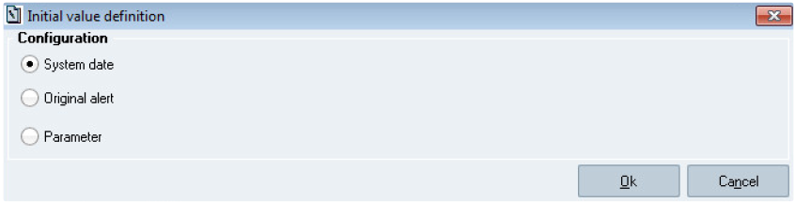

**The Initial value definition window – Date**   
There are 3 methods to initialise a date parameter:

1. Selecting the *System date* radio button allows initialising the date from the system date;

2. Selecting the *Original alert* radio button will display a drop-down list, from where the user will be able to

initialise the date from a piece of information (i.e. the date when the alert was entered);

3. Selecting the *Parameter* radio button will display the *Parameter* button. By clicking it, the *Parameter list* window

will become available and the user will be able to initialise the tag from the result of a parameter.

38 Sp-EBRDesign-2511

### 6.7.4

*Parameter Management*

*Parameters Configuration*

The Time Parameter

This parameter allows the user to define time:

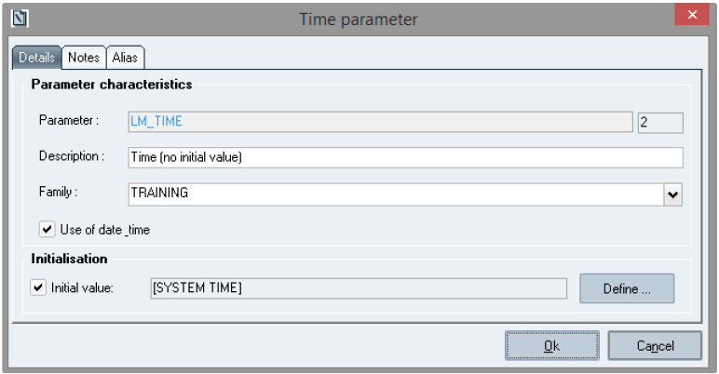

**The *Time parameter* window**

**Window description:**

***Use of date_time:*** allows determining if a value that is stored for this parameter uses date and time.

If that box is ticked, the date and time are stored for the value of the parameter.

If that box is left blank, only time is stored for the value of the parameter.

**The *Initialisation* section:**

Enables the user to define an initialisation method for the tag that will be associated with the parameter.

Ticking the Initial value check box allows displaying the Initial value definition window – Time (which is identical to Figure: The Initial value definition window – Date, except it displays the System time radio button instead of the System date radio button).

There are 3 methods to initialise a time parameter:

1. Selecting the *System time* radio button allows initialising time from the system time;

2. Selecting the *Original alert* radio button will display a drop-down list, from where the user will be able to

initialise time from a piece of information (i.e. time when the alert was entered);

3. Selecting the *Parameter* radio button will display the *Parameter* button. By clicking it, the *Parameter list* window

will become available and the user will be able to initialise the tag from the result of a parameter.

Generally, when a time parameter is read:

The date and time of the value is provided, if the parameter "uses" date/time.

Only the time of the value is provided, if the parameter only "uses" time.

### 6.7.5

The Signature Parameter

That parameter enables the user to define a signature:

Sp-EBRDesign-2511

39

*Parameter Management*

*Parameters Configuration*

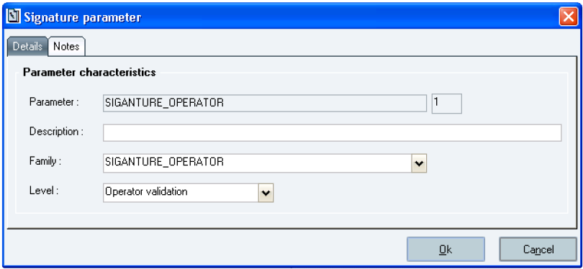

**The *Signature parameter* window**

**Window description:**

***Level:*** the user can select a value from the drop-down list, which includes the following validation levels:   
 **Operator validation**: signature of an authorised assistant, who will have to enter his/her name and

password. The user must have been assigned the access right 1540 (OPERATOR VALIDATION)

**Manager validation**: signature of a manufacturing manager, who will have to enter his/her name and password. The user must have been assigned the access right 1545 (MANAGER VALIDATION)

**Double Acq. different Operators** (validation): signature of two different authorised operators. Each of them will have to enter his/her name and password. One of them can be the operator who has been declared in the current session, although this is not mandatory. On the other hand, both must be authorised to manufacture. Both users must have been assigned access right 1540 (OPERATOR VALIDATION)

**Declared operator validation**: signature by the assistant who has been declared when launching the application. The assistant will have to enter his/her password when manufacturing. The user must have been assigned access right 1540 (OPERATOR VALIDATION)

**Double Acq. incl. declared Operator** (validation): signature of two different authorised operators, including the one who entered his/her name and password when launching the application. The first signatory is always the one who has been declared in the current session. S/he only must enter his/her password. The second signatory enters his/her name and password. S/he must be different from the first one and has to be authorised to manufacture. Both users must have been assigned access right 1540 (OPERATOR VALIDATION)

That field is initialised with the first value of the list. Mandatory input.

### 6.7.6 The Function Parameter

That parameter enables the user to define the formula of a calculation, which will then be called from a numeric parameter:

40 Sp-EBRDesign-2511

*Parameter Management*

*Parameters Configuration*

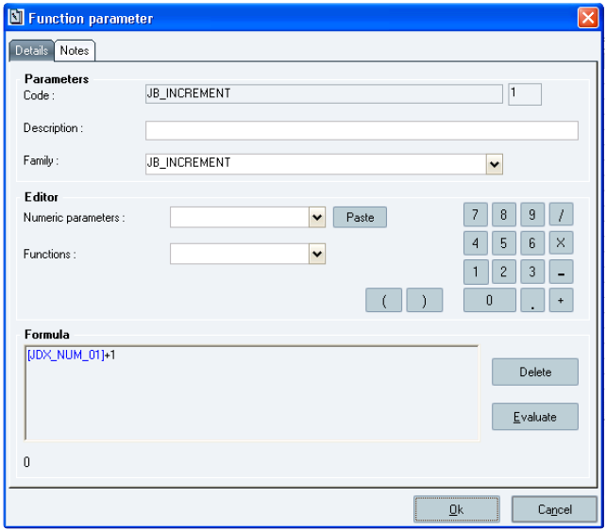

**The *Function parameter* window**

**Window description:**

**The *Editor* section:**

***Numeric parameters:*** drop-down list of numeric parameters that can be added to the function formula. Clicking the *Paste* button allows inserting that parameter into the formula.

**Calculator:** clicking one of its buttons enables the user to insert the corresponding character into the zone which allows entering the formula.

***Functions:*** drop-down list of arithmetic functions that can be added to the function formula.

N.B.: The LOG function is a natural logarithm.

***Delete:*** allows clearing the contents of the zone which allows entering the formula.

***Evaluate:*** allows evaluating the formula that is included in the zone which allows entering the formula.

***Zone to edit the formula: mandatory input.*** The user can enter the numeric values from the calculator displayed on the window, or directly enter it from the numeric pad. The operator is responsible for keeping the formula coherent (type: 250-character alphanumeric field).

### 6.7.7 The Labelling Parameter

That parameter enables the user to define the configuration of a barcode that will be generated when executing the PI:

Sp-EBRDesign-2511 41

*Parameter Management*

*Parameters Configuration*

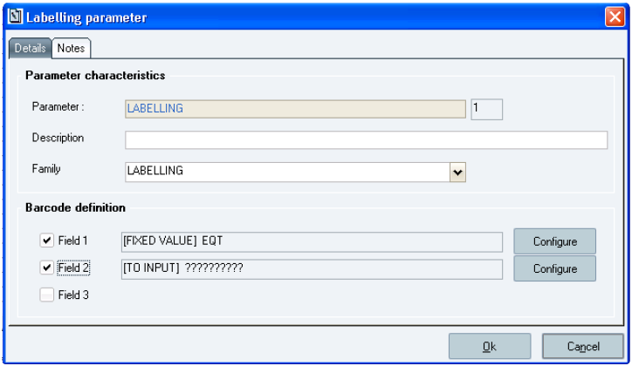

**The *Labelling parameter* window**

**Window description:**

**The *Barcode definition* section**:

***Field 1; 2; & 3*:** enable the user to define each barcode field. The following window is opened when one of these three check boxes is ticked. At least one of the three fields must be filled in (see below figure to see the window which is displayed after having clicked the *Field 3* check box from the *Labelling parameter* window):

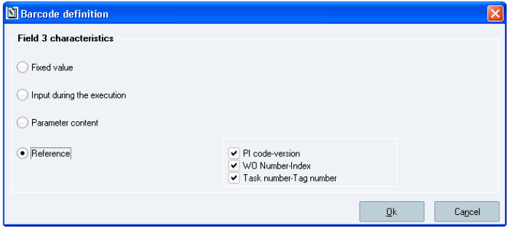

**The Barcode definition window when the Reference radio button is selected**   
There are 4 methods to initialise a text parameter:

1. Selecting the *Fixed value* radio button will display an input field to enter a fixed value that will be used for the field of the concerned barcode. That option is defined by default and pre-filled with the value that is defined in

the VAL_PAR_DEF_CHX_MARQ_EDIT parameter, where the letter X stands for the field number (i.e. there are three parameters: VAL_PAR_DEF_CH1_MARQ_EDIT, VAL_PAR_DEF_CH2_MARQ_EDIT, and VAL_PAR_DEF_CH3_MARQ_EDIT);

2. Selecting the *Input during the execution* radio button will display the *Capacity* field, which is automatically filled

in with the value of the TAILLE_PAR_DEF_CH_INC_MARQ_EDIT parameter that has been defined. In that case, the user will specify the value of the field later (i.e. when entering the Labelling tag);

42 Sp-EBRDesign-2511

*Parameter Management*

*Parameters Configuration*

3. Selecting the *Parameter content* radio button will automatically display the *Parameter* button and then the *Parameter list* window. The user will therefore be able to create the barcode with the value that is defined in a

numeric or a text parameter by selecting a value from that window;

4. Selecting the *Reference* radio button will automatically display three check boxes and their values, which

correspond to the different options to define the field of the barcode. The user can make all the combinations s/ he wants with these three parameters (i.e. PI code–version, *WO Number-Index*, *Task number-Tag number*).

***Ok***: allows validating the entered value. The associated field is selected and the entered value is displayed beside it.

***Cancel:*** allows not taking the entered value into account; the fields remain blank.

### 6.7.8 The Identification Parameter

That parameter enables the user to define the characteristics of the barcode that will have to be identified.

**Note**

A labelling tag which references the labelling parameter must be executed before the identification tag.

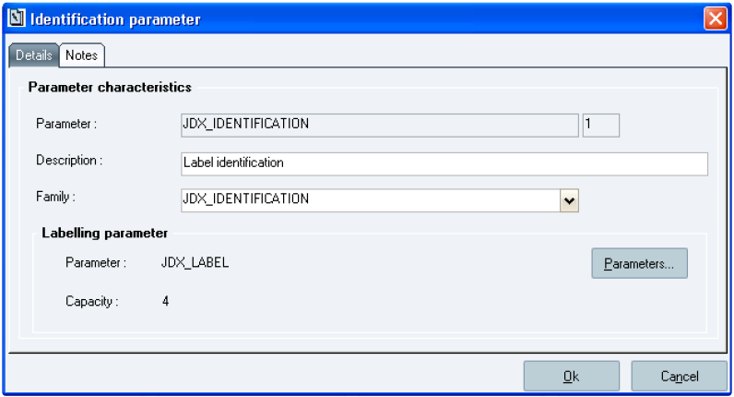

**The *Identification parameter* window**

**Window description:**

**The Labelling parameter section:**

***Capacity:*** size of the Label variable, associated with the Identification variable. Calculated by the system according to the size of the selected labelling parameter.

***Parameter*:** name of the labelling parameter with which the barcode to identify must be associated with. Mandatory input.

### 6.7.9

The Barcode-Identification Parameter

That parameter enables to define and configure the reading of a label for a given type:

Sp-EBRDesign-2511

43

*Parameter Management*

*Parameters Configuration*

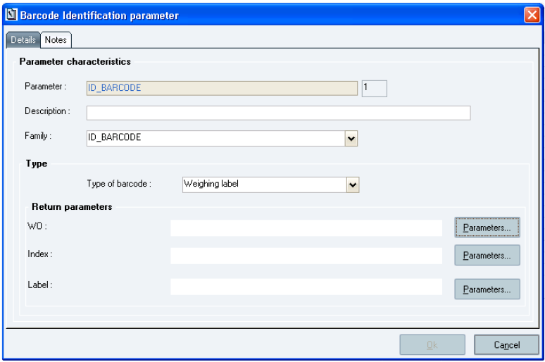

**The *Barcode Identification parameter* window**

**Window description:**

**The *Type* section:**

Type of the label that the user wants to receive and identify. For the moment, its selection is made from the following list of types:

1. *Weighing label*

2. *Warehouse container*

3. *Equipment*

4. Other (enables the user to receive a barcode with a type that is not specified yet)

**The *Return parameters* section:**

Set of parameters of the Text type that will receive the different pieces of information that are extracted from the barcode. The number of return parameters and what they mean depend on the selected type of label:

The types of Label

**Type of label**

Warehouse container

Weighing label

44

**Return parameters**

Item code Lot code Container Location Pallet

WO number WO index Label number

 Sp-EBRDesign-2511

**Type of label**

Equipment

Other

*Parameter Management*

*Parameters Configuration*

**Return parameters**

Equipment code

Whole gross barcode

### 6.7.10

The Report parameter

To be able to use that parameter (prerequisites):

This functionality can only be used with an executable that is provided with Microsoft SQL Server 2014 (not   
provided in the Opcenter Execution Pharma software, for more information, please refer to the Opcenter Execution Pharma installation document).

The report parameter allows a user to define a template for a report. A template is an .RDL file that has been created from Reporting Services (provided in SQL Server 2014). It contains the report layout and the input key of the template that is required to fill the execution requests in. The set of requests is named a Datasource.

When creating a report parameter, the user associates the template with the parameter, records the input keys of the template and validates the creation of the parameter.

Once the creation of the parameter is saved, the template associated with the parameter is recorded in the Opcenter Execution Pharma database.

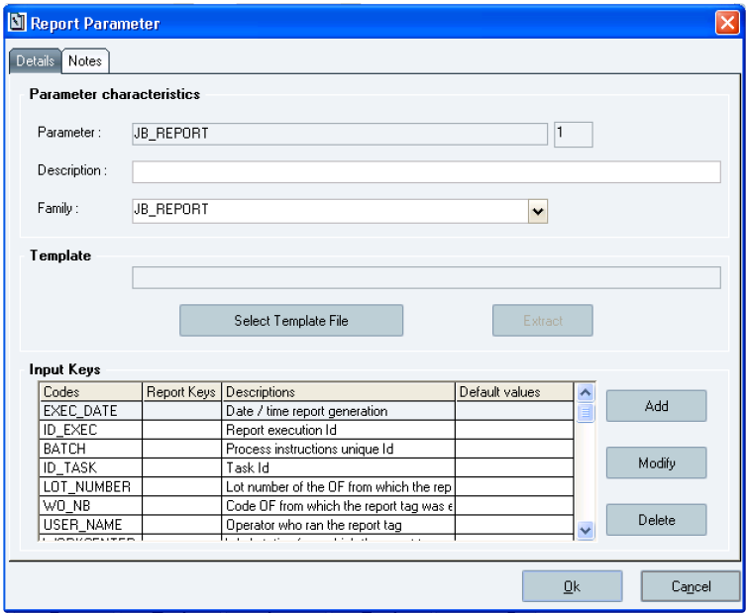

**The *Report Parameter* window**

Sp-EBRDesign-2511 45

*Parameter Management*

*Parameters Configuration*

**Window description:**

**The *Template* section:**

The field which is included in that section displays the template that is associated with the parameter. It is filled in with the name and the extension of the file. Mandatory input.

***Select Template File:*** allows the user to select a template file in a browser.

***Extract:*** allows the user to extract the template that was recorded at that time in the Opcenter Execution Pharma database. The user can make a local copy of the file. This button is shaded (i.e. not available) in the following cases:

When a parameter is created;

When a parameter is modified, if the user has modified the template field.

**The *Input Keys* table:**

Lists the fields of the template that can be customized. It is made up of the following columns:

*Code:* key codes that have been entered. Mandatory input.

*Report Keys:* code of the key in the template. Mandatory input.

*Descriptions:* description of the entered keys.

*Default values:* default value of the entered key, which can be filled in with a string of characters or with a parameter. If this field is filled in, when the parameter is used in a reporting tag, then the default value is displayed in the tag.

When creating a new reporting parameter, the table is previously filled in with standard keys. The code of these   
keys is already filled in and the default values are cannot be modified. These default values are already set up to get the good value. When setting up the input key, the user only has to fill in the report-key codes. The standard keys can be deleted.

If a standard key is deleted, the user can re-create it by creating a new input key with a code that corresponds to the standard key code.

When the creation of such a key is validated, a warning message is displayed to inform that the new key corresponds to a standard key. After validating this message, the setup of the standard key is retrieved and the standard key is added to the list of the input key.

List of standard input keys:

Date/Time: date and time when the tag is executed (code: EXEC_DATE). If the EBR_VIEW_LOCALTIMEREF

parameter is set to 1, the date and time are based on GMT (locale time). If the EBR_VIEW_LOCALTIMEREF parameter is set to 0, the date and time is displayed without it.

Execution identifier: Identifier that is generated once the reporting tag has been executed (code ID_EXEC)   
 Batch ID: unique PI Identifier (code: BATCH)

Task ID: Identifier of the task (code: ID_TASK)

Lot: number of the lot that corresponds to the WO from where the reporting tag is executed (code: LOT_NUMBER)

OF: code of the WO from where the reporting tag is executed (code: WO_NB)

Operator: user who has executed the reporting tag (code: USER_NAME)

Workcentre: workcentre from where the reporting tag is executed (code: WORKCENTER)

User who has generated the report (code: USER_PRINT_NAME). This key is evaluated only when the report generation is requested.

When a user clicks the *Add* button, the following window is displayed:

46 Sp-EBRDesign-2511

*Parameter Management*

*Parameters Configuration*

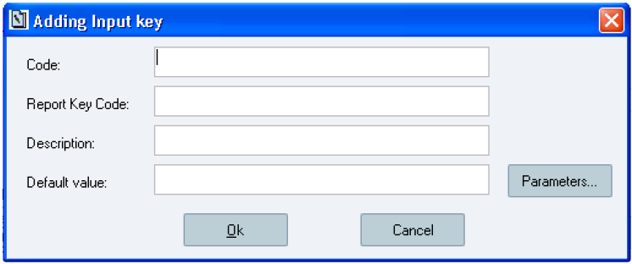

**The *Adding Input key* window**

**Window description:**

***Code:*** mandatory input. This code is always in uppercase letters.

***Report Key code:*** mandatory input. Corresponds to the code of the key in the template. ***Description***

***Default value***

Once the mandatory fields have been filled in and if the user clicks the *Ok* button, the new key is added to the list of input keys.

If the user clicks the *Cancel* button, the key is not added to the list.

To create a new key in a reporting parameter, the following conditions have to be met:

The code of the new key must differ from the code of a key that has already been defined in the parameter   
 The Report key of the new key must differ from the Report key of a key that has already been defined in the parameter

Otherwise creating the key is not possible.

When a user selects an input key and clicks the *Modify* button, the following window is displayed:

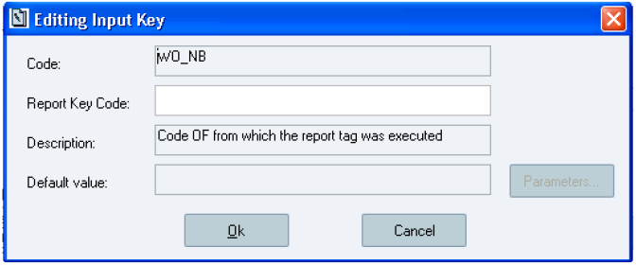

**The *Editing Input Key* window**

**Window description:**

Sp-EBRDesign-2511 47

*Parameter Management*

*Parameters Configuration*

**Note**

The following fields are identical to those of the *Adding Input key* window (i.e. they are defined the exact same way), except one of them cannot be modified.

***Code:*** cannot be modified

***Report key code:*** can be modified ***Description:*** can be modified ***Default value:*** can be modified

To modify a key in a reporting parameter, the following condition has to be met:

The Report key of the key must differ from the Report key of a key that has already been defined in the

parameter

Otherwise modifying the key is not possible.

When a user selects an input key and clicks the *Delete* button, the following window is displayed:

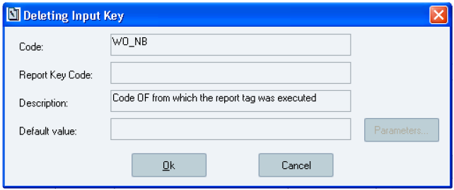

**The Deleting Input Key window**

If the user clicks the *Ok* button, the key is deleted from the list of input keys. If the user clicks the *Cancel* button, the

key is not deleted.

Once the list of input keys is entered, the user can validate the creation of the reporting parameter.

The validation of that creation allows saving the template and the input keys in the Opcenter Execution Pharma database.

If the user clicks on the *Cancel* button, the reporting parameter is not created. Consequently, the template and the input keys are not saved in the Opcenter Execution Pharma database.

After that the reporting parameter has been created, if the user access the window which allows modifying the parameter, s/he can modify the following fields:

**Template:** the user can modify the template that is associated with the reporting parameter. The modification will be taken into account once the user validates the parameter modification. N.B.: if the template field is modified, it is up to the user to check that the input keys match with the new template.

***Input key* table:** the input keys can be modified.

Once the modifications have been performed and validated by clicking the *Ok* button, and if the template field has been modified, then the template that was recorded in the Opcenter Execution Pharma database is replaced by the new one.

If the input keys have been modified, these modifications are saved.

48 Sp-EBRDesign-2511

*Parameter Management*

*DCS/PCS relevant parameters*

**Note**

## 6.8

if these modifications are cancelled, and if the fields of the template were modified, the recorded template in the Opcenter Execution Pharma database is the one that has been recorded when the modification of the reporting parameter was last validated.

DCS/PCS relevant parameters

### 6.8.1

Purpose

A DCS/PCS relevant parameter is a parameter which is available in Batch recipe (within SIMATIC BATCH) and that the client can use from the Opcenter Execution Pharma. This piece of information is useful when it comes to the communication between SIMATIC BATCH and Opcenter Execution Pharma (batch element, Event PI, etc.)

**Note**

This functionality requires that the data from batch system has been correctly uploaded

Please refer to ***Batch_process_and_configuration-i.pdf*** technical documentation for more details.

### 6.8.2 Master recipe upload

Here is the upload behavior for a recipe:

Replaces the master recipe structure (xml stored in IL_RECIPE) by the new one.

Replaces all master recipe's parameters (deletes all and add new):

If a parameter (same ContId, TermId and name) was defined as relevant, it still remains relevant after

upload but all fields are updated (initial value, material code, etc.).

If a parameter defined as relevant is not part of the master recipe anymore, it is deleted from relevant parameters.

If new parameters are part of the master recipe, they will be available in DCS/PCS parameters screen. They are not relevant; the user has to define them as relevant.

The header parameters of the recipe are deleted and replaced. So if no relevant parameters are defined, when selecting the recipe in batch element, all header parameters will be available.

If a batch parameter type is not managed in Opcenter Execution Pharma, it is not recorded during the recipe upload (not stored as relevant or header parameter). The managed types are defined in IL_Datatype table: Used set to 1.

For now, the batch parameters declared as managed are: Float, Numeric, Text, Input material, Output material, Boolean, Unit. In addition to these, enumerations are managed.

These types are then managed as follow:

Text, Input material, Output material, Unit: managed as text.

Float, Numeric, Boolean: managed as Numeric.   
 Enumerations: managed as text + special treatment.

### 6.8.3 Configuration

The *DCS/PCS relevant parameter* *management* tab allows visualising and selecting these parameters for each Batch recipe.

Sp-EBRDesign-2511 49

*Parameter Management*

*DCS/PCS relevant parameters*

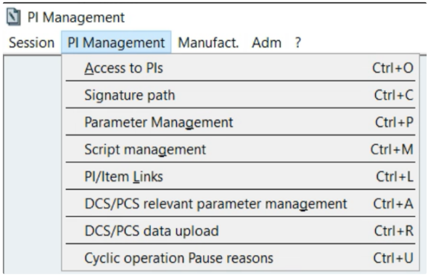

**How to access the *DCS/PCS relevant parameter management* window**

The users must have been assigned the access right 1907 (DCS/PCS RELEVANT PARAMETER MANAGEMENT) to access the corresponding functionality (if so, s/he will have to enter his/her name and password again).

50 Sp-EBRDesign-2511

*Parameter Management*

*DCS/PCS relevant parameters*

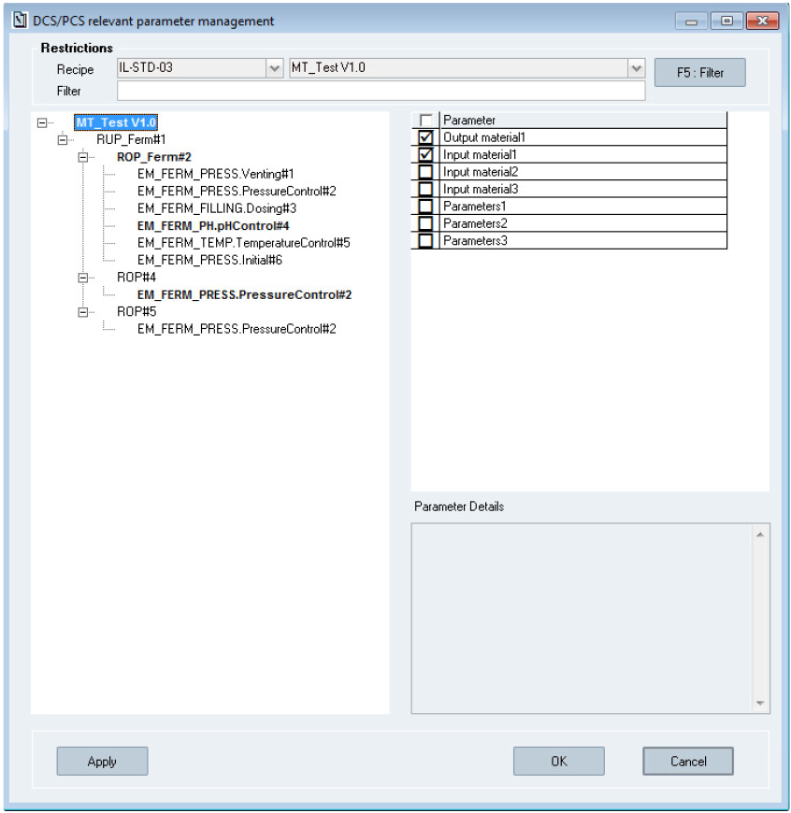

**The *DCS/PCS relevant parameter management* window**

**Window description:**

***Restrictions:***

**Recipe**: List of all PCell and recipes, automatically retrieved when the window is opened. When a PCell is selected, the related recipes are loaded in the second drop down list. Once selected, the recipe's structure is displayed in the tree view.

Note: if a new recipe is uploaded the window is not refreshed, it should be re-opened to see the new recipe in the list.

**Filter:** Free filter input.

The free input in the filter could limit elements and parameters to display: when a filter is applied, the tree view stays opened and displays only the elements and parameters which fulfil the filter criteria.

Sp-EBRDesign-2511 51

*Parameter Management*

*DCS/PCS relevant parameters*

***Tree view:***

The selected recipe's structure is displayed in the tree view.

The elements that are in bold have some DCS/PCS relevant parameters configured.

***Parameters:***

Parameters of the recipe element selected in the tree view.

By default, no parameters are checked.

***Parameter details:***

Detail of the selected parameter.

If the selected parameter is an enumeration, the enumeration name is displayed in "Type of data" field:

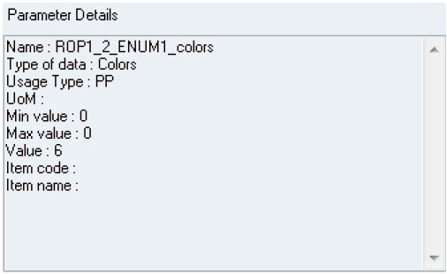

**Type of data for enumeration**

**Note**

The min and max values are only available in Opcenter Execution Pharma if provided by SIMATIC Batch during

master recipe upload. In SIMATIC Batch these values (high recipe limit value and low recipe limit value) are either "defined" (displayed in black) or "calculated" (displayed in green). SIMATIC Batch only provides "defined" values during master recipe upload, "calculated" values are not provided so they will not be available in Opcenter Execution Pharma.

For Unit parameter, the displayed value is always N/A.

**Actions:**

**F5: Filter:** Reload the tree view and the parameters list filtered with recipe selection and free input

: Select/unselect all parameters displayed in the parameters list.   
 **Apply:** Save all modifications done.

 **OK:** Save all modifications done and close the window.

**Cancel** or

**Rules:**

**:** Close the window without saving

52

The free input filter is applied to all recipe elements and to parameter names:

If a recipe element contains the text put in the filter, it appears in the tree view and all its parameters are

visible.

 Sp-EBRDesign-2511

*Parameter Management*

*DCS/PCS relevant parameters*

If a recipe element doesn't contain the text put in the filter, only its parameters that match the input filter are visible.

If a recipe element doesn't contain the text put in the filter and none of its parameters matches with the filter, the element is not displayed in the tree view.

To define a parameter as DCS/PCS relevant, its checkbox must be checked; then the user must save his modification with "apply" or "ok" button.

**Note**

Only the relevant parameters will be available in the batch element, after recipe selection.

Specific case: if no relevant parameters are defined for a recipe, only the recipe header parameters will be available in the batch element, after recipe selection.

There are three types of batch parameters:

Product Input: Corresponds to the material to use

Product Output: Corresponds to the goods to produce

Process Parameter: Corresponds to recipe parameters (only numeric and text type)

Each DCS/PCS relevant parameter added or deleted generates an audit trail stored in critical actions.

### 6.8.4 New version upload for a recipe already configured

If a new recipe version is uploaded, the DCS/PCS relevant parameters of the previous version should be configured for the new version.

**Rules:**

If a master recipe (Pcell, name, version) has not been uploaded but there are some recipes with same Pcell and same name that have already been uploaded, the system will determine the previous version of the uploaded recipe:

If no previous version is found, no DCS/PCS relevant parameters will be configured by default.   
 If a previous version is found and if:

the parameter exists in the previous and in the new version, the system applies the DCS/PCS relevant parameters configuration of the previous version to the uploaded version,

the parameter exists only in the new version, this parameter is defined as no DCS/PCS relevant parameter.

the parameter does not exist in new version, the system does nothing.

Sp-EBRDesign-2511 53

*Parameter Management*

*DCS/PCS relevant parameters*

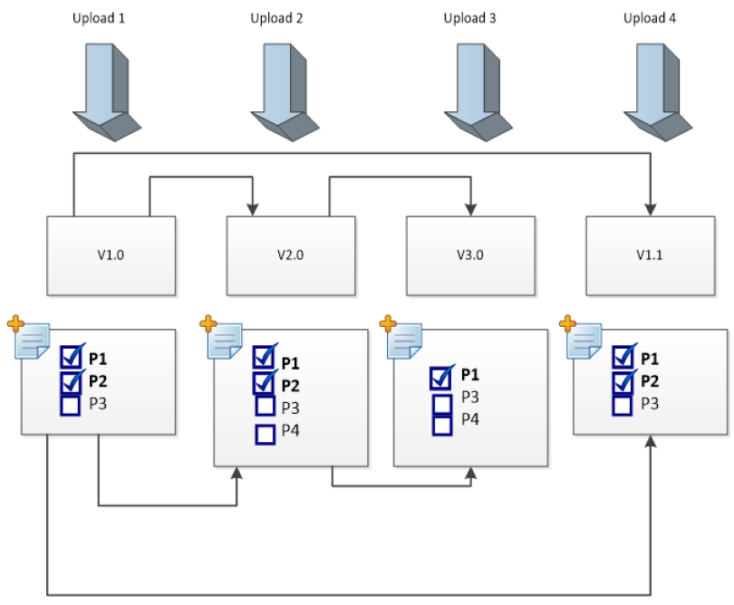

The previous version is determined in the following way:

If the uploaded version format is VX.Y where X and Y are numeric, the systems assumes that recipe versioning in

batch system is configured in "aided-version". In this case, the system gets the previous version based on X.Y value. Note that all previous versions that are not in the aided-version format are ignored.

Example:

**Version currently uploaded** **=>**

54

**PCell**

Pcell01

Pcell01

Pcell01

**Pcell01**

Pcell01

**Recipe Name**

MyRecipe

MyRecipe

MyRecipe

**MyRecipe**

MyRecipe

**Recipe Version**

V01.00

**V01.01**

V01.02a

**V02.00**

V02.01

**<= This is the previous version**

<= IGNORED!

 Sp-EBRDesign-2511

Pcell01

MyRecipe

*Parameter Management*

*DCS/PCS relevant parameters*

V03.00

If the version format of the new version is not VX.Y where X and Y are numeric, the system assumes that recipe versioning in batch system is not configured in "aided version". In this case, the system gets the previous version based on alphabetic order.

Example:

**Version currently uploaded** **=>**

**PCell**

Pcell01

Pcell01

Pcell01

**Pcell01**

Pcell01

Pcell01

**Recipe Name**

MyRecipe

MyRecipe

MyRecipe

**MyRecipe**

MyRecipe

MyRecipe

**Recipe Version**

A01

**B45**

**V2a**

V2b

XYZ

**<= This is the previous version**

### 6.8.5

DCS/PCS data upload

The DCS/PCs Data Upload menu allows the user to perform a phase type and enumeration upload for a selected PCell.

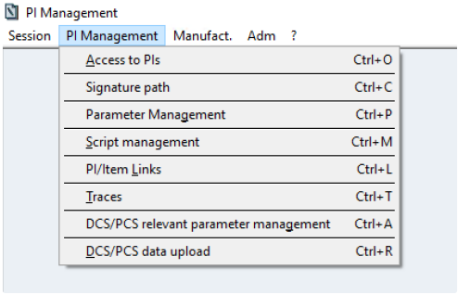

**Accessing DCS/PCS data upload menu**

When selecting this menu, thefollwing windows is displayed:

Sp-EBRDesign-2511

55

*Parameter Management*

*MBR relevant parameter*

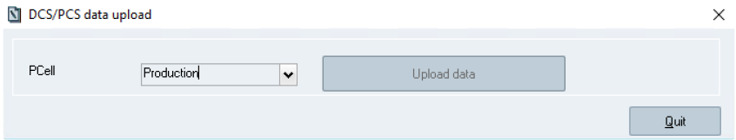

**DCS/PCS data upload screen**

**Window description:**

The combobox allows the user to choose the PCell on which the phase type and enumeration upload will be performed. The list of PCell is filled out with running PCells. If a PCell is disconnected, it will not be part ofthe list;

The button "Upload data" sends a request to perform the phase type and enumeration upload.

**Note**

The Script service must be running. Ensure BIL services are running.

## 6.9 MBR relevant parameter

### 6.9.1 Purpose

A MBR relevant parameter is critical PI parameter that should be managed/display at the MBR level. During the PI designing phase, PI parameters could be defined as MBR relevant.

### 6.9.2 Configuration

The MBR relevant notion should be defined in the link tab (see The Links Tab).

## 6.10

Standard parameters

The standard parameters (with their default values) are the following:

Parameters for Cyclic operations:

CO_EVENT_PI_CTX_COTITLE : Cyclic Operation Title

CO_EVENT_PI_CTX_USER : Who Created the CO

CO_EVENT_PI_CTX_PERIODICITY: Interval for executing the cycle CO_EVENT_PI_CTX_MINTOLERANCE: interval for alerting that the Period is getting over CO_EVENT_PI_CTX_MAXTOLERANCE: interval for alerting that the Period is over CO_EVENT_PI_CTX_CYCLEIMMEDIATE: Immediate cycle at the task start CO_EVENT_PI_CTX_CYCLE_NUMBER: Number of current cycle CO_EVENT_PI_CTX_CYCLIC_RULE : Time, event or on demand rule CO_EVENT_PI_CTX_END_CONDITION: End of cyclic operation CO_EVENT_PI_CTX_STARTDATE: Start date of CO

CO_EVENT_PI_CTX_CYCLESTATUS: Cycle Status

CO_EVENT_PI_CTX_COUNTDOWN: Cycle countdown

56

Sp-EBRDesign-2511

*Parameter Management*

*Standard parameters*

CO_EVENT_PI_CTX_COUNTDOWNLABEL: Cycle countdown label (Will be NA for event based or On Demand execution

CO_EVENT_PI_CTX_PAUSE_DATE : last pause date for initialize cycle and create cycle   
 CO_EVENT_PI_CTX_PAUSE_REASON : Pause Reason

CO_EVENT_PI_CTX_RESUME_DATE: Resume date of paused CO

CO_EVENT_PI_CTX_DURATION : last pause duration

CO_EVENT_PI_CTX_USER_PAUSED: Who paused the CO

CO_EVENT_PI_CTX_USER_RESUMED: Who resumed the CO

CO_EVENT_PI_CTX_CYCLEPAUSEDUR: Cumulative value of pause for the entire cycle \[initialize + create \]

These parameters allow using data from the cyclic operation and are used as such in the Open PIs (i.e. **they do not need to be configured as input parameters for the Open PIs**), their value will be automatically initialized at parameter usage time.

**Note:** These parameters are automatically created once the first CO element is configured (they are not included in an empty database).

Parameters for Batch Element:

EVENT_PI_CTX_BATCHID: Batch ID (Opcenter Execution Pharma data)

EVENT_PI_CTX_BATCH_NUMBER: Batch name

EVENT_PI_CTX_BATCH_ORDER: Batch order

EVENT_PI_CTX_BIL_PLANT_ID: PCell

EVENT_PI_CTX_CTRL_STRAT: Control Strategy

EVENT_PI_CTX_EQ_MODULE: Equipment Module

EVENT_PI_CTX_RECIPE_NAME: Recipe name

EVENT_PI_CTX_RECIPE_VERSION: Recipe version

EVENT_PI_CTX_SBATCH_CONTID: Batch Element ContID (SIMATIC BATCH data)   
 EVENT_PI_CTX_SBATCH_TERMID: Batch Element TermID (SIMATIC BATCH data)   
 EVENT_PI_CTX_WO_INDEX: WO index

EVENT_PI_CTX_WO_NUMBER: WO number

EVENT_PI_CTX_ACT_COUNTER: Activation counter (the number of activations of the element in the Batch system)

EVENT_PI_CTX_PRT_ACT_COUNTER: Parent (ROP) activation counter

They can neither be revised nor deleted.

These parameters allow exchanging data from the batch of SIMATIC BATCH to Opcenter Execution Pharma and are used as such in the Event PIs (i.e. **they do not need to be configured as input parameters for the Event PIs**), their value will be automatically initialized at Event PI launch.

Notes:

These parameters are automatically created if they do not exist when batch configuration window is recorded

(they are not included in an empty database).

Sp-EBRDesign-2511 57

*Script Management*

*Introduction*

# 7 Script Management

## 7.1 Introduction

PI scripts are used to insert new functions that are not part of the Opcenter Execution Pharma standard product. Scripts are managed like parameters.

## 7.2

Script Lifecycle

A script has the same lifecycle as a parameter:

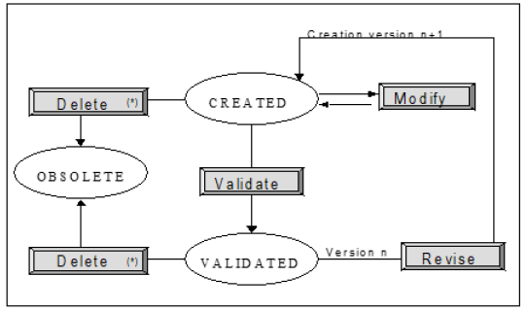

**The script lifecycle**

* Impossible if the script is referenced in a non-obsolete PI or script.   
A script can display one of the following statuses:

***Created***: status of a script once created. A script can be created when adding a new script, or when copying an available script. It is then assigned a unique code. Its creation index is 1. When a script is revised, it keeps the same code, but a new version is created. Revising version *n* triggers the creation of version *n+1*.

A script which displays the *Created* status can be:   
 Modified. If so, it keeps the *Created* status.

Validated. If so, its status is changed to *Validated*.

Deleted. That action is possible only if the script is not referenced in a non-obsolete PI or script. The script status changes to *Obsolete*.

***Validated***: status of a script once validated.

All scripts referenced in a PI need to be validated to authorize the PI signature. Scripts can be validated from the list

of scripts or when signing the PI.

A *Validated* script can be:

Revised. Revision automatically triggers the creation of index n+1 for the script that displays the *Created*

status

Deleted. That action is possible only if the script is not referenced in a non-obsolete PI or script.

58 Sp-EBRDesign-2511

*Script Management*

*Script Management*

***Obsolete***: the script cannot be used anymore. It is no longer referenced in scripts or ongoing PIs.

## 7.3

Script Management

The *List of scripts* window (which allows managing scripts) can be accessed from the PI Management module (i.e. "PIManagement.exe" > *PI Management* > *Script Management*) or from the Script Management standalone application (i.e. "ScriptManagement.exe").

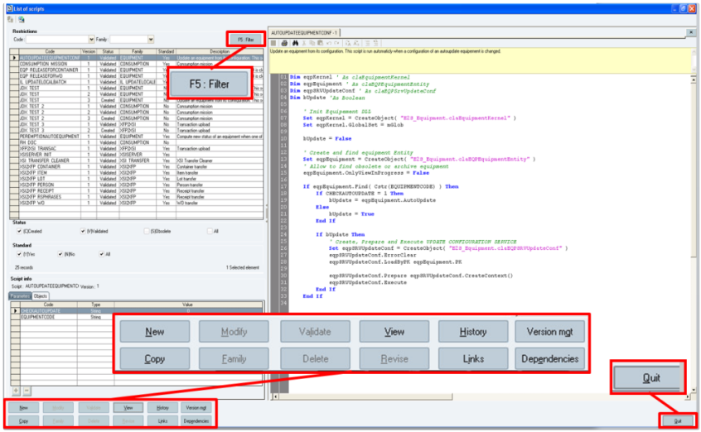

**The *List of scripts* window**

**Window description:**

***F5: Filter***: allows creating a list of scripts that corresponds to the selected criteria (name of the script and its family)

***New:*** allows creating a new script

***View:*** allows opening the contents of the selected script in Read-only mode

***Modify*** (or double-click)***:*** allows opening the contents of the selected script for modification

***Validate:*** allows validating the selected script (the script status changes to *Validated*)

***History:*** allows accessing the history to see all the versions of a script

***Version mgt:*** allows accessing version management of a script

***Copy:*** allows copying the selected script

***Family:*** allows modifying the script family

***Delete:*** allows deleting the selected script, only if it is not used in a PI that is not obsolete and in a script that is not obsolete (the script status changes to *Obsolete*)

***Revise:*** allows creating a new version of the selected script (by revising it)

***Dependencies:*** allows accessing dependencies that is available between the selected script and PIs

***Links:*** allows accessing the window that shows the links between scripts

***Quit:*** allows closing the *List of scripts* window (N.B.: No confirmation message is displayed).

Sp-EBRDesign-2511

59

*Script Management*

*Script Management*

N.B.: The *Dependencies* and *Version* mgt buttons cannot be clicked from the Script Management module; they can only be accessed from Script Management in a PI.

### 7.3.1 New, Modify, View, Copy, Revise, Validate, Delete, Version mgt

These functions are described in the ***Sp-ScriptManagement-i.pdf*** specification.

### 7.3.2 Managing the versions of a script

From the list of scripts, using the version of a script by PIs can be checked by clicking the *Version mgt* button.   
The version of a script can be managed from the following window:

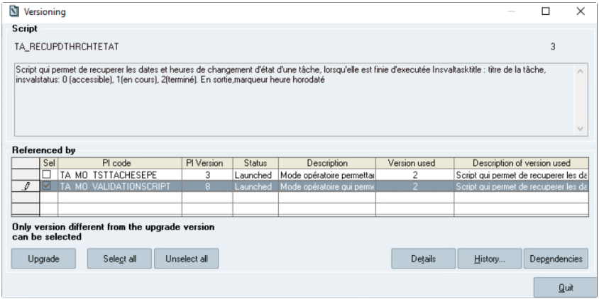

**The *Versioning* window**

This window provides the details for the selected script (i.e. code, version, description) and gives a list of all the

non-obsolete PIs that use any of the versions of the selected script.

This list of PIs gives the following values:

The code/version of the PI that uses the script

The PI status

The PI description. If required, this description (text) can be wrapped

The version of the script that is used in that PI

The version description of the script that is used in the PI. If required, this description (text) can be wrapped.

The window indicates that only version that are different from the used script version can be selected.   
The following actions can be performed from that window:

**Button description:**

***Upgrade***: upgrade the version of the script that is used in the PI by the version that is currently being viewed. It is possible to update a set of PIs at the same time by selecting multiple rows from the list (i.e. by ticking the corresponding checkboxes).

60 Sp-EBRDesign-2511

*Script Management*

*Script Management*

A check of the script parameters is performed before upgrading the version. If it is available, a message is displayed to warn the user that there is a difference of parameter configuration between the current version of the script and its version that is used by the selected PI:

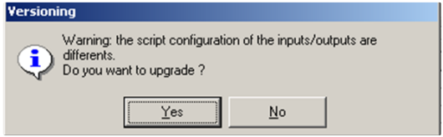

As a consequence, the user can decide to continue or to cancel the upgrade.

**Warning:** **the upgrade of this script will generate errors when the script is used in PIs. This is why it is recommended not to use the "Upgrade version" option.**

**Anyway, if the user chooses to keep on upgrading the version (i.e. by clicking the *Yes* button) then s/he has to** **check and manually modify the parameters of the script that are used by the updated PI.**

Several PIs can be upgraded simply by selecting more than one PI from the list.

After having clicked the *Upgrade* button, a recap window appears to display:

all the PIs for which an upgrade has been requested   
 for each PI:

its code, version, status, modification performed from version X to version Y, and comment.

the confirmation that the upgrade can be performed, or the reason why the upgrade cannot be performed (according to the upgrade rules).

This window can be either confirmed or cancelled. If confirmed, the upgrade occurs. In all cases, the selection is kept (the tick boxes are still selected) and the *Versioning* window is eventually updated with the new versions.

If the upgrade is confirmed, the following trace is generated for the function which requires the access right 1143 (SCRIPT UPGRADE): "Modification of the version of the utilized script "Script code": "previous version" => "new version".

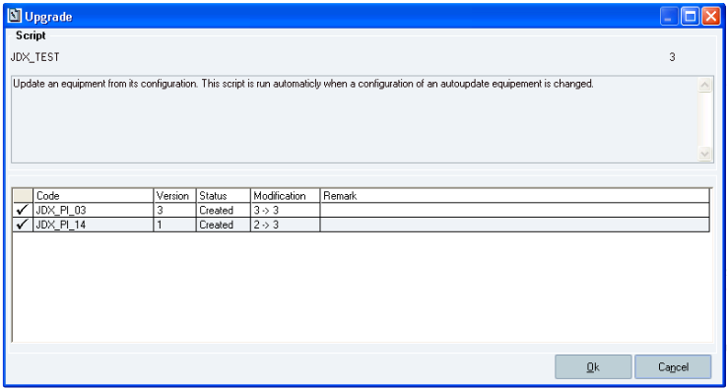

**The *Upgrade* window**

Sp-EBRDesign-2511 61

*Script Management*

*Script Management*

**Window description:**

The table lists all the PIs that will be modified and displays the following columns: the (PI) *Code*, (PI) *Version*, (PI) *Status*, *Modification* (version X = > Y), and *Remark* columns.

**Button description:**

***Select all***: allows selecting the entire list

***Unselect all***: allows not selecting the entire list

***Details***: allows accessing the detailed documentation of the selected PI. The script can be found with a hyperlink.

***History…***: allows accessing the history of the selected PI.

***Dependencies***: allows accessing a complete chart that displays how PIs are used and all the links to understand the impact when modifying the versions.

***Quit:*** *allows closing the Upgrade window.*

### 7.3.3 Rules for upgrading versions

Upgrades are subject to the access right 1143 (SCRIPT UPGRADE).   
The upgrade applies the following rules:

If the script status is set to *Created*, only *Created* PIs can be upgraded.   
 If the script status is set to *Validated*:

If the PI_VERSIONING_IMPACT parameter is set to 1:

All non-obsolete PIs can be upgraded. The PI does not have to be revised.

If the PI_VERSIONING_IMPACT parameter is set to 0:

Only *Created* PIs can be upgraded. An upgrade cannot be performed for PIs that display the following statuses: *To*

*qualify*, *Approved*, and *Launched*. These PIs will have to be revised and an upgrade will be authorized on this new version.

The PIs that are currently being modified cannot be upgraded.

### 7.3.4 History

The history of a script shows all its versions. This window is displayed by clicking the *History…* button:

62 Sp-EBRDesign-2511

*Script Management*

*Script Management*

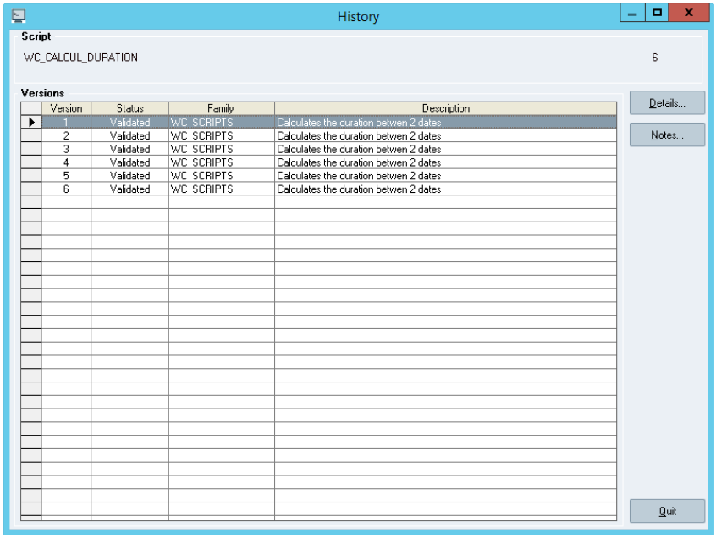

**The *History* window**

**Window description:**

The list shows all the versions: from version 1 to the last available version of a script.

***Details:*** allows opening the details of the selected version in Read-only mode. All the script characteristics are

shown.

***Notes:*** allows accessing the list of notes for that script. It is also possible to add or delete notes.

### 7.3.5 Traces

A trace is created whenever there is a modification in the version of a script that is used by a PI (see Accessing Traces).

### 7.3.6

Standard scripts for PIs

Standard PI scripts are available within Opcenter Execution Pharma. Please refer to the ***Sp-ScriptsStandard-i.pdf*** specification to get the exhaustive list and the details of these Standard PI scripts.

Sp-EBRDesign-2511

63

*Creating a PI*

*Script Management*

# 8 Creating a PI

New PIs can be created by clicking the *New* button from the *Process Instructions List* window (see Accessing PIs for a complete description of that window).

The access right 1100 (PI CREATION) is required to perform that action.

Remark: When creating PI Code using copy/past the integrity of the source should be guaranteed by the designer. It is not recommended to copy content from an external source such as Word, Notepad++, etc…

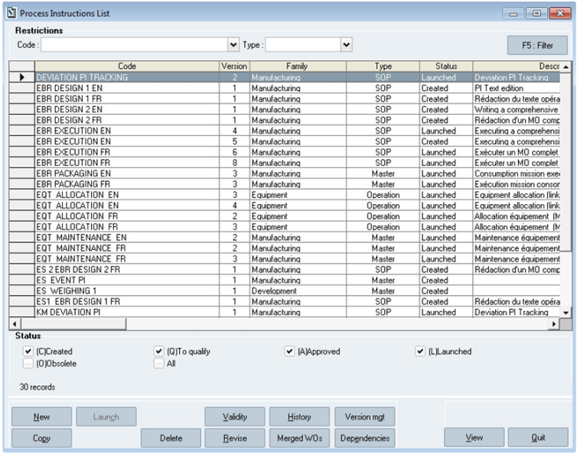

**The *Process Instructions List* window**

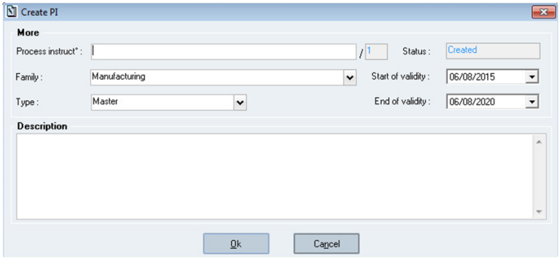

**The *Create PI* window**

64 Sp-EBRDesign-2511

*Creating a PI*

*The Header Tab*

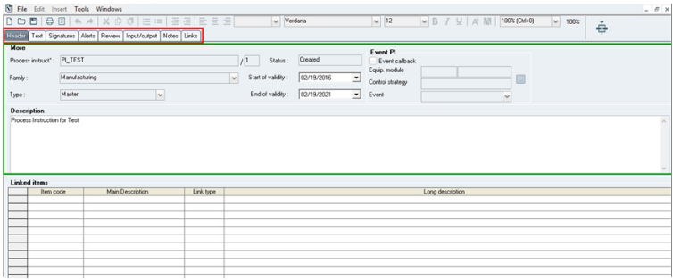

**The *PI Management – [Process instructions:* Name*]* window**

**Tab description:**

Writing a PI consists in precisely defining manufacturing instructions and the order in which they need to be executed. The data that have to be entered are grouped together under different tabs:

***Header:*** defines the general characteristics of the PI



***Displays the workflow:*** enables the user to define the sequence of the different manufacturing instructions

***Text:*** enables the user to write the details of the instructions

***Signatures:*** enables the user to assign the validation path that will be applied when validating the writing of the

PI

***Alerts:*** enables the user to define the type of alert that will be managed and the alert tracking   
 ***Review:*** enables the user to assign the validation path that will be applied during review   
 ***Input/output:*** enables the user to configure the exchange of data between the different linked PIs   
 ***Notes:*** enables the user to view the list of notes

***Links:* enables the user to view the list of parameters/versions and the linked PIs/versions that have been used to write that PI**

## 8.1

The Header Tab

The PI header includes the general characteristics and properties of use of the PI:

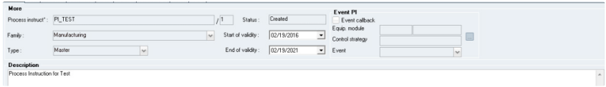

**Description of the *Header* tab:**

Sp-EBRDesign-2511

65

*Creating a PI*

*The Header Tab*

The header enables the user to define or view a set of PI properties. It is made up of two sections and of one list (table):

**The *More* section:** enables the user to read the PI characteristics

**The** ***Event PI* section:** enables the user to read the Event PI characteristics

**The *Linked items* list:** list of items that are linked to that PI is display underneath it.

### 8.1.1 PI Characteristics (the More section)

***Process instruct°*/Revision (index):** code /revision of the PI that has to be created. Once created, the value of the PI index is set to 1 and cannot be modified. The system checks that these two fields are not blank and that the PI is not already available. A PI is uniquely identified with its code (30-character alphanumeric field) and its index (3 positions).

***Status:*** PI status. Value: *Created*, cannot be modified.

***Type:*** The type of a PI enables the user to locate it hierarchically in relation to other PIs. A hierarchic classification is defined between the different types of PIs to enable the user to define possible links between PIs. The following list recaps the different types, which are arranged in decreasing hierarchical order:

Master (PI);   
 Procedure;

Unit procedure;   
 Operation;   
 Phase.

PIs can only call other PIs of the same level or of inferior level (e.g. a Master PI can call a Master PI or a PI of the Operation type).

Two other types are defined, with no hierarchical classification:

SOP: Standard Operating Procedure;   
 SOC: Standard Operating Conditions.

Both types can be called from – and can call – any type of PI.

***Family*** (optional): PIs can be classified into families according to their context of use. That property enables the

user to display PIs by family if the corresponding filter is activated.

Values: *Manufacturing*, *Equipment*, *Control*, *Development*, *Clinical*.

Note that these values are displayed in the user local settings during the PI creation and will not be translated if you change the local settings.

The default family is *Manufacturing*. The name of the family appears in the menu when creating a new PI.   
 N.B.: It is possible to integrate by script the "specific" families, which would be added at the end of that list, to the list of available families. The code value in the table E2S_FAMILY must be included between 20 and 99.

Script example:

insert into e2s_pifamily(code, libelle) values(20, 'FILTRATION');   
insert into e2s_pifamily(code, libelle) values(21, 'CLEANING');   
commit;

***Validity period:*** During its validity period, if launched, the PI can be merged with a WO in order to be executed. That period is defined at the latest when launching the WO, and can be extended by an authorised user. The start date is initialised to the current date. The end date is **initialised to the current date plus 5 years**.

***Description:*** PI description. Free input text, optional.

66 Sp-EBRDesign-2511

### 8.1.2

*Creating a PI*

*The Header Tab*

Characteristics of an Event PI (the Event PI section)

#### [8.1.2.1](http://8.1.2.1)

Field/button description

***Equip. module*** (for "Equipment module"*):* input fields. May be filled in manually.

*First field:* Process Cell (PCell) information*.* Part of phase type identification No check is performed.

*Second field*: Equipment module information. A check is made after the input to check if this Equipment module is available.

***Control strategy:*** input field. May be filled in manually. A check is made after the input to check if this Control strategy is available for the associated Equipment module.

***Event:***

Allows selecting an Event among the 4 default Events.

If a phase type is already selected and event is configured or modified, the system checks that the configuration is available and if not, rejects the configuration.

***…*** (next to the *Control strategy* field)*:* displays the list of "phase types" (PCell/Equipment module/Control strategy); these phase types have been uploaded from batch system.

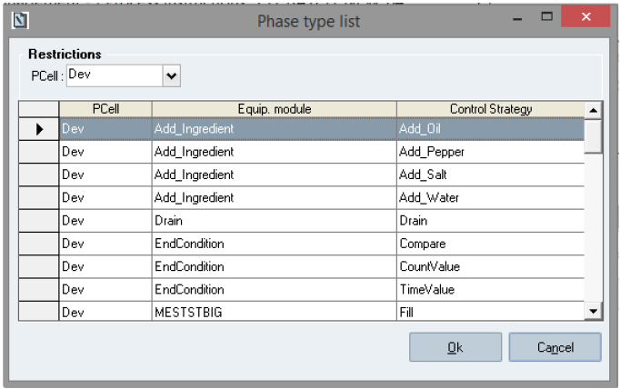

**The *Phase type list* window**

**Note**

This functionality requires that the data from batch system has been correctly uploaded.

Please refer to ***Batch_process_and_configuration-i.pdf*** technical documentation for more details.

#### [8.1.2.2](http://8.1.2.2)

Definition

An Event PI is a PI with the following characteristics:

Sp-EBRDesign-2511

67

*Creating a PI*

*The Header Tab*

It allows interaction between a Batch from SIMATIC BATCH and a WO from Opcenter Execution Pharma.   
It is configured to be raised on a particular "phase type" execution:

a "phase type" is an expression related to SIMATIC BATCH and corresponds to the logical behaviour of a piece of equipment (automation jargon)

it is composed of:

A PCell

An Equipment module (Name of the piece of equipment that is set from PCS7, in SIMATIC BATCH)   
 A Control Strategy (logical behaviour)

It is event based (i.e. it only reacts to a specific event which is sent from SIMATIC BATCH, related to a phase execution). Four events are set by default:

Start   
 Completed   
 Aborted   
 IRefresh

**Note**

Functionally, an Event PI cannot be used as main PI or sub PI. An Event PI is dedicated to the communication with SIMATIC BATCH via a batch element.

#### [8.1.2.3](http://8.1.2.3) Configuration

To configure a PI as an Event PI, the user has to tick *Event callback* check box to make the *Equipment module*, *Control strategy*, and *Event* fields available.

The access right 1906 (EVENT PI CONFIGURATION) is required to configure an Event PI.

The configuration can be done by selecting the needed "phase type" from the list displayed (PCell/Equipment module/Control strategy)

The user can also set a generic configuration by using a wildcard. A generic configuration is set by using the star character "*",entered manually. This wildcard can be used in PCell field and/or in Equipment module field. Only the "*" character is allowed as wildcard.

Only one Event PI (independently of the version) can be set for each Event configuration (the PCell-Equipment module-Control strategy-Event must be unique). When configuring an Event, the system checks that the same configuration is not already defined for another Event PI and if so, rejects the configuration.

When copying an Event PI, the configuration is not copied.

When revising a PI defined as an Event PI, its configuration is kept.

### 8.1.3 Items Linked to the PI (the Linked items list)

The list provides all the items that are linked to the PI.

If the PI can be merged with a WO, it can only be merged with WOs with a product code that corresponds to one of the items linked to the PI (see Managing PI-Item Links for further information).

68 Sp-EBRDesign-2511

## 8.2

*Creating a PI*

*Editing the Workflow*

Editing the Workflow

### 8.2.1

Calling the Workflow

The workflow is a graphic tool, which enables the user to define the order and the conditions of execution for the different manufacturing tasks. It is made up of elements that are linked by transitions. When PIs are executed, the workflow elements generate the tasks to be performed. Transitions define the conditions according to which tasks are available when PIs are executed.

Building a workflow can be performed by clicking on the



*Displays the workflow* icon.

### 8.2.2

Accessibility Conditions & Workflow Opening Mode

First, the button used to access the workflow is always available, except for ***PIs that cannot be modified*** (i.e. signature is in progress or signed) ***with no workflow***.

Second, the workflow status is identical to the PI status:

A workflow called from a non-modifiable PI cannot be modified; A workflow called from a modifiable PI can be modified.

Sp-EBRDesign-2511

69

*Creating a PI*

*Editing the Workflow*

### 8.2.3

Building a Workflow

#### [8.2.3.1](http://8.2.3.1)

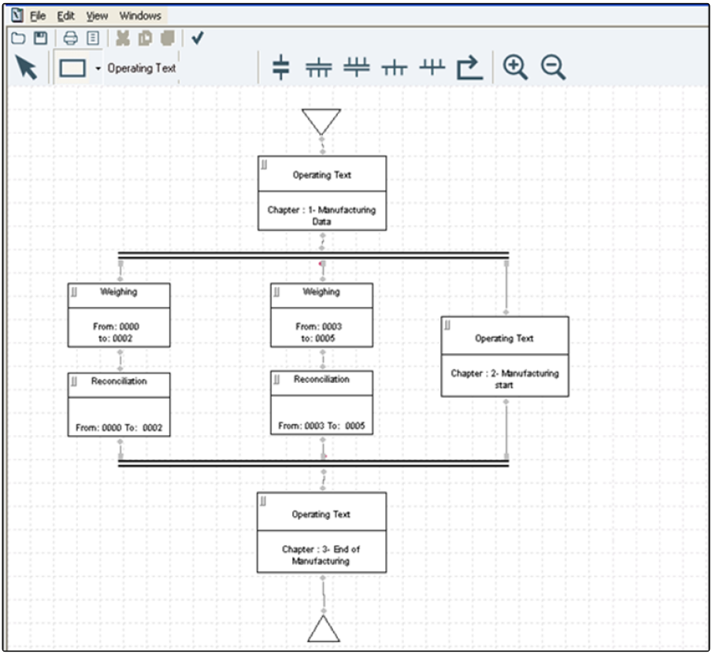

#### [8.2.3.2](http://8.2.3.2)

Main window

**The PI Management – [Process instructions: Name] – [Workflow: Name] window**

Creation Tools

A toolbar enables the user to quickly access the tools that allows creating a workflow.



: allows the user to draw an operation whose type corresponds to the one selected from the drop-down list.



: allows the user to define a transition.

 and : enable the user to define the start and end of simultaneous sequences.

70 Sp-EBRDesign-2511

and

*Creating a PI*

*Editing the Workflow*



: enable the user to define the start and end of a sequence selection.

: allows the user to define a looping.



: allows the user to select, move, or re-dimension the objects on the window.



: zoom in/out.

 : launches the coherence analyser.

Note: when the operator saves the workflow, the coherence analysis is launched in background:

If the workflow is coherent, workflow is saved.

If the workflow is not coherent, a confirmation pop-up is displayed with a warning about workflow incoherence: if the operator clicks on 'Yes' the workflow is saved with its incoherent status, otherwise workflow is not saved and keep its previous "coherence status".

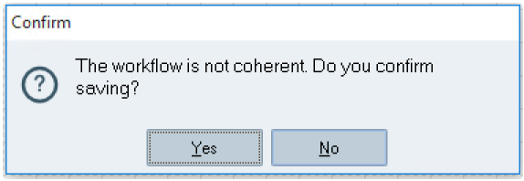

**Save not coherent workflow: saving confirmation**

Note: when the operator quits workflow window and if the workflow has not been saved after modification, the

coherence analysis is launched in background:

If the workflow is coherent, a confirmation popup is displayed.

If the operator clicks on 'Yes' the workflow is saved with its coherent status, otherwise workflow is not saved and keep its previous "coherence status".

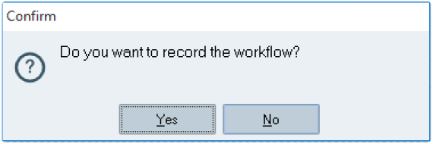

**Quit coherent workflow: saving confirmation**

If the workflow is not coherent, a confirmation popup is displayed with a warning about workflow

incoherence.

If the operator clicks on 'Yes' the workflow is saved with its incoherent status, otherwise workflow is not saved

and keep its previous "coherence status".

Sp-EBRDesign-2511 71

*Creating a PI*

*Editing the Workflow*

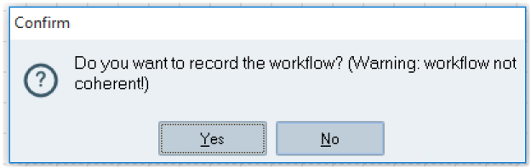

**Quit not coherent workflow: saving confirmation**

Note: You cannot add more than 999 operations onto the Workflow.

#### [8.2.3.3](http://8.2.3.3) Transitions

Transitions enable the user to condition the access to a sequence:

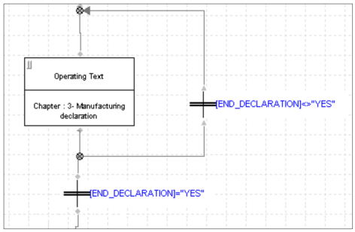

**How to use a transition (example)**

The following window enables the user to configure transitions and to edit a formula by using the available text and

numeric parameters (by taking the value of instantaneous parameters into account), mathematical functions, logical operators, and relation operators :

72 Sp-EBRDesign-2511

*Creating a PI*

*Editing the Workflow*

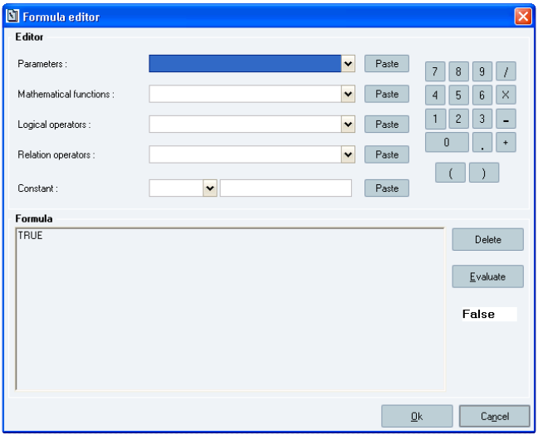

**The *Formula editor* window**

The operation which follows the transition is accessible only if the result of the formula assessment is TRUE.   
N.B.:

Text parameters can be used in formulas, but it is not possible to enter the value of these parameters on several rows.

The LOG function available from the list of *Mathematical functions* is a natural logarithm.

#### [8.2.3.4](http://8.2.3.4)

Looping

Looping allows the user to make loops that are conditioned – or not – by transitions.

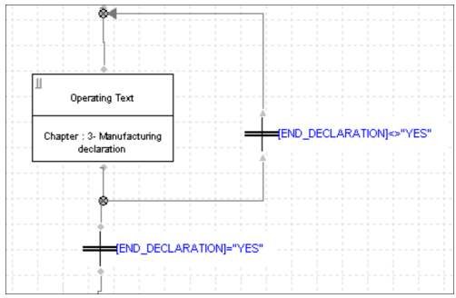

**How to use a looping with a transition (example)**

Sp-EBRDesign-2511

73

*Creating a PI*

*Editing the Workflow*

#### [8.2.3.5](http://8.2.3.5) Returns, Breaks & Loops

The system allows designing different kind of workflow when using transitions and looping. For instance, a series of operations can be repeated as long as a condition has not been fulfilled.

The system also enables the user to execute – or not – a series of operations according to a condition.

#### [8.2.3.6](http://8.2.3.6) Starting and Ending Simultaneous Sequences

The system enables the user to re-synchronise sets of operations that are executable in parallel:

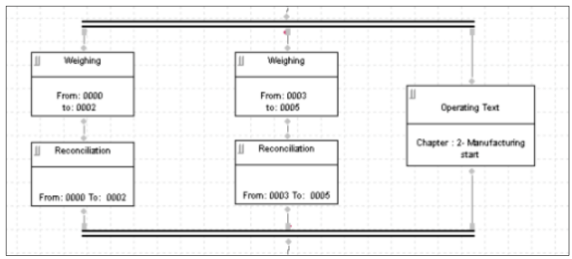

**How to synchronize tasks (example)**

Executing both sequences (one of them being made up of a "Weighing" element followed by a "Reconciliation"

element, and the other one of two "PI" elements) makes the rest of the processing available.

#### [8.2.3.7](http://8.2.3.7) Starting and Ending Sequence Selection

The system enables the user to perform one and only one processing, automatically selected during the execution according to the value of a condition:

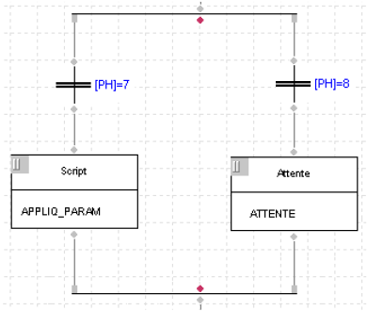

**How to select a sequence according to the value of the [pH]**

Ending execution of the activated sequence is sufficient to make the rest of the processing available.

74 Sp-EBRDesign-2511

### 8.2.4

*Creating a PI*

*Editing the Workflow*

Types of Operations (Elements)

The available types of operations (elements) can be selected from a drop-down list displayed when clicking

the

 *Activity operat°s* icon (in the toolbar):

Start: to start the manufacturing process. Unique operation, not preceded by other elements. No configuration is required for that operation

Operating Text

Process instructions

Script

Weighing

Reconciliation

Combination

Move

Transfer

EPE

Allocation

Release

Wait

Requisition

End: to end the manufacturing process. Unique operation, not followed by other elements. No configuration is required for that operation

Step

Batch

Test Execution and Verification

Cyclic Operation

Remark:

At the end of that list, it is possible to find new elements corresponding to standard libraries of PIs (if they were installed). If managed, these elements can be configured and executed is the same way of the PI element.

#### [8.2.4.1](http://8.2.4.1) Standard Configuration of the Elements

**1. Task Description:**

The description of each element needs to be configured when creating the workflow.

It is defined from the configuration window of each element and cannot exceed 120 characters. Defined when editing the workflow, the description of an element can be fixed or depend on the value of certain parameters.

Types of parameters that can be inserted:

text;   
 numeric;   
 date;   
 time.

When monitoring the manufacturing process, the values of the parameters are updated as soon as the element is accessible.

When a parameter is set to 1 in the description of an element, it must be specified between square brackets. During the execution, if the description includes parameters that are not available or that are not specified, these parameters are considered as text and are not modified.

E.g.: “Equipment = [EQUIPEMENT] / Date = [DATE]”:

Sp-EBRDesign-2511 75

*Creating a PI*

*Editing the Workflow*

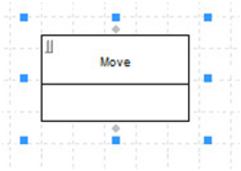

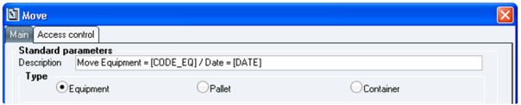

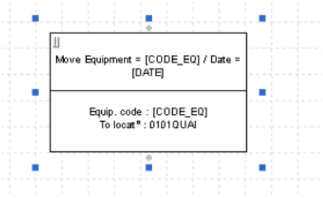

**How to describe an element**

How to describe an element:

To display an empty *Move* box: click the *Activity operat°s* icon > select the *Move* function > click and drag a box; To display the *Move* window: double-click the empty *Move* box that has been created;

To display the filled-in *Move* box: enter values from the *Move* window and click the *Ok* button.

**2. Access Controls:**

The work centre and the access right are defined when making up the elements of the workflow.

Remark : We strongly recommend that when the PI designer wants to fill in the Access Control tab, he should first fill in the "Main" section, then validate the changes, then reopen and this time go to Access Control and fill in this section. This will prevent PI Management from crashing, but if it does, simply relaunch the application and repeat the steps.

An *Access Control* tab is available from all the windows of each type of element which allows defining the functionality. That tab includes the functions necessary to define:

one (and only) work centre,   
 one (and only) access right:

76 Sp-EBRDesign-2511

*Creating a PI*

*Editing the Workflow*

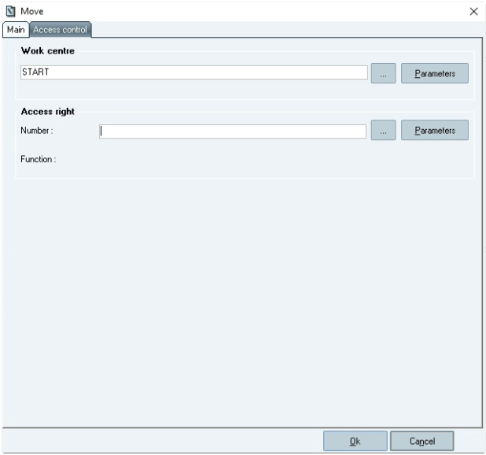

**The *Access control* tab from the *Move* window**

**Window description:**

***Work centre***

There are two ways to configure the work centre:

either by defining its name explicitly. It is then directly input into the associated zone, or selected from

the list of work centres,

or by referring to a parameter. The parameter code can be input between square brackets into the planned zone or selected from a list of text parameters.

The user has the possibility not to define any work centre (default option).

When validating that window, no check is carried out in relation to the selected work centre or access right.

***Access right***

There are two ways to configure the access right:

either by defining its number explicitly. It is then directly input into the associated zone, or selected from the list of client access rights (with a function number superior to 15,000),

or by referring to a parameter. The parameter code can be input between square brackets into the planned zone or selected from a list of text parameters.

The user does not have to define an access right (default option).

**Impact on Each Type of Element** (see the most part of the elements in Types of Operations (Elements)):

Elements of the "Equipment" Type

The task generated by these elements is associated with a mission. In its header (or its parameters), that mission

displays the work centre and the "configured" access right that must be checked.

Mission performed manually

Sp-EBRDesign-2511 77

*Creating a PI*

*Editing the Workflow*

Checks are always performed.

Why these checks are performed: to access the mission.

The check will concern the accesses, through: the RF terminal.

Mission performed automatically

Checks are carried out only if the element has been configured to be manually activated.

If everything is automatic, the mission is created and performed by the PI service. No check is therefore carried out. Why these checks are performed: mission generated through activation.

The check will concern the accesses, through:

the workflow;

the window which allows managing tasks (double-click the line which corresponds to the task from PI Process).

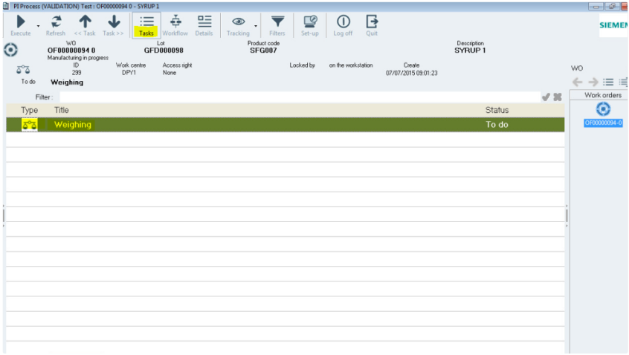

**The *PI Process* window**

The "Combination" Element

The task that is generated by these elements is associated with a mission.

In its header (or its parameters), that mission displays the work centre and the "configured" access right that has to be checked.

Why these checks are performed: access to the mission.   
The check will concern the accesses, through:

the RF terminal;

the window which allows managing tasks (double-click the line which corresponds to the task from PI Process);

the Compounding module, which is launched autonomously (when selecting the mission).

The "Script" Element

78 Sp-EBRDesign-2511

*Creating a PI*

*Editing the Workflow*

Why these checks are performed: the script is manually launched.

The check will concern the accesses, through:

the window which allows managing tasks (double-click the line which corresponds to the task from PI Process);

the workflow (double-click the element).

N.B.: the script tag will not be subject to these checks. The checks will have to be positioned on the PI text element in which the script is located.

The EPE (Equipment Procedural Element) Element

Why these checks are performed: the command is manually launched.

The check will concern the accesses, through:

the window which allows managing tasks (double-click the line which corresponds to the task from PI

Process);

the workflow (double-click the element).

N.B.: the EPE tag will not be subject to these checks. The checks will have to be positioned on the PI text element in which the tag is located.

The "PI Text" Element

Why these checks are performed:

Access to the PI text execution;

Access to the correction of the terminated PI text.

The check will concern the accesses, through:

the window which allows managing tasks (double-click the line which corresponds to the task from PI

Process).

the workflow (double-click the element).

N.B.: the access to the visualisation of the PI text is not checked, as well as the internal text execution (tags input, tags forcing, tag correction, input of alerts).

The "Weighing" Element

Why these checks are performed:

Access to the weighing execution application from the PI Process > Workflow (only once a PI has been created and linked to a WO);

Access to the correction of a weighing element.

The check will concern the accesses, through:

the window which allows managing tasks (double-click the line which corresponds to the task from PI

Process).

the workflow (double-click the element).

The "Reconciliation" (after weighing) Element   
Why these checks are performed:

Access to the reconciliation execution application from the PI Process module;   
 Access to the correction of a reconciliation element.

The checks will concern the accesses, through:

Sp-EBRDesign-2511 79

*Creating a PI*

*Editing the Workflow*

the window which allows managing tasks (double-click the line which corresponds to the task from PI Process.

the workflow (double-click the element).

The "Reconciliation" (before combination) Element

The task that is generated by these elements is associated with a mission.

In its header (or its parameters), that mission displays the work centre and the "configured" access right that must be checked.

Why these checks are performed: to access the mission.   
The check will concern the accesses, through:

the RF terminal;

the window which allows managing tasks (double-click the line which corresponds to the task from PI Process)

the workflow (double-click the element);

the "Compounding" module, which is launched autonomously (when selecting the mission).

The “Cyclic Operations” Element   
Why these checks are performed:

Access to the CO execution application from the PI Process > Workflow (only once a PI has been created and linked to a WO);

The check will concern the accesses, through:

the window which allows managing tasks (double-click the line which corresponds to the task from PI

Process).

the workflow (double-click the element)

The "Wait" Element

Why these checks are performed: unlocking further to the user's action (double-click), if that option has been

chosen when configuring the element.

The check will concern the accesses, through:

the window which allows managing tasks (double-click the line which corresponds to the task from PI

Process).

the workflow (double-click the element).

The "Script" element linked to the Consumption script

The consumption script generates a mission.

If this consumption script has been generated from a script element, the mission header (or the mission parameters) includes the work centre and/or the access right that has been configured for the corresponding script element.

The access to the missions is checked.

The checks are carried out by using: the RF terminal.

The "Allocation", "Release" and "Transfer" elements

80 Sp-EBRDesign-2511

*Creating a PI*

*Editing the Workflow*

The Access control checks of these elements are performed only when the command is manually launched and automatically executed.

For all the others configuration, the checks are not performed and the element is launched.

**3. Execution Report:**

According to the type of element that is inserted into the workflow, the user can define execution report

parameters. Their management is optional.

These parameters are automatically filled in by the system after having performed the task. The number and type of these parameters depend on the element.

E.g.: An element corresponds to the allocation of a piece of equipment (that belongs to the TANK class) to the WO in progress. When it comes to the execution report, the user can configure a parameter which enables the user to store the code for that piece of equipment, which is actually assigned when performing the task.

The values of these parameters can be viewed from the PI text via tags. They can also be used to create conditions, according to which some actions can be performed – or not.

**Parameters related to how Execution is returned:**

These parameters can be managed. They convey successful or failed operations. Their values are automatically provided by the system.

*nil value*: the task has correctly been performed;   
 *non-nil value*: an error occurred when executing it.

If the workflow is built so as to manage errors, that type of parameter enables the user to activate certain tasks, which can only be performed when an error occurs.

**4. Reporting Layer**

**Reporting layer Definition:**

The reporting layer configuration allows to filter the list of tasks to display in the execution report.

The purpose is to define a value of reporting layer for each elements in design. At the Execution report generation, the target reporting layer value is defined and all task with a reporting value lower or equals to the target are considered to be part of the execution report.

**Through Allocation Element by Element:**

All following standard elements can be configured in the design:

Weighing   
 Reconciliation   
 Combination

Process Instructions   
 Script

Ressource Allocation   
 Ressourcce Release   
 Move

Transfer

EPE

PI Text

Batch

Cyclic Operation   
 Wait

Sp-EBRDesign-2511 81

*Creating a PI*

*Editing the Workflow*

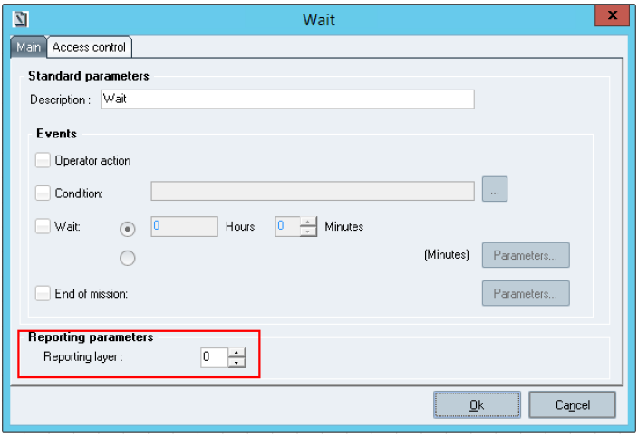

**The Wait element configuration window**

The value (from 0 to 99) can be input directly or increase/decrease with the buttons.

By default, the value is set to 0. It means that the reporting layer is not managed for the element and so, the task will be considered in the execution report.

**Accessing the Reporting layers:**

To quickly see the reporting layer configuration on elements of the current PI, the configuration can be displayed (i.e *View*) /hidden (i.e *Hide*) in the workflow from the menu "Reporting layer".

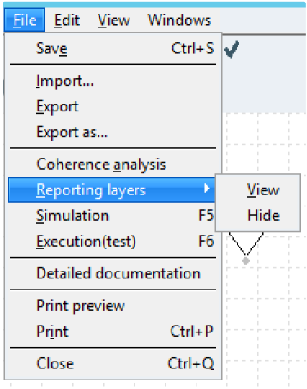

**menu to display/hide reporting layer configuration**

82 Sp-EBRDesign-2511

#### [8.2.4.2](http://8.2.4.2)

*Creating a PI*

*Editing the Workflow*

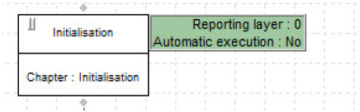

**How to view the reporting layer**

The Weighing Element

*Weigh* elements allow weighing the components of a WO from the Weighing module (i.e. "WeighDpy.exe"). Activating the corresponding task - when monitoring the manufacturing process - enables the user to directly   
access the Weighing module window.

The materials that have to be weighed are identified by the phase-s/ sequence-s/ dose-s of the WO. The writer defines a start phase/ sequence/ dose and an end phase/ sequence/ dose. If the sequences are not managed, the components are identified by their phases only. If a single material needs to be weighed, the start phase/ sequence/ dose and end phase/ sequence/ dose have to be identical (see Figure: The Weighing element configuration window .

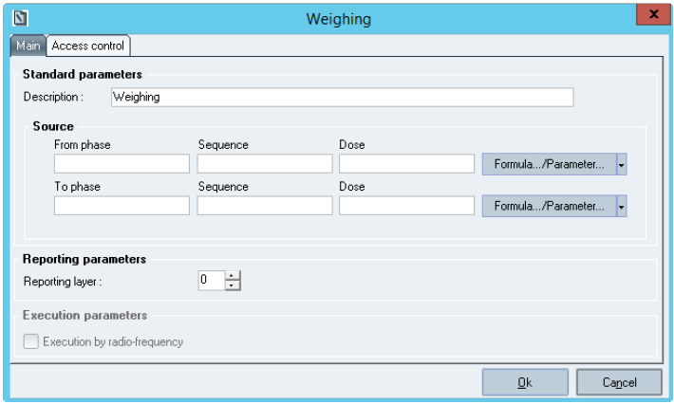

**The Weighing element configuration window**

#### [8.2.4.3](http://8.2.4.3) The Reconciliation Element

*Reconciliation* elements allow reconciling the weighing labels that belong to some of the components included in a WO. Reconciliation consists in identifying the weighing labels one by one, in order to check that all the preparations that correspond to the selected components are there and belong to the current WO. The reconciliation can be carried out:

From the dispensary: Reconciliation "After weighing" (action performed from the computer)

From the manufacturing workshop: Reconciliation "Before combination" (action performed from the computer or RF)

Sp-EBRDesign-2511 83

*Creating a PI*

*Editing the Workflow*

Components with weighing labels that must be reconciled:

Components are identified by the phases, sequences, and doses of the WO. The sequences and/or doses may not be managed, according to the Running mode.

Reconciliation "After weighing": definition of a start phase/seq/dose and of an end phase/seq/dose, either with   
a parameter or with a hard-coded value.

Reconciliation "Before combination": two possibilities

definition from a start phase/ sequence/ dose to an end phase/ sequence/ dose;

definition of a set of material lines, each line being identified by its phase/ sequence/ dose.

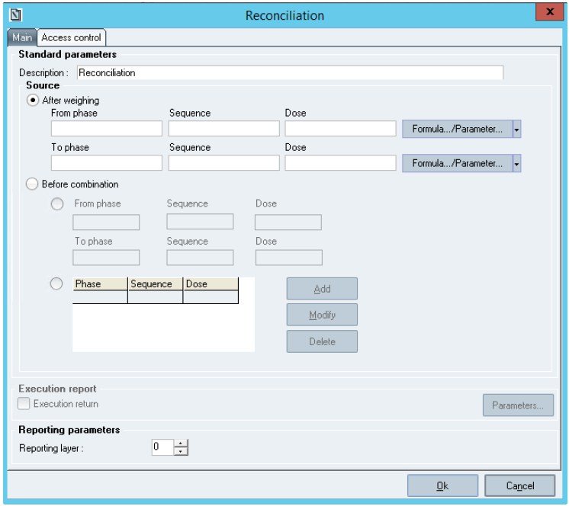

**The *Reconciliation* element configuration window**

#### [8.2.4.4](http://8.2.4.4) The Combination Element

*Combination* elements allow combining some of the components of a WO. Combination can be performed manually by actions from a computer, an RF terminal, or automatically.

Combination can be performed **manually**. The combination of the defined phases/seq/doses is checked by re-reading the barcodes of the weighing labels that were generated by weighing that item or the   
labels of the warehouse containers.

Combination can be performed **automatically**. It is used to update the database for a combination that has already occurred in the process.

**How to set up these elements:**

84 Sp-EBRDesign-2511

*Creating a PI*

*Editing the Workflow*

A combination element is configured the same way as a combination tag (see The Combination Tag for more information).

The only differences between the tag and the element are the following:

The element has no execution report (the tag inserts an execution report inside the Operating text).

Combination label (optional): selecting the label template (hard-coded value or value from a parameter)

To print labels from an RF terminal: the printer that is defined for the Radio service has to be linked to a Label service.

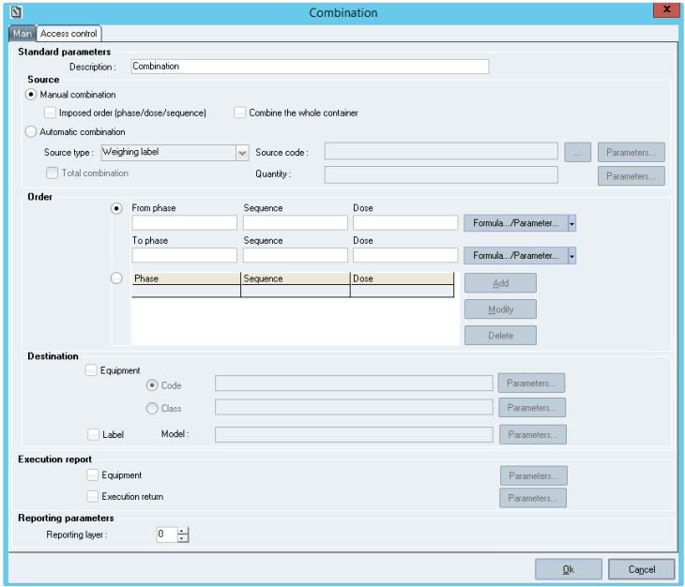

**The *Combination* element configuration window**

#### [8.2.4.5](http://8.2.4.5) The PI Element

Using linked PIs enables the user to manage standard "operations" that are common to several manufacturing processes or likely to occur several times during the same manufacturing process.

The linked PI is called via a PI element that has been inserted into the workflow of the calling PI.

Input and output parameters can be defined for each linked PI. They enable the user to exchange data between the calling PI and the linked PI.

**Input parameters** are used to initialise the values of some parameters that have been set for the linked PI. They can correspond to:

a fixed value;

the value of a parameter that have been set for the calling PI.

Sp-EBRDesign-2511 85

*Creating a PI*

*Editing the Workflow*

**Output parameters** enable the user to retrieve, in the calling PI, values that come from the linked PI. The output parameters of the linked PI are always linked to the parameters of the calling PI.

**How to set it up:**

**1. Selecting the Linked PI from the PI List:**

Selecting a PI for configuring the PI element is performed through a selection from a list which only displays the last non-obsolete version or the version available in the links (as when selecting a parameter - previously described, see above). Should the user want to specify another version, s/he can click the *Select version* button:

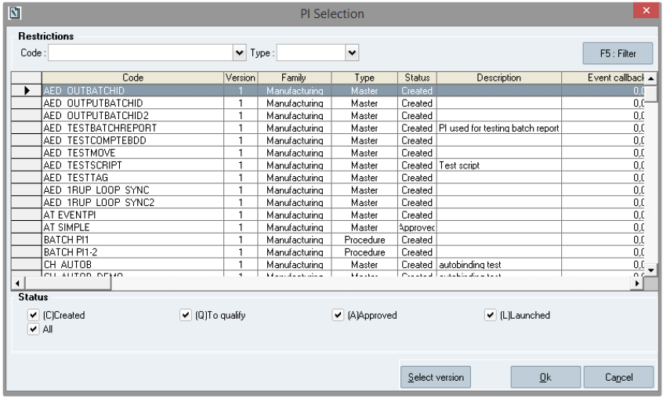

**The *PI selection* window**

Clicking that button displays the list of all the non-obsolete versions of the selected PI.

The system only suggests the non-obsolete PIs with a type that is compatible with the type of the calling PI. E.g.: if the calling PI displays the "Operation" type, only the PIs that display the "Operation", "Phase", "SOP", and

"SOC" types are suggested.

The *Link* button remains either hidden or shaded (i.e. not available) as long as no called PI has been selected.   
 The *Ok* button is always available.

Representation of a linked PI according to its type:

The character "+" is added to the upper/right corner of the PI element.   
The representation of the PI element depends on the type of the called PI.   
When the type of the called PI is:

*Procedure:* a diagonal bar is displayed in the four corners;

*Unit Procedure:* a diagonal bar is displayed in the upper/right, lower/left, and lower/right corners;   
 *Operation:* a diagonal bar is displayed in the upper/right and upper/left corners;

86 Sp-EBRDesign-2511

*Creating a PI*

*Editing the Workflow*

*Phase:* a diagonal bar is displayed in the upper/left corner.

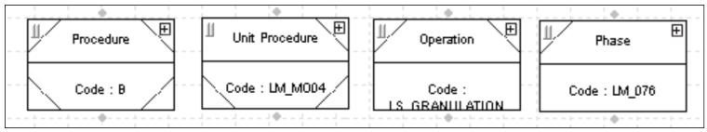In the other cases, no diagonal bar is added.

**Types of the called PI (i.e. *Procedure*, *Unit Procedure*, *Operation*, and *Phase*)**

**2. Configuring the Parameters – related to how Execution and Initialisation are returned – of the Linked PI**

These parameters enable the user to exchange data between the calling PI and the linked PI. The input and output parameters are automatically displayed after having selected the linked PI.

Input parameters (displayed in the *Initialisation* table): each parameter must be linked to a fixed value or to a parameter of the calling PI, of the same type.

Output parameters (displayed in the *Execution return* table): each parameter must be linked to a parameter of the calling PI, of the same type.

An **input** parameter of the called PI can be linked to a **parameter** of the calling PI or to a **fixed value.** In the same way, an **output** parameter of the called PI can be associated with a **parameter** of the calling PI.

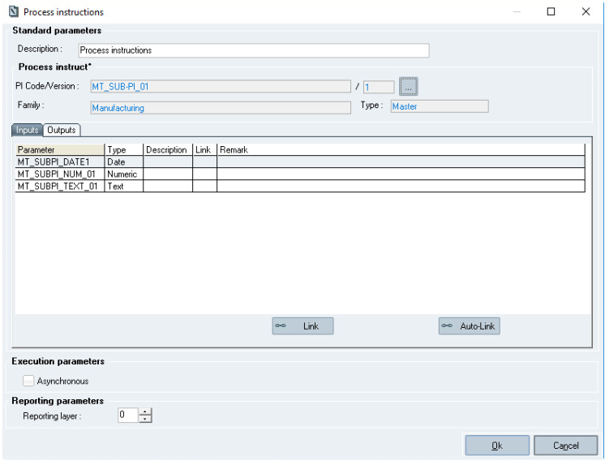

Sp-EBRDesign-2511 87

*Creating a PI*

*Editing the Workflow*

**The *Process instructions element configuration* window**

Remark : When entering an input or output value, the application may crash, so please restart it and try entering the value again.

**Window description:**   
**The Initialisation table:**

***Parameter:*** displays the input parameters of the called PI.

***Link:*** must be filled in with a **parameter** of the calling PI or a **fixed value.**

***Type:*** the type of the **parameter** that has been set for the calling PI or for the **fixed value** must correspond to the type of the input parameter.

To configure the list, the user must **select** a row and **click** the *Link* button or **double-click** the row to configure. The window below is therefore displayed; it enables the user to input the name of a parameter or of a fixed value:

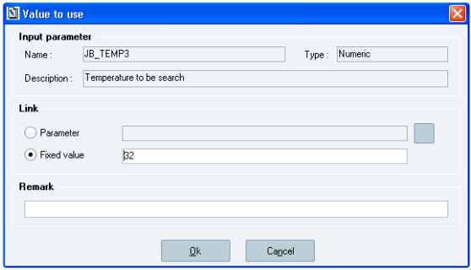

**The *Value to use* window**

N.B.: The *Remark* field is pre-filled with the description of the linked parameter if it has been inserted from the …

button; however, it still can be edited.

The **auto-link** button automatically links all the parameters in the current tab. For each parameter, it tries to find a matching parameter following the rules below:

If a parameter is already linked, its value is not modified by auto-link.

If no parameter is linked, Link = [Code] of parameter with PI parameter **code = input parameter code**, and the version is:

The last version of not obsolete PI parameter for parameter not already referred in the current PI.   
 The version used for parameters already referred in the current PI.

The auto-link functionality uses the standard script: EBR_DESIGN_AUTO-LINK_PARAMETER.   
**The Execution table:**

***Parameter:*** displays the output parameters of the called PI.

***Link:*** must be filled in with a **parameter** of the calling PI**.**

***Type:*** the type of the **parameter** that has been set for the calling PI must correspond to the type of the output parameter.

88 Sp-EBRDesign-2511

*Creating a PI*

*Editing the Workflow*

To configure the list, the user must **select** a row and **click** the *Link* button, or **double-click** the row to configure.

**3. Asynchronous Option (optional)**

**Synchronous PI:** the PI element of the calling PI is terminated only once the execution of the linked PI is complete.

**Asynchronous PI:** the PI element is terminated right after its activation while the workflow is executed. Both PIs can be executed in parallel. At the end of the calling PI, the system checks that the linked PI is terminated.

**4. Viewing the Linked PI**

The called PI can be viewed from the contextual menu (the *View* function, i.e. by right-clicking the *Process*

*instructions* box once created).

A separate window will be automatically opened to display the called PI, with the same constraints as when visualising from the list of PIs of the application.

N.B.: the contextual menu is not available if no PI has been selected.

**5. Editing the Linked PI**

The target can be edited from the contextual menu (the *Edit* function, i.e. by right-clicking the *Process instructions*

box once created).

That edition consists in opening the called PI in a separate window, with the same constraints as when editing from the list of PIs of the application.

N.B.: the contextual menu is not available if no PI has been selected.

#### [8.2.4.6](http://8.2.4.6) The Script Element

*Script* elements allow activating the execution of a script that meets diverse functional needs that are not planned by the standard application.

Script to execute: chosen from the list of selectable scripts.

Configuration of the script parameters: the configuration window can be accessed by clicking the parameter to configure. The script parameters can correspond to a fixed value or to a PI parameter.

Script execution mode:

Automatic: the script is executed as soon as the element is accessible.

Not automatic: when the element is accessible, the user must double-click the element or the corresponding task from the list of tasks to activate the script execution.

Sp-EBRDesign-2511 89

*Creating a PI*

*Editing the Workflow*

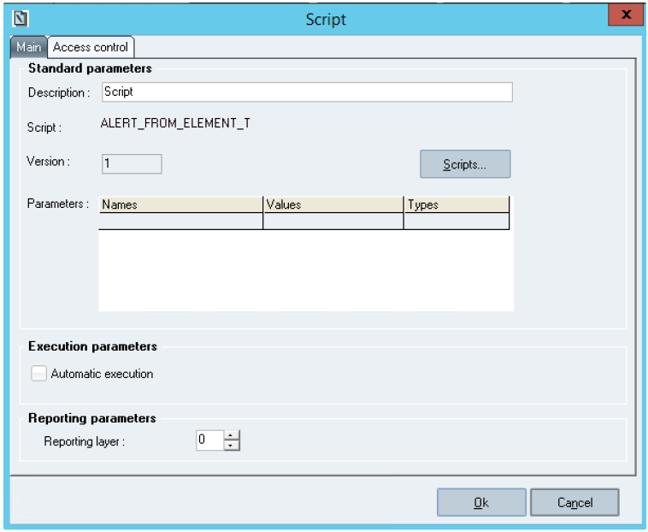

**The *Script element configuration* window**

#### [8.2.4.7](http://8.2.4.7)

The Resource Allocation Element

*Resource allocation* elements enable the user to assign a piece of equipment to the current WO.

**How to set up these elements:**

The following window enables the user to configure the parameters of the "Resource allocation" element:

90 Sp-EBRDesign-2511

*Creating a PI*

*Editing the Workflow*

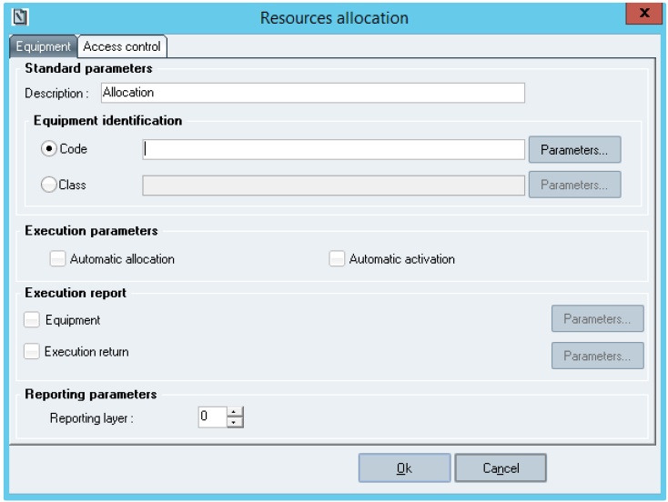

**The *Resources allocation element configuration* window**

**Window description:**

**The *Standard Parameters* section:**

***Description*:** enables the user to enter the text that will be displayed in the box during execution (60-character

alphanumeric field).

***Equipment identification*:** the piece of equipment to assign can be identified by its code or class. In both cases, these equipment data (equipment code or equipment class) can be specified by the writer of the workflow or via a text parameter.

**The *Execution Parameters* section:**

***Automatic activation*:** defines whether the allocation mission is generated automatically or manually by the

system further to the manual execution of the task by the operator.

***Automatic allocation*:** defines whether the piece of equipment can be automatically assigned to the WO (i.e. with no intervention from the operator). If so, the piece of equipment must be identified by its code.

#### [8.2.4.8](http://8.2.4.8)

The Resource Release Element

*Resources release* elements enable the user to release a piece of equipment.

**How to set up these elements:**

The following window allows the user to configure the parameters of the "Resource release" element:

Sp-EBRDesign-2511

91

*Creating a PI*

*Editing the Workflow*

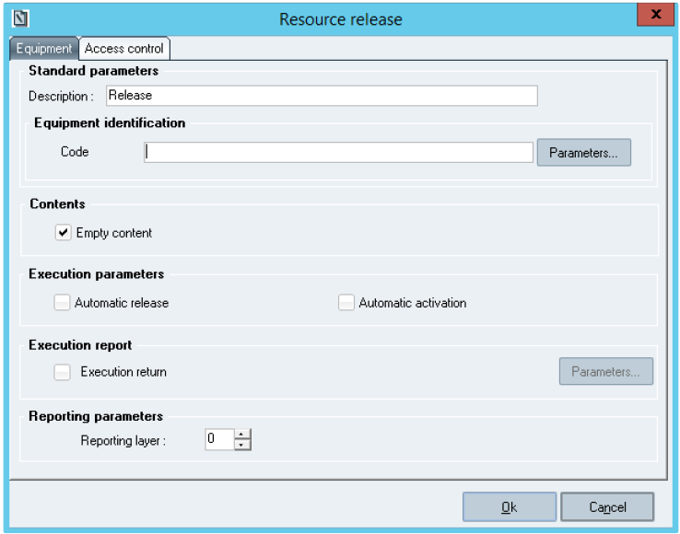

**The *Resource release element configuration* window**

**Window description:**

**The *Standard Parameters* section:**

***Description*:** enables the user to enter the text that will be displayed in the box during execution (60-character

alphanumeric field).

***Equipment identification*:** the piece of equipment to release is identified by its code and can be specified by the writer of the workflow or via a text parameter.

**The *Contents* section:**

Ticking that check box allows the user to determine if the piece of equipment is emptied upon release. This box is ticked by default.

**The *Execution Parameters* section:**

***Automatic activation*:** defines whether the release mission is generated automatically or manually by the

system further to the manual execution of the task by the operator.

***Automatic*** ***release*:** defines whether the piece of equipment can be automatically released (i.e. with no intervention from the operator). If so, the piece of equipment must be identified by its code.

#### [8.2.4.9](http://8.2.4.9) The Move Element

*Move* elements enable the user to move a piece of equipment or an entity (pallet, container) to a defined location or to a location of a defined zone. The move is performed when processing the associated mission.

**How to set up these elements:**

The following screen enables the user to configure the parameters of the "Move" element:

92 Sp-EBRDesign-2511

*Creating a PI*

*Editing the Workflow*

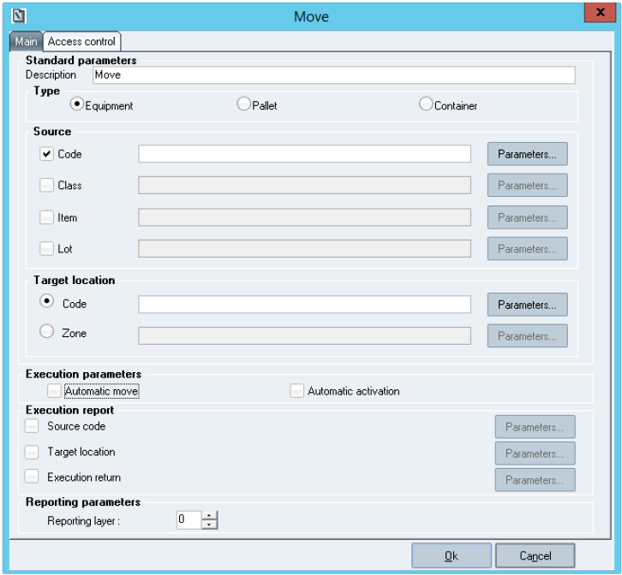

**The *Move element configuration* window**

**Window description:**

**The *Standard Parameters* section:**

***Description*:** enables the user to enter the text that will be displayed in the box during execution (60-character alphanumeric field).

***Type:*** piece of equipment, container, or pallet.

**The *Source* sub-section:**

There are three potential cases (i.e. ticking one of the three radio buttons from the Type sub-section will display information differently):

If the system moves a piece of equipment: in that case, the available selection criteria are an equipment code (i.e. the *Code* check box & field), an equipment class (i.e. the *Class* check box & field), an item linked to the piece of equipment (i.e. the *Item* check box & field) (DECLAREDPRODUCT property for the piece of equipment), and a lot linked to the piece of equipment (i.e. the *Code* check box & field) (DECLAREDLOT property for the piece of equipment).

If the system moves a pallet: in that case, the available selection criteria are a pallet code, an item linked to the pallet, and a lot linked to the pallet (see the corresponding check boxes & fields in the *Source* sub-section).

Sp-EBRDesign-2511 93

*Creating a PI*

*Editing the Workflow*

If the system moves a container: in that case, the available selection criteria are a container code, an item linked to the container, and a lot linked to the container (see the corresponding check boxes in the *Source* sub- section). The criteria can be identified by their code or by a text parameter.

**The *Target location* sub-section:**   
The target location can be defined:

by its code, or

by the zone where it belongs.

**The *Execution report* section:**

The target location can be defined by a zone. The location where the system moved the piece of equipment or entity can be sent back to the associated "Target location" parameter.

**Associated checks:**

At least one of the *Source* fields must be set up.

When pieces of equipment or entities are automatically moved: the corresponding *Code* fields must be filled in.

**The *Execution Parameters* section:**

***Automatic activation*:** defines whether the move mission is generated automatically or manually by the system

further to the manual execution of the task by the operator.

***Automatic allocation*:** defines whether the piece of equipment can be automatically moved (i.e. with no intervention from the operator). If so, the piece of equipment or entity must be identified by its code.

#### [8.2.4.10](http://8.2.4.10) The Transfer Element

*Transfer* elements enable the user to transfer the contents of a piece of equipment to another piece of equipment.

**How to set up these elements:**

The following window enables the user to configure the parameters of the "Transfer" element:

94 Sp-EBRDesign-2511

*Creating a PI*

*Editing the Workflow*

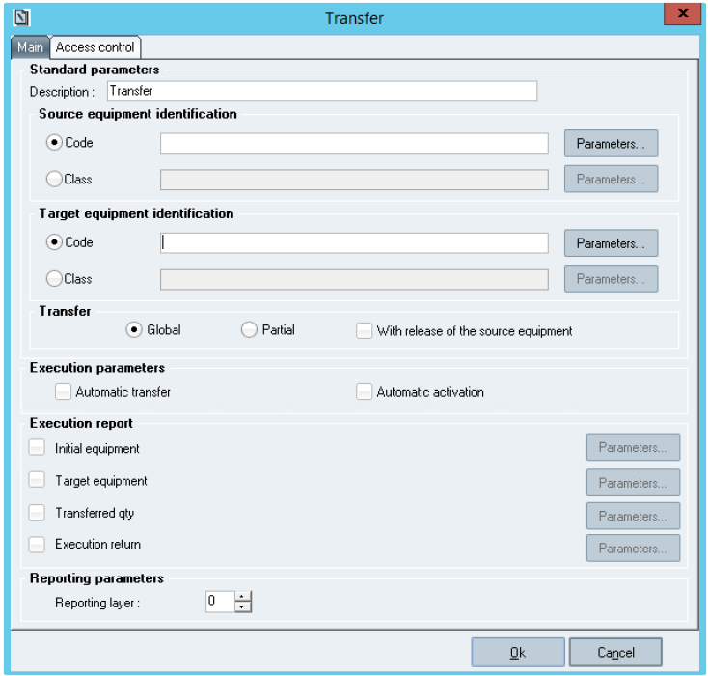

**The *Transfer element configuration* window**

**Window description:**

**The *Standard Parameters* section:**

***Description*:** enables the user to enter the text that will be displayed in the box during execution (60-character

alphanumeric field).

**The *Source equipment identification* sub-section:**

The piece of equipment to transfer can be identified by its code or class. In both cases, the equipment data (equipment code or equipment class) can be specified by the writer of the workflow or via a text parameter.

**The *Target equipment identification* sub-section:**

The target piece of equipment can be identified by its code or class. In both cases, the equipment data (equipment code or equipment class) can be specified by the writer of the workflow or via a text parameter.

**The *Transfer* sub-section:**

The transfer can be global or partial.

***With release of the source equipment:*** if that box is selected, during execution, the source piece of equipment will be released after the transfer (without emptying source equipment).

**The *Execution Parameters* section:**

Sp-EBRDesign-2511 95

*Creating a PI*

*Editing the Workflow*

***Automatic activation*:** defines whether the transfer mission is generated automatically or manually by the system further to the manual execution of the task by the operator.

***Automatic allocation*:** defines whether the piece of equipment can be automatically transferred (i.e. with no intervention from the operator). If so, the source and targeted piece of equipment or must be identified by their code, and the transfer must be global.

**The *Execution report* section:**

Return parameters are optional. They are taken into account if the corresponding check box is selected.

***Execution return:*** value that is returned to a numeric parameter (error code or 0). If the "Transferred quantity" parameter must be filled in and if the parameter unit is not compatible with the transfer, the value of the execution once returned is –2147120751 and the transfer has correctly been performed.

*Source equipment*: code of the source piece of equipment, returned to a text parameter. That code can be useful when the piece of equipment has been defined by its class.

*Target equipment*: code of the target piece of equipment, returned to a text parameter. That code can be useful when the piece of equipment has been defined by its class.

*Transferred quantity*: quantity actually transferred, returned to a numeric parameter. For global transfers, the transferred quantity is the quantity contained in the source piece of equipment. For partial transfers, the transferred quantity is the quantity entered during execution. The quantity will be returned once converted into the parameter unit, if available, or into the transfer unit, if it does not.

#### [8.2.4.11](http://8.2.4.11)

The EPE Element

*EPEs* are functions that are suggested by the piece of equipment.

EPEs are described in the equipment classes.

They are interfaced with external data (via OPC links or scripts).

EPE elements enable the user to execute the EPEs of a piece of equipment.

**How to set up these elements:**

The following window enables the user to configure the parameters of the EPE element:

96

Sp-EBRDesign-2511

*Creating a PI*

*Editing the Workflow*

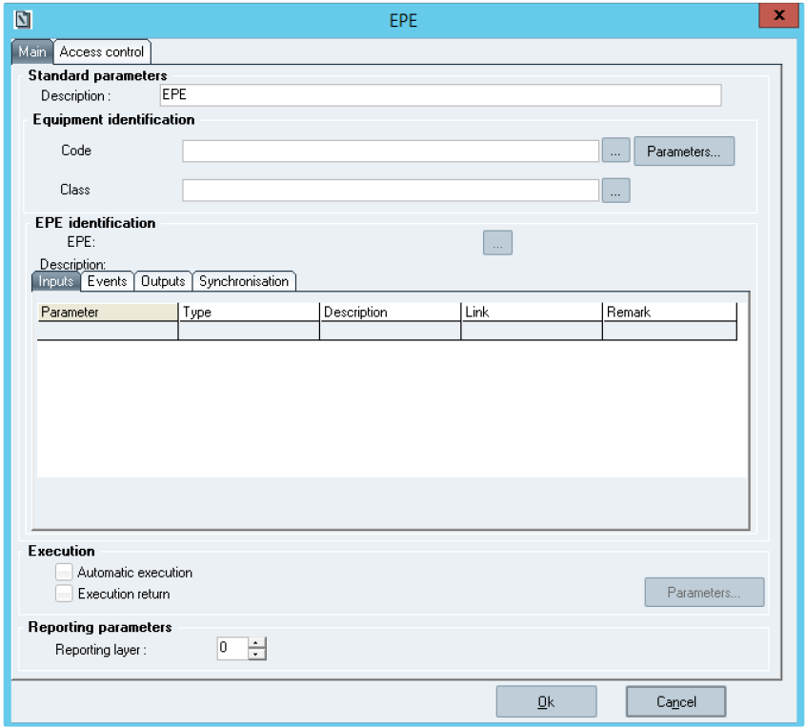

**The *EPE element configuration* window**

**Window description:**

**The *Standard Parameters* section:**

***Description*:** enables the user to enter the text that will be displayed in the EPE element. **The *Equipment Identification* sub-section:**

***Code:*** The equipment code can directly be entered or refer to a text parameter.

***… :*** allows displaying the list of equipment;

***Parameters:*** allows displaying the list of text parameters.

***Class:*** always specified; it determines the list of EPEs that are associated with the piece of equipment.

… : allows displaying the list of equipment classes;

When the equipment code is directly entered, the system automatically provides the equipment class.

During edition, a locking message is displayed if the piece of equipment is not coherent with the class.

During execution, an error occurs if the piece of equipment is not coherent with the class.

**The *EPE Identification* sub-section:**

***EPE:*** code of the EPE that will be executed.

Sp-EBRDesign-2511

97

*Creating a PI*

*Editing the Workflow*

***… :*** allows displaying the list of EPEs that have been defined for the selected class. Once the EPE has been identified, clicking that button allows displaying the list of EPE parameters is displayed from the *Selection of an EPE of an equipment class* window:

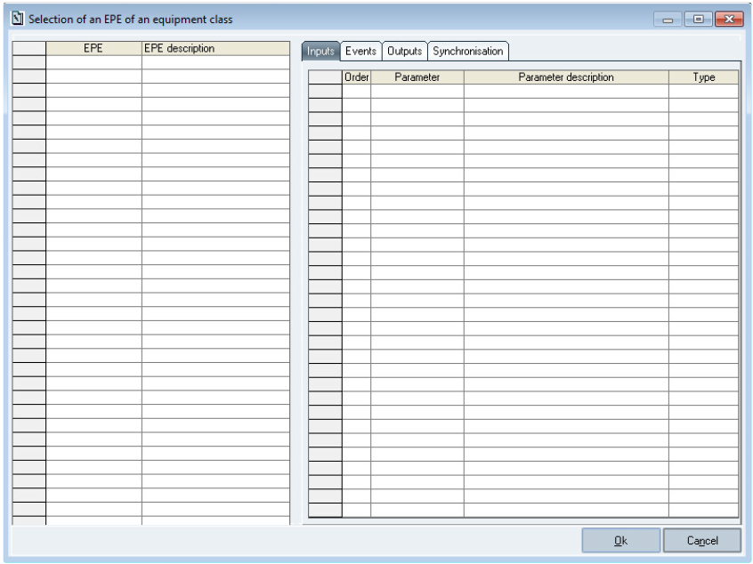

**The *Selection of an EPE of an equipment class* window**

The window displays the following tabs: *Inputs*, *Events*, *Outputs*, and *Synchronisation*.

The *Synchronisation* tab is provided for information only as it is an EPE internal notion, which may however concern the PI writer. That tab just displays the synchronisation that is managed from the equipment class. The *Link* button is hidden.

***Description:*** description of the EPE that will be executed. That field is automatically filled in as soon as the EPE is selected.

**The table below the *Description* field:**

*Parameter:* EPE parameter;

*Type:* type of parameter (i.e. text or numeric);   
 *Description:* EPE parameter description;

*Link:* parameter value:

for the input parameters: PI parameter or fixed value;   
 for the output parameters or events: PI parameter;

*Remark:* comment which was entered when inserting the link.

Links of the EPE parameters:

Each parameter is linked to a piece of information that is included in the PI. That link enables the user to define the way the parameter value is passed on between the PI and the EPE.

98 Sp-EBRDesign-2511

*Creating a PI*

*Editing the Workflow*

The Input parameters can be linked either to a PI parameter of the same type or to a fixed value (writing).The Output parameters or Events can only be linked to a PI parameter of the same type (reading).

To link a parameter, the row that concerns the parameter must be selected from one of the lists before clicking the *Link* button (or double-click the row).

Then, the window below is displayed. It enables the user to enter the name of a parameter or of a fixed value (for EPE input parameters):

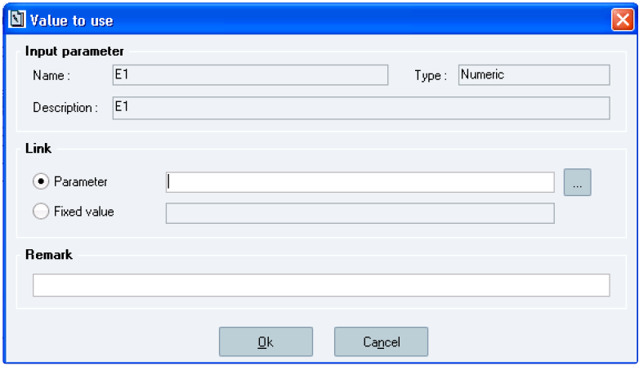

**The *Value to use* window**

The PI parameter to associate with the EPE parameter can be selected from a list, which is displayed after having

clicked the … button. That list just displays the PI parameters with a type that corresponds to the type of the EPE parameter.

Once the link has been created, the user validates his/her choice by clicking the *Ok* button.

The system then checks that the PI parameter (if it has been manually entered) or the input fixed value is consistent with the type of the EPE parameter (i.e. numeric or text). If not, an error message is displayed.

After validation, the list is completed:

the *Link* column displays the name of the parameter (between square brackets) or of the fixed value (with no

square brackets);

the *Remark* column displays the entered comment.

**The *Execution* Parameters section :**

*Automatic execution*: defines whether the execution of the EPE task is automatically launched or not.

*Execution return*: value returned to a numeric parameter (error code or 0). Optional parameter taken into account if the corresponding check box is selected.

**The *Printing Parameters* section:**

Enables the user to define the print order of the workflow operations.

Sp-EBRDesign-2511 99

*Creating a PI*

*Editing the Workflow*

#### [8.2.4.12](http://8.2.4.12) The Wait Element

*Wait* elements allow locking the workflow progression of a wait element until an event which has been previously configured occurs.

**How to set up these elements:**

The following window enables the user to configure the parameters of the *Wait* element:

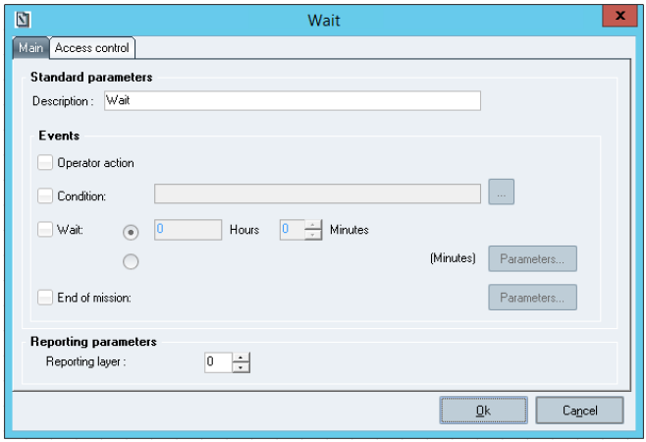

**The *Wait* window**

**Window description:**

**The *Events* section:**

This section enables the user to define the way/s to terminate the task that is associated with the *Wait* element from four check boxes:

***Operator action*:** the operator can execute the task whenever s/he wants to trigger the end of the waiting period.

***Condition*:** selecting this check box makes the … button available, which enables the user to display the following window:

100 Sp-EBRDesign-2511

*Creating a PI*

*Editing the Workflow*

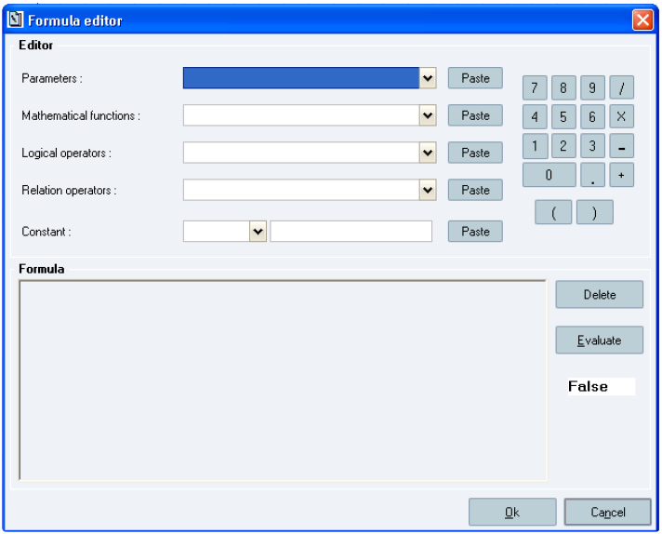

**The *Formula Editor* window**

This window allows creating the condition (same interface as for transitions). Clicking the *Ok* button updates the text field that follows the "Condition" wording in the element edition window.

The waiting period ends once the condition has been fulfilled.

***Wait :*** selecting this check box makes the *Hours* and *Minutes* fields available for fixed duration or the *Parameter*

button for duration that is filled in during execution. In the last case, the used parameter is numeric and indicates duration in minutes. That length of time represents the time that elapsed between the moment where the status of the associated task changes to *In progress* and the moment it is updated as *Terminated*.

***End of mission:*** selecting this check box makes the *Parameter* button available. The operator must specify the mission code (generated before when a Script element was executed) with the next workflow elements.

The user can select 0; 1; 2; 3; or 4 boxes from the *Events* section.

If no check box has been selected, the check box which corresponds to the *Wait* element in the workflow is simply left blank. The status of its associated task is directly changed from *In progress* into *Terminated*.

That kind of element is sometimes useful to facilitate the writing process of the workflow.

Selecting several boxes amounts to consider the different conditions as if the OR Boolean disjunction was selected. For example, if the *Condition* and *Wait* check boxes are selected, the task associated with the element ends as soon as the condition is assessed as True or once the duration has elapsed.

The box of properties related to the *Wait* element (green box displayed on the right-hand part of the element once the workflow has been created) displays that configuration.

#### [8.2.4.13](http://8.2.4.13) The PI Text element

*PI text* elements allow executing a PI text section which enables the user to follow the manufacturing instructions and to fill in tags.

Sp-EBRDesign-2511 101

*Creating a PI*

*Editing the Workflow*

**How to set up these elements:**

Configuring that element enables the user to define the sections of PI text to execute.   
The section to be executed can correspond to:

a whole chapter;

a section defined between two titles (the limits must also be executed).

The chapters are selected from the table of contents that has been defined in the corresponding PI text. A full chapter is defined by clicking the corresponding chapter. Sections are defined by clicking the initial limit, and by right-clicking the final limit.

N.B.: two elements can refer to the same PI text chapter.

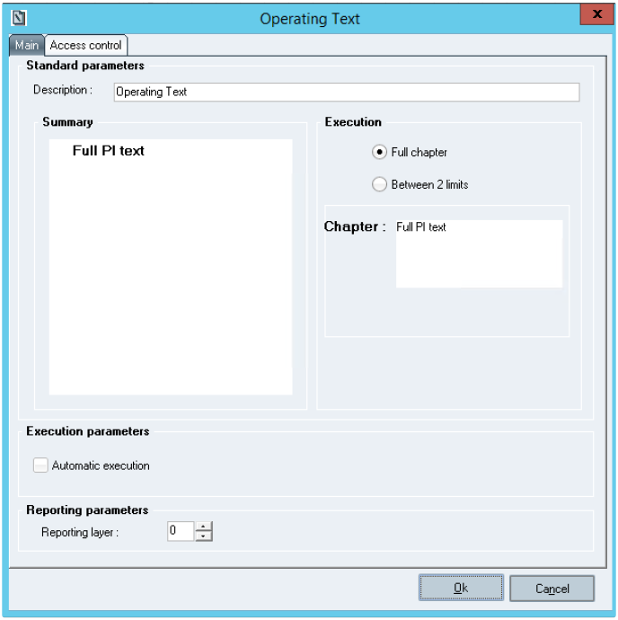

**The *Operating Text element configuration* window**

**Window description:**

**The *Execution Parameters* section:**

***Automatic execution:*** this check box is optional.

When it is not ticked: the user double-clicks the task to perform it.

When it is ticked: as soon as the element is available, executing the PI-text task is automatically managed by the PI service, with no intervention from a user. In the PI text, the tags to be filled in need to be configured to be automatically filled in. The automatic execution is interrupted if a tag cannot automatically be filled in or if an error occurs. A user can then continue the execution manually.

102 Sp-EBRDesign-2511

*Creating a PI*

*Editing the Workflow*

**Warning: Scripts**

**A script, which is included in a PI-Text element and which is automatically executed, should in no way trigger** **message display. Any message that is displayed during automatic execution is displayed on the PI service, which is inhibited until the message is validated.**

#### [8.2.4.14](http://8.2.4.14) The Requisition Element

*Requisition* elements of the workflow enable the user to synchronise requisitions with other stages of the manufacturing process:

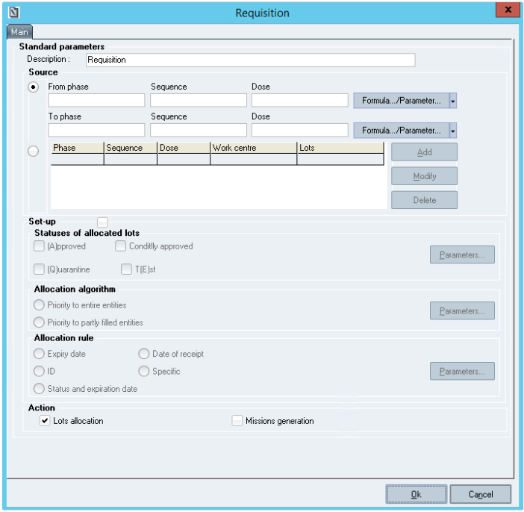

**The *Requisition element configuration* window**

**Window description:**

**The *Source* sub-section:**

Indicates the requisition range by defining a set of phases (and of sequences and doses, if necessary).For each phase (material line), the user can define a work centre and one or several mandatory lots, which can be specified manually or via a PI parameter. If several mandatory lots are defined, these ones need to be separated with a comma.

***Add:*** allows displaying a window which enables the user to select a phase/sequence/dose, a work centre (fixed value or PI parameter), and a lot (fixed value or PI parameter):

Sp-EBRDesign-2511 103

*Creating a PI*

*Editing the Workflow*

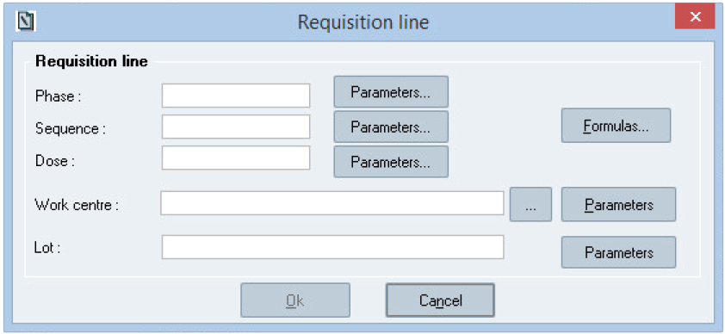

**The *Requisition line* window**

**The *Set-up* sub-section:**

Displays the configuration of the Requisition element.

The check boxes of that section define if the Requisition element must be configured independently or if it inherits of the global behaviour from the Requisition module (i.e. "Requisition.exe").

If the *Set-up* check box is ticked, the default configuration is defined with the default behaviour of requisitions. All parameters can be modified and are mandatory:

***Statuses of allocated lots:*** defines that the lot statuses could be allocated. The available statuses are:

(A)pproved;

Conditionally approved (C);   
 (Q)uarantine;

T(E)st.

They can be filled in manually by using the check boxes or a PI parameter (in Execution mode, the statuses must be identified by the letters A, C, Q, or E and separated with a comma).

***Allocation algorithm:*** *defines the allocation algorithm. The available algorithms are:*

priority to entire entities (1)   
 priority to part-filled entities (2).

It can be filled in manually by using the radio buttons or a PI parameter (in Execution mode, the allocation algorithm must be identified by the value 1 or 2).

***Allocation rule:*** defines the allocation rule. The available rules are:

rule based on lot expiration date (1)

rule based on lot reception date (2)

rule based on lot identifier (3)

rule based on the status and lot expiration date (4)   
 rule based on a specific lot selection (5).

It can be filled manually by using the radio buttons or a PI parameter (in Execution mode, the rule must be identified by the value 1; 2; 3; 4; or 5).

If the check box is not ticked, the parameters are not available and the applied configuration corresponds to the default behaviour of requisitions.

**The *Actions* sub-section:**

104 Sp-EBRDesign-2511

*Creating a PI*

*Editing the Workflow*

Requisitions are made up of two stages:

Allocation of lots; Generation of missions.

The user can indicate if both stages are performed at once or if only one must be performed.

#### [8.2.4.15](http://8.2.4.15)

The Batch element

##### 8.2.4.15.1

Overview

**Batch data for batch configuration**

The batch element is based on data retrieved from batch system. To be able to configure the batch element the following data should have been uploaded in Opcenter Execution Pharma:

Enumerations   
 Phase types

Batch master recipe

Please refer to ***Batch_process_and_configuration-i.pdf*** technical documentation for more details.

**How to set up this element:**

*Batch* elements of the workflow allow managing a batch on SIMATIC BATCH from a Opcenter Execution Pharma PI:

Sp-EBRDesign-2511 105

*Creating a PI*

*Editing the Workflow*

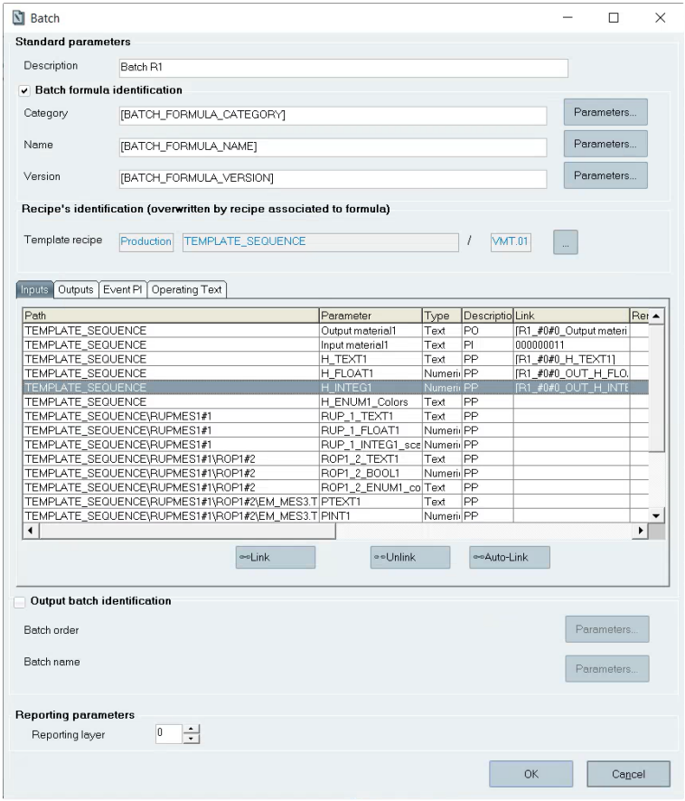

**The *Batch element configuration* window**

**Window description:**

**Standard parameters section** (please, refer to Standard Parameters)

**Input/Outputs tabs** (please, refer to The Batch parameters (i.e. the Inputs and Outputs tabs) **Event PI tab** (please, refer to Event PI)

**Operating Text tab** (please, refer to Batch Operating Text)

**Output batch identification section** (please, refer to Output batch identification)

**Detail display in workflow**

In the workflow, it is possible to see some parts of the batch element configuration. It is accessible by clicking on icon located in the top left corner of the element.

106 Sp-EBRDesign-2511

*Creating a PI*

*Editing the Workflow*

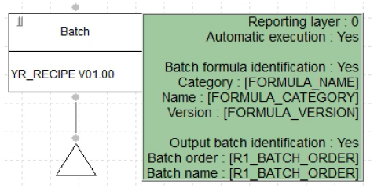

**Batch element details in workflow**

The following elements are displayed:

Print: print order

Automatic execution: Yes. (For batch element it is always yes and this value cannot be modified).   
Output batch identification: Yes or No. If Yes, the Batch order and batch name values are also displayed.

Note: for performance and readability reasons the input and output parameters configuration is not displayed in this detail.

Sp-EBRDesign-2511

107

*Creating a PI*

*Editing the Workflow*

##### 8.2.4.15.2 Standard parameters section

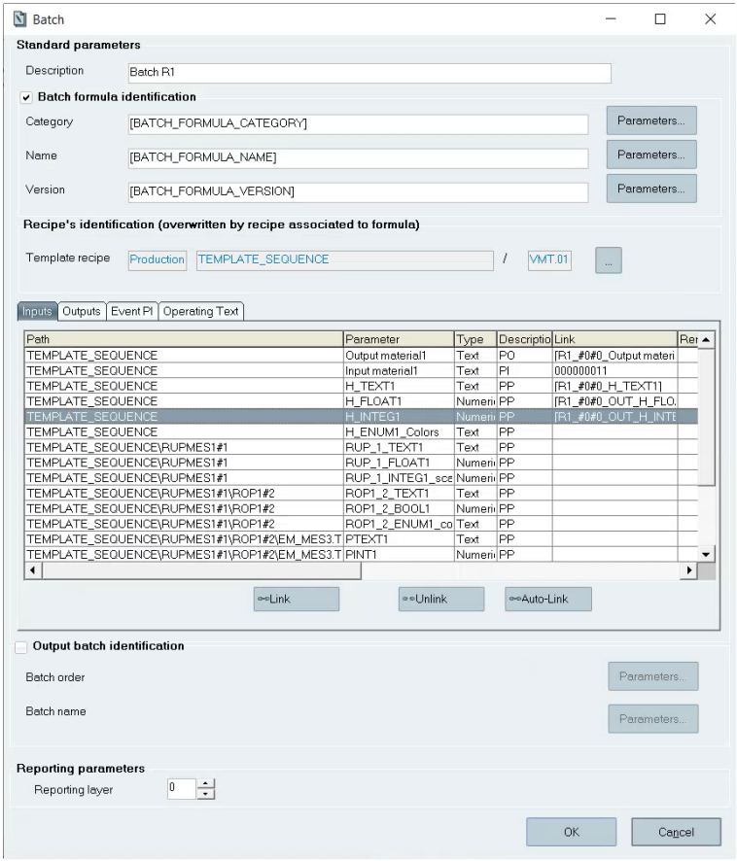

**Batch element – Standard parameters section**

***Description:*** this description will be displayed on the batch element.   
 ***Batch formula identification sub-section:***

The formula is identified by a category, a name and a version.

These fields are optional.

"Batch formula identification" checkbox is unchecked by default, Category, Name and Version are empty and "Parameters" buttons are disabled. In this case, the label "(overwritten by recipe associated to formula)" is hidden and "Template recipe" is replaced by "Recipe".

108 Sp-EBRDesign-2511

*Creating a PI*

*Editing the Workflow*

When the checkbox "Batch formula identification" is checked, the "Parameters" buttons are enabled. In this case Category, Name and Version fields should have a value. If one or all these fields are empty, an error message is displayed when the Batch element configuration is validated:

"Category must be filled in."

OR

"Name must be filled in."

OR

"Version must be filled in"

Formula category, name and version can be linked to Electronic Batch Record parameters:

On click on "Parameters" button, the parameters selection window is opened. Only text parameters are displayed. When the checkbox "Batch formula identification" is unchecked, the category, name and version values are emptied, and "Parameters" buttons are disabled.

***Recipe's identification* sub-section:**

The recipe is identified by a PCell name, a Recipe name and a Recipe version. Fields in read-only mode, must be

selected from the list of Recipe's list windows.

PCell is part of the information that uniquely identifies a batch recipe. It should be correctly managed in the application to allow multiple Batch instances.

***…:*** allows opening the list of batch recipes. The following window is displayed:

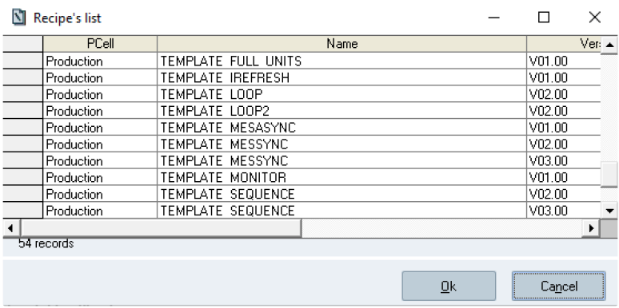

**The *Recipe's list* window**

Note: once configured, the batch elements are not impacted by the upload. All the information is stored inside

batch structure. To update the batch element in case of master recipe structure change, it is necessary to open the batch element and re-select the master recipe to update the parameters and Event PIs list.

Remark: Batch element detailed documentation: formula and recipe detail display.

Formula identification is displayed with Category, Name and Version in case a formula has been configured. Otherwise, these rows are not displayed, and "No" is displayed in Batch formula identification row.   
"Template Recipe" is displayed instead of "Recipe" in case a formula has been configured.

Sp-EBRDesign-2511 109

*Creating a PI*

*Editing the Workflow*

The "Detail recipe" (hierarchical) is displayed in the detailed documentation only if the batch recipe has been uploaded.

Otherwise a message is displayed in the field: "Not available (please upload the recipe)".

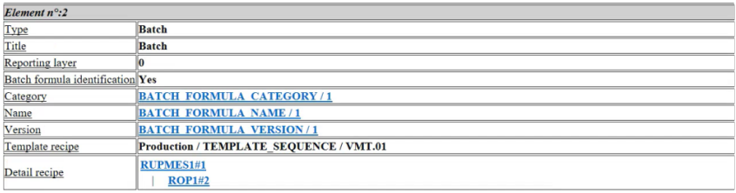

Once the recipe has been selected, the list of recipe parameters is displayed. It includes the *Inputs*, *Outputs*, *Event PI* and *Operating Text* tabs.

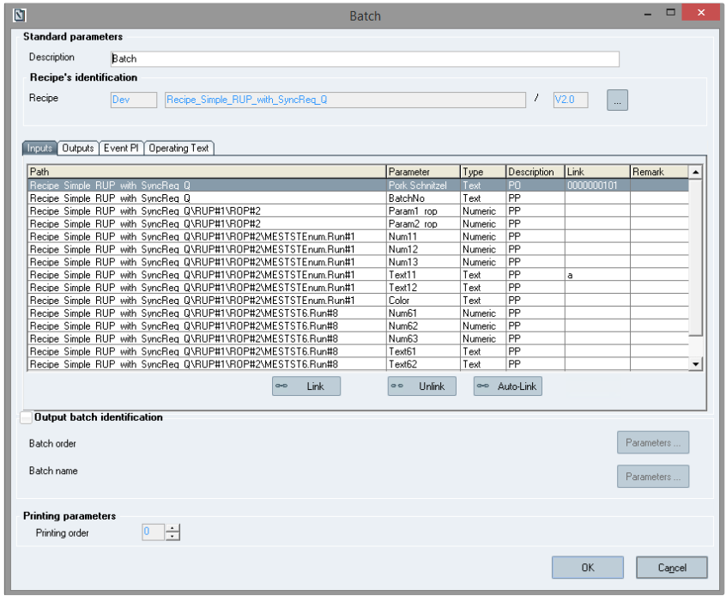

**Input and Output parameters, Event PI list and Operating Text list tabs**

110 Sp-EBRDesign-2511

##### 8.2.4.15.3

*Creating a PI*

*Editing the Workflow*

The Batch parameters (i.e. the *Inputs* and *Outputs* tabs)

**Table description**

Clicking these tabs allows displaying a table, which includes the following columns:

**Path**2**:** complete path of the batch parameter

Path format example: *Recipename\RUPname#ContID\ROPname#ContID\EquipementModule.ControlStrategy#TermID.*

**Parameter:** batch parameter (recipe parameter);

**Type:** parameter type (i.e. text or numeric); Enumeration parameters are handled as text.   
 ***Description****:* description of the batch parameter (type: PO, PI, PP);

***Link****:* Electronic Batch Record parameter or fixed value;

***Remark****:* remark entered when inserting the link.

2Column displayed only when some parameters have been configured as DCS/PCS relevant parameters.

The grid allows multi selection:

"Shift"+ click: selects all lines between the first line selected and the last one

"Ctrl" and "A": selects all the lines

"Ctrl" + click: adds the selected line to the previous selection. If this line was already selected before the click, it is unselected.

Simple click on one line: selects only this line, and replaces the previous selection

N.B.:

If no DCS/PCS relevant parameter is defined for this recipe, all the header parameters of the recipe are automatically listed in the batch element configuration.

If DCS/PCS relevant parameters are defined for this recipe, they are automatically listed in the batch element configuration.

If the configuration of the DCS/PCS relevant parameters is modified after the configuration of the batch element or if the recipe structure has changed (parameter deleted for instance), the recipe must be selected again in order to update the list of batch element parameters. The already configured values/ links for parameters are kept if the parameter is the same (same ContID, TermID and Name).

**Link**: button allows the user to link the selected batch parameter. This button is enable if one line is selected and disabled in case of multi-selection.

**Unlink**: button allows the user to unlink the selected batch parameter. This button is enable if one line is selected and disabled in case of multi-selection.

**Auto-Link**: button allows the user to link automatically the selected batch parameters. This button is enable if one line is selected or in case of multi-selection.

Links of the batch parameters

The parameters may be linked to some data of the PI, but this link is not mandatory. This link allows defining how the parameter values will be transferred from the PI to the SIMATIC BATCH.

For an Input parameter, it is possible to link it either to an Electronic Batch Record parameter of the same type or to a fixed value (writing).

For an Output type parameter, it is only possible to link it to an Electronic Batch Record parameter of the same type (reading).

Sp-EBRDesign-2511 111

*Creating a PI*

*Editing the Workflow*

**1-** **To link manually a parameter**, the user has to **select** it from the list and to **click** the *Link* button.

The following window is consequently displayed. The user enters the name of the parameter or a fixed value (if it is an Input parameter for a recipe):

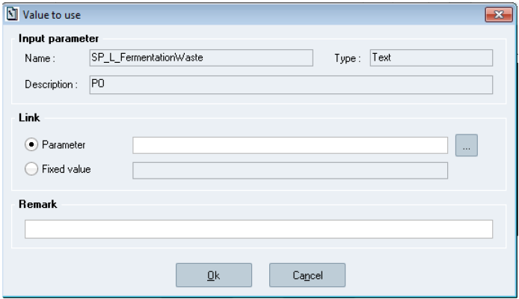

**The *Value to use* window**

The batch parameters of the **Process-Parameter type (PP)** can be used as input or output parameters and be

linked to different text or numeric Electronic Batch Record parameters (or fixed values).

**Note**

The PP parameters of type Unit can be used to allocate a Unit from Opcenter Execution Pharma. These parameters can only be defined at master recipe header parameters level. If you need to allocate the Unit from Opcenter Execution Pharma, you should correctly configure a master recipe header parameter of type Unit in SIMATIC Batch and provide a valid input value for this parameter in batch element configuration. This value will be provided to SIMATIC Batch with all the set point values during batch task execution.

The batch parameters of the **Product-Output (PO) or Product-Input (PI)** types can only be used as input parameters and be linked to text Electronic Batch Record parameters (or fixed values).

These parameters must be entered according to the definition of the phase/sequence/dose that is linked to the corresponding materials in the WO (e.g. 0000000101 for the phase 0000; sequence 0001; and dose 01). The system does not check the coherence of the links between parameters.

Warning:

The Product-Output (PO) parameter is mandatory and must be linked to the phase/sequence/dose that is linked

to the good to produce.

If a Product-Input (PI) parameter is configured from the recipe, it must be linked to the phase/sequence/dose that is linked to the same material to consume.

The Electronic Batch Record parameter to link to a batch parameter can be **selected from a list**, which can be displayed by clicking the "…" button. This list only displays Electronic Batch Record parameters with a type that corresponds to the type of the batch parameter.

If a link is already defined, the corresponding parameter is selected in the parameter's list at window's opening. Once the link is set, clicking the *Ok* button allows validating the selection.

112 Sp-EBRDesign-2511

*Creating a PI*

*Editing the Workflow*

The system checks that the Electronic Batch Record parameter (if manually entered) or the fixed value is coherent with the type of the batch parameter (i.e. numeric or text). If not, an error message is displayed.

Batch parameters of enumeration type can only be bound to Text Electronic Batch Record parameters.   
After the validation, the list is filled in with the following:

The *Link* column contains the name of the parameter (between square brackets) or the fixed value,   
 The *Remark* column contains the entered remark.

**2-** **To link automatically a parameter or more,** the user has to **select** it/them from the list and to **click** the *Auto-* *Link* button.

The selected parameters of the tab are automatically linked to matching parameters. If these ones do not exist, they are created following the rules described below.

The auto-link functionality uses the standard script: EBR_DESIGN_AUTO-LINK_PARAMETER.

The auto-link and parameters creation can be customized by replacing the standard script in EBR.xml manifest. (please refer to ***Sp-StandardScripts-i.pdf*** and Batch_process_and_configuration documents).

**Auto-link rules**

If a parameter is already linked, its value is not modified by auto-link.

The research of matching parameter is done among:

The Electronic Batch Record parameter should have Alias = "Path" \ "batch parameter name"

The Electronic Batch Record parameter should have the type that respects the mapping of type between batch parameter and Electronic Batch Record parameter below:

**Batch parameter type**

Integer

Float

Boolean

Text

Input material

Output material

Enum

**Electronic Batch Record parameter type**

Numeric

Numeric

Numeric

Text

Text

Text

Text

If more than one match is found, no link is done.

If a match is found, Link = [Code] of the parameter. The Electronic Batch Record paramerter version used is:

The last version of not obsolete Electronic Batch Record parameter for parameter not already referred in the current PI.

The version used for Electronic Batch Record parameters already referred in the current PI.

Sp-EBRDesign-2511 113

*Creating a PI*

*Editing the Workflow*

=> If no matching parameter is found, a parameter is **created**. **Parameter creation by auto-link**

Common characteristics:

***Parameter code***: a unique identifier on 30 characters is automatically generated with the following format: *BATCH_YYYYMMDDHHMMSS_xxxxxxxxx*

Where "YYYYMMDDHHMMSS_" is the date of click on the button, allows grouping all the parameters created by the auto-link click and "xxxxxxxxx" an unique identifier on 9 digits.

***Version***: always equal to "1"

***Family***: equal "DCS/PCS parameter"

***Description***: equal to Batch parameter name.

Remark: the number max of characters in description is 120 characters. If the batch parameter name is more than 120 characters, the description is truncated.

***Alias***: equal to "Path" \ "batch parameter name".   
***Status***: equal 'Created'

***Standard***: equal 'No'

For Text parameter:

**Possible Value:**

If the batch parameter type is "Enum" then the list of possible value is equal to the list of user visible values of the Enum in batch.

In other case: nothing is set

**Initialization:** nothing is set

For Numeric parameter:

**Unit:** equal to the unit of batch parameter. The unit is automatically created if the unit does not exist for PI numeric parameter.

Remark: the management of unit is case sensitive, so the case of batch parameter with unit "KG" brings the creation of unit "KG" that is different of "kg" (already exists for PI numeric parameter by default)

Limitation: the UOM size should be lower or equal to 10 characters, otherwise the parameter creation will fail. **Format:**

If batch parameter is type "Integer" then the format is 999999999

If batch parameter is type "float" then the format is 999999999.999   
 If batch parameter is type "boolean" then the format is 9

**Acceptable limits:** nothing is set (Max and Min of batch parameter not transferred)   
**Tolerance limits:** nothing is set (Max and Min of batch parameter not transferred)   
**Initial value:** nothing is set

##### 8.2.4.15.4 Event PI

The *Event PI* tab allows managing the links between the main PI and its Event PIs.

When a recipe is selected, the Event PIs "approved" or "launched" which are linked to the phases (PCell/Equipment module/Control Strategy) of the recipe are automatically imported into the configuration of the batch element. This List is updated each time the Batch Element configuration window is opened.

114 Sp-EBRDesign-2511

*Creating a PI*

*Editing the Workflow*

If some event PIs are configured with wildcards, they appear in the list as well if the configuration is matching the specified master recipe.

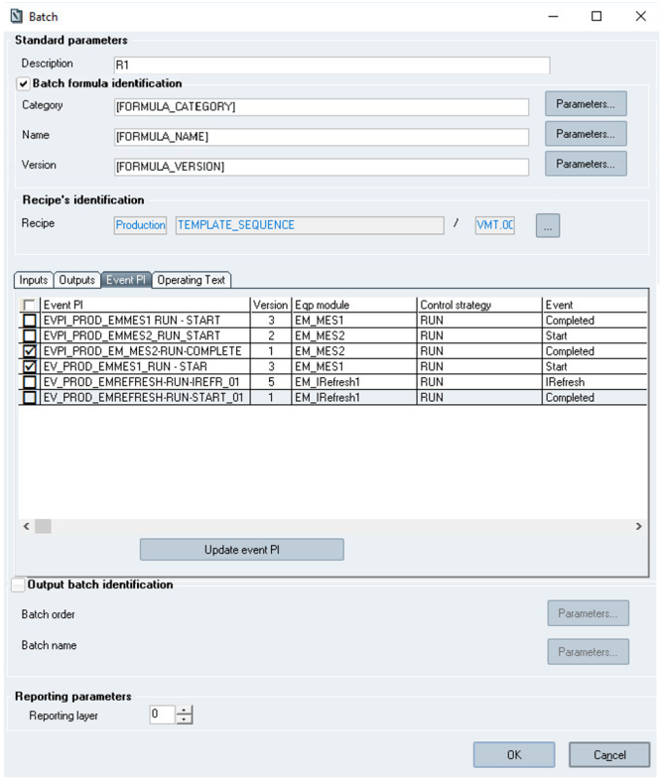

**The *Batch element configuration* window**

**Table description**

Clicking this tab allows displaying a table, which includes the following columns:

***Event PI****:* code of the PI that has been defined as an Event PI

***Version****:* version of the PI that has been defined as an Event PI (corresponds to the last validated version of the PI) ***Eqp module & Control strategy****:* type of the phase that has been defined for the Event PI

***Event****:* Event that has been defined for the Event PI

The Event PI can be selected/unselected. In the column "**Selected**":

If the checkbox is checked, the Event PI is selected (so in execution part, it is executed once the configured event for the phase type is processed)

If the checkbox is unchecked, the Event PI is not selected (so in execution part, it is NOT executed even if the configured Event for the phase type is processed).

Sp-EBRDesign-2511 115

*Creating a PI*

*Editing the Workflow*

By default, once the recipe is selected, the Event PIs displayed are not selected.

**Event PI update**

***Update event PI*** button allows updating the list of the Event PIs that are linked to the selected recipe with:

The latest versions of each validated Event PIs

The new Event PIs that have been validated since the last configuration of the batch element has been performed.

**Selection of same recipe** in Recipe's identification sub-section (same PCell and name but the version can be upgraded or not) **OR** **click** on the *Update event PI* button generate an Event PI updating:

the Event PIs previously displayed and not updated, keep their configuration ('selection' state and parameters links previously defined),

the Event PIs previously displayed and updated, keep their configuration ('selection' state and parameters links previously defined) but upgrade their version. If there are new parameters, their links must be defined,

the new Event PIs are 'unselected' by default and the parameters links must be defined.

**At batch element opening**, if Event PIs are upgraded (to upper version):   
 for selected Event PIs: the previous version is kept,

for unselected EventPIs: the latest version is displayed and can be selected.

**At batch element opening**, if SIMATIC Batch master recipe has not been uploaded and so the Event PI list cannot be retrieved, a warning message is displayed to the user: "You cannot configure event PIs because SIMATIC Batch data has not been uploaded. Please upload SIMATIC Batch data before configuring your batch element". Following the **selection of another recipe** (different PCell and/or name):

The Event PIs displayed are updated if they match with the new selected recipe (keep their 'selection state').

If they do not match, they are removed.

All new displayed Event PIs are 'unselected' by default,

The parameters links for each 'selected' Event PI must be defined.

**Links of the Event-PI parameters**

The user can configure the Parameters links for each Event PI if this one is "selected". Otherwise, the "Parameters" button is not displayed.

If parameters links has been configured for an Event PI and if the user unselect this Event PI, the links are kept in memory as long as the user does not record the configuration via the 'OK' button (so if the user selects once again this event PI, the previous binding is kept) or quits the window by 'cancel' button.

For the selected Event PI, if some parameters must be linked, a red point appears near the *Parameters* button.

116 Sp-EBRDesign-2511

*Creating a PI*

*Editing the Workflow*

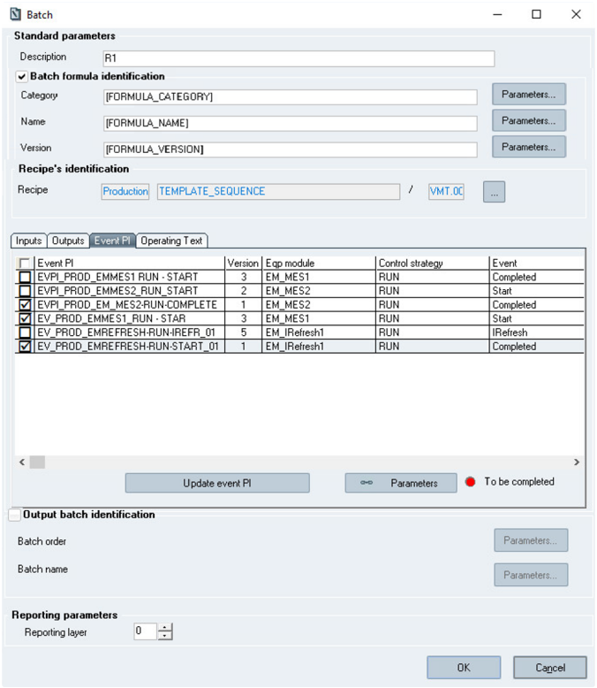

**Event PI parameters to be completed**

**To link the Event PI parameters**, the user has to **select** the Event PI from the list and to **click** the *Parameters* button.

The following window is consequently displayed and defining the links for the Electronic Batch Record parameters that correspond to the Event PI:

Sp-EBRDesign-2511 117

*Creating a PI*

*Editing the Workflow*

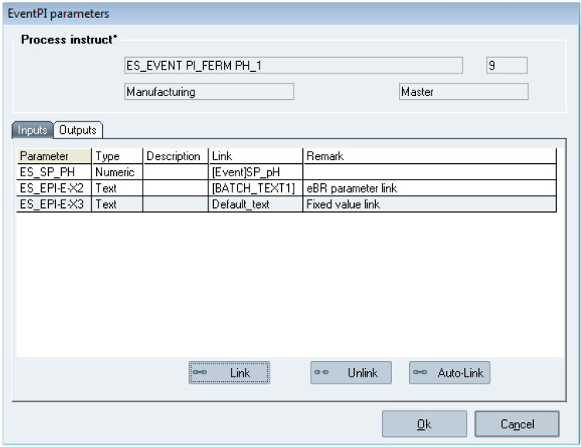

**The *EventPI parameters* window**

**Process instruct°**: Event PI code, version, family and type,   
**The *Inputs/Outputs* tabs** display the following columns:

***Parameter****:* Electronic Batch Record parameters defined as an Input/ Output parameter for the PI of the Event PI;

***Type****:* type of parameter (i.e. text or numeric);

***Description****:* description of the Electronic Batch Record parameter;

***Link****:* Batch parameter, Electronic Batch Record parameter or fixed value;   
***Remark****:* remark entered when the link was created.

***Link***: button allows the user to link the selected parameter. This button is hidden (i.e. not available) in case of links configure with a Batch parameter.

***Unlink***: button allows the user to unlink the selected parameter. This button is hidden (i.e. not available) in case of links configure with a Batch parameter.

***Auto-Link***: button allows the user to link automatically all parameters of the current tab.   
For an Input parameter, the links can be defined with:

A Batch parameter (link displayed with the [Event] prefix).

Links with Batch parameter should be defined when configuring the PI of the Event PI from the Input/ Output tab of

the PI (see Output Parameters);

An Electronic Batch Record parameter (link displayed between square brackets);   
 A fixed value;

For an Output parameter, the links can be defined with:

118 Sp-EBRDesign-2511

*Creating a PI*

*Editing the Workflow*

Electronic Batch Record parameters;

The configuration of the links between Electronic Batch Record parameters or between fixed values for the Event PI parameters is performed the same way as it is done for the configuration of the links between batch parameters.

Warning:

All parameters (input/output) of the Event PI must be linked; otherwise, when they are being executed, the PIs of the Event PIs will raise errors.

**Auto-link rules**

The **auto-link** button automatically links all the parameters in the current tab. For each parameter, it tries to find a matching parameter following the rules below:

If a parameter is already linked, its value is not modified by auto-link (so [Event]XXX parameters are not modified)

If no parameter is linked, Link = [Code] of the parameter with parameter **code = Event PI input parameter code**, and the version is:

The last version of not obsolete PI parameter for parameter not already referred in the current PI.   
 The version used for parameters already referred in the current PI.

The auto-link functionality uses the standard script: EBR_DESIGN_AUTO-LINK_PARAMETER.

##### 8.2.4.15.5

Batch Operating Text

The *Operating Text* tab allows managing the links between the main PI and its Batch Operating Text.

Sp-EBRDesign-2511

119

*Creating a PI*

*Editing the Workflow*

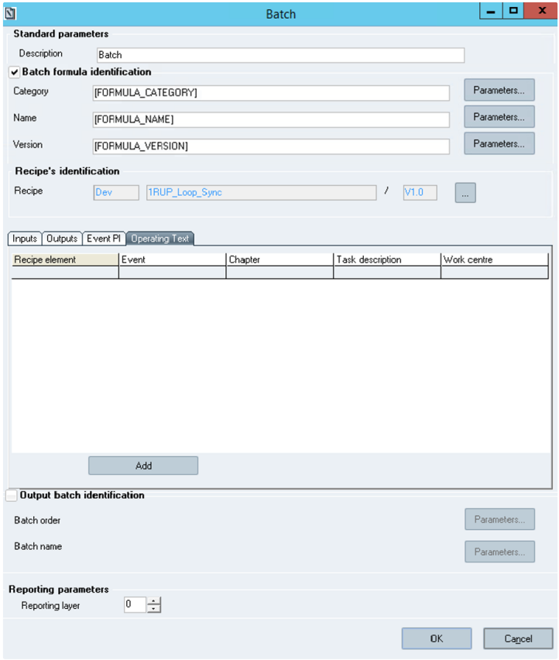

**Batch element - BOT list**

**Table description**

Clicking this tab allows displaying a table, which includes the following columns:

***Recipe Element:*** configured Recipe Element path;

***Event:*** Event configured for the Recipe Element to launch the Batch Operating Text

***Chapter:***

In full chapter option, displays the Name of Chapter to execute.

In Between two limit option, displays "From:" First Chapter to execute then "To:" Last chapter to execute. ***Task Description:*** Description of the Batch Operating Text task at execution

***Work Center:*** imposed Work center at execution. Empty if not defined.

**Actions**

120 Sp-EBRDesign-2511

*Creating a PI*

*Editing the Workflow*

***Add***: Open the Batch Operating Text configuration window in add mode.

***Modify***: Open the Batch Operating Text configuration window filled with the selected Batch OT information.   
***Delete***: Delete the selected Batch Operating Text after a confirmation message.

**Rules**

When there is no Batch Operating Text in the list, only the "add" button is visible.

When there is at least one Batch Operating Text on the list, all buttons are visible.

The Batch Operating Text list is not editable.

When the user changes the recipe (different recipe name), the Batch Operating Text list is cleared.

When the user selects a new version of the same recipe or another PCell for the same recipe name, the Batch Operating Text list is updated following these rules:

If the recipe element with the same ContID and TermID than the configured Batch Operating Text exists with the same path in the new recipe, the Batch Operating Text is kept.

If the recipe element of the configured Batch Operating Text doesn't exist (or path is different) in the new recipe, the Batch Operating Text is deleted.

When the user double clicks on a selected Batch Operating Text, the Batch Operating Text configuration window is opened in update mode.

When a Chapter label is modified in the Process Instruction Text tab, this modification does not automatically impact the Batch Operating Text. The Chapter label has to be updated manually in Batch Operating Text (re- selected).

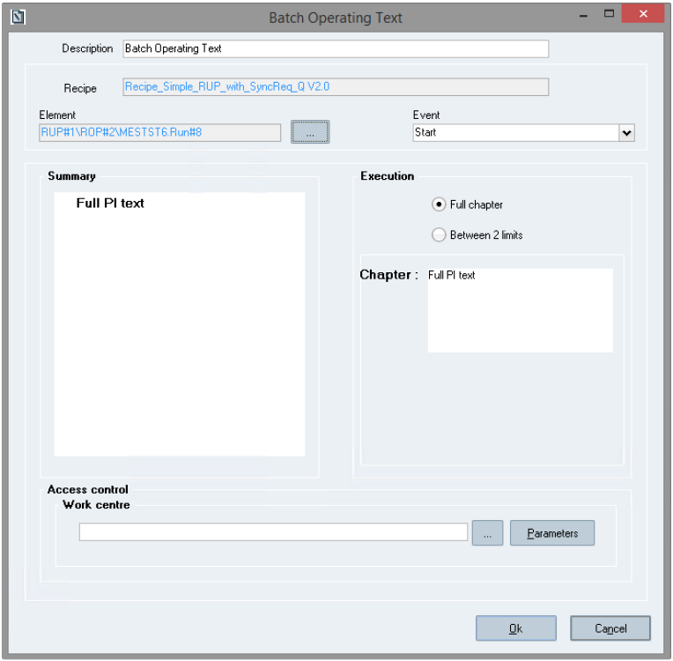

Sp-EBRDesign-2511 121

*Creating a PI*

*Editing the Workflow*

**Batch Operating Text configuration window**

**Display**

**Description:** Name of the Batch Operating Text.

This field is a free text input up to 256 characters, initialized with "Batch Operating Text".

The rules of a standard task description (like parameters to create a dynamic name) apply to this field.

**Recipe**: Name of the Master recipe. Information automatically retrieved from Batch Element configuration window.

This field is disabled.

**Element**: Recipe element (RUP, ROP or Phase). This field is disabled; the user must select a value from the Recipe Element selection window.

Here is an example of path format: RUPName#ContID\ROPName#ContID\EquipementModule.ControlStrategy#TermID.

**Event**: Recipe element event that launches the Batch Operating Text. This field is a list of recipe element events. 4 events are set by default:

Start   
 Completed   
 IRefresh   
 Aborted

**Summary**: Summary of the Process Instruction. Information automatically retrieved from Process Instruction. The tree view is not editable, but items are selectable.

**Execution**: Two radio buttons for Full chapter execution or execution between 2 limits.

In full chapter option (default option):

Chapter: Name of the chapter to execute.

This field is automatically filled by a tree view selection.

In Between 2 limits option:

"From": Name of the first chapter to execute. This field is automatically filled by a tree view selection (left click).

"To": Name of the last chapter to execute. This field is automatically filled by a tree view selection (right click). **Access control:**

Work center**:** work center where the BOT has to be executed.

This field is a free input, empty by default. The way to set work center is the same as the standard. But here the user defines one access by BOT, so it is possible to have different kind of access control for each BOT.

**Actions**

***…:*** Open the Recipe Element Selection window.

***OK***: Check the data validity, define (or modify) the Batch Operating Text, close the window and update the Batch OT list on Batch Element window.

***Cancel*** or

**Rules**

In add mode

: Close the window.

122

Fields automatically filled:

 Sp-EBRDesign-2511

*Creating a PI*

*Editing the Workflow*

Recipe (= recipe selected on batch element configuration window)   
 Summary (=summary of Process instruction)

Description (= "Batch Operating Text" by default)

Fields not filled:

Element   
 Event   
 Chapter

The option "Full Chapter" is selected by default.

In modify mode

All fields are automatically filled with selected Batch Operating Text.

In all modes:

The rules for "summary", "execution" option and chapter fields are the same than for a standard Operating Text element.

Several Batch Operating Texts can be defined for a same couple element/event.

A same chapter can be configured for several couple element/event.

To validate a Batch Operating Text:

Description has to be filled.

Element has to be filled.

An event has to be selected.

Operating Text rules have to be fulfilled.

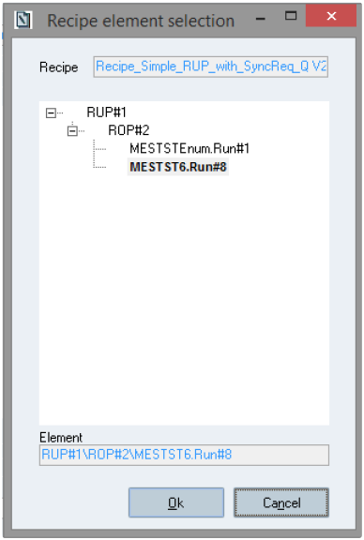

**Recipe Element selection window**

**Window description**

Sp-EBRDesign-2511 123

*Creating a PI*

*Editing the Workflow*

**Recipe:** Name of the Master recipe. Information automatically retrieved from Batch Element configuration window. This field is disabled.

**The tree view**: Displays the recipe hierarchical structure. Information automatically retrieved from Recipe information when the window is opened.

**Element**: This field is automatically filled by a tree view selection. Empty by default

**Actions**

***OK***: Modify the current Batch Operating Text, close the window and update the Batch Operating Text configuration window.

***Cancel*** or

**Rules**

In add mode

: Close the window.

Recipe element field is empty.

No recipe element is selected in the tree view. Treeview is collapsed.

In modify mode

Recipe element field is automatically filled with Batch Operating Text information.

The current recipe element is selected in the tree view.

In all modes

The tree view is automatically filled with Recipe structure.

Elements which are already defined with a Batch Operating Text are displayed in bold.   
 The user can select a RUP, a ROP or a Phase.

The recipe element field is updated when the user clicks on an element of the tree view.   
 To validate, the recipe element has to be filled.

##### 8.2.4.15.6 Output batch identification section

In this section, batch identification information can be provided.

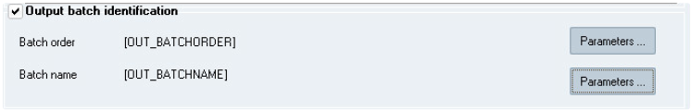

**Batch element – Output Batch identification section**

These fields are optional.

"**Output batch identification**" checkbox is unchecked by default, Batch order and Batch name values are empty and "Parameters" buttons are disabled.

When the checkbox "Output batch identification" is checked, the "Parameters" buttons are enabled. In this case both Batch order and Batch name fields should have a value. If one or both of these fields are empty, an error message is displayed when the Batch element configuration is validated:

"Batch order must be filled in."

124 Sp-EBRDesign-2511

*Creating a PI*

*Editing the Workflow*

OR

"Batch name must be filled in."

Batch order and batch name can be linked to Electronic Batch Record parameters:

On click on "Parameters" button, the parameters selection window is opened. Only text parameters are

displayed.

When the checkbox "Output batch identification" is unchecked, the batch order and batch name values are emptied and "Parameters" button are disabled.

#### [8.2.4.16](http://8.2.4.16) The Step Element

*Step* elements are elements that are inserted automatically when directly re-reading two of the following elements:

Starting simultaneous sequences   
 Ending simultaneous sequences   
 Starting workflow sequences   
 Ending workflow sequences

Step elements that are between these elements are necessary to correctly execute the workflow.

N.B.: Some actions can delete that element, which is necessary to correctly execute the workflow, at the wrong moment.

This element can be reintroduced:

Manually by selecting it from the drop-down list that is displayed in the toolbar or

Automatically by re-reading the concerned elements.

**How to set up these elements:**

The Step element cannot be configured. It is launched automatically in Execution mode.

#### [8.2.4.17](http://8.2.4.17) The At-Line Testing Element

Pre-requisite: This task can be configured in the PIManagement workflow, only if the user has updated the necessary configuration in the **Siemens.OcExPh.Task.AtLine.dll.config** located in the binaries folder.

The user is required to update the following entries in the configuration file.

**Element**

RDnLHostname

RDnLAuthentication

RDnLDatabase

RDnLUsername

Sp-EBRDesign-2511

**Value**

<hostname>

Basic

<OpcenterRDnL_DB>

<username>

**Note**

Hostname of the RD&L Server

Database name of the Opcenter RD&L

Username to communicate with RD&L

125

*Creating a PI*

*Editing the Workflow*

**Element**

RDnLPassword

RDnLGILProtocol

RDnLGIL

**Value**

<encrypted_passwor d>

<http> or <https>

<OpcenterRDnLGIL>

**Note**

Encrypted password using the **Openssl** utility. Check below step on how to encrypt the password.

Name of the GIL service created at the time of installation.

**Encrypting password using Openssl**:

The password of the RD&L user that is used for the integration can be encrypted and then updated in the configuration file **Siemens.OcExPh.Task.AtLine.dll.config** as follows.

Ensure the OpenSSL is installed on the machine with download link from [Binaries - OpenSSLWiki](https://wiki.openssl.org/index.php/Binaries) for Windows. (Version 3.3.1 or above) e.g. <https://slproweb.com/products/Win32OpenSSL.html>

Ensure that the OpenSSL installation path is added to PATH of **System Variables** (at Machine Level) in environment variable.

Launch CMD prompt and check OpenSSL is installed using below command

openssl -version

Run below command in the command prompt shell.

echo <RDnL_usr_Password> | openssl enc -aes-256-cbc -a -pass pass:<user_defined_key>

RDnL_usr_Password: Password of the Opcenter RD&L user user_defined_key: Any user defined alpha-numeric key to encrypt the password

The output from the above command (encrypted string) should be added as a value in the configuration file's element RDnLPassword.

The user_defined_key that was used to encrypt the password should be added to XFP config parameter LIMS_KEY using the setup.exe.

The At-Line Testing element is intended to perform testing and verification activities at the production line at the shopfloor.

At-Line testing is a process in which sampling is done at the production line for performing certain tests. The samples are sent to a Laboratory for testing purposes and the sample results are received back from the Laboratory. The samples are tested against a set of parameters typically defined by the Laboratory and the results are defined based on the parameter values.

The configuration of At-Line Testing element in PIManagement lets you select a Sample Type of which you can create samples using the At-Line Testing task at runtime in Operator Cockpit. The Sample Type, its Request Type and its Parameters are all configured in the Opcenter Research & Development Laboratory (RD&L). The Sample Type is passed onto Opcenter EX PH, through an integration of the two applications, and so, the configuration is dependent on the successful integration, so as to populate the exact Sample Types actually existing in Opcenter RD&L at that point of time. The Parameters configured for the Sample Type in Opcenter RD&L are passed on to the At-Line Testing task in Operator Cockpit.

The configuration and design of At-Line Testing element is done in PIManagement module and execution is done from Operator Cockpit. For information on execution of the At-Line Testing task, refer to

the ***OPERATOR_COCKPIT_UserManual***.

126 Sp-EBRDesign-2511

*Creating a PI*

*Editing the Workflow*

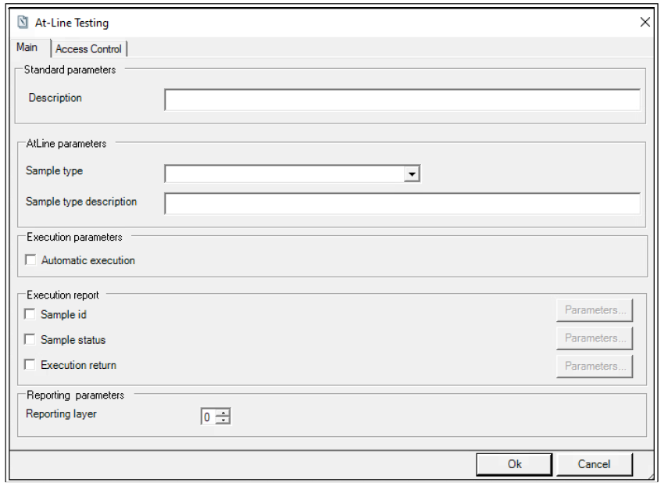

**At-Line Testing element configuration**

**How to set up this element:**

1. Select the **At-Line Testing** element from the **Start** menu and define it.

**Note**: An error is shown if Opcenter RD&L configuration file is missing, in which case you cannot define the

element. Please refer to the *Installation manual* of Opcenter Execution Pharma for information about the configuration file.

2. In the **Main** tab, provide a **Description** for the element.   
3. Select the **Sample Type**.

Only those Sample Types will be listed that are defined in Opcenter RD&L.

4. Provide additional information about the Sample Type in **Sample Type Description**.

5. Configure the **Execution Parameters** as:

**Automatic Execution** – Select this option for automatic execution of At-Line Testing task where the

Operator will not have to manually navigate to the task.

User needs to always select Automatic Execution. If unselected the Automatic Execution checkbox, task will be in To do status and will not be displayed in Operator Cockpit for execution.

6. Configure the **Execution Report** section. Select the optional check boxes as required:

**Sample id** – the identifier of the Sample will always be shown by default in the Details section in

PI Process and in Execution Report

**Sample status** – the status of the Sample after performing the test will always be shown by default in the Details section in PI Process and in Execution Report

**Execution return** – holds the value of task execution. To be able to see this value in the Details section in PI Process and in Execution Report, you are required to use the Operating Text element in your workflow.

0 – if the task executes successfully.   
 -1 – if the task goes in error.

7. Configure a numeric value for the **Reporting layer**, for generating the report accordingly.

Sp-EBRDesign-2511 127

*Creating a PI*

*Editing the Workflow*

8. In the **Access Control** tab, do the following: (This step is optional.)

enter the Work Center or select one by clicking **Work centers** or select a parameter by clicking

**Parameters**.

enter the Access right number or select one by clicking **Functionality list** or select a parameter by clicking **Parameters**. The **Function** name is displayed automatically when you select the Access right number.

**Note**: If you enter an incorrect Work Center or Access right number, a warning is shown that Work Center   
or Access right does not exist. Also, if you enter a Work Center that is more than 6 characters, a warning is shown.

9. Click **Ok**.

#### [8.2.4.18](http://8.2.4.18) The Cyclic Operation Element 8.2.4.18.1 Overview

The Cyclic Operation (CO) element enables you to configure periodic execution of a manufacturing step, to have its cyclic occurrence at runtime, such as at specific intervals or for specific number of units.

Various APIs belonging to the CO namespace are available for performing Cyclic Operations. For detailed information about the APIs, refer to ***Sp-APIs-List-i.pdf*** document.

**How to Setup this element**

The configuration screen of the CO element can be opened by double clicking on the CO element.

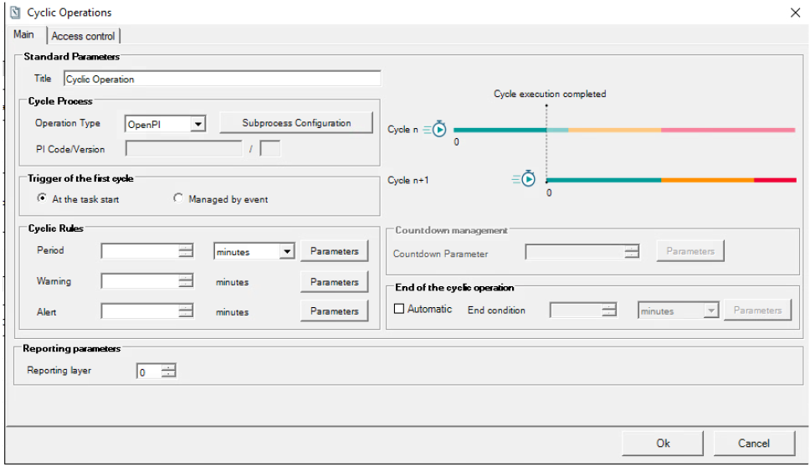

**Cyclic Operation element configuration window**

**Window description :**

**Main tab** (please, refer Main Tab section below)

128 Sp-EBRDesign-2511

*Creating a PI*

*Editing the Workflow*

**Access control tab** (please, refer Access Control Tab section below)

**Detail display in workflow:**

In the workflow, it is possible to see full details of the CO element configuration any time and at any status of the workflow. It is accessible by clicking on icon located in the top left corner of the element.

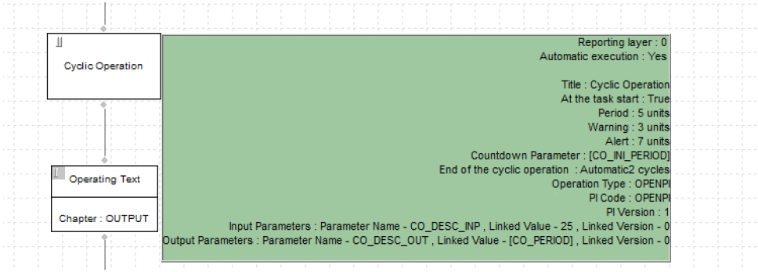

**Cyclic Operation details in Workflow**

##### 8.2.4.18.2 Main tab

The Main tab is divided into three sections: Standard, Execution and Reporting parameters.

Reporting parameters section follows the common rules (please, refer to Standard Configuration of the Elements)

**Main tab –Standard Parameters section**

**Title:** Title of the CO task that will be displayed to identify the CO in the CO supervision panel. Title should not

exceed 120 characters otherwise it is truncated at CO element configuration recording.

**NOTE**

As for all PI workflow elements, duplicate titles are allowed. The user should ensure unique naming of each CO task during the design of the CO element to distinguish between CO tasks in the supervision panel.

**Cycle Process:**

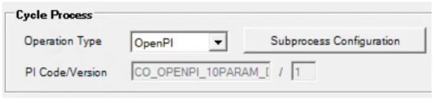

**Cyclic Operation element configuration window – Cycle Process** **Operation Type:** Only “Open PI” type is available.

Sp-EBRDesign-2511 129

*Creating a PI*

*Editing the Workflow*

**PI Code/Version:** filled, once the Open PI has been selected, with the selected PI code and its version. **“Subprocess Configuration”** button allows to reach the Open PI configuration screen. The selected PI will be triggered for each CO cycle.

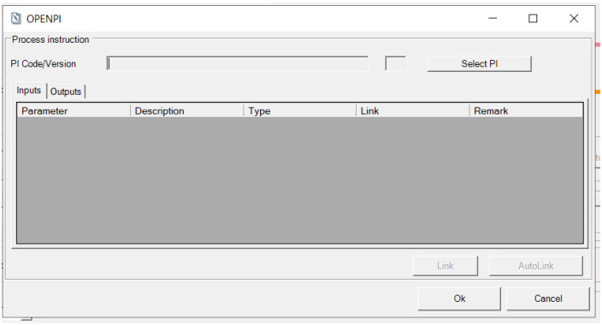

**Subprocess Configuration - OpenPI configuration**

**Open PI configuration - Window description**

**PI Code/Version:** filled, once the Open PI has been selected, with the selected PI code and its version.

**Remark: While typing the PI Code/Version, If using Oracle database following characters shall not be added in** **PI code/version “<” “>” “ ' ” “& “ , in case these characters are added, Launch of created Open PI will be unsuccessful**

**“Select PI” button:** allows to reach the PI selection dialog box, to choose the PI from the list of all available PIs (non-Obsolete). PI hierachy type is not considered here.

**NOTE:** If the Open PI is revised, the version must be adapted in the configuration of the CO Element. Thus, you must change the version of Open PI in the design configuration if the Open PI is revised. Also, if the Open PI is updated, you must adapt it again in the design configuration.

**Inputs and Outputs tabs:** The input and output parameters are automatically displayed after having selected the Open PI.

Input and output parameters can be defined for linked Open PI. They enable the user to exchange data between the calling PI and the linked PI.

**Input parameters** are used to initialize the values of some parameters that have been set for the linked PI. They   
can correspond to:

a constant value;

the value of a parameter that have been set for the calling PI.

PI input parameters will be initialized with the current values of the linked parameters at the moment the cycle PI starts.

**Output parameters** enable to retrieve, in the calling PI, values that come from the linked PI. The output   
parameters of the linked PI are always linked to the parameters of the calling PI.

130 Sp-EBRDesign-2511

*Creating a PI*

*Editing the Workflow*

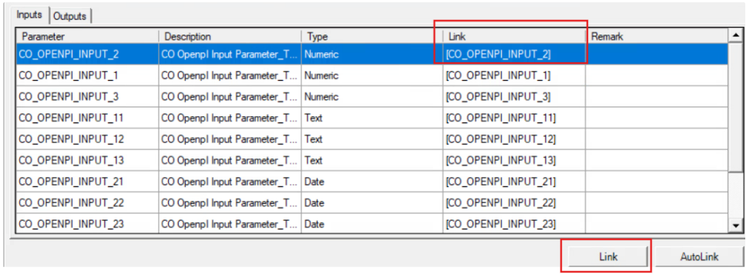

**Subprocess Configuration – Input/output tabs**

**Open PI configuration (input/output tabs) - Table description**

**Parameter:** parameter code;

***Description****:* description of the parameter;

**Type:** parameter type (i.e. text or numeric

***Link****:* parameter or fixed value;

***Remark****:* remark entered when inserting the link.

“**Link**” button allows to configure the link for the input/output parameters of the Open PI. This button is available if a row is selected in the table.

After clicking on the “Link” button, the “Value to use” dialog box is opened to configure the selected parameter (as a constant, or Parameter).

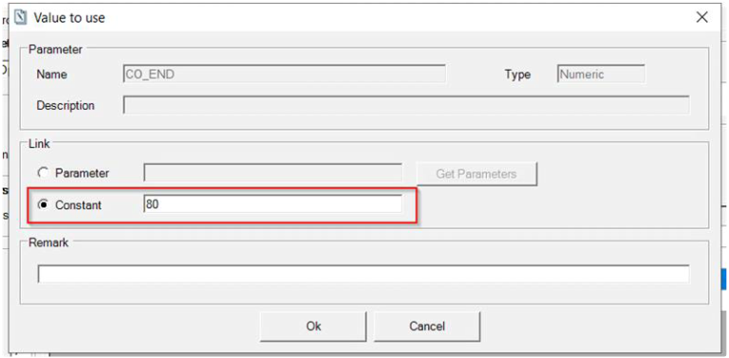

“**Value to use’ dialog box for *OpenPI parameter configuration***

Sp-EBRDesign-2511 131

*Creating a PI*

*Editing the Workflow*

**Important Remark**   
**For Input Parameter:**

 ‘Text’ and ‘numeric’ types can be bind with parameters or constant

‘Date and Time’ types can be bind only with parameters.

**For Output Parameter:**

In current version, constant value field is not disabled, but fixed value should not be used as link of output parameters, linking will only be done with the parameters of the calling PI

**“Auto-link”** button automatically links all the parameters in the current tab.   
For each parameter, it tries to find a matching parameter following the rules below:

If a parameter is already linked, its value is not modified by auto-link.

If no parameter is linked, Link = [Code] of parameter with PI parameter **code = input parameter** **code**, and the version is:

The last version of not obsolete PI parameter for parameter not already referred in the current PI.

The version used for parameters already referred in the current PI.

The auto-link functionality uses the standard script: **CO_DESIGN_AUTO-LINK_PARAMETER.**

**Trigger of the first cycle:**

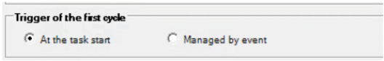

**Cyclic Operation element configuration window – Trigger of the first cycle**

**At the task start** – In this option countdown of the first cycle will be started when the CO task will switch to “In progress”

**Managed by event** – In this option initialization of cycle is done at the configuration of events. (it is possible to do it from the PI by calling a script - refer document ***How_to_Configure_Cyclic_Operation-*** ***i.pdf***). Until the cycle is initialized, the Operator can see that there will be a CO but cannot execute the first cycle.

**Cyclic Rules:**

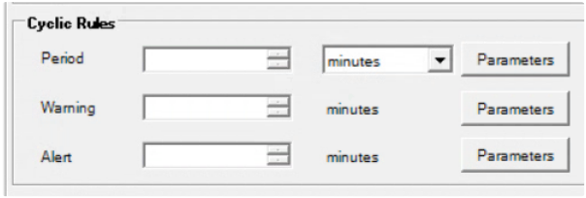

**Cyclic Operation element configuration window - Cyclic Rules**

The element provides a **Cyclic Rule** to configure the execution of cycles. The Cyclic Rule consists of the following configurations:

132 Sp-EBRDesign-2511

*Creating a PI*

*Editing the Workflow*

**Period** – an interval for executing the cycle (set point of the cyclic operation)

Possible units of measure: minutes, hours, days or units (To be selected if Cyclic operations to be managed by event)

Once selected for the period, it is common for period/warning/alert.

**Warning** – the starting point, in time or units after the start, to mark the current cyclic operation as “near

limit”. The operator will see the warning from supervision panel.

**Alert** – the starting point, in time or units after the start, to mark the current cyclic operation as “late”.

Cyclic Rule (Period, Warning, Alert) can be configured with numeric values or Parameter. **“Parameters” button:** Open the “Parameters” dialog box where only numeric parameters can be

selected (if the numeric parameter selected is configured with a unit, this unit is not taken into consideration)

**NOTE:** Parameter links will always display only the latest version of the parameters

**Note**

The numeric value for the Period, Warning and Alert should not be more than 9 digits.

If you configure numeric values the below rule will hold true otherwise it will show an error message, and ‘OK’ button will be disabled until the rules are correctly managed.

**Remark :** If you configure Parameter, you must select a value in such a way that it fulfills above rule.

**Period>Warning** AND **Alert>Period**   
**CO cycle visualization**:

According to cycle rule configuration, shows the actual configuration of the rule.

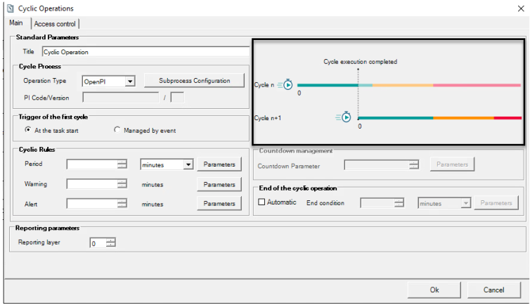

Sp-EBRDesign-2511 133

*Creating a PI*

*Editing the Workflow*

**CO Cycle visualization**

As seen in the above figure (CO cycle visualization):

Green color indicates the cycle execution is still as planned

Yellow color indicates the execution of cycle should be completed soon   
 Red color indicates the execution of cycle is late / delayed

Based on the cyclic rule configuration, the cycle execution takes place in 3 phases:

The cycle goes available from the start of the Period

The cycle is set to Warning when the Warning interval starts, and the cycle execution is not terminated   
 The cycle is set to Late state when the Alert moment is reached

The cycle is set to On Hold in which case there is possibility to call the script that initializes the next cycle during the current cycle. It allows the process to start the timer/countdown of the next cycle without waiting the end of the current one

**Example**:

**Cyclic Rule**

Period = 60 minutes

Warning = 55 minutes

Alert = 70 minutes

Period = 50 units  Warning = 45 units Alert = 60 units

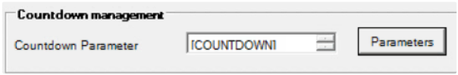**Countdown management**

**Execution**

the cycle must be executed at every 60 minutes. The cycle will be set to Warning at 55 minutes. And the cycle will be set as Late at 70 minutes.

the cycle must be executed at every 50th unit. The cycle will be set to Warning at the 45th unit. And the cycle will be set as Late after the 50th unit.

134

**Cyclic Operation element configuration window – Countdown management**

**Countdown Parameter**: display the configured parameter. Field enabled and mandatory only in case of Event based condition (i.e. when cyclic rules configured to use “units”).

**“Parameters” button:** Open the “Parameters” dialog box where only numeric parameters can be selected (if the numeric parameter selected is configured with a unit, this unit is not taken into consideration)

The selected parameter will be used by the system to get the current value of the number of units and to update the status of the cycle accordingly

Countdown value can be provided using a script (refer document ***How_to_Configure_Cyclic_Operation-i.pdf*** )

**End of cyclic operation**

 Sp-EBRDesign-2511

*Creating a PI*

*Editing the Workflow*

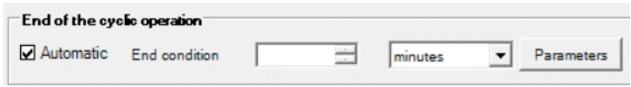

**Cyclic Operation element configuration window – End of the cyclic operation**

**Automatic** checkbox: should be enabled only in case of cyclic operation with planned number of cycles.

Unchecked: CO will continue until manually stopped by the user.

Checked: CO will continue until the defined conditions are met or until manually stopped by the user.

**End condition**: fixed value or parameter which specify the number of cycles for the end of the cyclic operation (numeric). In case of parameter, the end condition is set with the current value of the parameter when the CO task goes to “in progress” status.

Possible units of measure: minutes, hours, days or units

**“Parameters” button:** Open the “Parameters” dialog box where only numeric parameters can be

selected (if the numeric parameter selected is configured with a unit, this unit is not taken into consideration)

**Remark**: End condition rule shall be configured in such a way that End condition > Periodic rules always.

**Note**

The Numeric value for the end condition should not be more than 9 digits

**Configuration uses cases**

The following use cases are examples.

The trigger of the first cycle is not associated with the type of the periodicity. A periodicity can be Event-based with a trigger of first cycle set as At the task start.

**TIME BASED PERIODICITY with Automatic end**

Set trigger of first cycle as At the task start

Set the Period, Warning and Alert (minutes, hours, days or units)   
 Select the Automatic checkbox

Configure the options in END Of the Cyclic Operation section

**TIME BASED PERIODICITY with Manual end**   
 Set trigger of first cycle as At the task start

Set the Period, Warning and Alert (minutes, hours, days or units)

Leave the Automatic checkbox unselected, which means that Cyclic Operation will end manually as required

**EVENT BASED PERIODICITY with Automatic end**

Set trigger of first cycle as Managed by event

Set the Period, Warning and Alert (units only)

Select the Automatic checkbox

Configure the options in END Of the Cyclic Operation section

**EVENT BASED PERIODICITY with manual end**   
 Set trigger of first cycle as Managed by event

Set the Period, Warning and Alert (units only)

Sp-EBRDesign-2511 135

*Creating a PI*

*Editing the Workflow*

Leave the Automatic checkbox unselected, which means that Cyclic Operation will end manually as required   
**ON DEMAND CYCLIC OPERATION**

Leave the Cyclic Rules empty   
 Configure only the end condition

**Note:** In this scenario, there will be no transition of status, since the cyclic rules are not defined. Operator can work on this cyclic operation till time is required and all the operations will be manual.

##### 8.2.4.18.3 Access Control Tab

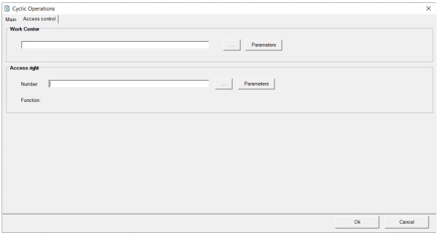

**Cyclic operations Access Control Tab**   
**Work center:** defined work center, it can be set by :

Constant, selected from the list of existing Work Center (using button “**...**”)   
 a text parameter (using button “**Parameters”)**

**Access right:** access right needed for execution of the task.

Constant, selected from the list of existing custom functions (using button “**...**”)

a text parameter (using button “**Parameters**”)

##### 8.2.4.18.4

Cyclic Operations Detail Documentation

The configuration of the CO element is displayed as per following in the Detailed Documentation:

136

Sp-EBRDesign-2511

*Creating a PI*

*Editing the Workflow*

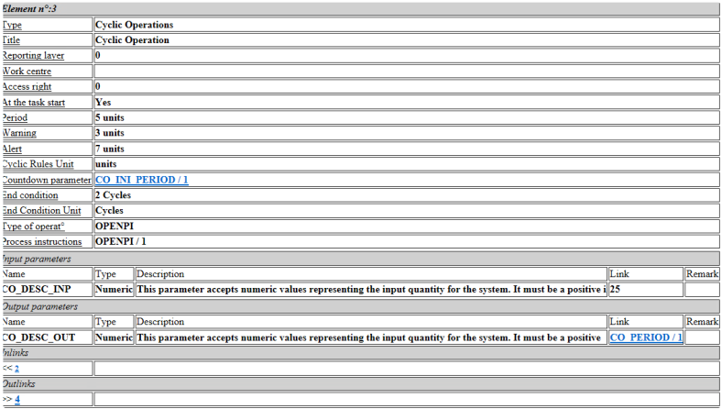

**Cycle operations Detail Documentation**

Remark: At the task start information = ‘yes’ if the element is configured to trigger the first cycle at the task start,   
‘no’ if the element is configured to trigger the first cycle by event.

##### 8.2.4.18.5 Cyclic Operation Pause Reason Management

The Cyclic Operation Pause Reason tab allows Addition, Modification or Deletion of Pause reasons, Once defined these reasons will be available through Operator Cockpit when Operator choose to Pause any Cyclic Operation task.

**How to access the Cyclic Operation Pause Reason management window**   
It is accessible through PI Management dropdown

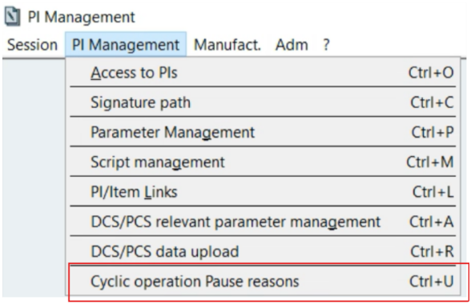

**Access the Cyclic Operation Pause Reason management window**

**Managing Cyclic Operation Pause Reasons**

Sp-EBRDesign-2511 137

*Creating a PI*

*Editing the Workflow*

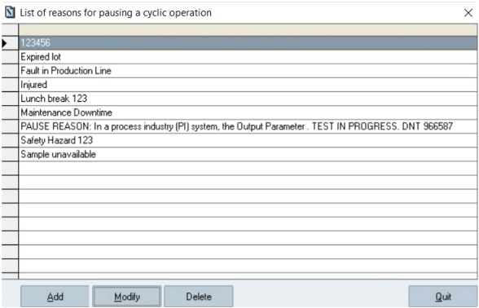

**Cyclic Operation Pause Reason management window**

Following actions can be performed on Cyclic Operation Pause Reason management window

**Add:**

Click on 'Add' button allows Addition of a new Pause reason

A new window popup 'Add Pause Reason' to add the new reason

Maximum length of Pause reason can be '100 Characters'

Once New Reason is added, select 'OK' to Save or 'Cancel' to cancel operation

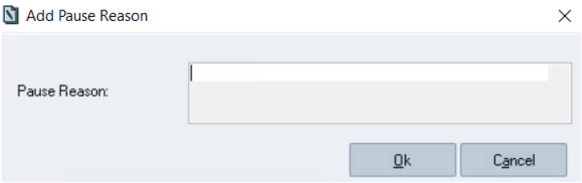

**Add Pause Reason Window**

**Modify:** Allows Modification of the existing Pause reason   
 Select any preexisting reason from the list to Modify

Click on 'Modify' button to open Modify the Pause reason popup window   
 Modify the reason and click on 'OK' to Save or 'Cancel' to cancel operation

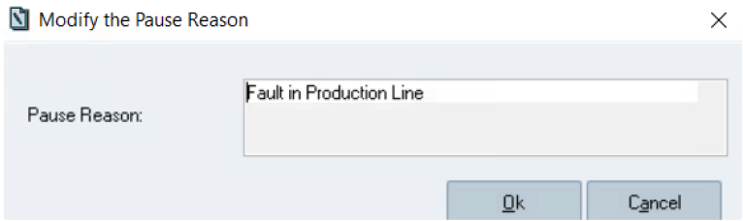

**Modify Pause Reason Window**

138

Sp-EBRDesign-2511

*Creating a PI*

*The PI Text Tab*

**Delete:** Allows Deletion of an existing Pause reason

Select any preexisting reason from the list to Delete

Click on 'Delete' button and confirm deletion

**Quit:** Close this window

#### [8.2.4.19](http://8.2.4.19)

Printing the Graph

The whole graph that sketches the workflow can be printed by clicking the *Print* icon that is included in the taskbar or by clicking the *Print* function from the *File* tab. The access right 1526 (PRINT PI EDITION) is required to perform that action.

#### [8.2.4.20](http://8.2.4.20) Print Preview of the Graph

A print review of that graph can be viewed by clicking the *Print* icon that is included in the taskbar or by clicking the *Print* function from the *File* tab. The access right 1526 (PRINT PI EDITION) is also required to perform that action.

## 8.3 The PI Text Tab

### 8.3.1 Writing the PI Text

Clicking the *Text* tab, allows displaying the word processor to write the PI Text, which includes a set of menus and toolbars that enable the user to format the text and to insert tags:

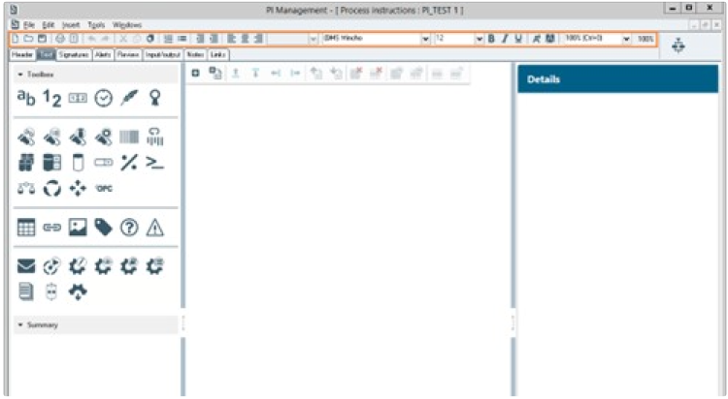

**The *PI Management text editor* window** The PI text can be entered directly or copied/pasted from other PIs.

Sp-EBRDesign-2511 139

*Creating a PI*

*The PI Text Tab*

**Important**

When using copy/past (or drag/drop) the html structure integrity of the source text should be guaranted by the designer. Therefore, it is **no more recommended** to copy or drag content from a PI text with instructions disabled or from any external source because of possible html structure inconsistencies or style "pollution".

If the html structure of the edited operating text becomes inconsistent it can lead to some html rendering or instructions identifications issues.

The content of a PI operating text created from scratch in 2205.0000.0000 has a correct html structure and can be copied/pasted.

To avoid rendering issue of the operating text, the screen resolution should be the same for all the PI designers and should reflect the expected screen resolution of the production environment. Some style or rendering adjustments could be done by customization.

The Copy/Paste functions are available from the *Edit* tab, from the contextual menu, or by using the usual keyboard shortcuts (i.e. CTRL+X; CTRL+C, CTRL+V, CTRL+A).

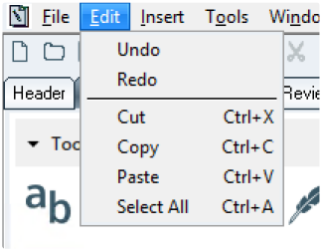

**Functions that can be accessed from the *Edit* tab**

#### [8.3.1.1](http://8.3.1.1)

Formatting the Text and Paragraphs

Here is the toolbar that is included in each edit window and that enable the user to format a text:



Each icon is defined as follows:

Commands (from the left to the right)

140

Sp-EBRDesign-2511

1.

2.

3.

4.

5.

*New PI:* create a new PI

*Open PI:* access the list of PIs

*Save PI:* record PIs

*Print PI:* print PIs

*Print Preview*

10.

11.

12.

13.

14.

*Creating a PI*

*The PI Text Tab*

*Paste:* paste the content of the buffer

*Numbering*

*Bullets*

*Left shift:* decrease indent

*Right shift:* increase indent

6. *Cancel:* cancel the last action (keyboard shortcuts: CTRL+ Z)

7. *Redo:* redo the action last cancelled (keyboard shortcuts: CTRL+Y)

15.

16.

17.

*Just. on the left:* align to the left

*Centre*

*Just. on the right:* align to the right

8.

9.

*Cut:* cut the selected zone

*Copy:* copy the selected zone

Text attributes:

Font, size, style (bold, underlined, italic), foreground and background colours (i.e. characters and background).

Rules applied for a PI supporting instructions identification:

Alignment and text attributes except the style (bold, underline, italic) can be applied only on the parent html

container following this hierarchy:

current cell of table

otherwise, current cell of section

otherwise, header of table

otherwise, current list (numbering or bullets)   
 otherwise, current paragraph.

Alignment and text attributes inserted via Copy/paste, section import, or html import and coming from previous versions are automatically removed by the system to avoid inconsistency.

Style (bold, underlined, italic) can be applied on the selected OT part.

That means, for example, that in a table, only one color, font and size can be applied to the whole content of a cell (and especially to all the instructions in this cell).

To highlight important information, use the bold, underline, italic styling.

*E.g. :*

*For PIs not supporting instructions identification* *the following formatting was* *- and is still - allowed:*

The sampling temperature **must be inferior to 25°C** to be valid.

*For PIs supporting instructions identification, the only* *possible formatting is:*

The sampling temperature **must be inferior to 25°C** to be valid.

OR

The sampling temperature **must be inferior to 25°C** to be valid.

Sp-EBRDesign-2511 141

*Creating a PI*

*The PI Text Tab*

#### [8.3.1.2](http://8.3.1.2) Contextual Menu when writing Text

When the cursor is placed in a text zone, right-clicking the selected area allows to display the following contextual menu:

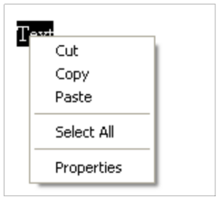

**The contextual menu**

#### [8.3.1.3](http://8.3.1.3) Finding something through the Text

The keyboard shortcut CTRL+F enables the user to search for information through the text.

To find it, the user can enter text (the *Highlight all matches* tick box is selected by default), enter a single word (by ticking the *Match whole word only* tick box), or take into account the differences between the upper and lower cases (by ticking the *Match case* tick box).

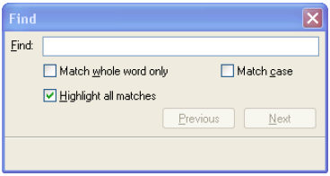

**The *Find* function**

#### [8.3.1.4](http://8.3.1.4) Document Background Attributes

There are two ways of customising the document background by changing its colour or by adding a picture.

142 Sp-EBRDesign-2511

*Creating a PI*

*The PI Text Tab*

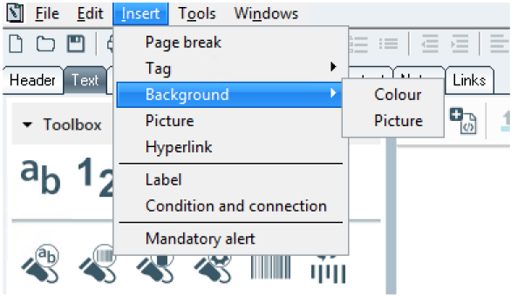

**How to change the background**

The background of the PI text can be a picture. The identified formats vary according to the host system. Fixed pictures can be brought to the front by clicking the *Background* and then the *Picture* functions from the *Insert* tab:

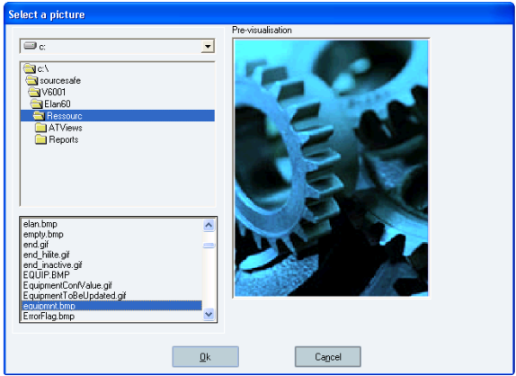

**How to add a picture to the background**

N.B.: Pictures that are inserted in the Operating Text can be displayed on all the workstations that use the

concerned PIs. But the pictures must be stored in a repository which can be accessed from the same access path for all the workstations (i.e. if any network mapping, it must be the same for all the workstations). It is also true when archiving and exporting.

#### [8.3.1.5](http://8.3.1.5)

Instructions

##### 8.3.1.5.1

Concept

PIs having instructions identification enabled are PIs:

Created with 'New' functionality in version 2205.0000.0000 or upper,

Sp-EBRDesign-2511

143

*Creating a PI*

*The PI Text Tab*

Created by copying or revising a PI already managing instructions,

Created by copying or revising a PI migrated to support instructions identification *(refer to* Copying PIs *and* Revising PIs*).*

For PIs supporting instructions identification, when the PI Text is saved, the text is splitted into instructions. An instruction is a sentence which explains what the operator should do.

Instructions must be identified to enable the translation of PI text *(refer to* PI Translation*).*

##### 8.3.1.5.2 Instructions identification

The instructions are identified when the PI Text is saved.   
Rules:

An instruction can contain text.

An instruction can be multi-lines but it can not contain carriage return (e.g. paragraphs).

An instruction can contain tags with deactivated (read-only) input mode but not tags with mandatory or optional input mode.

An instruction can be defined in a section cell, in a table cell, in an item list or in a paragraph.

An instruction can be a table header

An instruction can be the text of a hyperlink

The instruction is highlighted by a border when the mouse hovers it or when it is selected.

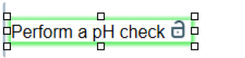

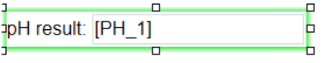

**Display of selected instructions**   
New PI Text entries are identified as instructions **when the PI Text is saved.**

After identification, instructions can be edited but the available actions are limited (e.g. addition of tag inside the instruction is not available, paste is not available inside an instruction).

##### 8.3.1.5.3 Instruction unlocking

To undo an instruction identification, the instruction can be unlocked, using the unlock icon on the right side of the instruction. Click on this icon turns the instruction into free text. When the PI is saved, new instruction will be identified.

The unlock icon is available for PI with created status when the mouse is over the instruction.

If the input mode of read-only tag, included in instruction, is modified to 'mandatory' or 'optional' the system turns the instruction into free text when the tag configuration is saved.

To avoid duplicated instructions, the system turns instructions into free text for:

copy of an existing instruction,   
 section import,

html import.

144 Sp-EBRDesign-2511

##### 8.3.1.5.4

*Creating a PI*

*The PI Text Tab*

Instruction formatting

Only the styles bold, italic, underline can be applied to a part of an instruction.   
Other attributes (font , size, color...) can only be applied to the whole instruction.

#### [8.3.1.6](http://8.3.1.6) Sections

##### 8.3.1.6.1 Section management

Section allows to organize the content of the document and to simplify the design of operating text.

Operating text can be added in a section cell or directly into to the document. So, section is not mandatory.

A new operating text does not have section by default.

The management of sections is fast and easy by using combination of shortcut and buttons from the following toolbar:



**Section management toolbar**

The toolbar is accessible from 2 locations:

Always displayed at on top of the designer screen.

Available after right click. The toolbar disappear after 6 second if unused or if the user use the cross icon (displayed when the cursor is on its position).

**Section toolbar description**

Each icon is defined as follows (from the left to the right):

*New section:* (keyboard shortcuts: ALT+ +) Add a new section at the focus. If the focus is in the section content, the section is inserted below.

*Import section:* (keyboard shortcuts: ALT+SHIFT+ +) Add a new section from a template after the focused section. *Insert above:* (keyboard shortcuts: ALT+ ↑) Add new line above the focused line of a section. The new line has the same style than the focused one. Enable if focused cell.

*Insert below*: (keyboard shortcuts: ALT+ ↓) Add new line below the focused line of a section. The new line has the same style than the focused one. Enable if focused cell.

*Insert left :* (keyboard shortcuts: ALT+ ←) Add new cell at the left of the focused cell of a section. The new cell has the same style than the focused one. Enable if focused cell and number of cells less or equal to 11

*Insert right :* (keyboard shortcuts: ALT+ →) Add new cell at the right of the focused cell of a section. The new cell has the same style than the focused one. Enable if focused cell and number of cells less or equal to 11

*Import above* : (keyboard shortcuts: ALT+SHIFT+ ↑) Add new lines from a template above the focused line of a section (seeExport/Import section). Enable if focused cell

*Import below* : (keyboard shortcuts: ALT+SHIFT+ ↓) Add new lines from a template below the focused line of a section (seeExport/Import section). Enable if focused cell

*Merge*: Merge selected cells *(*see Merge cells section). Enable if more than one cell is selected.

Sp-EBRDesign-2511 145

*Creating a PI*

*The PI Text Tab*

Note: the cells content is merge as follow:

Cell style is the one defined in the left cell.

Each text keeps its own style.

The content of the right cell is merged bellow the one of the left cell.

*Undo merge*: Undo the last merge on a selected cell *(*see Merge cells section). Enable if one merged cell is selected and number of cells under 12

Notes: the new empty cell is located at the right side.

*Delete section*: Delete the selected section. Enable if a section is selected (focus on cell)

*Delete Line*: Delete the selected line. If the line was the last one, the section is deleted. Enable if focused cell *Show/Hide section*: Show/Hide the selected section (seeVisibility section) Enable if a section is selected   
*Show/Hide line*: Show/Hide the selected line (seeVisibility section*).* Enable if focused cell

**Formating the Section**

Section width is the full width of the displayed Operating Text part (growth automatically with the OT part

width) and cannot be resized.

The height growth automatically according to the content of the section.

A section line is divided into cells (**min: 1, max: 12**)

The cell width is defined in design.

The style of the section is customizable by css file (the standard style css file is available in the ressourc folder and can be overwritten by css file in the customer ressourc file).

The cell background color is customizable directly in the designer:

When the cursor is positioned in a section cell, right-clicking the selected area allows displaying the following contextual menu**.** The contextual menu from section cell) :

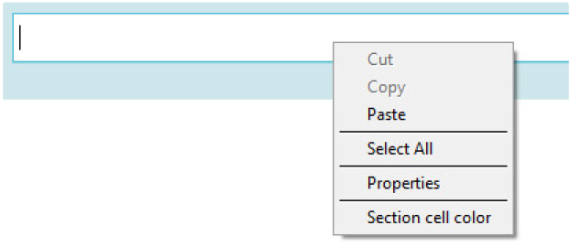

**The contextual menu from section cell**

The style for section Cell is managed by "*Section cell color*" menu: open the box of paints to select the background

color of the section cell

Notes :

The background section cell is applied on top of the operating text background.

The focus should be done on top/bottom of the cell because line background color could be configured too.

By default, the content of the section is displayed at execution/report time.

146 Sp-EBRDesign-2511

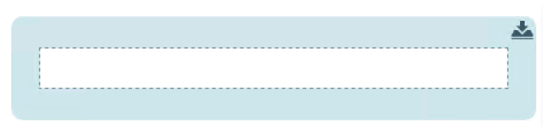

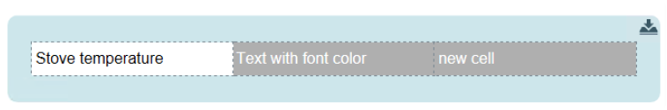

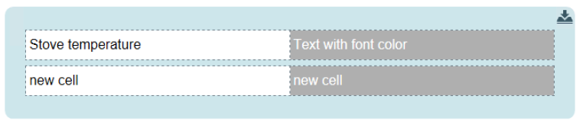

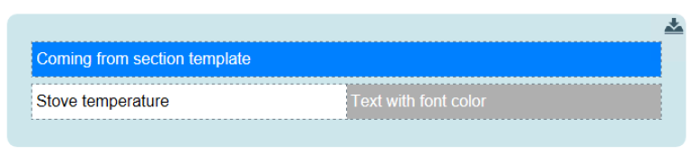

**Navigation**

Sp-EBRDesign-2511

*Creating a PI*

*The PI Text Tab*

**section display after creation**

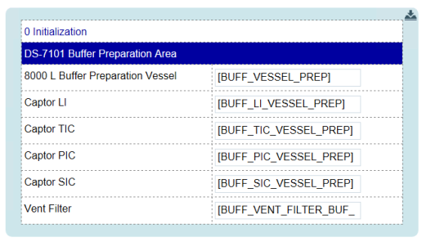

**Example of section**

**section with cell added at the right of the focused cell**

**section with cell added below the focused cell**

**section with cell added from template above the focused cell**

147

*Creating a PI*

*The PI Text Tab*

To increase the user experience, all cells are accessible using the tabulation key from the keyboard (left to right then top to down).

**New cell/line (without import)**

The style of the new cell/line is inherited from the focused cell:

Background color

Font of the first text (font, font size, bold, italic, underline, text color, background color)

The number of cells of the new line is equal to the one of the line of the focused cell.

The content of the new cell/line has no content and is selected (first on the left for the new line)   
The following picture represents all possible cases for cell creation:

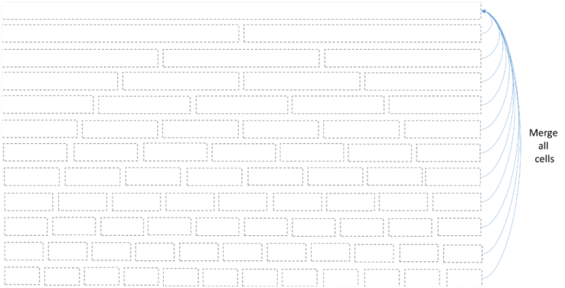

**Adding new cell**

In case of no merged cells, all cells have the same size. To be able to return to 1 cell, all cells of the line should be

merged. After merging, the behavior follows again the same rules.

**Conditions and labels**

At section level, the line spaces can contains several conditions and labels, please refer to Labels and Conditions*.* **Note : Limitations**

Text inside section could not be set as chapter (the functionality will be not available – disable field).

The lines are independent of other lines (for example: no merge between lines, no cell addition with multi-lines selection…).

A line cannot contain more than 12 cells.

A section cannot contain another section.

##### 8.3.1.6.2 Merge cells

The merging process allows to group the selected cells into one cell.   
Features :

Cells are selected by using CTRL + mouse click or SHIFT + click (as Windows)

The size of the new cell is the size of all selected cells

The content of the cells is merged. Content of the cells at the right side of the first cell is merged below the content of the first cell.

148 Sp-EBRDesign-2511

*Creating a PI*

*The PI Text Tab*

A button allows to undo the merge action. Only the last merge can be undone. The content of the cell is kept into the cell at the left side.

To understand how the merging process and addition of columns work together, the following schema, which is the representation of lines according to the number of cells, has to be kept in mind (see figure: Adding new cell).

To explain the behavior of merged cells, the example of the merge of 2 cells (last ones at the right) on a line composed of 6 cells is took:



**rendering of line with 6 cells**

In this example, at the end of merging action, the last cell takes the space of the two previous cells and all other

cells are not impacted.



**rendering of line with 5 cells and 1 merged cell** Consider the merged cell as a cell composed of 2 cells, so, if a new cell in the line is added:

The width of non-merged cells will be the same as the one of a line of 7 cells.   
 The width of the merged cell will be the width of 2 cells.



**rendering of line with 7 cells**



**rendering of line with 6 cells and 1 merged cell** The following pictures show more examples of merged cells.

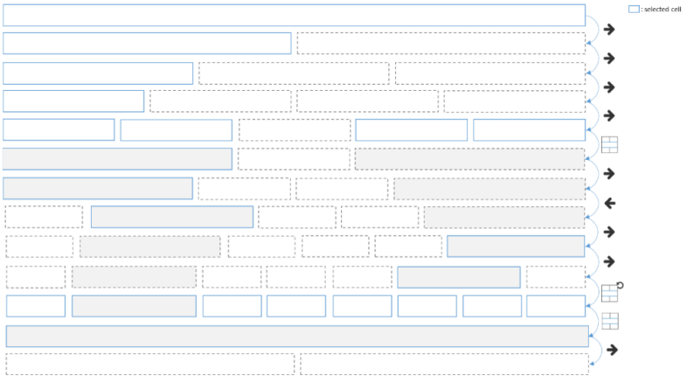

**example of merging actions and cell addition actions**

Sp-EBRDesign-2511 149

*Creating a PI*

*The PI Text Tab*

##### If the result of the merge is a line with one cell, the undo merge is not available because it is considered as a reset. 8.3.1.6.3 Visibility

To increase the reading of the operator and to keep only relevant instructions, a section, section line or tag can be configured as "hidden" for execution, detail and batch record.

In this case the section, section line or tags included in a section will be executed but transparent in the executed task and in the reports (detail and Electronic Batch Record).

**Note**: The **hidden tags used outside a section** keep the behavior described in Inserting Tags > *Tag Configuration*. **Visibility configuration rules :**

Section visibility :

Configuring a section as "hidden" means that all the section content becomes invisible.

Configuring a section as "displayed" means that all section lines become "displayed". The visibility configuration of tags is not impacted so, a tag configured as "hidden" keep its configuration.

Section line visibility :

Configuring a section line as "hidden" means that all content of this lines become invisible.

Configuring a section line as "displayed" does not impact the visibility configuration of tags so, a tag configured as "hidden" keep its configuration.

Tag visibility :

Configuring a tag as "hidden" or "displayed" impact only the tag itself. Configured a tag as visible is

always enable even if the section or the line is already invisible. In this case, the configuration at tag level is not taken into account.

The invisible sections/lines and hidden tag in section have a specific rendering ( in following examples). This rendering can be customized (please refer to ***How_to_EBR_OperatingText_Customization-i.pdf*** technical document).

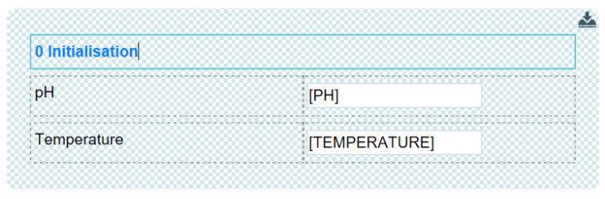

**Section configured as hidden in Operating text designer**

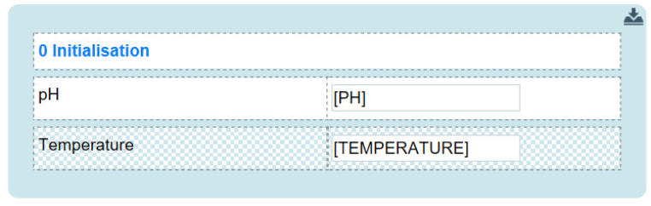

Section **line** configured as hidden in Operating text designer

150 Sp-EBRDesign-2511

##### 8.3.1.6.4

*Creating a PI*

*The PI Text Tab*

Section execution mode

The execution mode inside section is horizontal. Tags are ordered row by row, from the left to the right, as it is in horizontal and left-to-right writing systems (e.g. as in English or French)

##### 8.3.1.6.5 Export/Import section [8.3.1.6.5.1](http://8.3.1.6.5.1) Export

In order to reuse part of instructions, sections are exportable as template (using of *Export section* button available



from section itself: ).

A popup allows to select the destination folder and to input the name of the template. By default, the selected folder is the "OTTemplates" folder (located in the customer folder). Filter is applied to display only html/htm files.

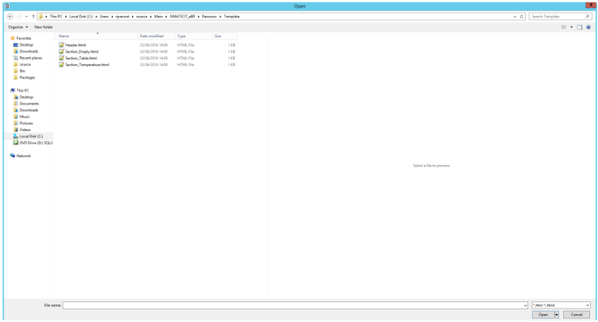

**Popup raised to select the location of section to export**

###### [8.3.1.6.5.2](http://8.3.1.6.5.2) Import

There are two ways to import a template which depends on the expected rendering:

*Import section*: The selected template is imported as a **new section below the selected section or at the focus**

if the focus is not in a cell of a section.

Source section configuration :   
 Visibility configuration is kept

Style is kept

*Import above* or *Import below*: the content of the section coming from the template is added as **new lines in the** **selected section**.

Source section configuration :

Sp-EBRDesign-2511 151

*Creating a PI*

*The PI Text Tab*

Visibility configuration is kept for the resulting lines in the related section if the destination section is visible. If imported section is invisible and destination section is visible, imported lines become invisible in destination section.

Style is kept

When the button is clicked, a popup is raised to select the template to import. By default, the selected folder is the "OTTemplates" folder (located in the customer folder). Filter is applied to display only html/htm files.

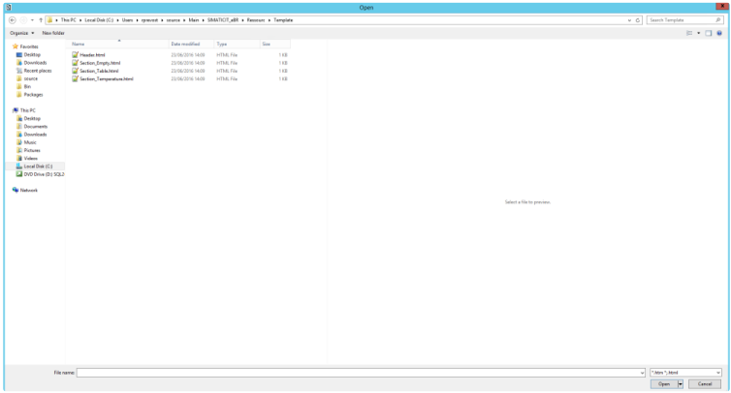

**Popup raised to select the location of section to import**

#### [8.3.1.7](http://8.3.1.7)

Tables

Text, tags, and pictures can be created from tables.

152

Sp-EBRDesign-2511

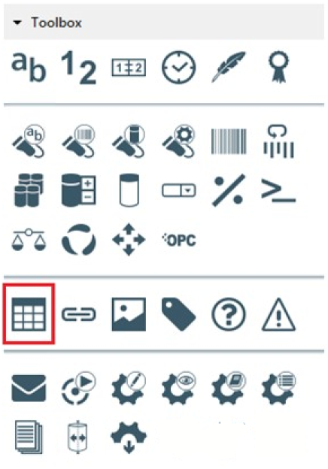

**How to access the *Table* function**

Clicking the *Insert table* icon allows displaying the *Insert a table* window

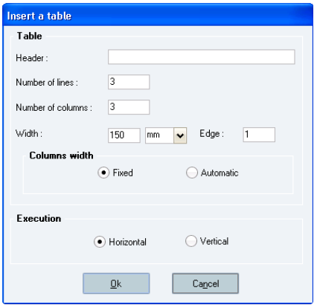

**The *Insert a table* window**

**Window description :**

***Header:*** table caption, which will be displayed as the first line of the table. That field is optional.

Sp-EBRDesign-2511

*Creating a PI*

*The PI Text Tab*

153

*Creating a PI*

*The PI Text Tab*

***Number of lines:*** number of lines in the table (mandatory field). That number equals to the initial number of lines. The writer will later be able to insert and delete lines (see the *Contextual Menu in Tables* part below).   
 ***Number of columns:*** number of columns in the table (mandatory field). That number equals to the initial number of columns. The writer will later be able to insert and delete columns (see the *Contextual Menu in Tables* part below).

***Width:*** enables the user to define the table width (e.g. 100% indicates that the table will take up the whole page width; 50% indicates that the table will take up half of the page).

***Column width:*** enables the user to choose between a fixed or an automatic column size.

During edition :

If the table is initialised to a fixed column width, the column width is not modified according to the column

content.

If the table is initialised to an automatic column width, the columns are automatically re-sized according to their content.

***Edge*** (next to the *Width* field)***:*** allows defining the size of the table edge. The higher that number, the higher is the table edge.

***Execution:*** allows defining the direction for the text in the cells to define in which order the tags will be executed. Two options are available:

Horizontal direction (default option): tags are ordered row by row, from the left to the right, as it is in horizontal and left-to-right writing systems (e.g. as in English or French):

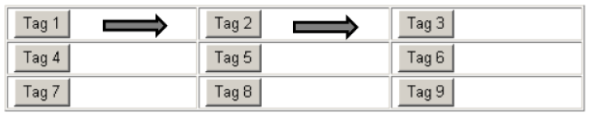

**Table with horizontal direction**

Vertical direction: tags are ordered column by column, from the top to the bottom, as it is in vertical and

top-to-bottom writing systems (e.g. as in Chinese). If a cell includes multiple tags, they will be displayed from the left to the right and from the top to the bottom:

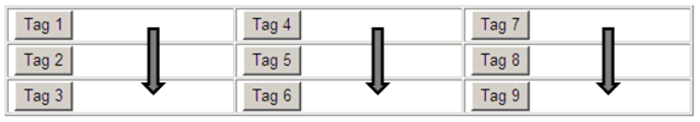

**Table with vertical direction**

Specific case : Merged cells :

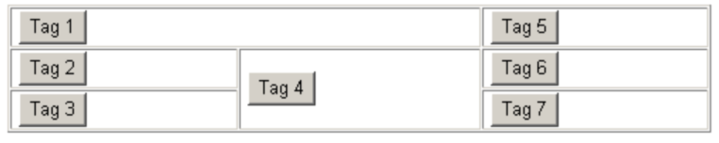

**Vertical execution for tables with merged cells**

**Contextual Menu in Tables:**

The following contextual menu is displayed when right-clicking the table:

154 Sp-EBRDesign-2511

*Creating a PI*

*The PI Text Tab*

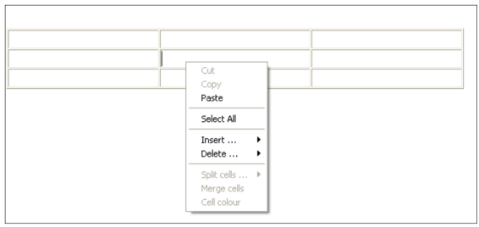

**The contextual menu available from a table**

In addition to the common edit functions (see Formatting the Text and Paragraphs section), that contextual menu enables the user to modify a table after it has been created. It enables to add or delete lines and columns, but also to merge adjacent cells or to split one cell into multiple cells).

All these actions do not require selecting a cell before right-clicking it: the user only has to position the pointer anywhere in the table to right-click the required cell.

On the other hand :

To make the *Split cells* and the *Cell colour* functions available from the contextual menu, the user will

have to double click the required cell:

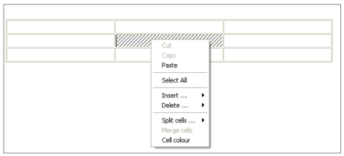

**The *Split cells* and *Cell colour* functions, when available**

To make the three last functions from the contextual menu available (i.e. the *Split cells*, the *Merge cells*,

and the *Cell colour* functions), the user will have to double click two cells at least:

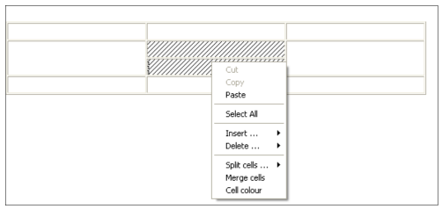

**The Split cells, *Merge cells*, and Cell colour functions**

Sp-EBRDesign-2511 155

*Creating a PI*

*The PI Text Tab*

#### [8.3.1.8](http://8.3.1.8) Hierarchic Organisation in PI Sub-parts

**Defining Headings (titles) :**

Inserting a title into the PI text enables the user to create an entry for the table of contents, by selecting the required row and heading levels – from the most to the least important – from the corresponding drop-down list:

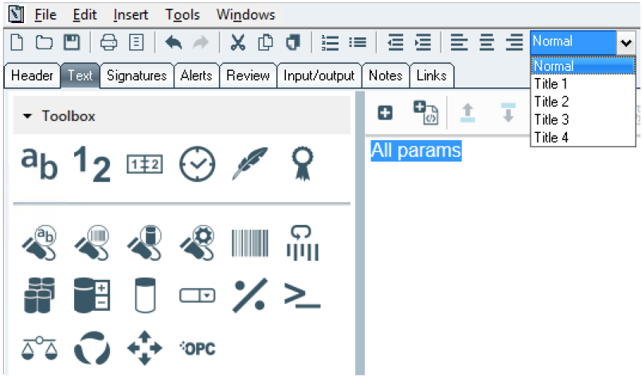

**The drop-down list to select heading levels** Headings can only be created for rows with text, with no title, number, tag, etc. Headings cannot be created inside section.

However, the user can modify the "titled" row once created.

The selected text is then framed to indicate that it is a title:

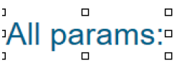

Its contents can be modified by double-clicking the frame. The following window will therefore be displayed:

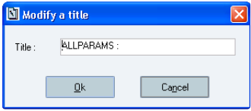

**The *Modify a title* window**

The *Navigation panel* displays the table of content for the corresponding PI, which is generated from the headings

that have been defined from the PI text (empty if no heading defined):

156 Sp-EBRDesign-2511

*Creating a PI*

*The PI Text Tab*

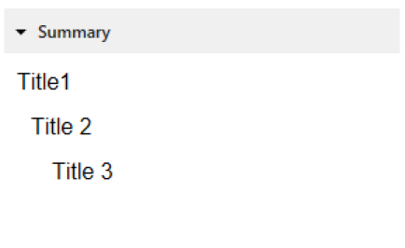

**Navigation panel from PI management**

The table of content cannot be displayed if the tree structure is not coherent, for one of the following reasons:

The heading levels are not coherent (e.g. a level 4 title cannot directly follow a level 2 title).

There are titles that are set with a higher level than the one that has been defined for the first title.   
 A click on a chapter make scroll the operating text to put the focus on the related chapter.

A click on the header minimize/maximize the navigation panel.

#### [8.3.1.9](http://8.3.1.9) Page Breaks

Page breaks can be inserted into the PI text by positioning the cursor on the desired line and by selecting the *Page* *break* function from the *Insert* tab:

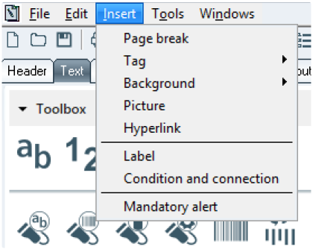

**How to access the Page breaks function**

A new line is then inserted into the PI text. That line is only visible when writing the PI, and will trigger a page break

when printing the PI.

#### [8.3.1.10](http://8.3.1.10)

Zoom

The user can zoom in or zoom out in operating text. Several ways to do it:

By selecting zoom level in a dropdown list:

Zoom in: zoom in of 10%. Zoom in max is 1000%.

Zoom out: zoom out of 10%. Zoom out max is 10%.

Sp-EBRDesign-2511

157

*Creating a PI*

*The PI Text Tab*

200%   
 175%   
 150%   
 125%   
 100%   
 50%

By a CTRL + mouse wheel (by 5%)

By using shortcut: CTRL + + (zoom in 25%) or CTRL + - (zoom out 25%) or CTRL + 0 (zoom reset to 100%)

Current zoom level is displayed in the toolbar next to the dropdown list:

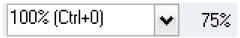

#### [8.3.1.11](http://8.3.1.11) Style

##### 8.3.1.11.1 New style definition

A new style is provided by default for the Operating Text.

The new style is applied as a theme, which means that element colors are linked to variables that contains the correct color values.

Styles are not limited to text only, they will also define the look-and-feel of buttons, inputs, tables and any other elements in the screen or paper.

This new style can be customized (please refer to ***How_to_EBR_OperatingText_Customization-i.pdf*** technical document).

The default/customized style can be overwritten by applying attributes available in the toolbar (please refer to Formatting the Text and Paragraphs section) for free text, chapters, link tag and hyperlink.

Operating text items are formatted as defined below:

**Free text**

Operating Text Style is Arial 12, regular, black

**Instruction**

Based on free text formatting.

**State**

**Identified, on mouse-hover**

**Identified, selected**

**Titles Style**

158

**Example**

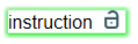

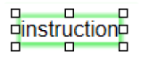

 Sp-EBRDesign-2511

**Type of Title**

Title 1

Title 2

Title 3

Title 4

**Buttons Style**

**State**

**Enabled**

**Enabled, on mouse-hover**

**Disabled**

**Inputs tags Style**

**State**

**Enabled**

**Enabled and selected**

Sp-EBRDesign-2511

*Creating a PI*

*The PI Text Tab*

**Example**



**Title 2**

Title 3

Title 4

**Example**





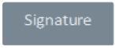

**Example**

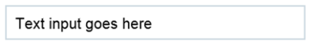

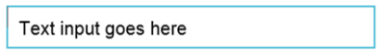

159

*Creating a PI*

*The PI Text Tab*

**State**

**Disabled**

**Tables Style**

Example :

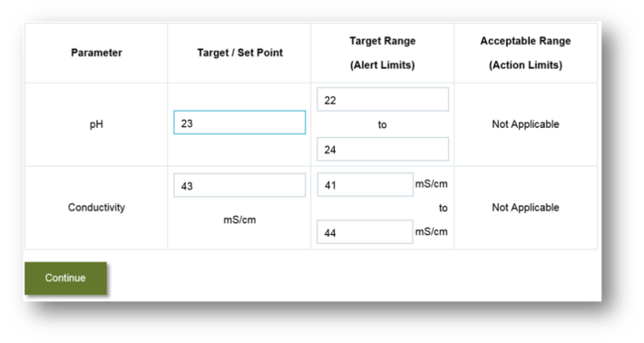

**Label/Condition Style**

**Type**

**Label**

**Condition**

**Example**

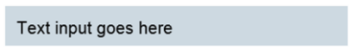

**Example**

**Note:** Style of label and condition is no more editable

**Link tag Style**

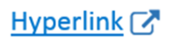

160

Sp-EBRDesign-2511

##### 8.3.1.11.2

*Creating a PI*

*The PI Text Tab*

Old style/New style

The following rules are applied to Pis:

A PI designed before the migration to Opcenter Execution Pharma [6.1.2.0](http://6.1.2.0) will be display with the old style

applied.

On new PI (by using "new" button), the new style is applied.

A copy or revision of PI generate a PI with the same style than the copied/revised PI.

**Note**: The old style is new stylesheets to be similar as the style of the previous version. In PI Management, a new menu allows to switch the style of Operating Text:

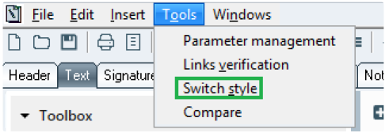

**The *Switch style* function**

The style is saved at PI saving.

Once the PI signed, in design the style can be switched but in execution the applied style is these one recorded when the PI has been signed.

### 8.3.2

The Detail panel

The Detail panel of the PI Text Tab allow visualization of the selected tag properties and context datas:

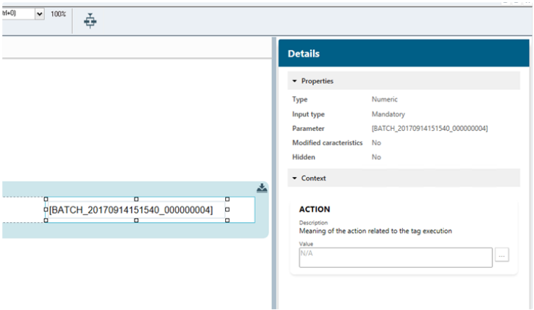

If the PI is editable and user has the Access right 1902, Value and Description of context datas can be edited from the Details panel.

‘…’ button allows selecting an existing parameter as value of the selected context data.

Sp-EBRDesign-2511

161

*Creating a PI*

*The PI Text Tab*

If the value starts by ‘[’ and finished by ‘]’, it will be interpreted as a parameter link.   
**Note:** for ACTION context data, only the value is editable.

### 8.3.3 Inserting Tags

#### [8.3.3.1](http://8.3.3.1) Introduction

To make the system interactive, a toolbox enables the user to insert input zones called **tags** into the PI text.

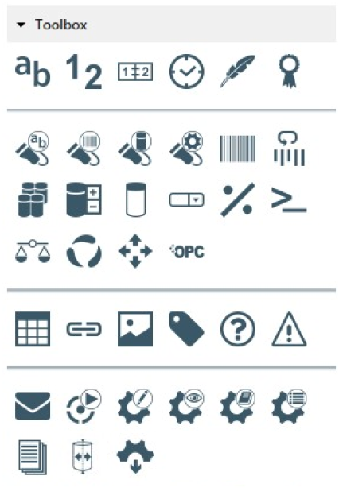

**The *toolbox***

These icons – which allow inserting tags – are, from left to right: Text, Numeric, Date, Time, Signature, Electronic

Signature, Identification, (Label, Barcode, Container, & Equipment), Labelling, Re-labelling, Manufacturing Declaration, Declaration Adjustment, Stock Adjustment, List, Efficiency application, Script, Weighing, Combination, Move, EPE, Table, Link, Picture, Label, Condition, Alert, eMail, WO launch, Equipment property (modification, read, display, list), Report, Splitting, Batch parameter update.

These tags can be inserted by clicking these corresponding icons from the toolbox or from the *Tag* function from the *Insert* tab:

162 Sp-EBRDesign-2511

#### [8.3.3.2](http://8.3.3.2)

*Creating a PI*

*The PI Text Tab*

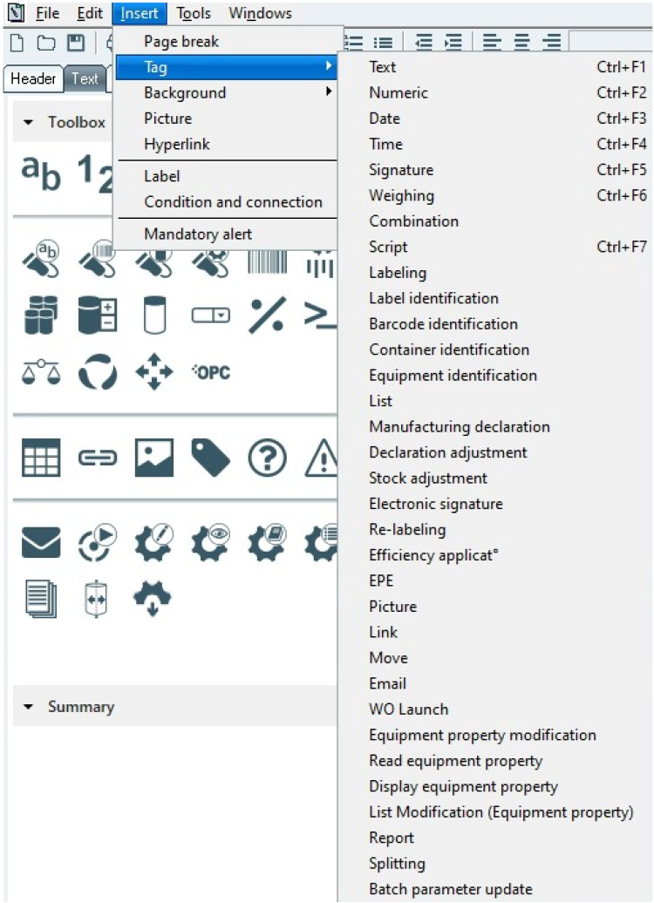

**Accessing the tag functions from the *Insert* tab**

Tag Configuration

The windows that are opened once the user has clicked one of these icons practically display the same fields:

**The *Input* part:**

Enables the user to define the type of the tag, which is either:

Sp-EBRDesign-2511

163

*Creating a PI*

*The PI Text Tab*

***Mandatory:*** if the tag is left blank, it cannot be validated;

***Optional:*** the tag can be validated, no matter if it is left blank or not;   
 ***Deactivated:*** no data can be entered; the value is displayed in Read-only mode.

**The *Parameter* part:**

Enables the user to modify, **only for this tag**, some characteristics of its associated parameter by using:

The defined configuration;   
 A new configuration.

**The *Visibility* part and the *Hidden* check box*:*** *if the tag is used:*

**outside a section:** allows determining whether a tag will be inserted in the batch record. The tag is always

visible while drafting the PI and while executing it. If the Hidden check box is ticked, the tag will be hidden in the batch record.

**in a section:** allows determining whether a tag will be displayed at execution and in reports. Please refer to Writing the PI Text > Sections > Visibility.

#### [8.3.3.3](http://8.3.3.3) Context Data Management

Context data is additional information that gives a context to manufacturing data while the Operating Text is executed. Context data can be linked to the following tags :

Numeric

Text

Date

Time

Signature

Electronic signature

The windows that correspond to these tags display a *Context* tab in which context data can be added, modified, and deleted. These actions require the access right 1902 (CONTEXT DATA MANAGEMENT).

164 Sp-EBRDesign-2511

*Creating a PI*

*The PI Text Tab*

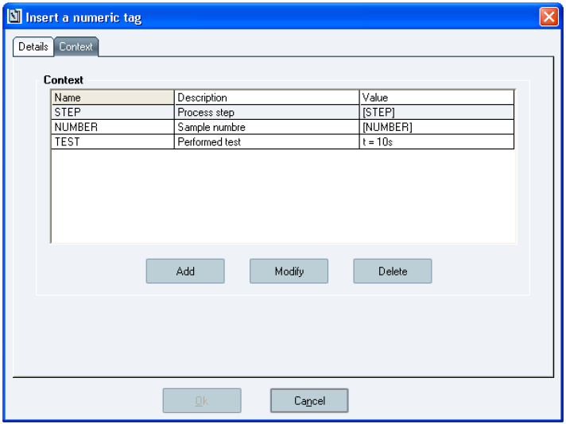

**The *Insert a numeric tag* window**

Each context data has a name, a description, and a value.

**Window description :**

***Name:*** Mandatory field (type: 50-character alphanumeric field). A name can only be used once per tag. The name can be manually entered or selected from the list of context data that are already used in the PI. ***Description:*** Optional field (type: 100-character alphanumeric field).

***Value:*** Mandatory field. The value of context data can be:

Fixed alphanumeric value (type: 4000-character alphanumeric field).

Value of the parameter: a non-obsolete date, time, numeric, or text parameter can be selected. It is important to point out that using a parameter in a context data does not create a PI link. The parameter must be used elsewhere in the PI so that it can follow versioning rules and so that the export/import of the PI work properly.

The name of a context data cannot be modified.   
 ***Add/Delete:*** allows adding/deleting a value to use.

***Modify:*** allows the user to modify the description and value of a context data.

NB: These 3 buttons are enabled if the metadata module is activated with the licence key

#### [8.3.3.4](http://8.3.3.4)

ACTION Context Data

All tags except for label, condition and picture tags and also for chapter, have an ACTION Context Data added dynamically at design.

Description of ACTION Context Data is: "Meaning of the action related to the tag execution".

Default value of ACTION Context Data is: "N/A".

Only tags having a "Context" tabulation in its design form can change the value of the ACTION Context Data. The description can't be changed.

Sp-EBRDesign-2511

165

*Creating a PI*

*The PI Text Tab*

**Note**

This context data **can't** be deleted.

### 8.3.4 The Alert Tag

An alert tag allows inserting an alert requested by the writer when monitoring the manufacturing process. There are two types of alerts: remark or deviation. A validation path specific to each type can be defined from the PI. The alert context is recorded in the batch record (activation context, date, time, operator, input comment, etc.)

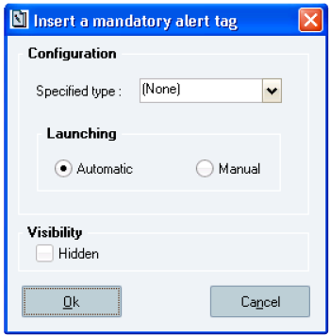

**The *Insert a mandatory alert tag* window**

**Window description:**

**The Configuration section:**

***Specified type:*** type of alert

*(None):* the type is chosen by the user when executing the tag.

*Remark*   
 *Deviation*

If imposed, the type cannot be modified by the user when the tag is executed.

From the PI text, alert tags are displayed as pictures of different colours depending on the expected type of alert:

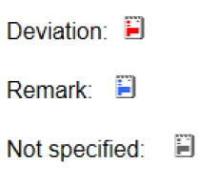

**How to display the different types of *a*lert tags**

### 8.3.5 The Batch parameter update Tag

The batch parameter update tag is composed of a command button that updates batch parameters according to its configuration. The tag updates the set point values in Batch system.

Note: this functionality requires that the data from Batch system has been correctly uploaded. Please refer to *Batch_process_and_configuration* technical documentation for more details.

166 Sp-EBRDesign-2511

#### [8.3.5.1](http://8.3.5.1)

*Creating a PI*

*The PI Text Tab*

Batch Parameters configuration window

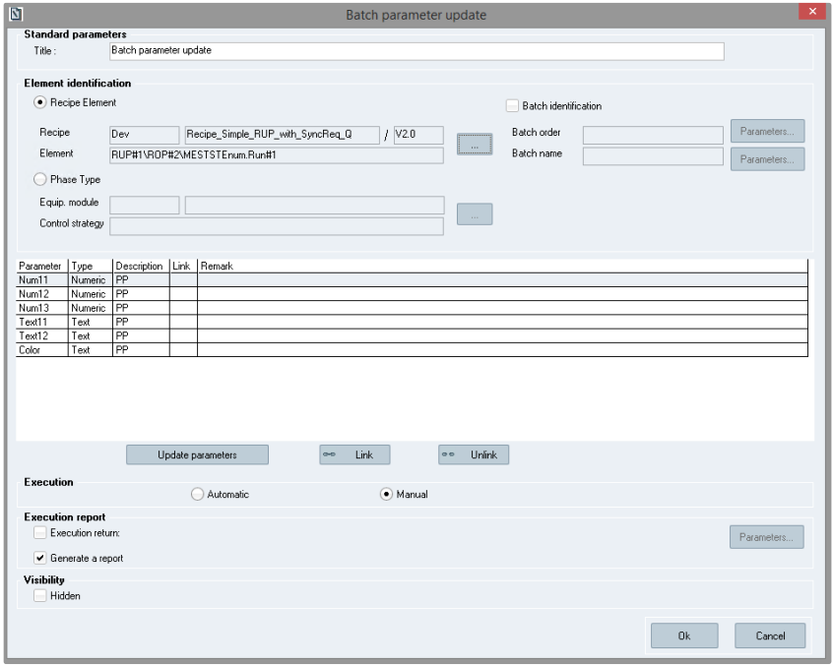

**Batch parameter update tag configuration window**

**Window description**   
 **Standard parameters**

**Title:** caption of the button at tag execution. Free text, limited to 60 characters. Initialized with the text: "Batch parameter update". Mandatory.

**Element identification** *(please refer to* Element identification *section)*

**Parameters grid** *(please refer to* Parameters grid section*)*

**Execution:** Defines the tag execution mode: automatic or manual. Manual execution is set by default.   
 **Execution report** *(please refer to* Execution report*)*

**Visibility**: The checkbox is unchecked by default

**Actions**

**Ok**: Checks that the mandatory fields are correctly filled, if it is not the case error message is displayed. Then

creates (or modifies) the tag, closes the window and displays the command button on Operating Text.

Fields that should not be empty:

Title

Recipe or Phase Type configuration

If Batch Info checkbox checked: Batch order and Batch name parameters   
 If execution return checkbox checked: execution return parameter.

Sp-EBRDesign-2511 167

*Creating a PI*

*The PI Text Tab*

*At least one parameter should be linked to a fixed value or to a PI parameter otherwise an error message is displayed:* *"There are no parameters configured".*



**Cancel** or : Closes the window.

#### [8.3.5.2](http://8.3.5.2) Element identification section

There are two configuration choices:

Recipe element configuration (default except in Event PI at tag creation)

Phase type configuration (default only in Event PI at tag creation)

It is mandatory to configure the recipe element or the phase type.

**1) Recipe Element configuration case**

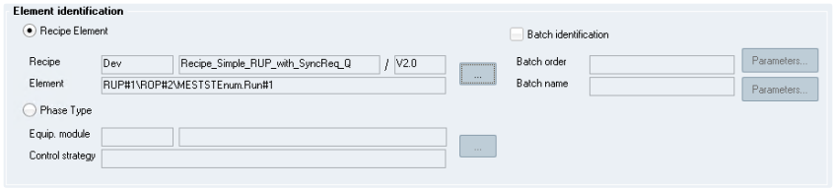

**Recipe Element configuration**   
When recipe element radio button is selected:

Phase type fields are emptied and related fields and buttons are disabled.

Recipe Element fields and buttons are enabled. Batch identification checkbox is unchecked by default. All fields are initialized with empty values.

**Recipe Element (mandatory)**

**Recipe \ Element**: These fields are disabled and can only be filled through "…" button.

Master recipe (PCell, Recipe Name and Recipe version) and element information should be provided. It is possible to select a Master recipe without element (to update its header parameters).

If the selected element is a phase, it is displayed as follow: *path\equipment module.control* *strategy#TermId*.   
If the selected element is a RUP or a ROP, it is displayed as: RUPName#ContId or RUPName#ContId\ROPName#ContId.

**'…'**: This button displays a selection window where the batch master recipe and the element can be selected.

168 Sp-EBRDesign-2511

*Creating a PI*

*The PI Text Tab*

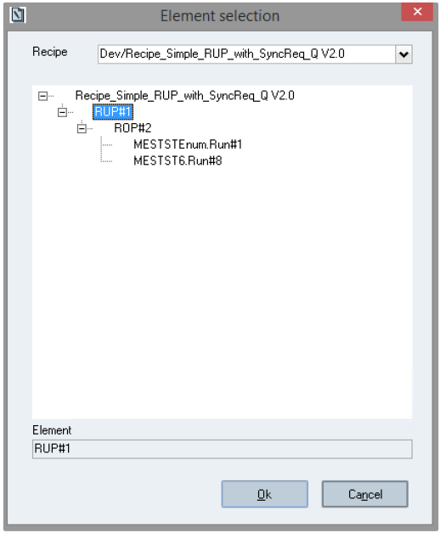

**Element selection window**

Window description

**Recipe**: Dropdown list with all known master recipes. The name of the master recipe is defined as follow: PCell / Master Recipe Name Master Recipe Version. The recipes are ordered by PCell, Recipe name and Recipe Version. **Tree view**: structure of the selected Master recipe. Recipe Name/version, RUP, ROP and Phase are displayed. The Phase is displayed as follow: equipment module.control strategy#termId. the RUP and ROP are displayed as follow: RUP or ROP name#ContId. By default, the tree-view is expanded.

**Element**: This field is automatically filled by the tree view selection. This field is disabled.

Behavior

The window is initialized with tag configuration information. If there is no defined configuration, the fields are

blank and no tree view is displayed.

The user should first select a master recipe in the drop-down list. Then its structure is loaded in the tree view part.

The user can then select a recipe or an element from the tree view. An element selection automatically fills the element field. This selection is optional.

If the master recipe is changed in the drop down, the element field is emptied and the tree-view is reloaded with the current master recipe structure.

If the element selection is changed in the tree-view by the recipe, the element field is emptied.

Actions

**Ok**: Closes the window and updates the tag configuration window.

Sp-EBRDesign-2511 169

*Creating a PI*

*The PI Text Tab*



**Cancel** or

: Closes the window.

Once the master recipe and the element are configured, the parameters grid is populated with its DCS/PCS relevant parameters.

If no DCS/PCS parameters are configured in this element, the grid remains empty.

If the chosen element is the Master recipe and no DCS/PCS relevant parameters have been configured, all header parameters are considered as relevant and displayed in the grid.

**Batch identification configuration part (optional)**   
 Batch identification information can be provided.

When the checkbox is checked, both -"Parameters" buttons are enabled. The parameter codes fields are not editable, they cannot be filled manually, the parameter selection window should be used.

When the button is unchecked, the parameter codes are erased and buttons are disabled.

Click on "Parameters" opens the parameters selection window where a parameter can be selected. Only text parameters are displayed. If Batch identification checkbox is checked, a value should be provided for both batch order and batch name. If one or both of these fields are empty, an error message is displayed when clicking on OK:

"Batch order must be filled in."   
OR

"Batch name must be filled in."

**2) Phase Type configuration case**

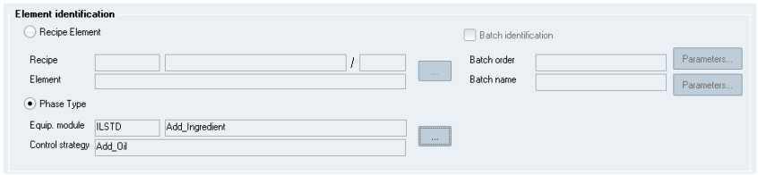

**Phase type configuration**

When phase type radio button is selected:

Recipe Element fields are emptied and fields and buttons are disabled.

Phase type fields and button are enabled.

**Phase type configuration (mandatory)**

Equipment module and control strategy should be filled using the "…" button.

**'…'** : Open the phase type list windows :

170 Sp-EBRDesign-2511

*Creating a PI*

*The PI Text Tab*

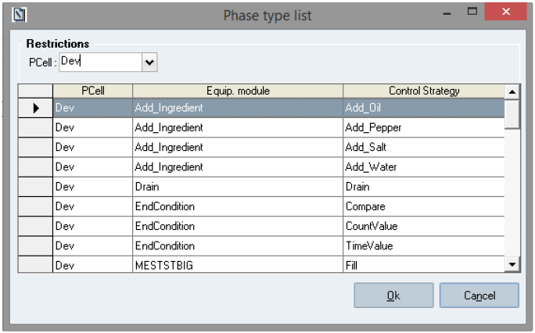

**Phase type list**

Table description

Grid with following information: PCell, equip. module and control strategy.   
Behavior

All phase types are displayed. The user can select a phase type in the list.

The phase types are ordered by PCell, Equip. module and Control Strategy.

If a phase type was configured in tab configuration window, this phase type is selected by default when the screen opens.

Actions

**Ok**: Closes the window and updates the tag configuration window.



**Cancel** or : Closes the window.

Once the phase type is configured, the parameters grid is populated with phase type parameters.   
Note:

All phase type parameters should appear; there is no "relevant" parameters definition on a phase type).   
 Configuration help in case of tag used in Event PI:

The **first time** the tag is inserted in an Event PI (tag creation), the phase type radio button is selected by default and the PCell, Equip.module and Control strategy are pre-filled with Event PI information. The user can then modify this configuration or choose to configure an element.

The **first time** the tag is inserted in an Event PI (tag creation) which is generic (configured with wildcards), the phase type radio button is selected by default and the PCell, Equip.module and Control strategy are pre-filled with Event PI information including the wildcards. The user can choose another configuration but not a wildcard configuration, the wildcard configuration is set only at tag's creation.

Warning:

Coherence check is not performed at design but at execution. Some configurations are not supported (for more information, please refer to the ***Sp-EBRExecution-i.pdf*** documentation):

Sp-EBRDesign-2511 171

*Creating a PI*

*The PI Text Tab*

Tag used in

**Phase Type configured**

**Element configured**

Event PI

Batch Operating Text

Operating Text

Supported with condition

**Not supported**

**Not supported**

Batch identification = No

Supported with condition

Supported with condition

**Not supported**

Batch indentification = Yes

Supported

Supported

Supported

#### [8.3.5.3](http://8.3.5.3)

Parameters grid section

Once the Recipe element or Phase type configuration defined, the grid is populated:

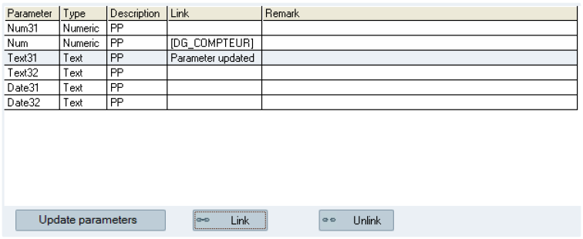

**Parameters grid**

In case of phase type configuration with wildcards (generic event PI), the displayed parameters are all the common

parameters to all phase types matching the wildcard criteria.

Table description

The following columns are displayed:

**Parameter**: Name of the batch parameter

**Type**: Parameter type (text or numeric)

**Description**: Type of the batch parameter (PI, PO or PP)   
 **Link**: Opcenter Execution Pharma parameter or fixed value,   
 **Remark**: Remark

Actions

***Link***: button allows the user to link the selected parameter.

***Unlink***: button allows the user to unlink the selected parameter (Link and Remark are deleted.)

172 Sp-EBRDesign-2511

*Creating a PI*

*The PI Text Tab*

***Update parameters***: Reloads the DCS/PCS relevant parameters or Header parameters or all Phase type parameters associated to the element following the merge algorithm described in the note.

Links of the batch parameters

The configuration of the links between Opcenter Execution Pharma parameters or between fixed values is performed the same way as it is done for the configuration of the links between batch parameters (see The Batch element > The Batch parameters (i.e. the *Inputs* and *Outputs* tabs).)

In Recipe Element configuration case: if the master recipe and/or recipe element is modified, the parameters configuration is merged with the new master recipe configuration following the merge algorithm described in the note.

In Phase Type configuration case: if the phase type is modified, the parameters configuration is merged with the new phase type parameters following the merge algorithm described in the note.

**Note**

Parameter merge algorithm:

Parameter with same name and type = link and remark is preserved, description is updated.

Parameter with same name and different type = link and remark are erased, description and type are updated.   
 New parameter: added, no link.

Parameter does not exist anymore: removed

#### [8.3.5.4](http://8.3.5.4) Execution report

**Generate a report** (optional parameter)

A tag execution report will be inserted into the PI text after having executed the tag, if the corresponding check box

is checked. That option is selected by default.

**Execution return** (optional parameter)

Value returned to a numeric parameter (error code or 0). That option is NOT selected by default.

It is taken into account if the corresponding check box is checked. When the checkbox is checked, the "Parameters" button is enabled and the user can select a parameter from the parameters selection window, only numeric parameters are displayed.

If the checkbox is checked and no parameter is selected, an error message is displayed when the tag configuration is validated: "Execution return: must be filled in".

If the checkbox is unchecked, the execution return parameter code is deleted and the button "Parameters" is disabled.

### 8.3.6 The Combination Tag

Combination can be:

**Manual:** the system checks the combination of the defined phases/ sequences/ doses, by re-scanning the

barcode (a) of the weighing labels that have been generated when weighing that item or (b) of warehouse container labels.

**Automatic**: used to update the database to reflect combination that has already occurred in the process. This automatic combination is used when combining weighing labels, warehouse containers, or piece-of-equipment contents.

Once inserted, the tag is displayed as a button to click to start combination.

Sp-EBRDesign-2511 173

*Creating a PI*

*The PI Text Tab*

The following window allows configuring a combination tag:

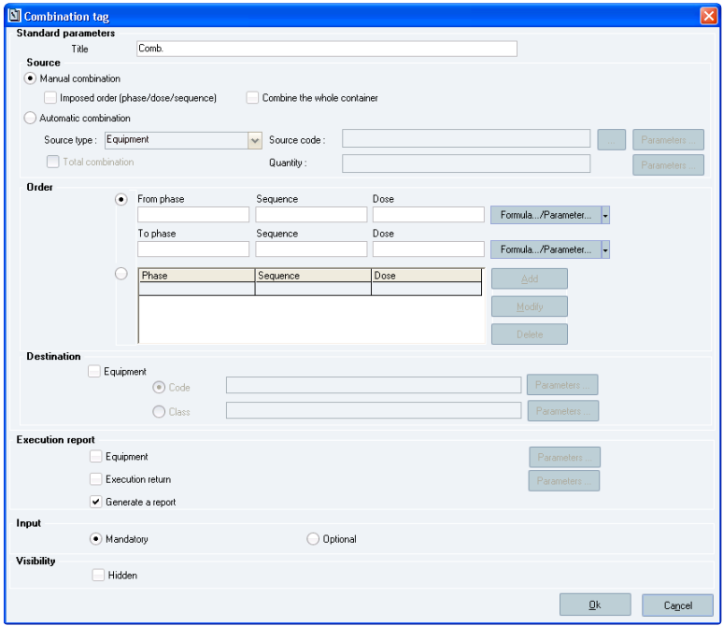

**The *Combination tag* window**

**Window description:**

**The *Standard parameters* section:**

***Title:*** alphanumeric string that appears on the tag once it is inserted in the Operating Text. Mandatory (type: 60- character alphanumeric field).

**The *Source*** **sub-section:**   
 ***Manual Combination:***

*Imposed order (phase/dose/sequence):*

1. The combination order has to be followed if that check box is ticked. The operator has to respect the phase/

dose/ sequence order. If this order is not followed, a warning message appears and the expected phase/ sequence/ dose order is displayed.

2. The access right 1892 (FORCE COMB IMPOSED ORDER) allows overriding this combination order. The operator

has to sign in as soon as a line that should be combined is not combined.

3. If not ticked, the FINISH_COMBINING_LINE_STARTED parameter is used to customize the order from which the

components are combined. If this parameter is set to 1, the system is set up to perform a total combination procedure for any dose that was started in the same phase/dose/sequence.

174 Sp-EBRDesign-2511

*Creating a PI*

*The PI Text Tab*

If the FINISH_COMBINING_LINE_STARTED parameter is set to 0: no constraint regarding the combination order is added. The user has total freedom over the order in which the components are combined.

If the FINISH_COMBINING_LINE_STARTED parameter is set to 1: no constraint regarding the increasing phase/ dose/sequence order is added, but the system checks the entirety of the combined dose before authorising the combination of another dose.

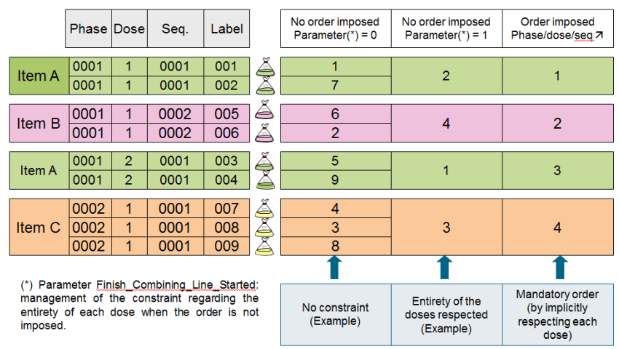

**Example of Components combination order**

Combine the whole container (is automatically validated):

When combining a warehouse container, the entire contents of the identified container are combined – if that box is

checked. The operator does not have to enter a quantity and the end-of-container question is not asked. As such, scanning a warehouse container barcode is enough to validate the combination of this container.

***Automatic Combination:***

If this option is selected:

The options that are available when the *Manual combination* check box is ticked are shaded (i.e. *Imposed order* and *Combine the whole container*).

*Source type:* the type of source is one of the following: *Equipment*, *Container*, and *Weighing label*. Mandatory field.

If the *Equipment* value is selected, the contents of a piece of equipment (CONTENT property) are combined. This entails that a container (declared contents) or weighing labels (undeclared contents) will be combined.

If the *Container* value is selected, the source code is a container code which is either manually entered or provided in a parameter. This is the container that will be combined.

If the *Weighing label* value is selected, the source code is a weighing-label code which is either manually entered or provided in a parameter. This is the weighing label that will be combined.

*Source code:* the source code (i.e. equipment code, container code, weighing label) must be entered. The source code is either:

Sp-EBRDesign-2511 175

*Creating a PI*

*The PI Text Tab*

An equipment code: the code can be manually entered or selected from the list of pieces of equipment that are In Progress (i.e. neither obsolete nor archived). This code has to belong to an available piece of equipment that is In Progress (i.e. neither obsolete nor archived).

Provided by a parameter: the parameter code can be manually entered or selected from the list of text parameters that are not obsolete. A parameter code differs from other pieces of information as it is in square brackets.

The execution return is mandatory and a parameter code must be provided.

Quantity:

If the Equipment value is selected, combining the contents of a piece of equipment can be totally or

partially done. A quantity must be given for partial combination. This quantity is either manually entered or given by a numeric parameter. This quantity is expressed in the source-equipment unit (QUANTITY unit).

A quantity cannot be specified for total combination.

If the Container value is selected, combining a container can be totally or partially done. A quantity must

be given for partial combination. This quantity is either manually entered or given by a numeric parameter. This quantity is expressed in the source unit (container unit).

A quantity cannot be specified for total combination.

If the Weighing label value is selected, automatic combination is automatically set up; no quantity can be

provided.

**The *Order* sub-section:**

Allows the user to define the set of weighing lines that will be checked. This set can be defined the same way as it is done for the tag of efficiency application. However, in Combination, the user can select parameters for each phase, sequence, and dose, if s/he chooses to use two limits (identified by filling in the two sets of ***From Phase/ Sequence/ Dose – To Phase/ Sequence/ Dose*** fields).

Lines that will be combined:

The user that is drafting the workflow can specify:

A start phase, a start sequence, a dose sequence, an end phase, an end sequence, and/or an end dose with hard- coded values or with parameters:

From phase aaaa, sequence bbbb, dose cc   
 To phase xxxx, sequence yyyy, dose zz

A set of weighing lines: the user creates a list of lines for combination in a table that includes Phase, Sequence, and Dose columns. This table can be modified by clicking the Add, Modify and Delete buttons.

In both cases, the user does not have to fill all the fields in.   
E.g.:

If the user enters the values *From phase 0001 to phase 0002*, the system determines that all weighing lines of the phases 0001 and 0002 will be combined.

If the user does not give an end phase/sequence/dose, the system determines that all weighing lines that follow the given start phase/sequence/dose will be combined (i.e. if the user enters the values *From phase 0001 to phase …*, the system expects the combination of the phase 0001 and of all the phases that follow the phase 0001 in the WO).

If the user enters the values *phase 0001, dose 1,* and *sequence 0001* and *To phase 0001, dose 1*, the system uses the less restrictive line (i.e. all sequences of phase 0001 and dose 1 are combined).

If the operator clicks the *Ok* button to confirm the tag setup, consistency tests are performed to validate this configuration. These tests are the following:

176 Sp-EBRDesign-2511

*Creating a PI*

*The PI Text Tab*

For phase intervals:

If a start sequence and/or start sequence is defined, the system checks that the start phase is also

defined.

If the end sequence and/or end dose is defined, the system checks that the end phase is also defined.

If the dose (start and/or end) is provided by a value, the system checks that this value lies between 0 and 99.

If the start and end phases are both provided by hard-coded values, the system checks that the end phase is greater than the start phase.

If the start and end phases are given and are identical (values or parameters) and if the start and end sequences are hard-coded values, the system checks that the end dose is greater than the start dose.

For a list of phases:

For each phase/sequence/dose line that is added, the first and third checks described above are

performed.

The system checks that the list is not empty.

If one of these consistency tests fails, an error message is generated and the cursor is placed in the field that was   
not correctly entered.

**The *Destination* sub-section:**

Is used to define the targeted piece of equipment, which is identified by its code or its class. These two pieces of information can be hard-coded (i.e. equipment code that is already known) or parameters can be used.

In automatic combination, a targeted piece of equipment (if applicable) must be identified by its code and not by its class. This code has to belong to a piece of equipment that is neither obsolete nor archived.

This field is optional.

**The *Execution report* section:**

***Equipment:*** once ticked, allows storing the targeted piece-of-equipment code that was used during combination in a parameter (optional).

***Execution return*:** once ticked, allows determining the numeric tag in which the identification result will be recorded. Optional – activated if the *Execution return* check box is selected. The value of that parameter will be set to 1 if an error occurs; 0 if not.

***Generate a report:*** once ticked, allows automatically inserting an execution report in the Operating Text. This option is selected by default.

**The *Input* section:**

***Mandatory:*** *allows defining whether the tag execution is mandatory;*

***Optional:*** *if the tag has been defined as optional, the next tag can be accessed directly without having carried out* *combination.*

**Here is an example of tag that has been used into a PI text:**

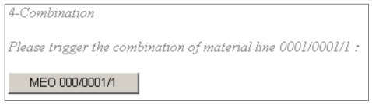

The name of the button is made up from concatenating the following chains:

COMB in that example (by default): name defined when defining the tag;

The starting and ending limits of the material lines, separated by "…"; or the set of material lines, separated by commas.

Sp-EBRDesign-2511 177

*Creating a PI*

*The PI Text Tab*

### 8.3.7 The Date Tag

When inserted into the PI text, a date tag enables the user to define a date field that will have to be filled in when executing the PI.

When none initialisation is defined, the user must select the date in a calendar or input it manually when executing the tag. The initialization value can be modified for this type of tag.

Once inserted, the tag becomes an input zone which contains the name of the associated parameter.

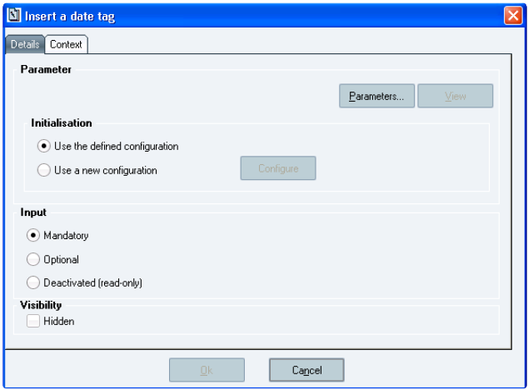

**The *Insert a date tag* window**

### 8.3.8 The Declaration-Adjustment Tag

Declaration-Adjustment tags allow the user to adjust previous manufacturing declarations. These tags are not mandatory to perform manufacturing declarations.

Once inserted, the tag is displayed as a button which contains the defined title from the following window.

178 Sp-EBRDesign-2511

*Creating a PI*

*The PI Text Tab*

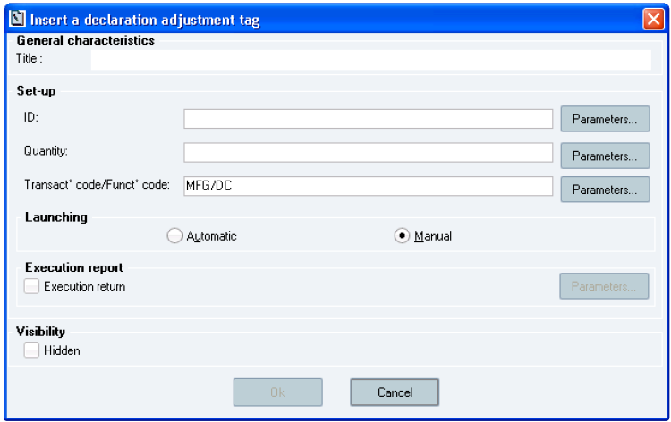

**The *Insert a declaration adjustment tag* window**

**Window description:**

**The *Set-up* section** (parameters)**:**

The container (i.e. ID), function code/transaction code, and quantity are the three tag attributes. If the Container (i.e. ID) and Quantity parameters are not defined, the *Ok* button is still shaded (i.e. not available).

The Transaction code and Function code parameters are respectively initialised with the MFG and DC codes.   
The container corresponds to a container code (type: 49-character alphanumeric field). Mandatory input. The container parameter inserted into the tag is of Barcode-identification type (i.e. Warehouse-barcode type).

The quantity corresponds to the quantity to adjust for the input entity (type: alphanumeric character). Mandatory input. That quantity can be negative or positive. If negative, its absolute value should not be superior to the container quantity.

**The *Launching* sub-section:**

***Automatic/Manual:*** defines if the tag is activated automatically or manually (i.e. user's click) as soon as it is

available.

**The *Execution report* sub-section** (Return parameters)***:***

***Execution return*** (return code)***:*** indicates the report of the tag execution by using a code.

The return code indicates:

an error;

*0* if the tag was correctly executed.

### 8.3.9

The Efficiency-Application Tag

When inserted into the PI text, an efficiency application tag enables the user to manage the modification of the quantities to be weighed for a phase of the WO, according to the value of an efficiency (obtained, for instance, through calculations on the previous phases), by using the following formula:

Sp-EBRDesign-2511

179

*Creating a PI*

*The PI Text Tab*

Final quantity = Initial quantity x Efficiency

E.g.: according to the manufactured quantity of an intermediate product, the tag can update the quantities of the other materials used later in the manufacturing process.

Once inserted, the tag is displayed as a button.

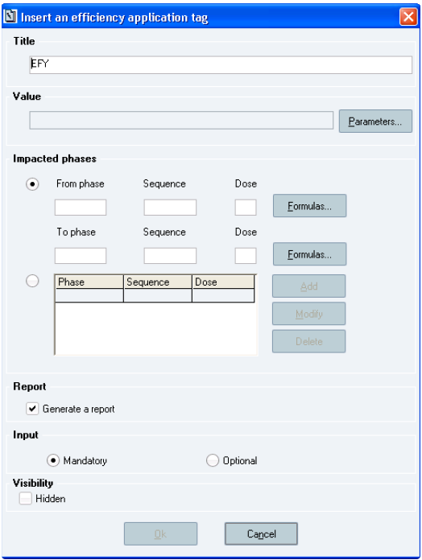

**The *Insert an efficiency application tag* window**

**Window description:**

**The *Title* section:**

Title that will appear in the tag once it is inserted in the PI text. By default, the prefix "EFY" is added to the title (type: 60-character alphanumeric field).

Either the formula which enables the user to calculate the efficiency, by inserting a Function parameter   
 Or directly the value of the efficiency, by specifying a Numeric parameter.

***Parameters…:*** enables the user to access the list of parameters that includes both types.

The field which displays the code of the selected parameter between square brackets cannot be modified through a

direct input.

**The *Impacted phases* section:**

180 Sp-EBRDesign-2511

*Creating a PI*

*The PI Text Tab*

There are two ways to define the set of lines impacted by the tag:

***From Phase/ Sequence/ Dose – To Phase/ Sequence/ Dose:*** either by defining two limits that are identified by the Phase/ Sequence/ Dose triplet. In that case, the concerned material lines are all those that are included between the starting and the ending, both limits inclusive. These starting and ending limits must be coherent as far as the order is concerned. If not, an error message is displayed when validating the window;

**Table:** Or by a set of lines. That set is defined from the windows that can be opened by clicking the *Add, Modify*, and *Delete* buttons*.* Lines are added or modified via the following window:

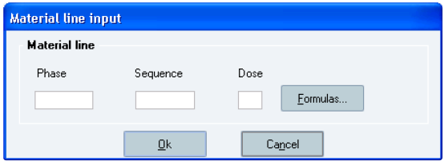

**The *Material line input* window**   
In all cases, the characteristics (phase, sequence, and dose) are provided:

either directly in the planned input zones, or

by clicking the *Formulas…* button, which enables the user to access the list of non-cancelled formulas:

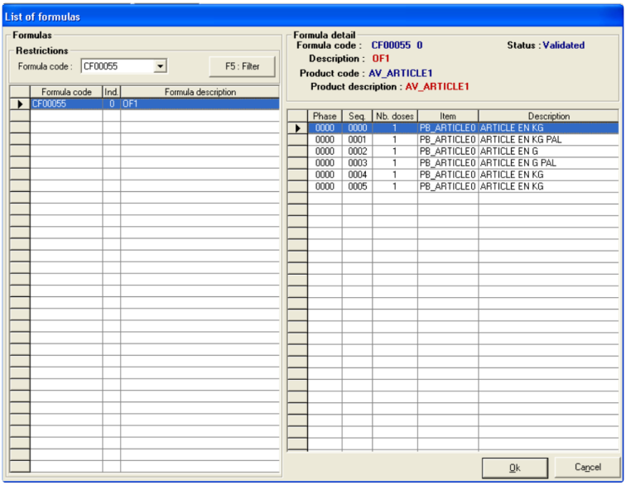

**The *List of formulas* window**

**Window description:**

That screen is divided into two sections:

Sp-EBRDesign-2511 181

*Creating a PI*

*The PI Text Tab*

1. The left-hand part displays the list of ***non-cancelled*** formulas;

2. The right-hand part displays the detail of the lines for the selected formula. Material lines can be selected from

that list by double-clicking on the corresponding row, or by clicking and validating that same row by clicking the *Ok* button.

The references (i.e. phase & sequence) of the material line are then inserted into the input zones. If the selected line includes a single dose, the input zone that corresponds to the dose is initialised to the value *1*.

N.B.: the *Seq.* and *Nb. doses* fields are optional. If not filled in, all sequences and/or doses of the phase are   
impacted.

**The *Report* section:**

If the *Generate a report* check box is ticked, it means that the user wants the report to be automatically generated and inserted into the PI text, once the tag has been executed. That option is selected by default.

**The *Input* section:**

Mandatory or optional feature when the tag is entered (executed). When the tag is optional, the next tag can directly be accessed without having to open the efficiency application.

**Here is an example of tag that has been used into a PI text**

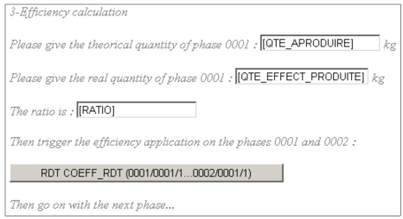

The name of the button is made up from concatenating the following chains:

RDT in that example (by default): name defined when defining the tag;

COEFF_RTD in that example: code of the parameter which contains the ratio (formula or numeric);

Between brackets: the starting and ending limits of the material lines, separated by "…"; or the set of material lines, separated by commas.

### 8.3.10 The Electronic-Signature Tag

When inserted into the PI text, an electronic signature tag enables the user to record the signature of a user that is

to be validated, during an operation that is performed when monitoring the manufacturing process (Code of

Federal Regulations Title 21 (CFR21), part 11 – "Electronic records; Electronic signatures"). That electronic signature is also recorded in the WO traces.

Information related to the signature is automatically inserted into a table in the PI text, after having validated the tag and is the following:

Name of the signatory;

Date;

Time;

Comment defined at electronic signature validation.

The user who signs must have a set of configurable rights for the signature to be validated.

182 Sp-EBRDesign-2511

*Creating a PI*

*The PI Text Tab*

Once inserted, the tag is displayed as a button which displays the name that the user has configured before.

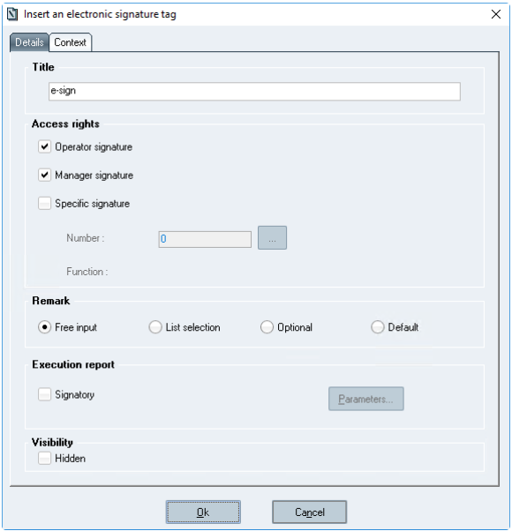

**The *Insert an electronic signature tag* window**

**Window description:**

**The *Title* section:**

Title of the button which will refer to the electronic signature tag once inserted into the PI text.   
**The *Access rights* section** (checked when the signature is appended)**:**

***Operator signature:*** if that check box is ticked, the system checks whether the user has been assigned the access right 1540: (OPERATOR VALIDATION)

***Manager signature:*** the system checks whether the user has been assigned the access right 1545: (MANAGER VALIDATION)

***Specific signature:*** the system checks the specific access right which is selected from the specific access rights.

**The *Remark* section:**

Free input/ List selection/ Optional/ Default. The ''Free input'' radio button is ticked by default.

**Important**

If 'List selection' remark type is configured, predefined comments must be defined. Please refer to ***How_to_Configure_ES_Comments-i.pdf*** document.

Sp-EBRDesign-2511 183

*Creating a PI*

*The PI Text Tab*

**The *Execution report* section:**

***Signatory:*** if that check box is ticked, the signatory's long name will be returned to a text parameter. Optional

parameter.

***Ok:*** that button is available if:

a. The title has been entered;

b. At least one of the three access rights has been selected, and if the specific access right is specified.

### 8.3.11 The E-mail tag

This tag sends an e-mail to one or several recipients to inform them (for example) of an operation that was performed or of tasks to be planned during manufacturing:

The e-mail tag appears in the list of tags in the PI application.

#### [8.3.11.1](http://8.3.11.1) Window description

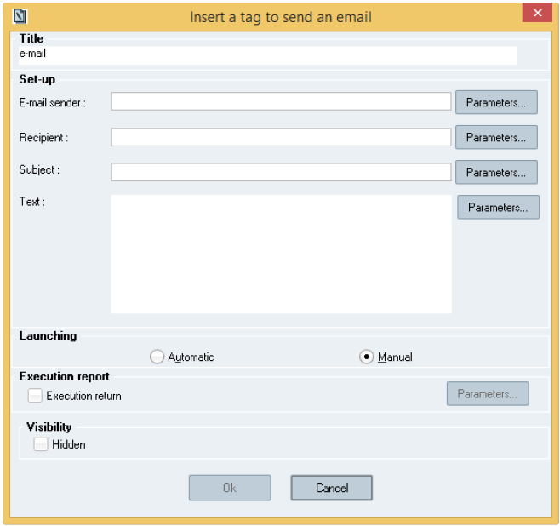

**The *Insert a tag to send an email* window**

**The *Title* section:**

The e-mail tag is displayed as a button in the PI and its title is the alphanumeric character string entered form here. Mandatory input. By default, the prefix "e-mail" is added to the title.

**The *Set-up* section:**

Mandatory fields. The *Ok* button is not available until one of the fields does not get a value. The *E-mail sender* and *Recipient* fields must hold the *@* character to ensure compatibility with Windows®.

184 Sp-EBRDesign-2511

*Creating a PI*

*The PI Text Tab*

The following fields are optional: execution return, object, and text.

***Recipient*:** List of e-mail address/es. Addresses can be separated by a semi-colon (i.e. ";") if there are several recipients. If information about the recipient/s is passed by a parameter, then all recipients must be in the same parameter and their address must be separated by a semi-colon. (type: alphanumeric field).

***E-mail sender:*** E-mail address of the sender (type: alphanumeric field).

***Subject:*** E-mail subject (type: alphanumeric field).

***Text:*** E-mail content (type: alphanumeric field).

Each field can be manually entered or provided in a parameter. A parameter must be in square brackets to differentiate it from a constant. The parameters must be inserted in the Operating Text in order to give them values before executing the e-mail tag.

**The *Launching* section:**

***Automatic/Manual:*** defines if the tag is activated automatically or manually (i.e. user's click) as soon as it is

available. The Manual radio button is ticked by default.

**The *Execution report* section:**

***Execution return*:** 0 if the tag has been properly executed; 1 if an error occurs. Optional parameter.

#### [8.3.11.2](http://8.3.11.2) Executing the tag

During execution, the sender – passed by parameter – sends the e-mail to the list of senders – also passed by parameter. The e-mail subject – passed by parameter – includes the message – also passed by parameter. The performed checks are identical to the checks performed while entering the message.

#### [8.3.11.3](http://8.3.11.3) Configuration

Configuring the e-mail tag as described above is not sufficient for the e-mail tag to work properly.

The name and set-up of the e-mail server must also be provided. Everything is stored in two parameters, which can be modified from the System Setup module (i.e. "Setup.exe"):

The MAIL_SERVER_NAME parameter provides the name of the server that will be used by the e-mail tag.

The MAIL_SERVER_PORT parameter provides the port number that will be used by the e-mail server. The default value is 25, which is the most commonly used value.

**Important**

Please refer to the ***Security-i.pdf*** documentation for recommendation about sender email address and mail server configuration.

Moreover, using this e-mail tag has constraints that relate to user access rights. The connected user must have been assigned the required access rights to send e-mails for each workstation that will execute the e-mail tag (i.e. workstations on which PIProcess is running).

### 8.3.12

The EPE Tag

EPEs are functions that provide from equipment.

These EPEs are described in the equipment classes.

They are interfaced with external data (from OPC links or scripts).

Sp-EBRDesign-2511

185

*Creating a PI*

*The PI Text Tab*

EPE tags enable the user to execute the EPEs that are included in a piece of equipment:

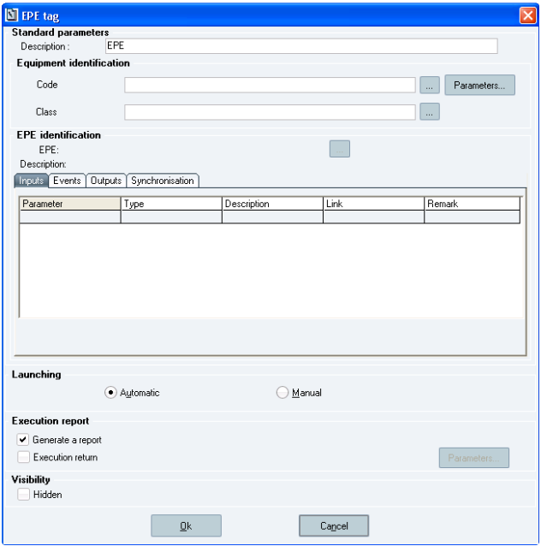

**The *EPE tag* window**

**Window description:**

**The *Standard parameters* section:**

***Description:*** enables the user to enter the title that will appear in the tag button.

**The *Equipment Identification* section:**

***Code:*** *the equipment code can directly be entered or refer to a text parameter.*

***…:*** displays the list of equipment.

***Parameters…:*** displays the list of text parameters.

***Class:*** the class must be specified; it determines the list of EPEs that are associated with the piece of equipment.

***…:*** displays the list of equipment classes.

When the equipment code is directly entered, the system automatically provides the equipment class.

During edition, a blocking message is displayed if the piece of equipment is not coherent with the class.   
During execution, an error occurs if the piece of equipment is not coherent with the class.

**The *EPE Identification* section:**

***EPE*:** code of the EPE that will be executed.

***Description:*** description of the EPE that will be executed. That field is automatically filled in as soon as the EPE is selected.

186 Sp-EBRDesign-2511

*Creating a PI*

*The PI Text Tab*

EPE Parameters: once the EPE has been identified, the list of EPE parameters is displayed in the table of that section:

*Inputs:* displays the list of Input parameters of the EPE;

*Outputs:* displays the list of Output parameters of the EPE;

*Events:* remains blank; the tag does not manage events;

*Synchronisation:* displays synchronisation when not managed; the tag does not manage synchronisation.

If the user wants to manage EPE events and synchronisation, s/he has to use an EPE element.

During edition, a blocking message warns the user that this EPE cannot be selected if it includes a managed event   
or synchronisation.

The list of parameters includes the following columns:

*Parameter: EPE parameters;*

*Type: type of each parameter (text or numeric);*   
 *Description: description of each EPE parameter;*   
 *Link: value of the parameter:*

for input parameters (initialisation) = PI parameter or fixed value;   
 for output parameters (report) = PI parameter.

*Remark:* comment entered when inserting the link.

Links of EPE parameters:

Each parameter is linked to a piece of information of the PI. That link enables the user to define the way the

parameter value is passed on between the PI and the EPE:

An input parameter (initialisation) of the EPE can be linked to a parameter of the PI or to a fixed value,   
 An output parameter (report) of the EPE can just be linked to a parameter of the PI.

To link a parameter, the corresponding row has to be selected from one of the lists. Then, the user can click the *Link* button (or double-clicking the line), which is displayed once the table is filled in, to display the window that enables the user to enter the name of a parameter or fixed value (for EPE input parameters)

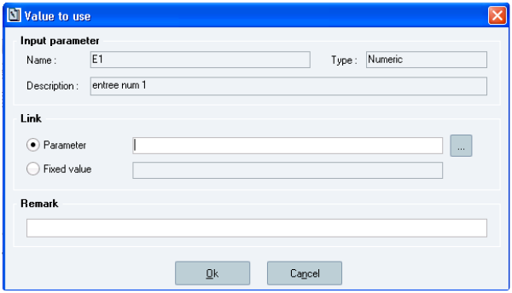

**The *Value to use* window**

**Window description:**   
**The *Link* section:**

***…:*** displays a list which allows selecting the PI parameter to associate with the EPE parameter. That list displays the PI parameters with a type that corresponds to the type of the EPE parameter.

Sp-EBRDesign-2511 187

*Creating a PI*

*The PI Text Tab*

***Ok:*** once the link has been created, enables to validate the selection.

The system then checks that the PI parameter (if entered manually) or input fixed value is coherent with the type of

the EPE parameter (numeric or text). If not, an error message is displayed.

After validation, the list is completed:

the *Link* column displays the name of the parameter (between square brackets) or the fixed value (with

no square brackets);

the *Comment* column displays the entered comment.

**The *Launching* section:**

***Automatic/Manual:*** defines if the tag is launched automatically or manually (user's click) as soon as it is

available.

**The *Execution report* section:**

***Execution return*:** once ticked, the value – which is returned to a numeric parameter – will be set to 1 if an error

occurs; 0 if not. Optional parameter.

***Generate a report:*** once ticked, allows automatically inserting a tag execution into the PI text after having executed the tag. This option is optional and selected by default.

**Here is an example of tag that has been used into a PI text:**



The name of the button is made up from concatenating the following chains:

The tag description;

The piece of equipment, followed by its class.

188 Sp-EBRDesign-2511

### 8.3.13

*Creating a PI*

*The PI Text Tab*

The Equipment tags

#### [8.3.13.1](http://8.3.13.1)

The Display Equipment Property tag

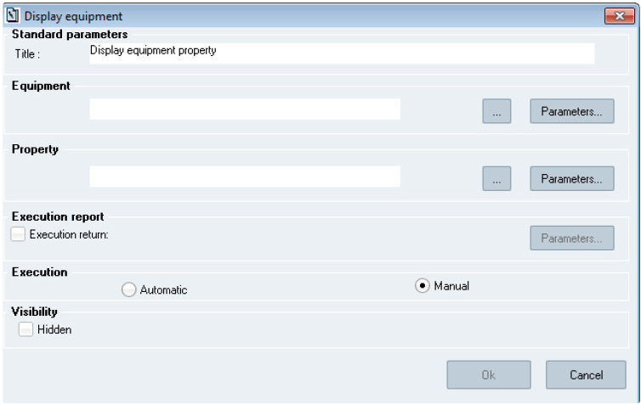

**The *Display equipment* window**

**Window description:**

**The *Standard parameters* section:**

***Title:*** alphanumeric string that appears on the tag once it is inserted in the Operating Text. Mandatory (type: 60- character alphanumeric field).

**The *Equipment* section:**

This section is used to determine a constraint on the equipment code for which the user wants to read an equipment property that will be displayed in the Operating Text.

The piece of equipment that will be identified can be provided by:

Its code: the expected piece-of-equipment code can be manually entered or selected from the list of

pieces of equipment that are *In Progress*.

A parameter that holds the piece-of-equipment code: the parameter code can be manually entered or selected from the list of text parameters that are not obsolete.

This constraint is mandatory for automatic execution. A value that is in square brackets is a parameter code. **The *Property* section:**

**Code:** Property that will be displayed.   
That code is either:

Manually entered or selected from the list of available properties. In both cases, the property cannot be obsolete.

Sp-EBRDesign-2511 189

*Creating a PI*

*The PI Text Tab*

Provided by a parameter: The parameter code can be manually entered or selected from the list of non-obsolete text parameters.

**The *Execution report* section:**

***Execution return*:** Is used to determine the numeric tag in which the identification result will be recorded.

Optional – activated if the *Execution return* check box is selected.

**The *Execution* section:**

***Automatic/Manual:*** defines if the tag is launched automatically or manually as soon as it is available.

#### [8.3.13.2](http://8.3.13.2) The Equipment Property Modification tag

An equipment-modification tag is used to modify the value of one or several equipment properties (text, numeric, or status properties) by checking the consistency of the requested modification with the selected piece-of- equipment properties. Configuration properties cannot be modified from this tag.

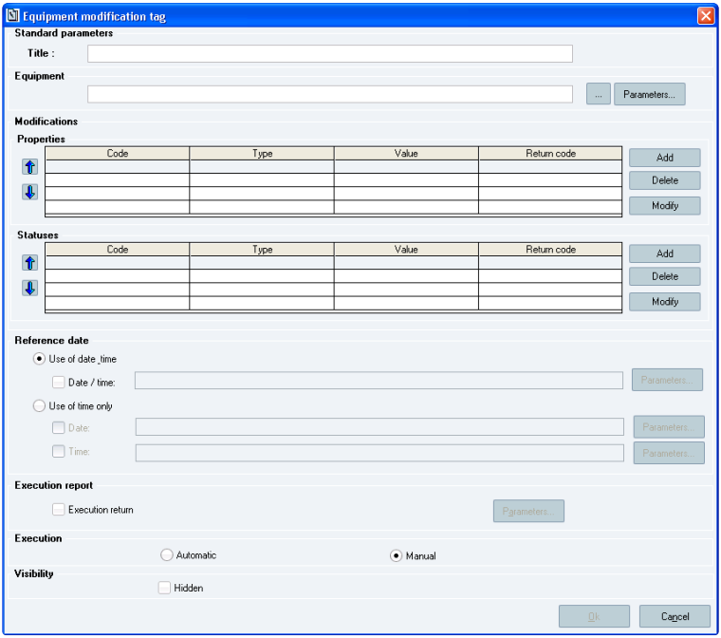

**The *Equipment modification tag* window**

**Window description:**

**The *Standard parameters* section:**

190 Sp-EBRDesign-2511

*Creating a PI*

*The PI Text Tab*

***Title:*** alphanumeric string that appears on the tag once it is inserted in the Operating Text. Mandatory (type: 60- character alphanumeric field).

**The *Equipment* section:**

This section is used to determine a constraint on the equipment code.   
The piece of equipment that will be identified can be provided by:

Its code: the expected piece-of-equipment code can be manually entered or selected from the list of pieces of equipment that are *In Progress*.

A parameter that holds the piece-of-equipment code: the parameter code can be manually entered or selected from the list of non-obsolete text parameters.

This constraint is mandatory for automatic execution.

**The *Modifications* section:**

his section is used to add/modify/delete properties (text, numeric, status) that will be modified in the piece of equipment.

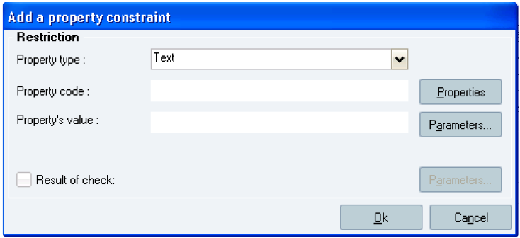

**The *Add a property constraint* window**

**Window description:**

***Property type:*** Mandatory, type of property that will be modified. Can be selected from one of the following

options: Text, Numeric, and Status.

***Property code:*** Mandatory. Code of the property that will be modified. The property code can be manually entered or selected from the list of properties that are not obsolete. The property has to belong to the selected type (text, numeric, or status, according to the chosen type of property).

***Property's value:*** new value of the property. The new value can be manually entered or provided by a text or numeric parameter. The new value must match the selected type of property (text, numeric, or status).

Text property: the length of the new value must be less than the maximum length that is configured in the property. The property will be emptied if no character string is provided (value is not mandatory).   
 Numeric property: mandatory value. The new value must be numeric and there are up to 4 digits in the decimal part.

Status property: mandatory value. The new value must be part of the statuses of possible values for the property.

***Result of check:*** Optional field. Numeric parameter that is used to store the execution return when modifying the property (or error code).

**The *Reference date* section**

Sp-EBRDesign-2511 191

*Creating a PI*

*The PI Text Tab*

This reference date is used when recalculating the expiry date/time of status properties that are impacted by the update.

The date of reference can be based on date/time or only based on time.

***Use of date/time:***

Manually entered: the system checks that the entered value is indeed a date and time (separated by a

space) and that they respect the formats of Opcenter Execution Pharma locale settings. Otherwise, the input is rejected.

Provided by a time parameter, selected from the list of time parameters that are not obsolete. After confirming the selection, the system checks whether the parameter is based on date/time and it rejects the selection if the parameter is only based on time.

***Use of time only:*** the reference date can be configured independently from the reference time.

The date can be:

Manually entered: must respect the date format of Opcenter Execution Pharma Locale Settings.

Provided by a date parameter, selected from the list of date parameters that are not obsolete.

The time can be:

Manually entered: must respect the time format of Opcenter Execution Pharma's Locale Settings.

Provided by a time parameter, selected from the list of time parameters that are not obsolete.

**The *Execution report* section:**

Allows identifying a numeric parameter in which the result of the identification will be recorded. Optional – activated only if the *Execution return* check box is selected.

**The *Execution* section:**

***Automatic/Manual:*** defines if the tag is launched automatically or manually as soon as it is available.

#### [8.3.13.3](http://8.3.13.3)

The List-Modification tag

A list-modification tag is used to modify the list of piece-of-equipment property by either:

Adding elements to the list. Deleting elements from the list.

192

Sp-EBRDesign-2511

*Creating a PI*

*The PI Text Tab*

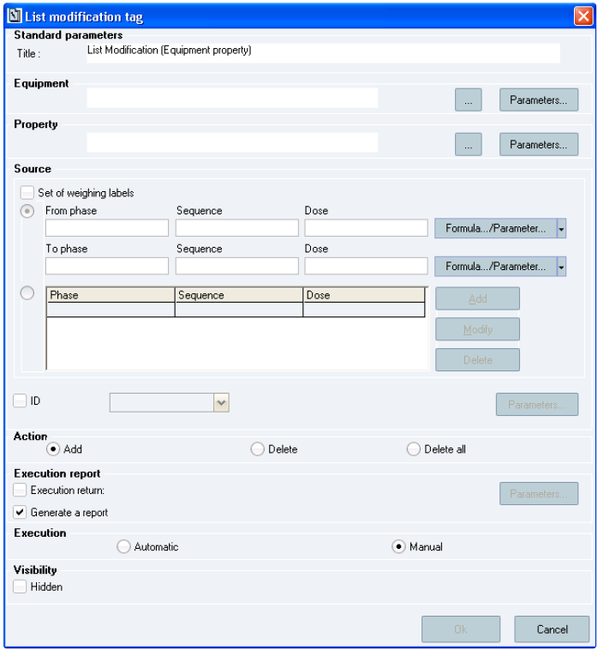

**The *List modification tag* window**

**Window description:**

**The *Standard parameters* section:**

***Title:*** alphanumeric string that appears on the tag once it is inserted in the Operating Text. Mandatory (type: 60- character alphanumeric field).

**The *Equipment* section:**

This mandatory field is used to identify the piece of equipment that will be modified.   
The piece of equipment that will be identified can be provided by:

Its code: the expected piece-of-equipment code can be manually entered or selected from the list of pieces of equipment that are *In Progress*.

A parameter that holds the piece-of-equipment code: the parameter code can be manually entered or selected from the list of text parameters that are not obsolete.

This constraint is mandatory for automatic execution. A value that is in square brackets is a parameter code.

Sp-EBRDesign-2511 193

*Creating a PI*

*The PI Text Tab*

**The *Property* section:**

Property code: Property that will be displayed.   
That code is either:

Manually entered or selected from the list of available properties. In both cases, the property cannot be obsolete.

Provided by a parameter: The parameter code can be manually entered or selected from the list of non-obsolete text parameters.

**The *Source* section:**

The source describes the elements that will be added to/removed from the list.   
The source can be described in two parts:

A set of weighing labels: according to the configured phase/sequence/doses.

A single element: provided by the type (weighing label, container, equipment, other) and the ID code (manually entered or provided by a text parameter).

A least one of the two parts must be selected.   
**The *Action* section:**

The type of modification is one of the following:

***Add***

***Delete***

***Delete all: the list is emptied.***

**The *Execution report* section:**

***Execution return*:** Is used to determine the numeric tag in which the identification result will be recorded.

Optional – activated if the *Execution return* check box is selected.

**The *Execution* section:**

***Automatic/Manual:*** defines if the tag is launched automatically or manually as soon as it is available.

#### [8.3.13.4](http://8.3.13.4) The Read Equipment Property tag

A tag to read an equipment property is used to read a text/numeric/status property and to record it in a PI parameter.

The result can be stored in one or several parameters. The following values can be read, according to the type of property:

Text: value of the property

Numeric: value of the property

Status: value of the property, Expiry date – if the value has expired.

194 Sp-EBRDesign-2511

*Creating a PI*

*The PI Text Tab*

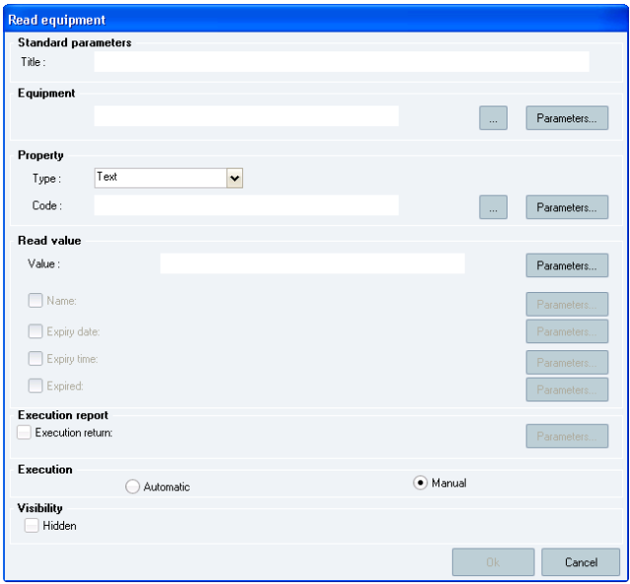

**The *Read equipment* window**

**Window description:**

**The *Standard parameters* section:**

***Title:*** alphanumeric string that appears on the tag once it is inserted in the Operating Text. Mandatory (type: 60- character alphanumeric field).

**The *Equipment* section:**

This section is used to determine a constraint on the equipment code for which the user wants to read an equipment property.

The piece of equipment that will be identified can be provided by:

Its code: the expected piece-of-equipment code can be manually entered or selected from the list of pieces of

equipment that are *In Progress*.

A parameter that holds the piece-of-equipment code: the parameter code can be manually entered or selected from the list of non-obsolete text parameters.

This constraint is mandatory for automatic execution. A value that is in square brackets is a parameter code. **The *Property* section:**

***Type:*** Mandatory. Type of property that will be read. It is a drop-down list which allows selecting either the *Text*, *Numeric*, or *Status* value.

The property code from which the user wants to read the value is either:

Sp-EBRDesign-2511 195

*Creating a PI*

*The PI Text Tab*

Manually entered or selected from the list of available properties. In both cases, the property cannot be obsolete. The type of property has to match the specified type (text, numeric, or status).

Provided by a parameter: The parameter code can be manually entered or selected from the list of non- obsolete text parameters.

**The *Read value* section:**

Is used to choose the parameters in which the read values will be recorded.

Text: text parameter (mandatory). The parameter code can be manually entered or selected from the list of non- obsolete text parameters.

Numeric: numeric parameter (mandatory).

Status:

A text parameter that holds the code for the value of property (mandatory)   
 A text parameter that holds the name for the value of property (optional)

A date parameter that holds the expiry date of the value (optional)

A time parameter that holds:

The expiry time of the value, if a time parameter – that is only based on time – was used

Or the expiry date/time of the value if a time parameter – that is based on date/time – was used (optional)

A numeric parameter that holds information about the expiration of the value (optional).

**The *Execution report* section:**

***Execution return*:** Is used to determine the numeric tag in which the identification result will be recorded.

Optional – activated if the *Execution return* check box is selected.

**The *Execution* section:**

***Automatic/Manual:*** defines if the tag is launched automatically or manually as soon as it is available.

### 8.3.14 The Hyperlink

Hyperlinks are text elements which allow accessing external targets at any time in the PI text.

The three available types of target elements

**File**

**HT** **TP**

**HT**

**TP**

**S**

**Mai** **lTo**

196

The target element is a document available from the workstation which executes the PI text. The targeted file is referred to by its full path (i.e. network drive, absolute path, file name).

The target element is referred to by an HTTP address.

The target element is referred to by an HTTPS address.

The target element is a series of e-mail addresses (each address is separated by a ";"). When clicking the link, the mail client configured on the workstation is opened in a window which enables the user to write a mail to people that has been designated from the hyperlink.

 Sp-EBRDesign-2511

*Creating a PI*

*The PI Text Tab*

During edition, hyperlinks enable the user to designate the insertion location, the type of link, and the link target. When writing the PI, hyperlink links can be inserted by clicking the *Hyperlink* function from the *Insert* tab.

After having validated the configuration, the hyperlink is inserted into the PI text. It is an underlined text.

**How to set up these hyperlinks:**

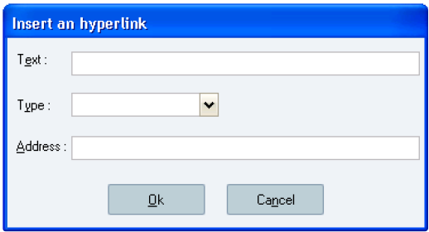

**The *Insert a hyperlink* window**

**Window description:**

***Text:*** text of the hyperlink (can be modified).

***Type:*** type of hyperlink (i.e. *File*, *HTTP*, or *MailTo*).   
 ***Address:*** hyperlink address (can be modified).

**Note:**

When the hyperlink is directly written in the Operating Mode edition, do not save the following pattern http://[text]: [text] (or https), it will turn PI to error.

### 8.3.15 The Hypertext-Link Tag

Documentary references enable the user to reference electronic documents from a PI. These documents are loaded and presented when executing the PI:

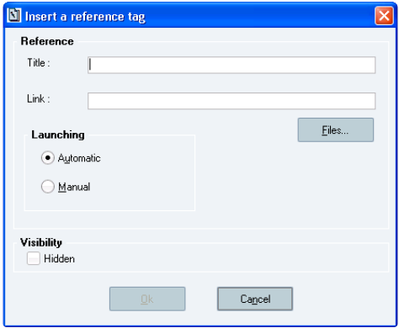

Sp-EBRDesign-2511 197

*Creating a PI*

*The PI Text Tab*

**The *Insert a reference tag* window**

**Window description:**

**The *Reference* section:**

***Title*:** title of the link displayed in the PI text. That input is optional. ***Link*:** path to access the file.

***Files…:*** allows selecting the appropriate file.

**The *Launching* sub-section:**

Mode to trigger the document. Two options are available:

***Automatic:*** the document will be loaded with no intervention from the operator;   
 ***Manual:*** the operator has to click the document title to load it

### 8.3.16 The identification tags

#### [8.3.16.1](http://8.3.16.1) The Barcode-Identification Tag

When inserted into the PI text, a barcode-identification tag enables the user to identify an entity that displays an ID (barcode) that is recorded in the Opcenter Execution Pharma database when executing the PI.

The system checks that the identified barcode is recorded in the database before approving the identification. That identification also enables to extract data from the barcode to Text parameters.

Once inserted, the tag is displayed as an input zone that is intended to receive the barcode, which results from the identification of the label by the appropriate piece of equipment, connected to the PC.

The following configuration window complies with all types of tags that are linked to a parameter:

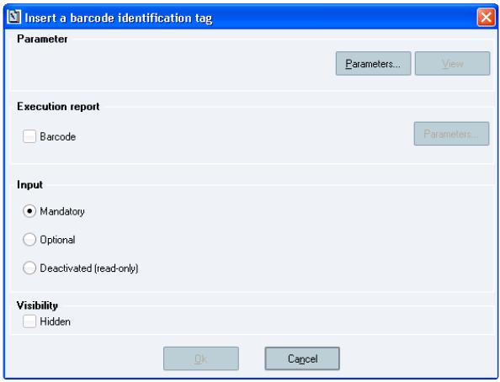

**The Insert a barcode identification tag window**

198 Sp-EBRDesign-2511

*Creating a PI*

*The PI Text Tab*

The execution report includes the choice of a text parameter that will receive the identified barcode. That field   
is **optional.**

#### [8.3.16.2](http://8.3.16.2) The Container-Identification Tag

A container-identification tag enables the user to identify a warehouse container barcode of a specified item code and to extract the description and lot from that barcode.

Once inserted, the tag is displayed as an input zone.

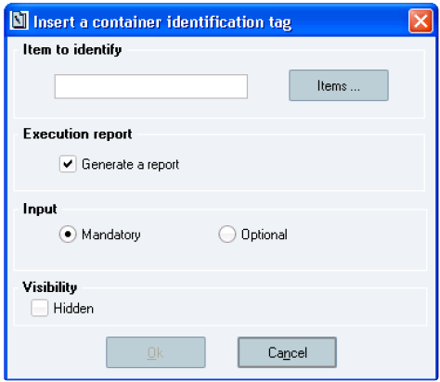

**The *Insert a container identification tag* window**

**Window description:**

**The *Item* section:**

Item that will have to be identified during execution:

either by directly entering the code into the planned input zone;

or by selecting a value from the list of ***validated*** items stored in the system, after having clicked the *Items* button. Once the *Ok* button has been clicked, the system checks whether the selected item is available and whether it is valid.

**The *Execution report* section:**

There is a possibility to request the automatic generation and insertion of a report into the PI text, after that the tag has been executed. The *Generate a report* check box is ticked by default.

**The *Input* section:**

***Mandatory:*** allows defining whether the tag is mandatory;

***Optional:*** if the tag has been defined as optional, the next tag can be accessed directly without having carried out the identification.

**Here is an example of tag that has just been inserted into a PI text:**

Sp-EBRDesign-2511 199

*Creating a PI*

*The PI Text Tab*

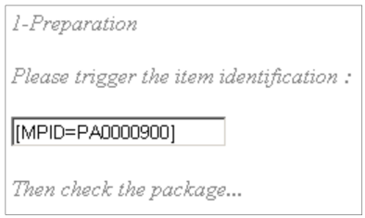

It includes a chain of characters between square brackets, which refers to an identity and which defines the restrictions that will be applied to the scanned barcode.

The first part of the identity defines the barcode characteristic to which the restriction is applied. In the   
example, *MPID* refers to the item code.

The second part defines the value that is required for that characteristic. In the example, the item code   
"PA0000900" is required.

So in that case, the user expects a barcode which displays the item code PA0000900.

#### [8.3.16.3](http://8.3.16.3) The Equipment-Identification Tag

An equipment-identification tag is used to identify a piece of equipment and to determine if it meets the constraints that pertain to its class, properties, or contents:

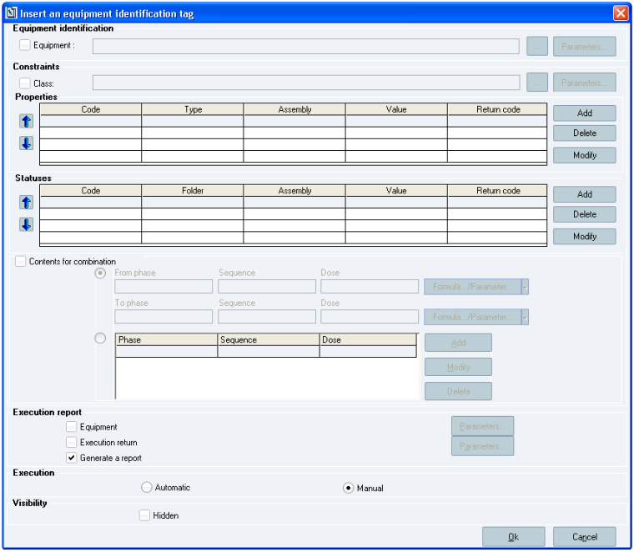

200 Sp-EBRDesign-2511

*Creating a PI*

*The PI Text Tab*

**The *Insert an equipment identification tag* window**

**Window description:**

**The *Equipment Identification* section:**

This section is used to determine a constraint on the equipment code.   
The piece of equipment that will be identified can provide from:

Its code: the expected piece-of-equipment code can be manually entered or selected from the list of pieces of equipment that are *In Progress*.

A parameter that holds the piece-of-equipment code: the parameter code can be manually entered or selected from the list of text parameters that are not obsolete.

This constraint is mandatory for automatic execution.   
**The *Constraints* section:**

***Class:*** this field is used to determine a constraint on the equipment class.   
This constraint can provide from:

The class code: the expected piece-of-equipment class can be manually entered or selected from the list of classes that are not obsolete.

A parameter that holds the class code: the parameter code can be manually entered or selected from the list of text parameters that are not obsolete.

This constraint is not mandatory.

**The *Properties* sub-section:**

It is possible to add, modify, or delete constraints from the piece-of-equipment text or numeric properties.   
This type of constraint is not mandatory

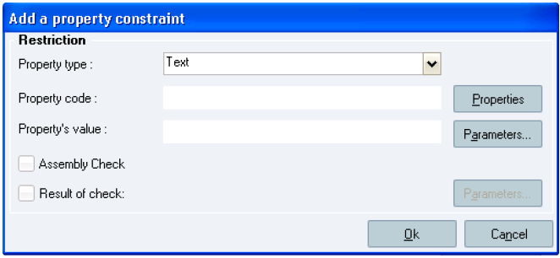

**The *Add a property constraint* window**

**Window description:**

A text/numeric property constraint has the following attributes, which correspond to the columns of the table:

***Property type:*** mandatory attribute, which corresponds to the type of property that will be checked. Either the *Text* or *Numeric* value can be selected.

Sp-EBRDesign-2511 201

*Creating a PI*

*The PI Text Tab*

***Property code:*** mandatory attribute, which corresponds to the checked property code. It can be manually entered or selected from the list of non-obsolete properties for the selected type, after having clicked the *Properties* button.

***Property's value:*** mandatory attribute, which correspond to the expected value for the selected property. The expected value can be manually entered or provided by a text or numeric parameter (according to the type of property).

N.B.: A code/value pair for a given property can only appear once included in the list of constraints.

***Assembly Check:*** ticking that check box allows determining whether the defined constraint also applies to equipment that is part of the identified piece of equipment to assembly that will be identified (see the ASSEMBLY property of the identified piece of equipment).

***Result of check:*** optional attribute, which allows defining the numeric parameter in which the result – that was get when checking the text/numeric constraint – will be stored.

**The *Statuses* sub-section**

This section is used to add/modify/delete constraints that pertain to the "status" properties of the piece of equipment.

This type of constraint is optional.

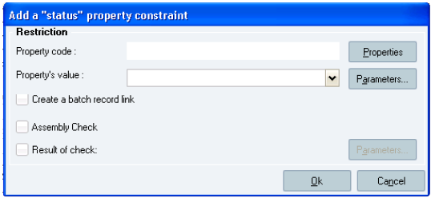

**The *Add a "status" property constraint* window**

**Window description:**

A status property constraint has the following attributes:

***Property code:*** mandatory attribute, which corresponds to the property code that is checked. It can be manually entered or selected from the *Status* properties that are not obsolete.

***Property's value:*** mandatory attribute, which corresponds to the expected value for the selected property. This value can be manually entered, selected from the list of possible values, or provided by a text parameter.

N.B.: A code/value pair for a given property can only appear once in the list of constraints.

***Create a batch record link:*** a link will be made between the batch record that has the identification tag and the batch records that were used to modify the properties that were defined in the constraints.

***Assembly Check:*** ticking that check box allows determining whether the other pieces of equipment to assemble also have the same property with the same value (see the ASSEMBLY property of the identified piece of equipment).

***Result of check:*** optional attribute, which allows defining the numeric parameter in which the result – that was get when checking status – will be stored.

**The *Contents for combination* sub-section & check box:**

This sub-section is used to configure a constraint on the piece-of-equipment contents.   
Piece-of-equipment contents are described by:

A set of weighing labels (the product has not yet undergone a manufacturing declaration) OR

202 Sp-EBRDesign-2511

*Creating a PI*

*The PI Text Tab*

A container (a manufacturing declaration has already been performed).

The check of the contents applies to these weighing labels or to the container.

The following is checked: the piece-of-equipment contents can undergo combination for a sub-set of lines among the lines that are configured in the tag by phase/sequence/dose.

This constraint is not mandatory.

**The *Execution report* section:**

The execution report is divided into three parts:

***Equipment:*** ticking that check box allows identifying a text parameter in which the identified equipment code will be recorded. Optional – activated only if that option is selected.

***Execution return:*** ticking that check box allows identifying a numeric parameter in which the result of the identification will be recorded. Optional – activated only if that option is selected.

***Generate a report:*** Optional and ticked by default. An execution report for the tag execution will be inserted in the Operating Text, after executing the tag.

**The *Execution* section:**

***Automatic/Manual:*** defines if the tag is launched automatically or manually as soon as it is available.

#### [8.3.16.4](http://8.3.16.4) The Label-Identification Tag

When inserted into the PI text, a label-identification tag enables the user to check a barcode during the execution. Once inserted, the tag is displayed as a button which contains the name of the tag.

N.B.: A labelling tag that references the same labelling parameter must be inserted before the identification tag.

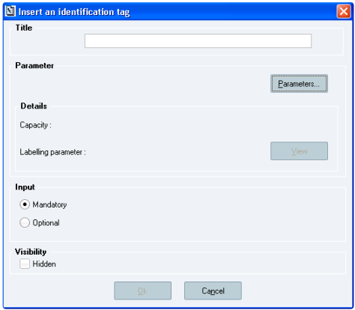

**The *Insert an identification tag* window**

**Window description:** **The *Parameter* section:**

Sp-EBRDesign-2511 203

*Creating a PI*

*The PI Text Tab*

***Parameters…:*** enables the user to choose the identification parameter that will be associated with the tag. Once this parameter has been chosen, the associated labelling parameter and the size of the barcode that have been defined for that parameter are displayed.

***Ok:*** validates the tag insertion.

### 8.3.17 The Labelling Tag

When inserted into the PI text, a labelling tag enables the user to print a barcode label when executing the PI.   
Once inserted, the tag is displayed as a button that contains the tag heading.

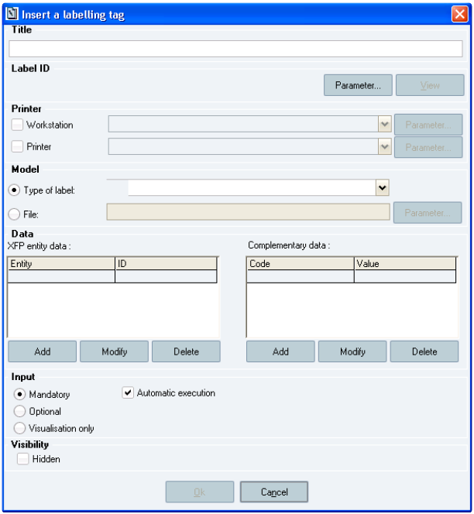

**The *Insert a labelling tag* window**

**Window description:**

**The *Title* section:**

Enables the user to enter the tag title. That text is used to name the button that correspond to the tag in the PI text. **The *Label ID* section:**

Enables the user to select the parameter of the label that has been used.

***Parameters…:*** enables the user to select the parameter of the label that will be used for printing.

***View:*** enables the user to view the details of the selected parameter (that button is shaded if no parameter has been selected).

204 Sp-EBRDesign-2511

*Creating a PI*

*The PI Text Tab*

**The *Printer* section :**

***Workstation:*** enables the user to select the workstation from where the label will be printed (not mandatory). The workstation can be selected from the drop-down list, entered manually, or referenced in a Text parameter.

If the workstation is not specified, the current workstation (i.e. from which the tag is executed) is the one that is sending the print order.

If a workstation is specified, the label will be printed from the printer that is linked to that workstation.

***Printer:*** enables the user to select the printer from where the label will be printed.

The printer can be selected from the drop-down list, entered manually, or referenced in a Text parameter.

If the printer is specified, the label is printed from the printer that was defined for the tag.

If no printer is specified, the selected printer is the printer that is linked to the workstation that treats the request (i.e. workstation defined for the tag; otherwise current workstation) and configured to print the requested label.

N.B.: the name of the printer must be entered exactly as it appears in the service console (case sensitive).   
**The *Model* section:**

Enables the user to select the label template. That field is **mandatory**.

The template can be:

Selected from the drop-down list which displays the types of labels that are referenced by the system;   
 Directly indicated by the name of the variable file: manual input (without the path or the ".txt" extension, up to 8 upper cases);

Referenced in a Text parameter.

The types of labels referenced by the system

**Function**

Container manufacturing declaration

Sample lot manufacturing declaration

Pallet manufacturing declaration

Client manufacturing declaration

Containers preliminary labelling

Locations

Equipment

Phase label

Sp-EBRDesign-2511

**Template code**

MODEL_DECLARATION

MODEL_DECLARATION_LOT

MODEL_DECLARATION_PALET

MODEL_DECLARATION_CUSTO

MODEL_PRE_MANUFACTURING

MODEL_EMPLACEMENT

MODEL_EQUIPMENT

MODEL_MO

**Other functions**

205

*Creating a PI*

*The PI Text Tab*

**Function**

WO label

Weighing label

Pallet label

Container receipts

Batch record during receipt

Pallet receipts

**Template code**

MODEL_WORK_ORDER

MODEL_WEIGTH

MODEL_WEIGTH_PALET

MODEL_RECEIPT

MODEL_RECEIPT_LOT

MODEL_RECEIPT_PALET

**Other functions**

Material request label, intermediate label in SGFG

That list is completed with the list of labels that have been defined when multi-labelling the material flow.

**The *Data* section:**

Enables the user to specify data from the label. PI Labelling tag: additional data per Opcenter Execution Pharma Entity

The labelling tag generates a set of data that can be classified into three types:

Context data: these data are always generated from the labelling tag. See the description of the data generated

on the PI label in the ***Sp-Labelling-i.pdf*** specification to know the variables that identify each context data.

Data of Opcenter Execution Pharma entities: these data correspond to the set of properties of an entity that can be identified by its ID. Refer to the description of the data generated per Opcenter Execution Pharma entity in the ***Sp-Labelling-i.pdf*** specification to know the variables that identify data of a Opcenter Execution Pharma entity.

A value from the *Type of entity* drop-down list has to be selected to select Opcenter Execution Pharma entities for which data must be printed. Opcenter Execution Pharma entities can be added, modified, or deleted.

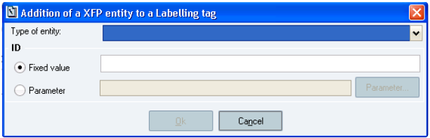

**The Adding a Opcenter Execution Pharma entity to a Labelling tag window**

The following entities are identified by a Labelling tag: *Item, Container, Location, Piece of equipment, Lot, Pallet, WO,*

*and Site.* The ID of an entity can be defined by a fixed value or by a parameter.

Labelling tags to identify entities

206 Sp-EBRDesign-2511

**Type of entity**

Item

Container

Location

Piece of equipment

Lot

Pallet

*Creating a PI*

*The PI Text Tab*

**ID**

Item code

Container barcode *

Location code (site + depot + code)

Equipment code

Lot barcode *

Pallet code

WO

Concatenate the WO number and the WO index.

The value of the WO number must be 10 characters long. If the WO number is less than 10 characters long, add the respective number of blank spaces to complete. Then, concatenate the index at the end (one character). *Example:* For a work order of number **OF12345** and index **1**, the value will be: **OF12345 1**

* According to the Identification mode configured in Opcenter Execution Pharma

When adding or modifying an entity, the system checks that the type of entity and the ID have been defined and that the selected type of entity is not yet used in the list. If so, a blocking message then indicates that this type of entity has already been selected.

Supplementary data: this type of data corresponds to supplementary values that can be sent to the label. They are identified by a code (which will enable the user to identify the piece of information in the label) and by a value that can be defined by a fixed value or by reference to a parameter.To select the additional data to be printed, the *Complementary data* table must be filled in. Supplementary data can be added, modified, or deleted.

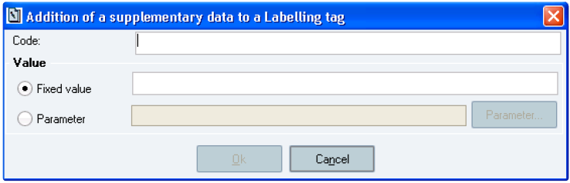

**The *Adding a supplementary data to a Labelling tag* window**

When adding or modifying a supplementary piece of information, the system checks that the code and value have

been defined and that the selected code is not yet used in the list. If so, a blocking message indicates that this code has already been selected.

Sp-EBRDesign-2511 207

*Creating a PI*

*The PI Text Tab*

**Important**

These 2 codes cannot be used as complementary data as there are already added in standard. These codes are: LABEL_EDIT_NUMBER and LABEL_REEDIT_NUMBER

**The *Input* section:**

Enables the user to define the type of input (i.e. mandatory, optional, or read-only). It also enables the user to configure the automatic execution of this tag.

### 8.3.18 The List Tag

When inserted into the PI text, a list tag enables the user to select data from a defined list and to save them in the execution parameters.

Once inserted, the tag is displayed as a button which contains the defined title from the following window.

E.g.: the list of equipment is displayed on the window. The user selects an element from that list and the execution parameters are recorded with each piece of information that has been retrieved

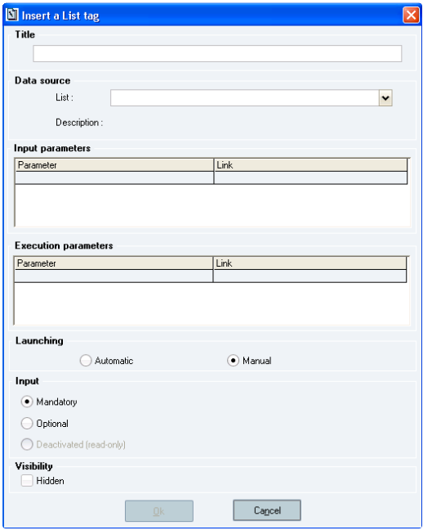

**The Insert a List tag window**

**Window description:**

**The *Title* section:**

Corresponds to the title of the button that corresponds to the list tag once inserted into the PI text.

208 Sp-EBRDesign-2511

*Creating a PI*

*The PI Text Tab*

**The *Data source* section:**

Corresponds to the list that will be executed when the tag will be executed. The user can choose among a set of standard lists:

Equipment list according to an Equipment class

List: Equipment list

Description: Equipment list according to a class

Displayed fields: equipment code, equipment class, allocation status, WO number (ASSIGNEDWO), location (LOCATION), product code (ASSIGNEDPRODUCT)

Input parameter: inEquipmentClass

Execution parameter: Equipment code

**Nb: If an equipment standard property used by one equipment present in this list and which is not associated** **to an equipment class, an equipment belonging to the equipment class will be displayed but with blank value** **for the missing property.**

Item list for a specific work order:   
 List: WO Material Lines list

Description: Material line for specific work order

Displayed fields: item code, description, phase, sequence, dose   
 Input parameter: inWONumber

Execution parameter: item code

List of available lots for a material (ordered by FEFO):

List: List of available lots

Description: List of available lots for a material (ordered by FEFO)

Displayed fields: lot code, location code, expiry date, total quantity, stock unit, status   
 Input parameter: inItemCode

Execution parameter: lot code

It is possible to add lists directly to the tables that are concerned to customise a request (see How_to_Create_Custom_Lists_for_ListTag document).

By default, those standard lists cannot be sorted (data that correspond to the requested type of list will be displayed on the window during execution).

**The *Input parameters*** **section:**

The character \ is not allowed for input parameters used value whether for a parameter or for a fixed value.

The *input parameters* display the list of parameters that are required to evaluate the request. Double-clicking a row will display the following window, which will allow entering these input parameters:

Sp-EBRDesign-2511 209

*Creating a PI*

*The PI Text Tab*

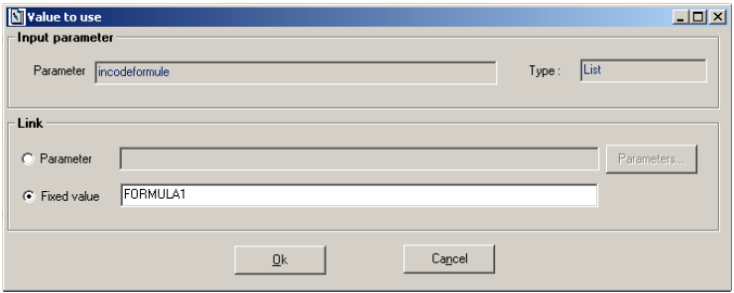

**The *Value to use* window**

There are two ways to update the value of input parameters:

A PI parameter;   
 A fixed value.

**The *Execution parameters* section:**

Displays all the possible parameters to retrieve and save in a parameter. Double-clicking a row will display the following window, which will allow entering these output parameters:

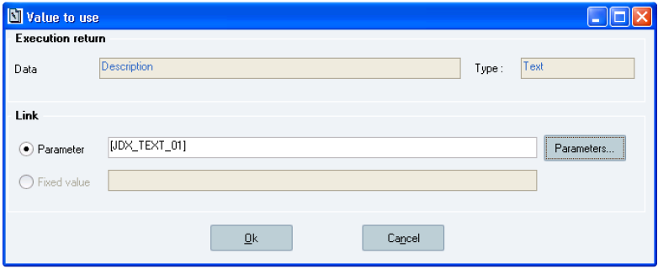

**The *Value to use* window**   
Only a PI parameter can be entered to get the selected value back.

**The *Launching* section:**

***Automatic/Manual:*** defines if the tag is activated automatically or manually (i.e. user's click) as soon as it is available.

**The *Launching* section:**

***Mandatory:*** allows defining whether the tag is mandatory;

***Optional:*** if the tag has been defined as optional, the next tag can be accessed directly without having displayed the list.

210 Sp-EBRDesign-2511

### 8.3.19

*Creating a PI*

*The PI Text Tab*

The Manufacturing-Declaration Tag

In general, these tags facilitate the performance of manufacturing declarations for "intermediate" products or "finished goods", while keeping the access and traceability aspects.

Manufacturing declaration tags enable the user to:

1. Create stock in the defined location;

2. Create containers declared as produced or declare the quantity produced in a piece of equipment;

3. Print the containers and/or equipment labels;

4. Generate the corresponding uploading to the ERP (if the transaction/function codes are specified);

5. Trace the declaration: manufactured products, produced lots, produced quantities, manufacturing dates and

times, users having performed the actions, etc.

Once inserted, the tag is displayed as a button which contains the defined title from the following window.

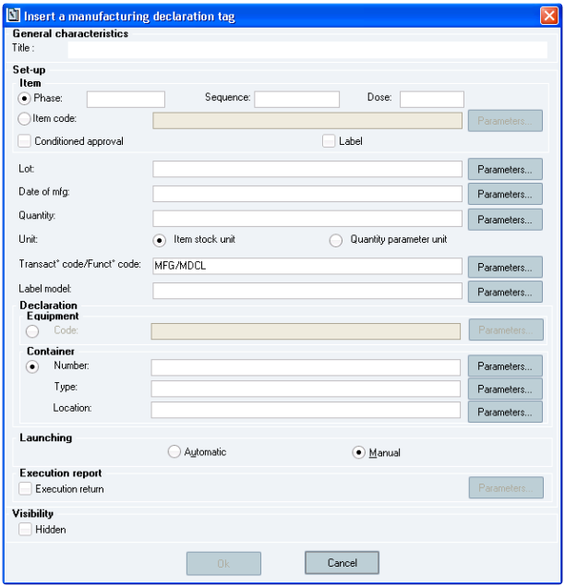

**The *Insert a manufacturing declaration tag* window**

**Window description:**

**The *General characteristics* section:**

***Title:*** in the PI, the declaration tag corresponds to a button. The input title is the name of that button (type: alphanumeric field). **Mandatory** input.

**The *Set-up* section (parameters):** **The *Item* sub-section:**

Sp-EBRDesign-2511 211

*Creating a PI*

*The PI Text Tab*

All the parameters which correspond to the selected options (i.e. one of the two radio buttons), except the equipment class, the ERP transaction and function codes, and the return parameters, will have to be entered (i.e. mandatory input) either with a parameter or a constant value.

Each field of that section is of alphanumeric type:

Of up to 20 characters if it is a parameter;

Of variable length, according to the parameter.

N.B.: The *Ok* button is not available if none of these fields has been filled in.   
The user can decide to enter:

***Phase/ Sequence/ Dose:*** that have been set for the WO (types – *Phase* & *Sequence*: 4-character alphanumeric fields; *Dose*: 1-character alphanumeric field)

***Item code:*** code available in Opcenter Execution Pharma and which belongs or not to the WO formula (18- character alphanumeric field).

N.B.: Both options exclude each other. The Phase/ Sequence/ Dose radio button is selected by default.   
 ***Conditioned approval:*** the display of that check box depends on how the LOT_PIREVIEW_IMPACT parameter

has been set up. Any lot that has been created from a manufacturing declaration tag on "conditioned approval" can be approved only once the batch record has been approved during review (see the Electronic Batch Record Review module; i.e. "PIReview.exe").

***Label:*** indicates whether labels must be printed.

**Manufactured *Lot:*** code of the manufactured lot. That lot can be available or not in Opcenter Execution Pharma (type: 24-character alphanumeric field).

***Date of mfg*** (for "Manufacturing date")***:*** date when the manufacturing process started (type: 10-character alphanumeric field).

***Quantity:*** quantity produced per container or piece of equipment (type: alphanumeric characters).

***Unit:*** the *Item stock unit* and *Quantity parameter unit* check boxes indicate the unit that is associated with the quantity (i.e. the stock unit that corresponds to the item for which production is declared, or the unit that is stored in the numeric parameter that has been entered for the quantity).Only one unit between the two can be ticked. The *Item stock unit* check box is selected by default.If the quantity is a numeric character: the *Item stock unit* check box is selected and cannot be deselected.If the quantity corresponds to a numeric parameter: both check boxes are available.

***Transact° code/Funct° code*** (for "Transaction code and function code")***:*** these codes are associated with the action and sent to the ERP (type: 5-character alphanumeric fields). By default, these fields are initialised with the MFG/MDCL codes. If it is a constant, the user enters the function code and the transaction code by using

the / separator between both codes.

***Label model*:** Template of the label that is used while printing labels (type: 8-character alphanumeric field).

Reminder about labelling rules:

Managing mono labels: no matter whether a template has been set up, the template that is recorded in

the database is the standard template that is used to declare containers;   
 Managing multi-labels:

if a template has been set up, it is recorded in the database;

if not, the template that is used to declare containers – defined in the label management – is recorded and used for reprinting.

**The *Declaration* sub-section:**

***Equipment:*** Equipment code or equipment class from which the manufacturing declaration will be performed.

***Container*** (selected by default)***:***

*Number:* number of containers to declare (type: 4-character alphanumeric field).

*Type:* corresponds to the type of all the containers that have been declared (type: 2-character alphanumeric field).

212 Sp-EBRDesign-2511

*Creating a PI*

*The PI Text Tab*

*Location:* location in which the produced containers will be created (type: 10-character alphanumeric field). The location code corresponds to the site (2-character alphanumeric field) + depot (yard) (2- character alphanumeric field) + location (6-character alphanumeric field).

N.B.: Each configuration field can be filled in manually or be defined by a parameter. The parameter will be displayed between square brackets in the field so as to make the difference between parameters and constants. The parameters must be inserted into the PI text in order to fill them before the manufacturing declaration is activated.

**The *Launching* section:**

***Automatic/Manual:*** defines if the tag is activated automatically or manually (i.e. user's click) as soon as it is

available.

***The* Execution report *section*** (Return parameters)***:***

***Execution return:*** determines the parameter that will hold the value of the execution return.

The return code indicates:

an error;

*Ok* if the tag was correctly executed.

Equipment code: if the manufacturing declaration has been made from a piece of equipment, the equipment code is returned.

### 8.3.20

The Move Tag

Once inserted, a move tag is displayed as a button which takes the value defined from the *Title* field:

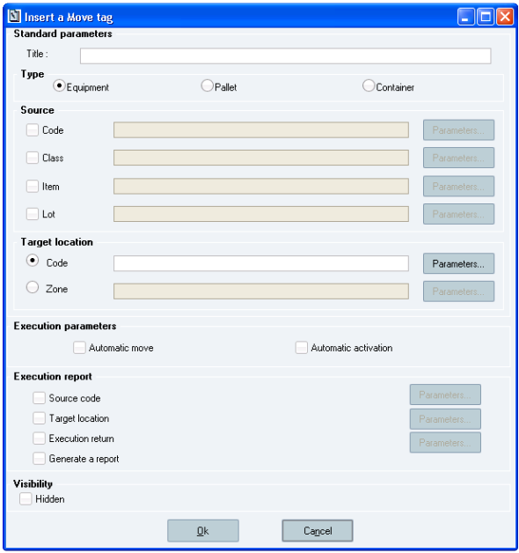

**The *Insert a Move tag* window**

Sp-EBRDesign-2511

213

*Creating a PI*

*The PI Text Tab*

**Window description:**

**The *Standard parameters* section:**

***Title*:** enables the user to enter the title that will appear on the button.

**The *Type* sub-section:**

Piece of equipment, container, or pallet (i.e. entities).

**The *Source* sub-section:**

There are three potential cases (according to the radio button that has been ticked from the *Type* sub-section):

A piece of equipment is moved: in that case, the available sort criteria are an equipment code, an equipment class, an item linked to the piece of equipment (DECLAREDPRODUCT property), and a lot linked to the piece of equipment (DECLAREDLOT property).

A pallet is moved: in that case, the available sort criteria are a pallet code, an item linked to the pallet, and a lot linked to the pallet.

A container is moved: in that case, the available sort criteria are a container code, an item linked to the container, and a lot linked to the container.Criteria can be identified by their code or by a text parameter.

**The *Target location* section:**

The target location can be defined:

by its code, or

by the zone to which it belongs.

**The *Execution report* section:**

The return parameters are optional and taken into account if their corresponding check box is selected. The values of data processed when moving the piece of equipment or entity can be retrieved from parameters (i.e. code of the entity or piece of equipment, location where they have been moved, execution return). Generating an execution report can also be requested:

Values generated in the execution report

**Type Code Targeted location Error code Error description**

**Associated checks:**

At least one of the source fields must be set up.

When a piece of equipment or an entity is automatically moved: the *Code* fields of the moved object and of the target location must be specified.

**The *Execution Parameters* section:**

***Automatic activation*:** defines whether the tag is activated alone or after a manual operation performed by the

operator.

***Automatic move:*** defines whether the piece of equipment can be automatically moved (i.e. with no intervention from the operator). If so, the entity or piece of equipment must be identified by a code.

214 Sp-EBRDesign-2511

*Creating a PI*

*The PI Text Tab*

**How to insert a Move Tag:**

There are two ways to insert a move tag:

From the *Insert* tab > the *Tag* function > the *Move* 2nd level function, or

From the icon

of the toolbar

### 8.3.21

The Numeric Tag

When inserted into the PI text, a numeric tag enables the user to define a numeric field that will have to be filled in when executing the PI:

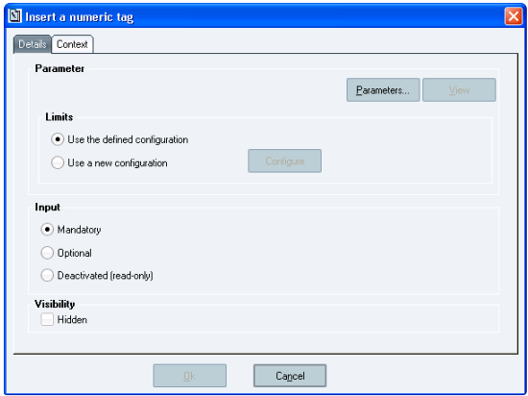

**The *Insert a numeric tag* window**

**Window description:**

**Numeric tags – specific case:**

**The *Limits* sub-section:**

The two radio buttons are available as soon as a parameter is chosen, if that parameter displays the numeric type.

***Use the defined configuration:*** identical to the configuration of the selected parameter;

***Use a new configuration*:** allows defining a new configuration, which differs from the configuration of the selected parameter and which is specific to the tag. Ticking the second radio button makes the *Configure* button available. Clicking that button allows displaying the sheet that details the selected parameter (N.B. if no parameter has been selected from the *Parameter list* window, available from the *Parameter* section by clicking the *Parameters…* button, no sheet will be opened).

Only the fields that can be modified (i.e. which are the 4 limits of the numeric parameter and the initialization value) are available.

**The *Parameter* section :**

***View:*** enables the user to find the configuration at any time, for example when calling the tag properties. If a

default configuration has been defined for that tag, clicking that button allows accessing the default standards. On the other hand, if a new configuration has been defined, clicking that button allows accessing the new configuration.

Sp-EBRDesign-2511 215

*Creating a PI*

*The PI Text Tab*

Once inserted, the tag becomes an input zone which contains the name of the associated parameter.

### 8.3.22 The Picture Tag

When inserted into the PI text, a picture tag enables the user to insert pictures into the PI during execution.

During edition, picture tags enable the user to indicate where to insert pictures, and their position, and size.

The managed picture formats are the standard ones: ".GIF", ".JPG", ".BMP".

Once inserted, the tag is displayed as a frame with the dimensions that have been defined in the tag. The description (title) is displayed on the frame. During edition, and once inserted, that frame can be re-dimensioned. The *Height* and *Width* dimensions are then recorded in the tag (see the description of the *Picture tag* window)

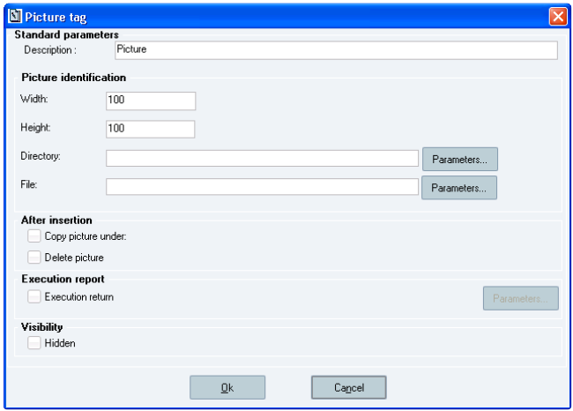

**The *Picture tag* window**

**Window description:**

**The *Standard parameters* section:**

***Description*:** enables the user to enter the title that will appear in the Picture tag during execution.

**The *Picture Identification* sub-section:**

All fields that are defined for pictures are optional, as they are not necessary for the execution. On the other hand, picture dimensions are important during edition as they cannot be modified during execution. The inserted picture is then stretched to fill the whole frame, or reduced not to be truncated.

***Width:*** picture width, expressed in pixels. The width is initialised to 100 pixels (so as to select it in the PI to give it the desired dimensions).

***Height:*** picture height, expressed in pixels. The height is initialised to 100 pixels

***Directory:*** default directory where pictures can be found and selected. By default, that field displays the value of the MO_PICTURE_PATH parameter. That field can be filled in with a PI parameter.

*File:* enables the user to define the name of the picture to be inserted. If that name is known in advance, that picture is not necessarily needed when editing the PI. That field can be filled in with a text parameter.

**The *After Insertion* sub-section:**

By default: the two following options are not selected.

216 Sp-EBRDesign-2511

*Creating a PI*

*The PI Text Tab*

***Copy picture under:*** enables the user to copy the picture after having inserted it into the PI text. By default, that field displays the value defined in the MO_PICTURE_PATH_COPY parameter.

***Delete picture:*** enables the user to specify that the picture must be deleted once it has been inserted.

Both actions can be combined or not.

**The *Execution report* sub-section:**

By default, that option is not selected.

Value returned to a numeric parameter (error code or 0). Optional parameter. It is taken into account if the corresponding check box is selected.

### 8.3.23 The Re-labelling Tag

Re-labelling tags enable the user to reprint labels for containers, equipment, etc.:

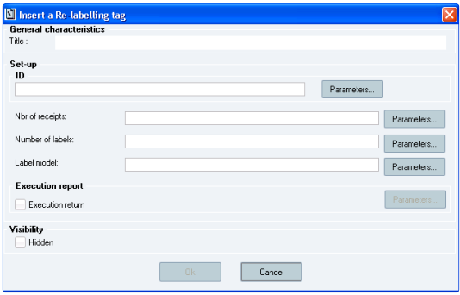

**The Insert a Re-labelling tag window**

**Window description:**

**The *Set-up* section** (parameters):

The container (i.e. ID), number of receipts, number of labels, and template (i.e. label model) are the four tag attributes. If the Container (i.e. ID) parameter is not defined (with a Barcode-Identification parameter that has a type which corresponds to the planned re-labelling: warehouse container), the *Ok* button is still shaded (i.e. not available).

The number of entities enables the user to define the number of entities to re-label; the container corresponds to the first code of the series to re-label. The series is sorted by alphabetical order (available for warehouse labels only).

E.g. The user identifies the container LOT1 0001; the number of entities equals to 3: the system re-labels the container LOT1 0001, LOT1 0002, and LOT1 0003.

The number of entities equals to 1 by default.

The number of labels corresponds to the number of label copies to label. The number of labels equals to 1 by default.

If a label model is filled in, all the entities of the series are reprinted with that template.

Sp-EBRDesign-2511 217

*Creating a PI*

*The PI Text Tab*

### 8.3.24 The Report Tag

N.B.: Prerequisites: this functionality can only be used with an executable that is provided in Microsoft SQL Server 2014 (it is not provided in Opcenter Execution Pharma software – for more information, refer to the Opcenter Execution Pharma installation document).

Report tags allow generating a report that is filled in with manufacturing data. It uses the report parameter and the template associated with this parameter.

The report tag has two Execution modes:

Execution-report mode

Review-report mode

Execution-report and Review-report mode

The Execution-report mode generates a report which displays manufacturing data when the tag is executed. It also allows defining if the report tag generates the report as an annex.

The Review-report mode prepares the edition of the review report from the WO review.   
Once the report tag is configured, it is displayed as a button in the PI.

218 Sp-EBRDesign-2511

#### [8.3.24.1](http://8.3.24.1)

*Creating a PI*

*The PI Text Tab*

Window description

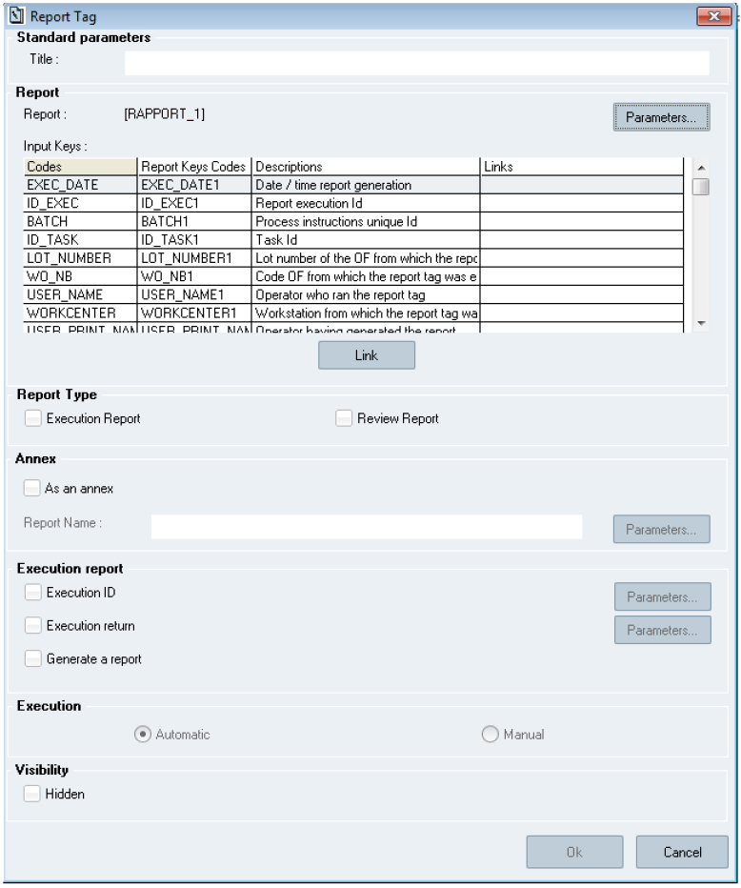

**The *Report tag* window**

**The *Standard parameters* section:**

***Title*:** enables the user to enter the title of the reporting tag. Mandatory input.

**The *Report* section:**

***Report:*** field to fill in with the reporting parameter to use to generate the report.

*Parameters…:* allows displaying a list with the created and validated report parameters to fill the *Report* field in.   
 ***Input keys:*** when filled in, this table is made up of the following columns:

Sp-EBRDesign-2511 219

*Creating a PI*

*The PI Text Tab*

*Codes:* once the report parameter is selected, this column is automatically filled in with the list of input keys defined in the parameter

*Report keys codes:* once the report parameter is selected, this column is automatically filled in with the report-key code defined in the parameter

*Descriptions:* once the report parameter is selected, this column is automatically filled in with the description defined in the parameter

*Links:* this column has to be filled in with manufacturing data required to generate the report. It can be filled in with fixed values or with parameters by clicking the *Link* button. An empty fixed value can be entered. In that case, when validating the tag, a confirmation message is displayed. If the user confirms, the value of the key is an empty value. If s/he does not, the system sent the user back to the *Report tag* window.

When a report parameter is selected in the report tag, if this parameter is set up with input keys that have default values, and for these keys, the link column is filled in with default values. These default values can be replaced with other values by clicking the *Link* button.

The standard key cannot be configured. They are automatically configured with the correct values.   
**The *Report Type* section:**

Allows selecting the type of report (i.e. Execution report or Review report).

There are three ways to set up the reporting tag:

Execution-report mode: the report is generated when the tag is executed. This report is displayed after that the tag has been triggered. In this configuration, executing the report tag is manually performed.

Review-report mode: the report is not generated when the tag is executed. The report is a Review report which is generated when available from the WO review. In this configuration, executing the report tag is automatically performed.

Execution-report and review report mode: the report is generated when the tag is executed. This report is displayed after that the tag has been triggered. A review report can also be generated from the WO review. In this configuration, executing the report tag is manually performed.

**The *Annex* section:**

Allows defining whether the generated report is also an appendix.

The *As an annex* checkbox is not ticked by default. If it does, the name of the report must be defined manually or by selecting a parameter after having clicked the *Parameters…* button.

The DOCUMENT_REPORT_BUSINESSTYPE parameter allows defining how the type of the appendix that is generated from the report tag.

The DOCUMENT_REPORT_SIGN_PATH parameter allows defining how the signature path of the appendix is generated from the report tag.

The file is generated in Html and stored in the repository folder, where appendices are saved (the path to access that folder is defined by configuring the DOCUMENT_REPOSITORY parameter).

This functionality is not available if the report tag is configured as a "Review report".   
**The *Execution report* section:**

***Execution ID:*** once ticked, unique identifier which is allocated when the tag is executed. This value is retrieved on the report.

***Execution return:*** once ticked, execution return that informs the user whether the tag has been successfully executed.

***Generate a report:*** once ticked, allows defining whether a report has to be displayed.

**The *Execution* section:**

220 Sp-EBRDesign-2511

*Creating a PI*

*The PI Text Tab*

Allows defining if the tag is executed manually or automatically.

If the Execution-report mode is selected, the execution of the tag is set to *Manual* (i.e. it is not possible to select the *Automatic* function).

If the Review-report mode is selected, the execution of the tag is set to *Automatic* (i.e. it is not possible to select the *Manual* execution).

When a report tag is inserted into a PI, the detailed documentation displays the following values:

*Type:* type of the tag, filled in with the "Report" note

*Start Type:* filled in with the "Manual" or "Automatic" note

*Title:* filled in with the tag title

*Hidden:* defines whether the tag is hidden

*Inserted report:* defines whether a report is displayed after that the tag has been executed

*Report type:* defines whether the tag is configured to generate an execution report, or a review report, or an execution and review report.

*Report Parameter:* filled in with the code of the report parameter set in the tag.

*Return ID parameter:* filled in with the code of the parameter set in the tag to get the ID

*Return parameter:* filled in with the code of the parameter set in the tag to get the execution return.

*Input keys list:* table where the input keys and their configuration are listed

#### [8.3.24.2](http://8.3.24.2) Executing the tag

During execution, the template associated with the report parameter is used to generate the report. The values of the keys are fixed or retrieved from a parameter.

N.B.: whatever its configuration, the simulation execution of the report tag does not generate a report.

#### [8.3.24.3](http://8.3.24.3) Configuration

The configuration of the report tag as described above is not sufficient for the report tag to work properly.

The name and set-up of the SQL Server and Reporting server must also be provided. Eight configuration parameters can be modified from the Setup module (i.e. "Setup.exe"):

GXP_INSTANCE: Name of the Reporting Services Instance

GXP_NOM_SERVEUR: Name or IP of the server on which Reporting Services are deployed   
 GXP_NOM_SERVEUR_SQL_SERVER: Name of the SQL Server that hosts the content of the Reporting Services   
 GXP_PORT: port number dedicated to Reporting Services in IIS (i.e. web frontend)

GXP_REPERTOIRE: folder in Reporting Services into which the report templates are deployed

GXP_RSNAME: Virtual directory in IIS dedicated to Reporting Services

GXP_USER_LOGIN: user login in Active Directory of the user who has been authorized to deploy the report templates in the dedicated Reporting Services Instance.

GXP_USER_PASSWORD: user password in Active Directory of the user who has been authorized to deploy the report templates in the dedicated Reporting Services Instance.

### 8.3.25 The Script Tag

Scripts are equivalent to macros Macros allow executing tasks automatically (e.g. executing repetitive actions with   
a single click). and enable the user to meet diverse functional needs that are not planned by the standard application:

Sp-EBRDesign-2511 221

*Creating a PI*

*The PI Text Tab*

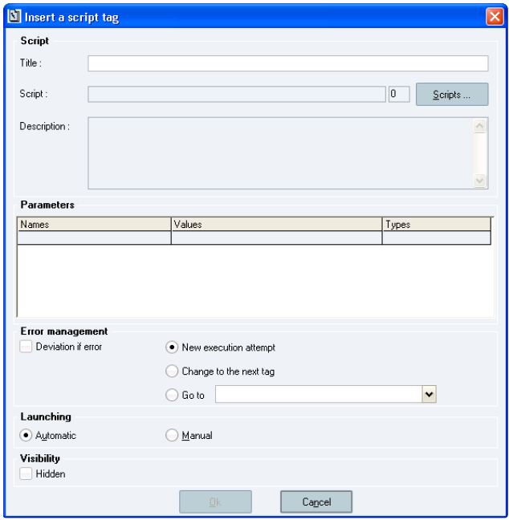

**The *Insert a script tag* window**

**Window description:**

**The *Script* section:**

***Title:*** title of the button which calls the script that will be displayed in the PI text. Mandatory input.

***Script:*** name and version of the script. The script is selected by clicking the *Scripts …* button, which opens the list of scripts that are recorded in the system (a version can be selected).

***Description:*** description of the selected script. It cannot be modified but is automatically specified as soon as a script is selected.

**The *Parameters* section:**

The parameters created for the selected script are displayed a table in order to view, for each of them, their name, type, and defined value:

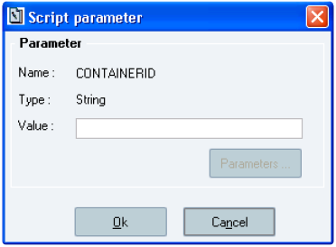

222 Sp-EBRDesign-2511

*Creating a PI*

*The PI Text Tab*

**The *Script parameter* window**

The way to input a value differs according to the type of parameter (i.e. character chain, Boolean, numeric, or reference to a parameter).

**The *Error Management* section:**

It is possible to define how the tag behaves when errors occur while executing the script.   
If so, the user can:

Request to enter an alert (which will be of the deviation type);   
 Request exception of execution by:

Re-executing the script;

Not taking the script into account and accessing the next tag;   
 Re-routing the execution to a label inserted into the PI text.

**The *Launching* section:**

It allows configuring the script activation mode.

***Automatic:*** defines that the script is executed automatically without any intervention from the operator before accessing the next tag.

***Manual:*** *defines that the operator must click the button that is associated with the script to activate the execution* *and access the next tag.*

#### [8.3.25.1](http://8.3.25.1) Use script tag as a checkbox

It is possible to use a script tag to enable the checkbox functionality. To do so, the script tag must be configured with the standard script provided, named "PI_CHECKBOX". This requirement follows a naming convention that links the checkbox functionality to the configured script name.

Once the tag is set up, a custom style will be applied automatically, replacing the default button with a checkbox. Tag title is not displayed.

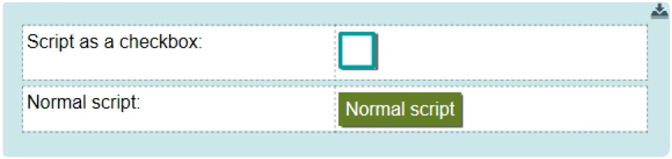

The behavior remains unchanged: users must double-click on the checkbox to access the configuration interface.

### 8.3.26 The Signature Tag

When inserted into the PI text, a signature tag enables the user to define a signature field that will have to be filled in when executing the PI.

Once inserted, the tag is displayed as a button that contains the name of the tag.

Sp-EBRDesign-2511 223

*Creating a PI*

*The PI Text Tab*

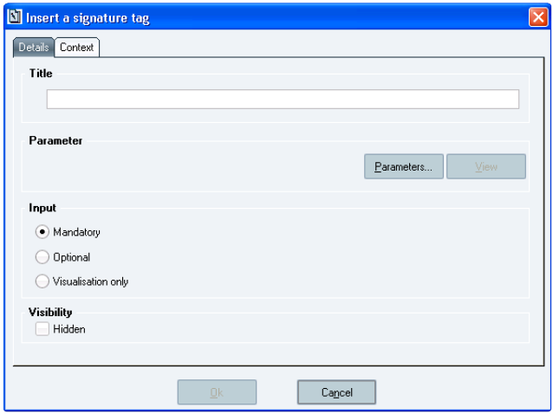

**The *Insert a signature tag* window**

### 8.3.27

The Splitting tag

The splitting tag is a plugin tag which allows splitting a container:

224

Sp-EBRDesign-2511

*Creating a PI*

*The PI Text Tab*

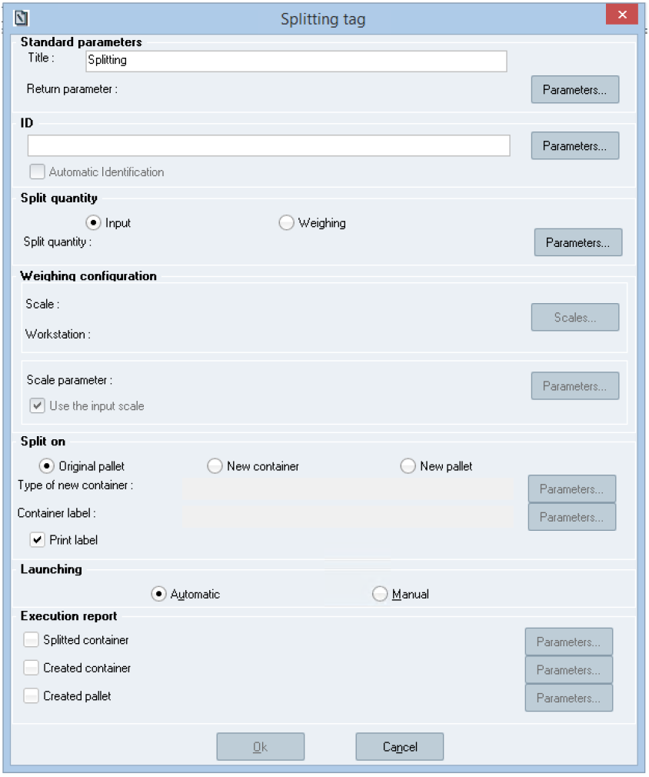

**The *Splitting tag* window**

**Window description:**

**The *Standard parameters* section**

***Title:*** allows defining the title of the button which will appear in an Operating Text. By default, the prefix "Splitting" is added to the title.

***Return parameter:*** numeric parameter to store the execution-return code when the tag is executed. This parameter is mandatory.

**The *ID* section** (for "Identifier")**:**

Sp-EBRDesign-2511

225

*Creating a PI*

*The PI Text Tab*

That section allows defining the barcode of the container that the user has to split. It can be filled in manually by entering a fixed value or defined by clicking the *Parameters…* button.

It is also possible not to specify the container barcode to split when configuring the splitting tag to allow the operator to identify that barcode when the tag is executed.

***Automatic identification:*** this checkbox is only available once the ID has been defined:

If checked, the ID of the container will be automatically entered in a tag field (by using a parameter value

or fixed value)

If not, the ID of the container will be requested to the user.

Default value: not checked.

**The *Split quantity*** **section:**

The quantity of containers to create can be filled in manually (i.e. the *Input* radio button is ticked) or weighed from connected scales (i.e. the *Weighing* radio button is ticked).

Default value: the *Input* radio button is ticked.

***Split quantity:*** Numeric parameter to store the entered or weighed quantity of the created container. This

parameter is mandatory.

If the *Input* radio button is ticked:

There are no requirements for the "Split Quantity" return parameter. When the tag is executed, the quantity will

be manually entered and expressed in stock unit of item for a container. The value of the quantity is transferred with no conversion unit.

If the *Weighing* radio button is ticked:

The item of the container that has been identified must display the *Manufacturing weighing* AND

*weighing in Dpy* options set to *Yes*. The configuration of the item is checked when it is executed (not when designed).

A mass unit must be set (see the Split Quantity parameter) to convert scale unit into parameter unit. The configuration of the parameter is done when it is executed (not when designed).

Setting the "weighing configuration" up is mandatory.

**The *Weighing configuration* section:**

Allows managing the way the scales will be used:

***Scale/ Workstation*** by clicking the *Scales…* button to select available scales. Once the scales are defined, the user has no other choice but using them in Execution.

***Scale parameter*** by clicking the *Parameters…* button to select a text parameter and by ticking the *Use the input* *scale* check box – or not. Its configuration is mandatory.

If that parameter is set with a parameter that will get a recorded value before the tag is executed AND if the check box *Use the input scale* is ticked, then the scales (inside the value of the parameter) is imposed in Execution.

In all the other cases, the scale parameter is a return parameter that returns the value of the scale that is used to split containers:

Cases and their corresponding configuration

226 Sp-EBRDesign-2511

**Cases**

*Creating a PI*

*The PI Text Tab*

**Configuration**

The operator must use the selected scales during design

The operator must use scales from the value of a parameter

The user is free to select the scales from current workstation

**The *Split on* section:**

*Scale/ Workstation* when the *Scales…* button is available: with a selected scale

*Scale parameter:* with a parameter (with or without value planed before the tag is executed). The parameter is a return parameter

The *Use the input scale* check box: checked or not

*Scale/ Workstation* (with the *Scales…* button): empty

*Scale parameter:* with a parameter that **will get** a recorded value before the tag is executed

The *Use the input scale* check box: checked

*Scale/ Workstation* (with the *Scales…* button): empty

*Scale parameter:* with a parameter that **will not get** a recorded value before the tag is executed. The parameter is a return parameter.

The *Use the input scale* check box: checked

*Scale/ Workstation* (with the *Scales…* button): empty

*Scale parameter:* with a parameter (that will or will not get a recorded value before the tag is executed). The parameter is a return parameter The *Use the input scale* check box: checked

The new container can be created on the/a:

***Original pallet***

***New container:*** on the same location as the one used for the original container. The original container cannot be located into a pallet location; otherwise an error occurs in Execution;

***New pallet:*** on the same location as the one used for the original container.

Default value: Original pallet.

***Type of new container:*** allows modifying the type of new container (when it differs from the original container).

The type of new container can be filled in with a fixed value or a text parameter.

That option is only available when splitting a new container. It is not mandatory. If not filled in, the created container gets the same type as the one set for the original container.

***Container label:*** allows defining the label template for a new container. The container label can be filled in with a fixed value or a text parameter.

That option is only available when splitting a new container. It is not mandatory. If not filled in, the label template is identical to the one set for the original container.

***Print label:*** when that check box is ticked, the container label is automatically printed when validating the splitting operation.

Warning: if that option is selected, the printing configuration must have been defined; otherwise no container will be created.

**The *Launching* section:**

Allows defining if the tag is automatically of manually (i.e. click by the user) executed as soon as it is available.   
The *Automatic* radio button is ticked by default.

Sp-EBRDesign-2511 227

*Creating a PI*

*The PI Text Tab*

**The *Execution return*** **section:**   
Optional configuration.

***Split container:*** Text parameter to store the ID of the split container.

***Created container:*** Text parameter to store the ID of the split container created.

***Created pallet:*** Text parameter to store the code of the split pallet if the *New pallet* option (from the *Split on* section) is selected.

### 8.3.28 The Stock-Adjustment Tag

The Stock-Adjustment tag enables the user to adjust a container stock in Opcenter Execution Pharma.   
Once inserted, the tag is displayed as a button which contains the defined title from the following window.

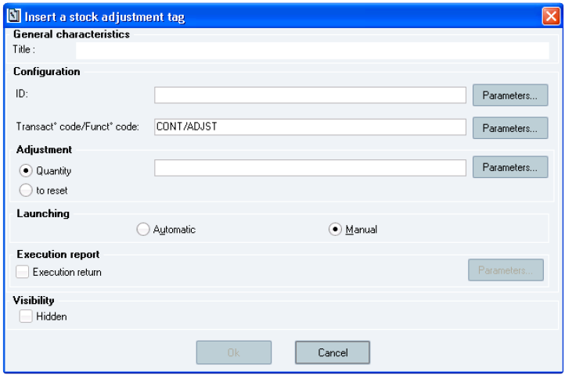

**The *Insert a stock adjustment tag* window**

**Window description:**

**The *Configuration* section** (parameters) **and the** ***Adjustment* sub-section:**

The container (i.e. ID), function code/transaction code, and quantity are the three tag attributes. If the Container (i.e. ID) and Quantity parameters are not defined, the *Ok* button is still shaded (i.e. not available). The Transaction code and Function code parameters are respectively initialised with the CONT and ADJST (Stock adjustment transaction) codes.

The container corresponds to a container code (type: 49-character alphanumeric field). **Mandatory** input. The container parameter inserted into the tag is of Barcode-identification type (i.e. Warehouse-barcode type).

The user can tick either the *to reset* radio button (to directly reset the container quantity) or the default *Quantity* radio button (i.e. thus corresponds to the quantity to adjust for the input entity). It is expressed in stock unit (type: alphanumeric characters). **Mandatory input if the option is activated**. This quantity can be negative or positive.

**The *Launching* section:**

228 Sp-EBRDesign-2511

*Creating a PI*

*The PI Text Tab*

***Automatic/Manual:*** defines if the tag is activated automatically or manually (i.e. user's click) as soon as it is available.

**The *Execution report* section** (Return parameters)***:***

***Execution return*** (return code)***:*** indicates the return value of the workflow tag by using a code.

The return code indicates:

the error code (its value differs from *0*) if the tag was not correctly executed;

*0* if the tag was correctly executed

### 8.3.29 The Text Tag

When inserted into the PI text, a text tag enables the user to define a text field that will have to be filled in when executing the PI:

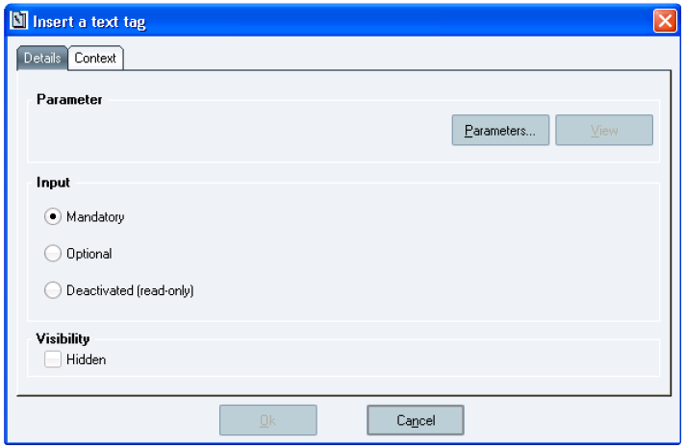

**The *Insert a text tag* window**

Once inserted, the tag becomes an input zone which contains the name of the associated parameter.

### 8.3.30 The Time Tag

When inserted into the PI text, a time tag enables the user to define a time field that will have to be filled in when executing the PI.

According to the configuration (the linked Time parameter is timestamped or not) a time picker or a calendar / time pickers are displayed to help the user. The Manual input are authorized.

The initialization value can be modified for this type of tag.

Once inserted, the tag becomes an input zone which contains the name of the associated parameter.

Sp-EBRDesign-2511 229

*Creating a PI*

*The PI Text Tab*

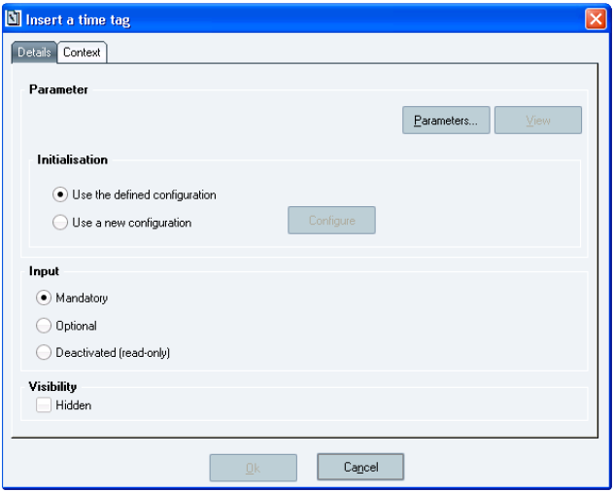

**The *Insert a time tag* window**

### 8.3.31

The Weighing Tag

When inserted into the PI text, a weighing tag enable, when executing the PI:

To get a weight by using scales that are connected to the workstation;

To reset scales;

To do as if there were scales which were connected to the system when testing it.

Once inserted, the tag is displayed as a button that contains the name of the tag.

#### [8.3.31.1](http://8.3.31.1) Declaring a Tag

The weighing tag is not really a type of parameter, but is made up of 2 numeric parameters and one text parameter that are defined as follows:

**Weighing Tag**

**Parameter function**

Acquisition results

Tag return value

Name of the last scale used in the current PI

230

**Fields**

Acquisition result

Execution return

Scale parameter

**Type of parameter**

Numeric

Numeric

Text

 Sp-EBRDesign-2511

#### [8.3.31.2](http://8.3.31.2)

*Creating a PI*

*The PI Text Tab*

Using the Parameter

The following window is displayed when inserting a weighing tag:

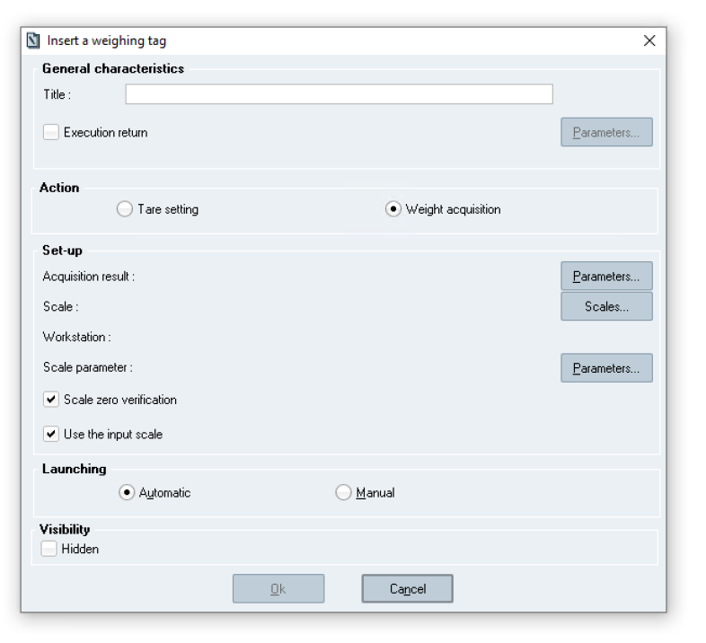

**The *Insert a weighing tag* window**

**Window description:**

The tag characteristics cannot be modified.   
**The *General characteristics* section:**

**Title**: in the PI, the Weighing tag corresponds to a button. The input title is the name of that button (type: alphanumeric field). Mandatory input.

***Execution return:*** Allows identifying a numeric parameter in which the result of the execution will be recorded. Optional – activated only if the *Execution return* check box is selected.

**The *Action* section:**

***Tare setting:*** the scales will acquire the weight and will then be reset. The acquired weight will be stored in the

*Acquisition results* parameter*.*

***Weight acquisition:*** the scales acquire the weight and store the value in the *Acquisition results* parameter*.*

Both actions exclude each other.   
**The *Set-up* section:**

Sp-EBRDesign-2511 231

*Creating a PI*

*The PI Text Tab*

***Acquisition result*:** Weight acquisition parameter (numeric parameter). The unit is one of the following: mg, g, or kg. The weight acquired with the scales is converted into the unit that is imposed by the parameter. Mandatory. ***Scale/Workstation:*** defined to impose a scale. The choice of the scale is ensured by the *Scales …* button, which enables the user to access the list of all known scale. The imposed scale is identified by its name (*Scale* field) and its WDU (*Workstation* field). No virtual scale can be selected.

***Scale parameter*:** text parameter used to store the used scale. Mandatory.

***Scale zero verification****:* if that check box is ticked, the system checks that the scales are reset before weighing. If not checked, it suggests resetting the scales or to exit. Default value: selected*.*

***Use the input scale:*** automatically selects the scale that has been used, in the current PI, during the last weighing procedure (if any) using a tag configured with the same *scale parameter.* Default value: selected. ***Parameters…:*** allows displaying the list of Numeric or Text parameters (according to the case).

### 8.3.32

The WO Launch tag

A WO launch tag is used to create a WO and to launch/merge it with a selected PI:

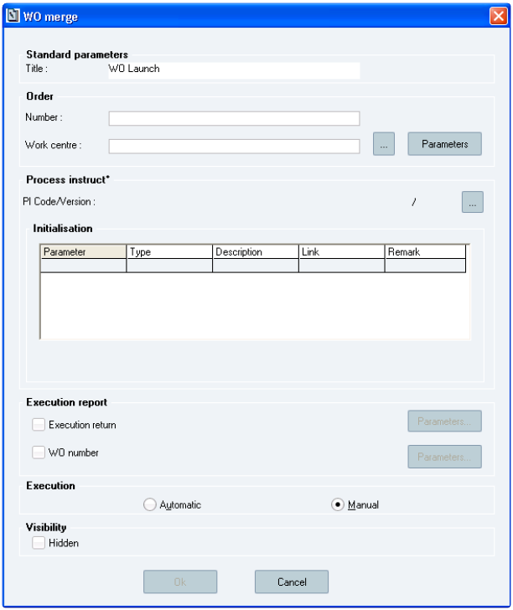

**The *WO merge* window**

**Window description:**

**The *Standard parameters* section:**

232

Sp-EBRDesign-2511

*Creating a PI*

*The PI Text Tab*

***Title:*** alphanumeric string that appears on the tag once it is inserted in the Operating Text. Mandatory (type: 60- character alphanumeric field).

**The (Work) *Order* section:**

***Number:*** mandatory field. Is used to define how the WO number will be created.

The WO number is created from different parts. Each part is of different types:

An alphanumeric chain

A PI parameter: is recognized as a parameter because it is in square brackets

A counter: is identified by a set of "####". Their number allows knowing how many characters can be displayed on the counter. There can only be one string of number signs (i.e. #) in the WO number.

The length of the counter added to the other parts cannot exceed ten characters.

E.g.: TT####[PARAM1]

If the value of the counter is 19987 and the PARAM1 holds XX, the new WO number will be TT9988XX.   
If the value of the counter is 2 and the PARAM1 holds XX, the new WO number will be TT0003XX.

***Work centre:***

Optional field. The work centre is the work centre from where the WO will be created. The work centre is either:

Hard-coded

Must be an available work centre

Can be manually entered or selected in the list of available work centres   
 Provided by a parameter

The value is provided by parameter (parameter code in square brackets). The parameter code can be manually entered or selected from the list of text parameters that are not obsolete.

**The *Process instruct°* section:**

Mandatory field. The PI that will be merged with the WO is identified by its code and a version. The PI version must meet version selection rules (it is linked to the PI in which the WO Launch tag is inserted. For each PI that is used in the main PI, the selected version and the latest non-obsolete version are shown).

The PI code can be manually entered or selected from the list of non-obsolete pIs.

This PI input parameters can be linked to values or to a PI code. This link follows the same rules as when a PI that is called by another PI.

**The *Execution report* section:**

***Execution return*:** Is used to determine the numeric tag in which the identification result will be recorded.

Optional – activated if the *Execution return* check box is selected.

***WO number*:** Is used to determine the text tag in which the created WO number will be recorded. Optional – activated if the *WO number* check box is selected.

**The *Execution* section:**

***Automatic/Manual:*** defines if the tag is launched automatically or manually as soon as it is available.

### 8.3.33 Labels & Conditions

PIs are executed from the left to the right and from the top to the bottom. Nevertheless, operators sometimes have to carry out the same sequence of PI instructions several times.

The use of labels and conditions enables the user to "break" the sequence execution and therefore to allow looping.

Sp-EBRDesign-2511 233

*Creating a PI*

*The PI Text Tab*

#### [8.3.33.1](http://8.3.33.1)

Inserting Labels

A label is a text that can only be viewed when writing the PI. It enables the user to define key points on which loops and breaks will be set.

**Inserting labels outside/inside section cell**

Labels can be inserted by clicking these corresponding icons from the toolbox or from the *Label* function from the *Insert* tab.

**Important**

It is strongly recommended to avoid the creation of labels with the same name inside a PI text.

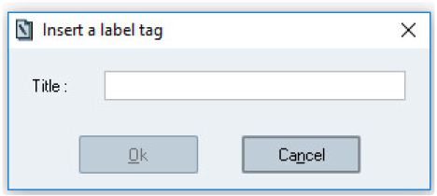

**The *Insert a label tag* window**

**Window description:**

***Title*:** heading of the label that is displayed in the PI text (type: 60-characters alphanumeric field, mandatory

field).

**Inserting labels at section level**

To be able to insert a section label, the condition that will refer to the label must be created first. Indeed, at section level, a label can be bound only one time and can be selected only for a specific condition.

If the user clicks on a line corresponding to an existing condition, a sub menu is displayed. This menu contains lines to insert labels:

A line with the comparator "**<**" (displayed only if the condition is not already linked to this comparator)   
 A line with the comparator "**=**" (displayed only if the condition is not already linked to this comparator)   
 A line with the comparator "**>**" (displayed only if the condition is not already linked to this comparator)

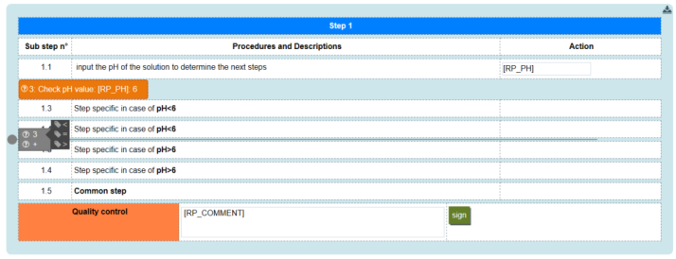

**Insertion of a label at section level**

234 Sp-EBRDesign-2511

*Creating a PI*

*The PI Text Tab*

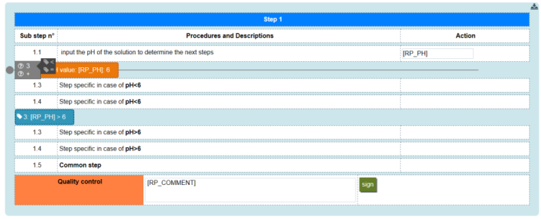

**Insertion of a label at section level of a condition already bind to label '>'**

When the user clicks on a line to insert a label, a label is inserted in the line. The text displayed in the label is formatted as below:

"<Insertion index> : <parameter to compare> <comparator> <value to compare>"

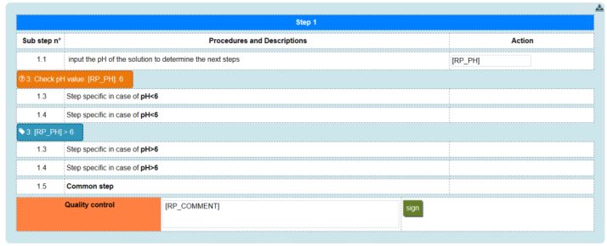

**Label at section level**

#### [8.3.33.2](http://8.3.33.2)

Creating a Condition

Conditions enable the user to define tests and to re-route the PI sequence execution according to the results of these tests (go to a specific label).

According to the container of the condition, only labels created in the same containter are available:

Outside section: the condition takes into account only labels located outside section.

Inside section cell: the condition takes into account only labels located inside the same cell. Inside section: the condition takes into account only labels located at the section level.

**Note:** Script tag inherits of this scope notion.

If a Script tag is defined outside a section, it can be linked only to Label tags defined outside sections.

If a Script tag is defined inside a section cell, it can be linked only to Label tags defined in the same section cell.

**Inserting condition outside/inside section cell**

Conditions can be inserted by clicking these corresponding icons from the toolbox or from the *Condition and* *connection* function from the *Insert* tab

After click, the condition popup is raised to configure the condition and labels linked to the condition.

Sp-EBRDesign-2511

235

*Creating a PI*

*The PI Text Tab*

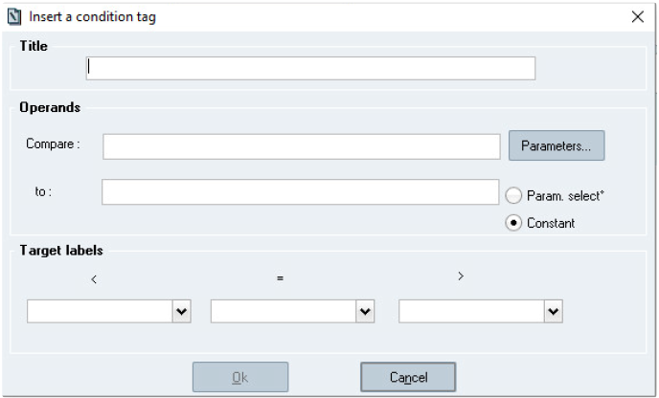

**The *Insert a condition tag* window**

**Window description:**

***Title*:** heading of the condition that is displayed in the PI text (optional field).

***Compare*:** 1st comparison operator. That field is filled in by selecting a value from the *Parameter list* window, after having clicked the *Parameters…* button.

***to*:** 2nd comparison operator. That field can display two types of value: a constant (text or numeric) or another parameter.

**Target labels:** The user can only bind labels created previously..

Thus when executing the PI, a comparison is made between operator 1 and operator 2. The result of this comparison can be one of the 3 following values:

**1. < :**

If the 1st Operand < 2nd Operand, the PI execution will restart from the tag which follows the label that is indicated under the sign "<".

**2. = :**

If the 1st Operand = 2nd Operand, the PI execution will restart from the tag which follows the label that is indicated under the sign "=".

**3. > :**

If the 1st Operand > 2nd Operand, the PI execution will restart from the tag which follows the label that is indicated under the sign ">".

**Note**: The tag that is located after the condition is executed if no label has been specified.

**Inserting conditions at section level**

The user moves the mouse over the expected section line. Then, a line appears. The user can click on this line to display the menu which allows to insert condition or labels. This menu contains:

A line with condition icon and the text "+" to insert new condition (always displayed)

A line with condition icon and the insertion index for each condition defined in the section, the condition is displayed in the menu only if it has at least one comparator not bind to labels

236 Sp-EBRDesign-2511

*Creating a PI*

*The PI Text Tab*

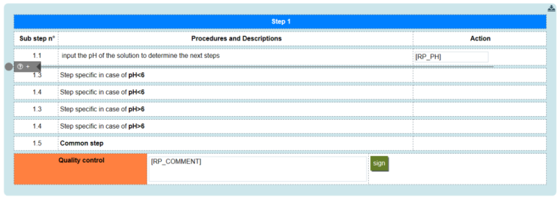

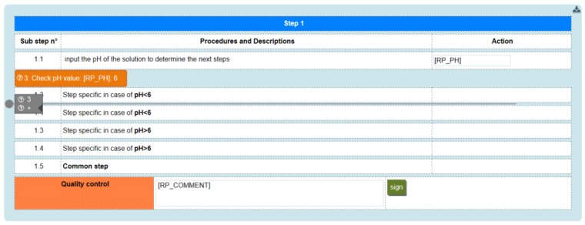**insertion of a condition at section level**

**Insertion of a new condition at section level, in a section containing a previously created condition not using** **all comparators**

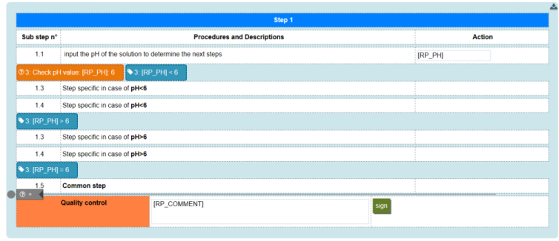

**Insertion of a new condition at section level in a section containing a previously created condition using all** **comparators**

When the user clicks on the line to insert new condition, a condition popup is raised to configure the condition.

Sp-EBRDesign-2511 237

*Creating a PI*

*The PI Text Tab*

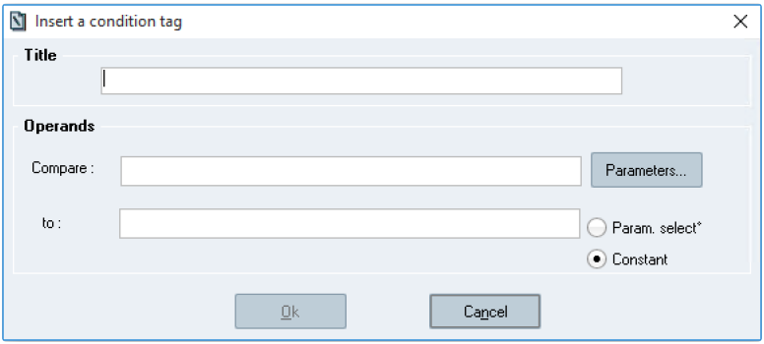

**The *Insert a condition tag inside section* window**

The popup is the same as condition inside or outside section but without label selection (selection of labels per comparators).

If the user clicks on "OK" button, the condition is inserted in the line and the text displayed in the condition is formatted as below:

"<Insertion index> : <title> : <parameter to compare> : <value to compare>"   
If the user clicks on "Cancel" button, the condition is not inserted.

#### [8.3.33.3](http://8.3.33.3) Delete a section labels

To delete labels at section level, the user should move the mouse over the label he wants to delete. Then, a button is displayed on the top right corner: .

When the user clicks on this button, the label is removed and the configuration of the linked condition is updated (a new label corresponding to the deleted comparator can be inserted now).

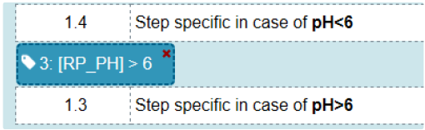

**Delete button displayed when mouse pointer is over label**

#### [8.3.33.4](http://8.3.33.4) Edit section condition

To edit condition at section level, the user should move the mouse over the condition he wants to edit, a button is

displayed on top right corner: . When the user clicks on it, a pop-up is displayed (same as previous version) but without label selection (selection of labels per comparators). Fields of the pop up are filled with current configuration of condition.

If the user clicks on "OK" button, the text displayed in the condition tag and in the linked label tags is updated according new configuration of the condition.

If the user clicks on "Cancel" button, condition tag and linked label tags are not updated.

238 Sp-EBRDesign-2511

#### [8.3.33.5](http://8.3.33.5)

*Creating a PI*

*The PI Text Tab*

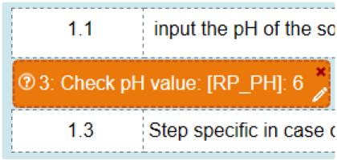

**Edit button displayed when mouse pointer is over condition**

Delete a section condition

To delete a condition at section level, the user should move the mouse over the condition he wants to delete, a button is display on top right corner: . When the user click on this button, the condition is deleted and linked

labels are updated (the icon displayed for "unlink" labels is

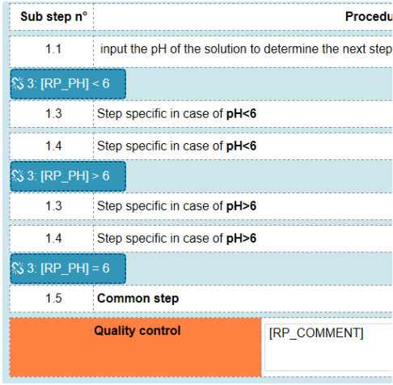

**"unlink" labels**

).

#### [8.3.33.6](http://8.3.33.6)

Rebind section label to section condition

To rebind a label, the user should move the mouse over the label he wants to rebind, a button is displayed on top right corner , the button is displayed only on "unlink" labels. When the user clicks on this button, a menu is displayed, which contains:

A line with condition icon and the insertion index for each condition defined in the section, the condition is displayed in the menu only if it has at least one comparator not bind to labels

When the user moves the mouse over the condition index in the menu, a sub menu is displayed, which contains:

A line with the comparator "**<**" (displayed only if the condition is not already linked for this comparator)   
 A line with the comparator "**=**" (displayed only if the condition is not already linked for this comparator)

Sp-EBRDesign-2511 239

*Creating a PI*

*The PI Text Tab*

A line with the comparator "**>**" (displayed only if the condition is not already linked for this comparator)

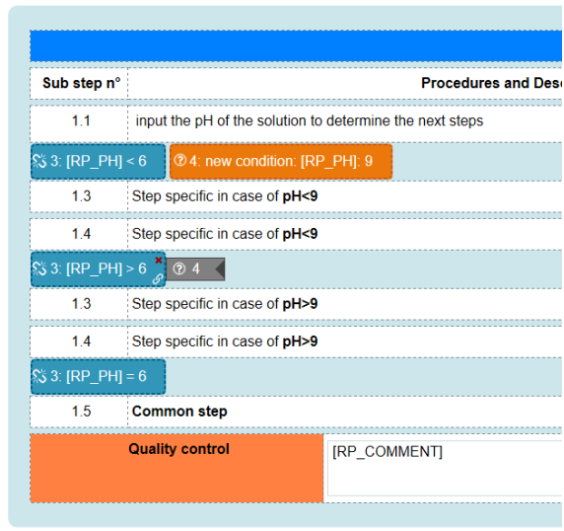

**"unlink" label before rebind**

When the user clicks on a line, the configuration of the condition now linked to this label is updated, the text

displayed in the label is updated according to the condition configuration and the label icon is replaced.

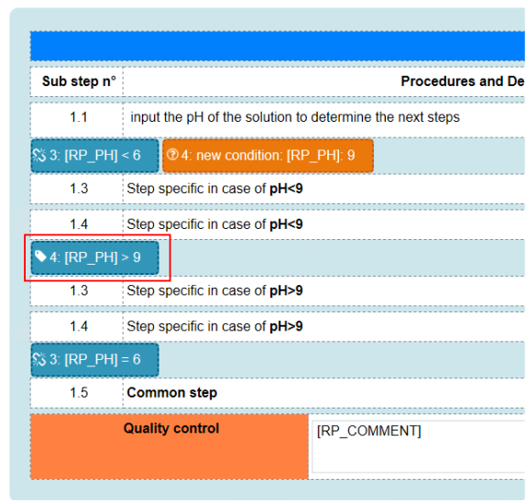

**"unlink" label after rebind**

240 Sp-EBRDesign-2511

### 8.3.34

*Creating a PI*

*The PI Text Tab*

Print Preview for a PI that is currently being written

#### [8.3.34.1](http://8.3.34.1)

Accessing the Functionality

The access to that functionality requires a specific access right (1526: PRINT PI EDITION).

The functionality is accessed only from Text tab and by clicking the *Print preview* function from the *File* menu or the *Print preview* icon from the toolbar of the *PI Management – [Process instructions: Name]* window (see Writing the PI Text > Formatting the Text and Paragraphs).

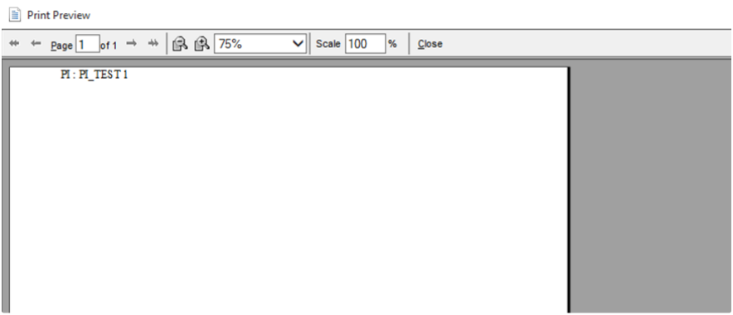

**The *Print preview* window**

**Window description:**

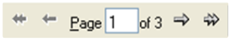

: tools to browse pages that are included in the preview.

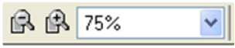

: allows zooming in and/or zooming out.

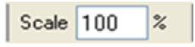

: allows modifying the size of the text.

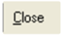

: allows closing the *Print preview* window.

#### [8.3.34.2](http://8.3.34.2)

Displaying the Preview

It aims at displaying the PI text as it will be printed.

It includes:

A page header which includes the references (i.e. code and index) of the PI to print; The PI text;

Sp-EBRDesign-2511

241

*Creating a PI*

*The Alerts Tab*

A page footer which includes the name of the operator who print the document, the page number, the total number of pages, and the date and time when the document was printed.

### 8.3.35 Printing a PI that is currently being written

Accessing that functionality requires a specific access right (1526: PRINT PI EDITION). Each time a document is printed, it is traced in the PI traces.

The functionality is accessed only from Text tab and by clicking the *Print* function from the *File* menu or the *Print PI* icon from the toolbar of the *PI Management – [Process instructions: Name]* window (see Writing the PI Text > Formatting the Text and Paragraphs).

When the user this functionality, the document is sent to the default printer.   
Once printed, the PI includes (it is possible to use a specific print template):

The page header, with:

The PI code/ version

The page footer:

The name of the user who printed the document

The page number/ total number of pages

The date and time when the document was printed

## 8.4 The Alerts Tab

### 8.4.1 Aim

When executing the tag, two types of alerts can be managed according to the context (i.e. *Remarks* or *Deviations)*. The context of activation, tracking, and validation path of the alerts are managed for each PI from *the* *Alert* tab. That tab enables the user to configure how alerts are entered and processed when executing the PI.

These alerts can be activated:

When the user asks for it: when entering an alert (type: *Remarks* or *Deviations*). This can be done at any time

during the process.

When an alert with the *Deviations* type is entered after a critical action:

A tag or an element is forced: the activation – or not – of an alert which displays the *Deviation* type can be configured.

Re-executing an erroneous element: the activation – or not – of an alert which displays the *Deviation* type can be configured.

Exceeded tolerance interval: an alert which displays the *Deviation* type is systematically activated.

When there is an intervention on a workflow that is performed in Manual mode: an alert which displays the *Deviations* type is systematically activated.

Alert generated after entering an alert tag: the writer could insert an alert tag which allows the operator to enter an alert during the manufacturing process. The type of alert depends on how the tag has been configured.

According to the defined configuration, alerts may require a signature path to be validated.

The module allows configuring how that alerts is managed, so as to make best use of these alerts during the final review stage of the batch record.

242 Sp-EBRDesign-2511

### 8.4.2

*Creating a PI*

*The Links Tab*

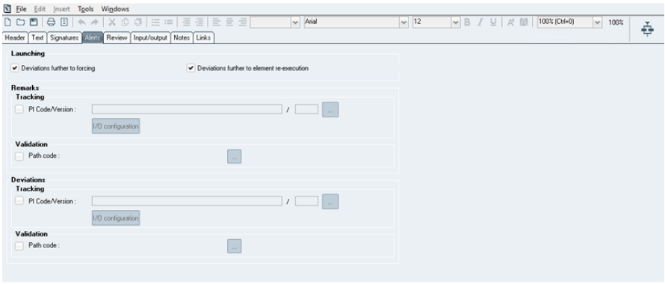Configuring Alerts

**The *PI Management – [Process instructions: Name]* window – when the Alerts tab has been clicked** **Window description:**

**The *Launching* section:**

Allows defining the context of activation

***Deviations further to forcing:*** if a tag or an element has been forced   
 ***Deviations further to element re-execution:*** if an element is re-executed.

**The *Remarks* and *Deviations* sections:**

For both types of alert (i.e. Remark/ Deviation), the system allows configuring:

The PI to execute if an alert is generated and of the potential input/output parameters, which enable the user to exchange data with that PI.

The signature path which allows validating the input alerts. To be validated, all the remarks that are entered into that PI must follow the signature path. By default, both signature paths are left blank. Optional fields.

**Warnings:**

If the signature path is not defined, the Deviation or Remark is automatically validated as soon as it is entered.

Do not use cascading Alert PIs (Alert PI linked to another Alert PI). Some unexpected errors could occur in execution (especially if the sub Alert PI has Input/Output parameters).

Alerts created from Electronic Signatures do not manage input parameters. Please consider this limitation.   
 Alerts PIs are asynchronous tasks and cannot manage output parameters. The Alert PI full workflow execution could occur after the end of the calling PI. Please consider this in the PI design process.

## 8.5 The Links Tab

### 8.5.1 Version Links

It is said that a PI uses a parameter (or a script) when the parameter (or script) is directly referenced in a tag or an element of the PI.

Sp-EBRDesign-2511 243

*Creating a PI*

*The Links Tab*

A parameter that has been referenced by PI can refer to other parameters. That type of <parameter-parameter> link is not impacted by version control. Thus, when creating a parameter, the version that is proposed when using another parameter is the last non-obsolete version.

A script that is referenced by a PI can also refer to other scripts. This <script-script> link is managed by the script that is referenced in the PI (for more information, see the ***Sp-ScriptManagement-i.pdf*** specification).

Generally speaking, a PI can only use a single version for a given entity (i.e. PI, parameter, or script).   
Information about that version can be found by clicking the *Links* tab.

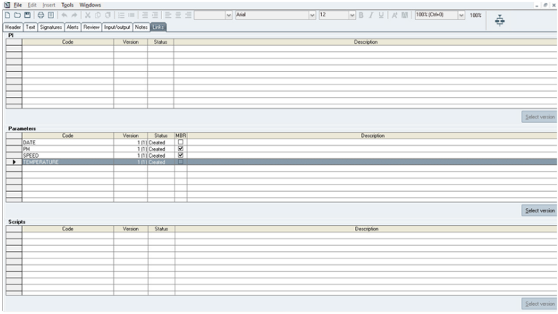

**The *PI Management – [Process instructions: Name]* window – when the Links tab has been clicked**

#### [8.5.1.1](http://8.5.1.1) Window Description

Three distinct parts are displayed on that window. Each one includes a list (i.e. of parameters, of PIs, and of scripts that are used in the selected PI), which is displayed in a table.

The columns of the three lists are the following:

***Code****:* code of the used entity (i.e. parameter or PI);

***Version****:* version which has been used (0 if entity does not exist), with the last non-obsolete version of that entity displayed between brackets;

***Description****:* version description;

***Status****:* status of the version for the corresponding entity.

***MBR*** (only for Parameter list)*:* editable checkbox to define the MBR relevant criteria for a specific parameter. The modification is taken into account when the PI is saved. *Not MBR relevant by default*;

Each part includes a *Select version* button to select the version of the corresponding entity:

244 Sp-EBRDesign-2511

#### [8.5.1.2](http://8.5.1.2)

*Creating a PI*

*The Links Tab*

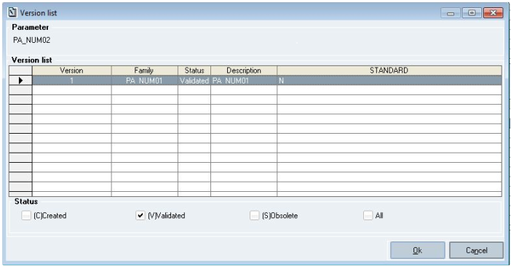

**The *Version list* window**

Generating Links

Generating a link can have various origins:   
 Inserting a tag with associated parameters;

Inserting an element with associated parameters;

Inserting a PI element;

Inserting a Batch element with a recipe that includes an Event PI;   
 Copying/Pasting a text or a workflow from another PI;

Importing an HTML text or an flw workflow from a file;

Adding PI input/output parameters;

Inserting a script tag/element;

Importing a section template.

In all cases, the rule is the following:

If a link is automatically created with a parameter/PI/script that is not yet referenced, the last non-obsolete

version of that entity is used.

If it is a linked PI (configured as an Event PI in the batch element) the created link is the one that has been configured in the Batch element (i.e. the latest validated version of the Event PI when the Batch element was last configured).

If a link is automatically created with a parameter or a script which is not existing yet. In this case, the version of the entity is 0 until the entity will be created.

#### [8.5.1.3](http://8.5.1.3)

Selecting a Parameter

When writing a PI, the writer may have to select a parameter.

There are three possibilities:

The code can be entered manually.

When validating the input:

a version link is already available for that parameter; in that case, the corresponding version is automatically used, or

no link is available for that parameter; if so, the last non-obsolete version is automatically used and a link is created for that parameter and that version.

Sp-EBRDesign-2511

245

*Creating a PI*

*The Links Tab*

A value is selected from a drop-down list of parameter codes (a formula is created).   
When validating the creation of the formula:

a version link is already available for that parameter; if so, the corresponding version is automatically used, or   
 no link is available for that parameter; if so, the last non-obsolete version is automatically used and a link is created for that parameter and that version.

A value is selected from a list after having clicked a button. That list displays all the parameters that can be selected:

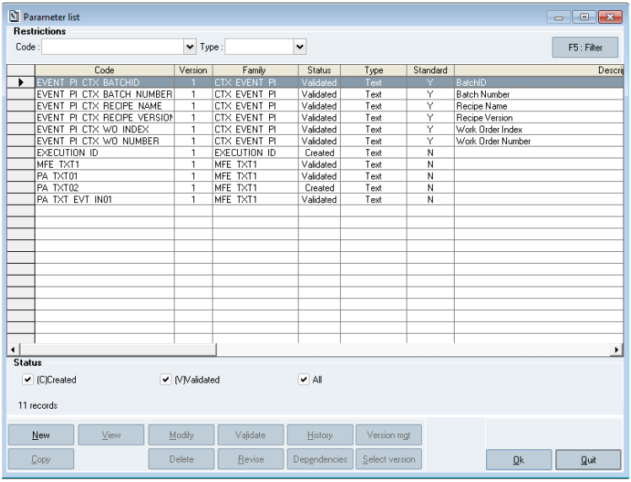

**The *Parameter list* window**

**Window description:**

**The table of parameters:**

From that list, each parameter gets a code and a version. The displayed version is the one that is inserted if the parameter was selected:

the version that is included in version links, if any, or   
 the latest non-obsolete version.

**The buttons below:**

***New:*** allows adding a new parameter;

***Modify:*** allows modifying the selected parameter/version, according to its status (if it is not possible to modify it, the button is not available);

***View:*** allows displaying the details of the selected parameter;

***Copy:*** allows copying the parameter;

246 Sp-EBRDesign-2511

*Creating a PI*

*The Links Tab*

***Revise:*** allows revising the parameter. This is possible only if the selected version corresponds to the last validated version and if no superior version is available for the parameter. If not, a message is displayed to explain the situation to the user;

***Version mgt:*** allows selecting another version. Clicking the *Select version* button allows opening the window from where non-obsolete versions are listed for the selected parameter. The version to use can then be selected by double-clicking it or by clicking the *Ok* button. After having selected the version, the version of the parameter is replaced from the main window, with the version selected from the intermediate window;

***Ok:*** allows validating the selection (it can also be validated by double-clicking a row).

If so:

a link is created if none is available for that parameter;

nothing changes if a link is available for that parameter and for the selected version;

if a link is available for that parameter, but for a different version, a message suggests the user either to keep on using the version defined in the link, or to modify the link so as to use the selected version from now on.

#### [8.5.1.4](http://8.5.1.4) Modifying a Link

Modifying a link from the *Links* tab can only be done if the PI displays the *Created* status.

Manually modifying a link, and therefore a used version, is made by using the 'Select Version' button, after selecting a link. The corresponding access rights are not checked here. Version links can be modified as long as the PI displays the *Created* status.

### 8.5.2 PI Links

PI-link management allows managing all the PIs that are used by a PI, and their versions.

It is said that a PI is used in another PI if it is directly referenced in an element PI or selected (i.e. checked) in the event PI tab of a batch element.

PI-link management is performed the same way as it is done for parameter management:

Generation – Deletion - Modification

If it is a linked PI (configured as an Event PI in a Batch element) the link cannot be modified.

**Important Note:**

For Cyclic Operation Element:

If there is a PI element and CO element in the same workflow, then there is a restriction to use the open PI of CO element as sub PI in the PI element, if open PI is used as sub PI in this case the user will not be allowed to select another PI version from the links tab, the link verification will show duplicate link with same versions in the link tab and if user wants to upgrade the PI version it will not allow to do so.

As per standard behavior, it is recommended to use the same version of Open PI in the workflow in case more than one cyclic operation element is used, to avoid any inconsistency regarding version of open PI. Also, User will get the warning pop up in case different version of Open PI will be given inside the different cyclic operation element. If user gets this warning message, it is expected to correct the version in order to be aligned with the workflow. The warning message will be as below:

Sp-EBRDesign-2511 247

*Creating a PI*

*The Links Tab*

### 8.5.3

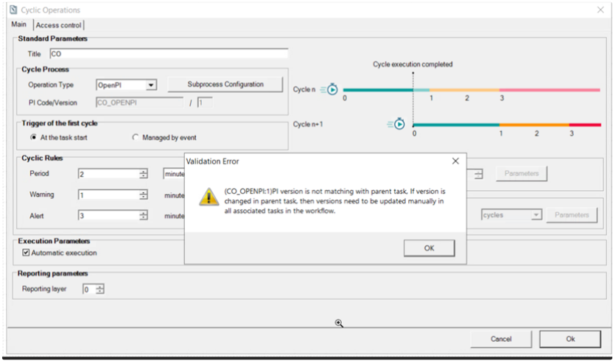

Script Links

Script-link management allows managing all the scripts that are used by a PI, and their versions.

Script-link management is performed the same way as it is done for parameter management:

Generation – Deletion - Modification

A user may want to choose a script while designing a PI:

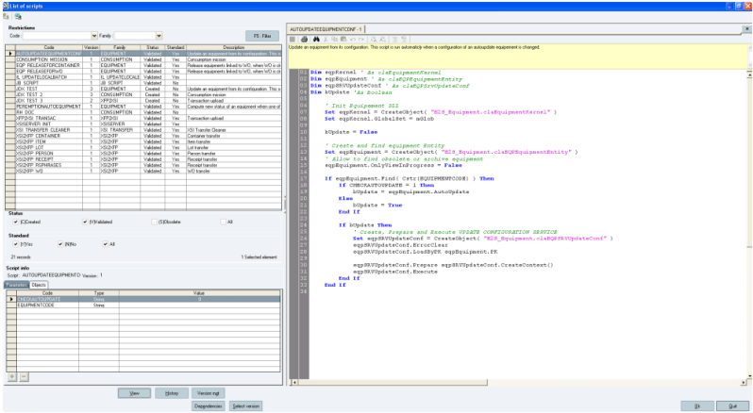

**The *List of scripts* window**

This list displays all the scripts that can be selected by providing:

248

Sp-EBRDesign-2511

*Creating a PI*

*The Links Tab*

Its latest version of non-obsolete scripts that are not used in a PI. The script/version pairs that are used in that PI

In that list, each script gets a code and a version. The version corresponds to the version that is inserted if the script is selected, which is either:

The version in the *Links* tab, if that link is available.   
 Or the latest non-obsolete version.

The following actions can be performed from that window:

Viewing the content of a script.

Validating the selection by clicking the *Ok* button or by double-clicking a row from the list.

If so:

If no link has already been created for that script, it is created and stored in the list of links from the *Links* tab.

If a link has already been created for that script and for the selected version, nothing from the list of links can be modified

If a link has already been created for that script but with a different version, the user is asked if s/he wants to keep on using the version that is defined in the links or to modify the link so that the new version is used.

It is also possible to select another version. Clicking the *Select version* button allows opening another window that displays the list of available (i.e. non-obsolete) versions. The version can be selected by double-clicking or by

selecting a version, to acknowledging by clicking the *Ok* button. Once a version is selected, the version of the script is replaced by the selected version. Obsolete scripts cannot be selected.

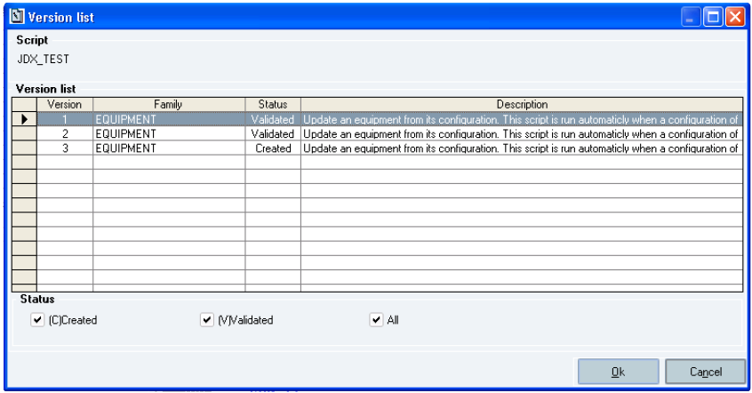

**The *Version list* window**

Note that a check of the script parameters is performed before upgrading the version. A message is displayed to

warn the user that there is a difference of parameter configuration between the current version of the script and version that is used by the selected PI:

Sp-EBRDesign-2511 249

*Creating a PI*

*The Signatures Tab*

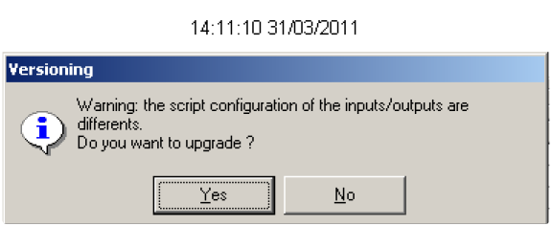

As a consequence, the user can decide to continue or to cancel the upgrade.

**Warning: If the user chooses to continue upgrading the version (i.e. by clicking the *Yes* button) then s/he has to check and manually update parameters of the script used by the updated PI.**

## 8.6 The Signatures Tab

The *Signatures* tab enables the user to select the signature path that will be used when validating that PI, before its use in production. Selecting a path displays the corresponding tree.

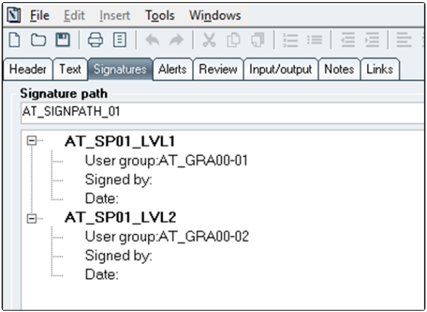

**The *PI Management – [Process instructions:* Name*]* window – when the *Signatures* tab has been clicked**

## 8.7 The Notes Tab

### 8.7.1 Window Description

Clicking the *Notes* tab displays a PI annotation tool.

That tab includes the exhaustive list of the notes which were entered for all the versions of the displayed PI.   
For each note, the system can display:

The PI version from which the note has been entered (and the code, of any);

250 Sp-EBRDesign-2511

*Creating a PI*

*The Notes Tab*

General information about the context of the notes; 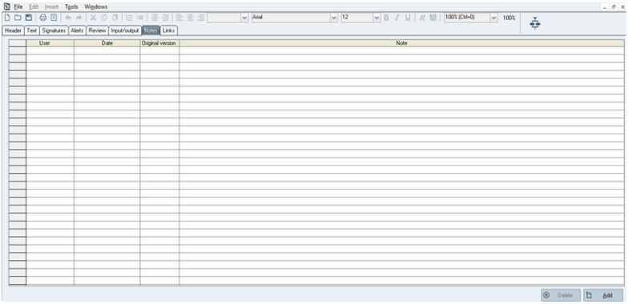The text of the corresponding notes.

**The PI Management – [Process instructions: Name] window – when the Notes tab has been clicked**

### 8.7.2 Notes Properties

Notes can be deleted after having been inserted. It requires a specific access right (1355: DELETE NOTE). Notes are retrieved when copying and revising a PI.

Notes can be added or deleted whatever the status of the annotated entity.

### 8.7.3 Adding Notes

Clicking the *Add* button allows displaying the following window to add notes:

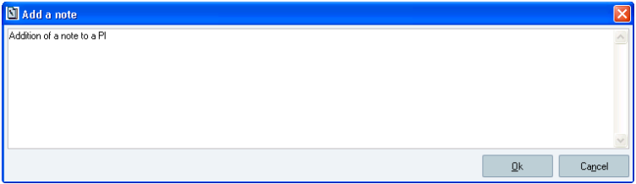

**The Add a note window**

The text that is entered from that window:

Can include several lines;

Is limited to 4,000 characters;

Corresponds to the text of the corresponding note, which will be displayed from the list of notes once validated (the list can display it on several lines).

Sp-EBRDesign-2511 251

*Creating a PI*

*The Input output Tab*

## 8.8 The Input output Tab

Input and output parameters can be defined for each PI, from the *Input/output* tab.

N.B.: during execution, the values of the parameters that are used by a PI are **local** to that PI (i.e. these values will not be directly accessible to **any** other PI).

E.g.:

PI A uses the parameter PH.

PI B uses the same parameter PH.   
PI A calls PI B.

When executing PI A, an operator enters the value 5 for the parameter PH.

PI A then calls PI B. The operator then enters the value 12 for the parameter PH in PI B.

If, afterwards, the parameter PH is viewed in PI B, its value is 12.

If, afterwards, the parameter PH is viewed in PI A, its value is 5.

Yet, input and output parameters can be used to communicate some parameter values between linked PIs.   
N.B.: a same parameter cannot be configured several times as input or output parameter (an error message is raised).

### 8.8.1 Input Parameters

PIs can have **none, one, or more** input parameters.

During execution, input parameters enable the user to exchange values between the calling PI and the called PI. If it is an Event PI, an input parameter can also be used to allow the transfer of a value between a parameter of a phase in a batch (from SIMATIC BATCH) and the PI defined as an Event PI.

### 8.8.2 Output Parameters

PIs can have **none, one, or more** output parameters.

During execution, output parameters enable the user to exchange values between the called PI and the calling PI.

### 8.8.3 Configuration

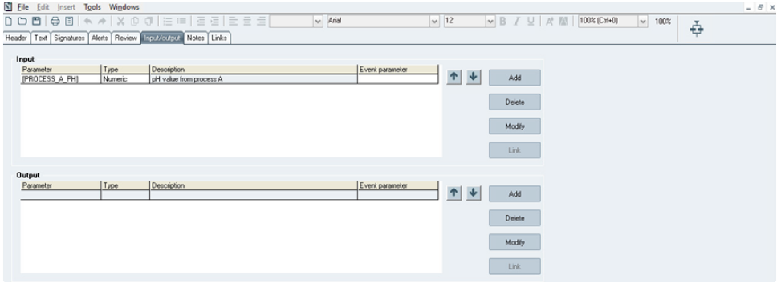

252 Sp-EBRDesign-2511

*Creating a PI*

*The Input output Tab*

**The *PI Management – [Process instructions: Name] window* – when the Input/output tab has been clicked** **Window description:**

**The *Input* and *Output* sections:**

***Add:*** enables the user to display the window that is used to enter the parameter and its characteristics:

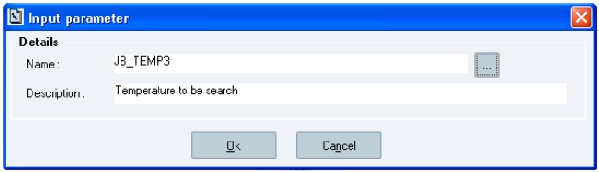

**The *Input parameter* window**

**Window description:**

***Name:*** name of the parameter (mandatory field – can be modified).

***…:*** displays the exhaustive list of non-obsolete PIs, except those with the "Formula" type.   
 ***Description:*** pre-entered with the parameter description but can still be edited.

N.B.: The *Input parameter* window is displayed when clicking the *Add* button from the *Input* section; the *Output parameter* window is displayed when clicking the *Add* button from the *Output* section.

***Delete:*** allows deleting the selected parameters from the corresponding list. That button is available only if at least one parameter has been selected.

***Modify:*** allows editing the selected parameter (from the *Input/ Output parameter* window). That button is available only if one and only one parameter has been selected.

***Link:*** allows linking an Opcenter Execution Pharma parameter with a "Phase type" parameter (SIMATIC BATCH) if the PI is defined as an Event PI. That link is not mandatory.

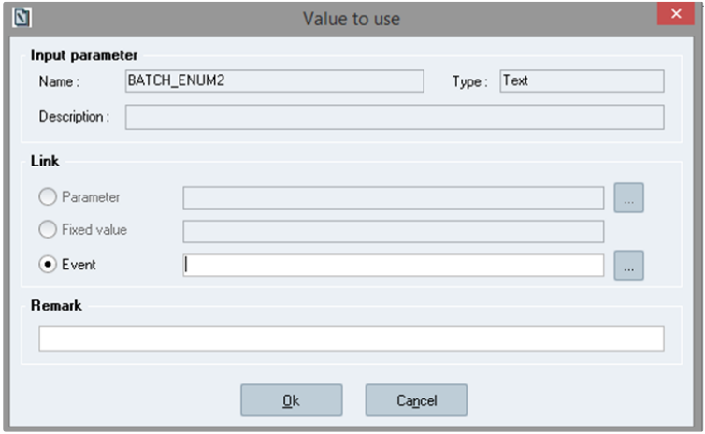

**Link Event PI input parameter to phase type parameter**

Sp-EBRDesign-2511 253

*Creating a PI*

*The Input output Tab*

The user can only select “Event” in this case. Clicking on “…” will open phase type parameters window. Only phase type compatible with the Opcenter Execution Pharma parameters type will be displayed.

If the event PI is generic (configured using wildcards), the displayed parameters are the ones common to all phase types matching the wildcard.

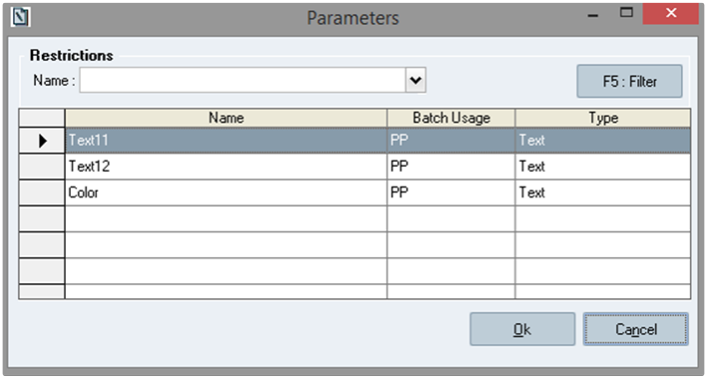

**Phase type parameter**

Once the link is configured, the name of the parameter is displayed in the *Event parameter* column (e.g. *[Event]xxxx*).

The Link button is shaded (i.e. not available) if the parameter is an output parameter or if the PI is not an Event PI. The *Event parameter* column is left blank.

Note: In the phase type parameter selection screen, to use the restriction, the user has to input it manually (cannot be selected from a list).



**and *:*** allow moving the selected parameter in the corresponding list. These buttons are available only once a parameter has been selected.

### 8.8.4 Modifying Parameters

If the PI is called from another PI, the input or output parameters that are added, modified, removed, or moved must be taken into account in the calling PI.

To do so, the following window is displayed as soon as the sheet is changed, when the PI is saved or closed:

254 Sp-EBRDesign-2511

*Creating a PI*

*The Review Tab*

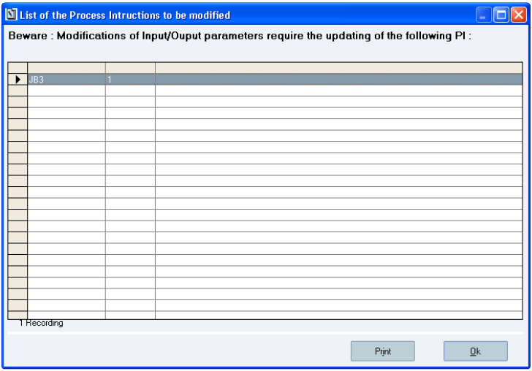

**The List of the Process Instructions to be modified window**

N.B.: The system displays the PIs that are impacted into that list, but does not update these PIs. The user has to open each calling PI, to open the properties of the PI element, and to validate by clicking the *Ok* button.

The user can print that list by clicking the *Print* button. The printed document will include the PI code, its version, and its description.

## 8.9 The Review Tab

The *Review* tab enables the user to select the signature path that will be used when reviewing the batch record

(see The Signatures Tab for further information about signature paths).Selecting a path displays the corresponding tree.

Sp-EBRDesign-2511 255

*Creating a PI*

*PI Translation*

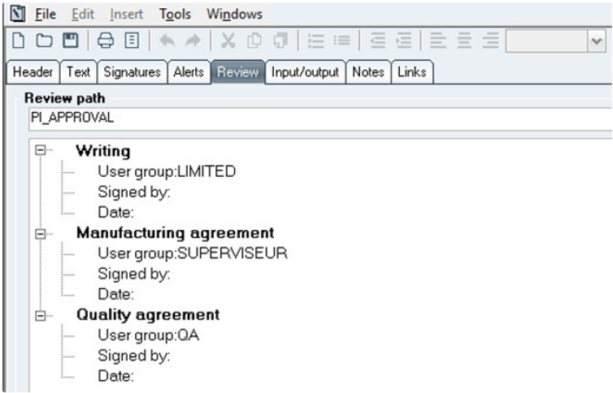

**The PI Management – [Process instructions: Name] window – when the Review tab has been clicked**

## 8.10 PI Translation

PI translation functionality can be activated using the configuration parameter PI_TRANSLATION_ENABLE.

When the translation is enabled, the parameter PI_LANGUAGES must be defined with languages managed by the system for the locale settings, using the ISO language and ISO country code (e.g : en_US, fr_FR…).

If the PI translation functionality is not activated, the behavior described in these sub-chapters is not applicable.

**Important**

To be able to translate the PI, instructions identification must be supported by this PI *(refer to* Writing the PI Text *>* *Instruction*).

### 8.10.1 PI Creation

When a PI is created using the "new" action, the system checks if the configuration parameter PI_LANGUAGES is well defined:

if there is no value or a defined value which does not match with a language managed by the system, a blocking message is displayed.

If the defined values are correct, the PI is created with a design language matching with the first value defined in the configuration parameter PI_LANGUAGES (default language).

### 8.10.2

PI Text translation

The PI design language is displayed on the toolbar of the PI Text tab.

256

Sp-EBRDesign-2511

*Creating a PI*

*PI Translation*



From PI text, the instructions and tags titles can be translated.

The translation is managed through the *Translation* tab displayed in the *Details* panel when a tag/instruction is selected. This tab is displayed only if the translation is activated and if the PI manages a Design language (*Refer* *to Contextual Menu when writing Text* to have detail about Details panel functionality).

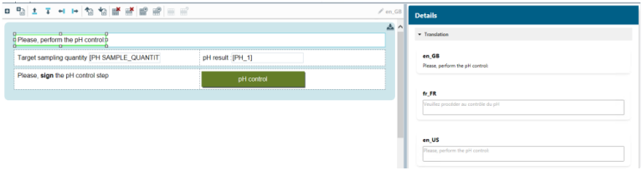

**Details panel displayed for a selected instruction when the PI translation is activated**

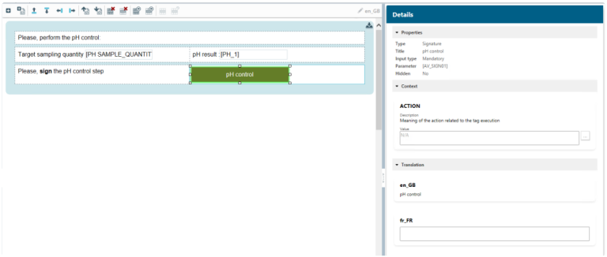

**Details panel displayed for a selected tag when the PI translation is activated**

**Translation part**

**xx_XX:** Languages (iso language and iso country code) available for translation. The design language is always displayed first, then the other languages are displayed in the order defined through the configuration parameter PI_LANGUAGES.

The label under the design language display the instruction message or the title of the tag as they are written in the Operating Text. This label can not be edited.

The fields under the other managed languages are used to translate. They can be edited if the PI status is 'Created'. These fields are empty if the translation is not yet performed.

Sp-EBRDesign-2511 257

*Creating a PI*

*PI Translation*

**Note**

Displayed instruction message may differ to the designed instruction:

'$n', it is due to parameter in read-only mode usage,

html tag like <strong></strong>, <em></em> or <u></u>, it is due to applied style regarding bold, italic and underline.

Refer to below section.

#### [8.10.2.1](http://8.10.2.1) Message translation management

When the PI text is saved, the system parses the PI text and creates in database the default messages associated to the instructions, tags and text parameters defined with list of values related to the design language.

The message for tags is the title of the tag defined during its configuration. Only tags having a title can be translated.

The message for text parameters configured with a list of predefined text values and referenced by text tags is built based on the concatenation of this values seprated by the character "|". This message can only be translated from the translation grid (refer to Edit PI translations).

*Text parameter possible values:* Yes, No

*Default message:* Yes|No

The message for instructions is built based on the instruction text visible in the PI Text and some rules:

Tags with Read-only input mode are replaced by '$n' where 'n' is the occurrence order of the tag within the

instruction.

Instruction: Target sampling quantity [PH SAMPLE_QUANTITY]   
*Default message: Target sampling quantity $1*

*=> Here $1 references the tag PH_SAMPLE_QUANTITY*   
 Bold text is surrounded by the html tag *<strong>*

*Instruction: Please,* ***sign*** *the pH control step*

*Default message: Please, <strong>sign</strong> the pH control step*

Underlined text is surrounded by the html tag *<u>* *Instruction: Please, sign the pH control step*

*Default message: Please, <u>sign</u> the pH control step*

Italic text is surrounded by the html tag *<em>*

*Instruction: Please, sign the pH control step*

*Default message: Please, <em>sign</em> the pH control step*

**Warning**

The person who performs the translation of the Operating Text at design time must pay attention to keep these parameters ($1, $2, $3…) and these html tags (<strong></strong>, <u></u>, <em></em>) when translating the messages in order to keep the tags values and the same styling in the translated message at execution time. These html tags could be not visible, depending on the style, don't be afraid if you don't see them.

258 Sp-EBRDesign-2511

*Creating a PI*

*PI Translation*

The translations can be added, updated, or deleted using the dedicated language fields. Each translation is recorded in the database as soon as the focus leaves the translation field (saving the PI does not save the translations).

#### [8.10.2.2](http://8.10.2.2)

PI text and translation consistency

To secure the consistency between the PI text content and all their translations, when the PI text is updated, the translation part from detail panel is locked and a warning message is displayed to inform the designer:

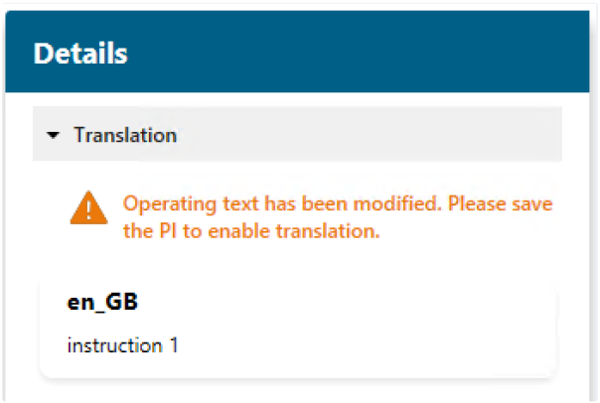

The translation fields cannot be edited as long as the PI text is not saved. Once the PI is saved, the translation is enabled again.

When the PI text is saved, the system compares the existing default messages in database to the ones in the operating text content:

If there are differencies on a tag , an instruction or values available for a parameter, the default message is updated and the related translations are deleted for the other managed languages.

If there are no differencies, the default message and its related translations are kept as it is.

When the unlock functionality is used to switch the instruction to free text, if translation was done for this instruction, the related translations messages are deleted when the PI is saved.

**Note**

As translated messages can be deleted after updating the PI text, it is recommended to do the translation at the end of the PI design process (before the PI validation).

Sp-EBRDesign-2511

259

*Creating a PI*

*PI Translation*

**Warning**

When the list of value of parameter used by text tag is modified from:

*The Parameter list* window (reach by tag configuration screen), the system detects the modication and the design/translated messages for the PI are updated regarding the modification.

*Parameter management* window, **the systems does not detect the modification** and design/translated messages for this specific parameter are not updated. So, inconsistency can occurs.

### 8.10.3 Workflow translation

When the workflow is saved, the system parses it and creates in database the default messages associated to the elements descriptions and corresponding to the design language.

Each message is built based on the description defined during the element configuration and this rule:   
 Parameters are replaced by '$n', where 'n' is the occurence order of the parameter within the element's

description.

*Element description: Transfert from [EQP_SOURCE] to [EQP_DEST]*   
*Default message: Transfert from $1 to $2*

*=> Here $1 references [EQP_SOURCE] parameter and $2 references [EQP_DEST] parameter*

The elements descriptions can be translated using the Translation management screen (refer to Edit PI translations).

When the Workflow is saved, the system compares the existing default messages in database to the ones in the description of workflow elements:

If there are differences on a description, the default message is updated and the related translations are deleted for the other managed languages.

If there are no differences, the default message and its related translations are kept as it is.

### 8.10.4 Edit PI translations

Default design messages are automatically generated when the PI is saved (Instructions, tags, text parameters with list of values or elements).

To translate those messages, the translation management grid is accessible from the menu tools -> Translation management when a PI is opened.

**Screen availability:**

Access is enabled if the PI Translation is activated.

Available for all PI statuses and for Archive mode

260 Sp-EBRDesign-2511

*Creating a PI*

*PI Translation*

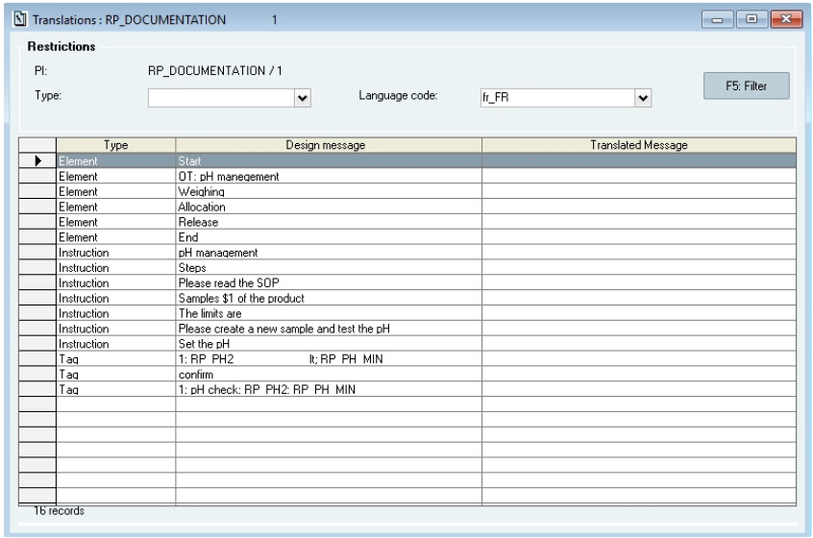

**Translation management screen**

That list includes all messages generated for the current PI (from PI Text and Workflow).

**Window description:**

**The Restrictions section**:

Enables the user to filter the displayed data.

***Type***: enables the user to select the type of messages. Empty by default.

***Language code***: enables the user to select the target iso language code. The list contains the languages configured by PI_LANGUAGES configuration parameter. The first (other than the design one) language code is selected by default.

***Filter*** button: enables the user to refresh the list according to filter configuration.

**Grid (standard configuration) section**:

***Type***: this column is automatically filled in with the type of messages.

***Design message***: this column is automatically filled in with message wrote in the design language.   
 ***Translated message***: this column is automatically filled in with translation of the message in the specific language selected in the restriction section.

***Translation edit* pop-up**

To edit a translation, press "enter" or double click on a row from the translation management grid. The pop-up is available if a language is selected and if the PI is editable.

Sp-EBRDesign-2511 261

*Creating a PI*

*PI Translation*

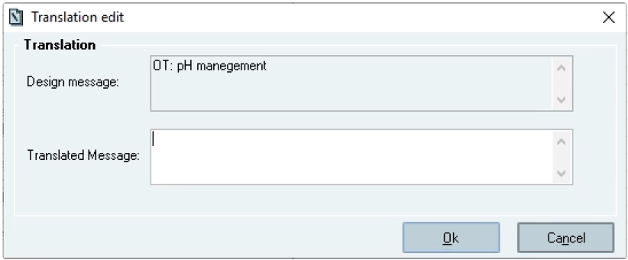

**Edit a translation**

**Popup description:**

***Design message***: this field is automatically filled in with the message in design language (read only).   
 ***Translated message:*** enables the user to define the translation of the message.

***OK*** button (shortcut: enter): enables the user to validate the defined translation.

***Cancel*** button (shortcut: escape): enables the user to cancel the defined translation.

### 8.10.5 Copying a PI with translation

When a PI is copied from a PI created by 'New' functionality in version 2205.0000.0000 or upper, the new created PI inherits the design language and all the defined translations from the source PI.

When a PI is copied from a PI in version prior to 2205.0000.0000 and migrated to support translation, the new created PI takes the language defined by the configuration parameter PI_LANGUAGES (first value) as default language. The default translation messages are created and must be translated.

### 8.10.6 Revising a PI with translation

When a PI is revised from a PI created by 'New' functionality in version 2205.0000.0000 or upper, the new version of the PI inherits the design language and all the defined translations from the source PI version.

When a PI is revised from a PI created in a version prior to 2205.0000.0000 and migrated to support translation, the new created PI takes the language defined by the configuration parameter PI_LANGUAGES (first value) as default language. The default translation messages are created and have to be translated.

262 Sp-EBRDesign-2511

# 9

*Managing <PI-Item> Links*

*Definition*

Managing <PI-Item> Links

## 9.1

Definition

<PI-Item> links enable the user to define, when writing PIs, which PI/s will have to be used to manufacture an identified product.

There are two types of links:

**Main:** a PI that is linked so as to be the main PI for an item will be suggested to the user when merging a WO with that item. That PI will be chosen if that merging operation is automatically performed.

**Secondary:** a PI that is linked so as to be a secondary PI for an item will neither be suggested to the user nor automatically merged, but will be available in the list of PIs that can be merged with the WO.

## 9.2 Rules

Link management is subject to the following rules:

There is only one main PI for a given item (i.e. it is only linked to one item);

A given PI can be linked to several items, for which it can be either main or secondary.

## 9.3

Managing Links

The following window is accessed by clicking the *PI/Items Links* function from the *PI management* tab. It displays the list of PIs and the list of validated items to which these PIs can be linked. The links can be added, deleted, or modified (and modifying a secondary link into a main link is also an option):

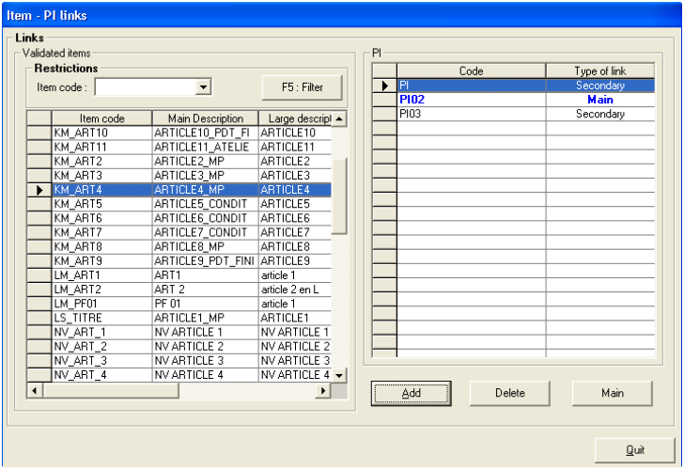

**The *Item - PI links* window**

The links between PIs and items are displayed as follows:

Sp-EBRDesign-2511

263

*Managing <PI-Item> Links*

*Managing Links*

All the validated items stored in the system (referred to by their code and description) are listed in the left part of the window;

All the PIs (referred to by their code) that have been linked to the item which has been selected in the left part are listed in the right part of the window;

The *Type of link* column specifies the type of link between the selected item and the PI.

**Window description:**

***Add:*** allows adding a link between an item and a PI. The user has to select a row from the list of items, to click

the *Add* button, and to select a PI from the list that appears on the *Process Instructions List* window.

That list of PIs is updated after a value has been selected. If the added link is the first that has been selected for that item, it is automatically defined as the **main** link.

If not, it is automatically defined as a **secondary** link. In any case, the user can later modify these attributes as required.

The unique main PI is displayed in the list in blue and bold characters. Accessing that functionality requires a specific access right (1600: DEFINE ITEM/PI LINKS).

A trace is added in Audit trail for this action.

***Delete:*** allows deleting a link between an item and a PI by selecting the item from the list of items, the PI from

the list of PIs, and by clicking the *Delete* button.

Deleting a link is subject to the following checks:

The system requires confirmation if the user tries to delete the main link by displaying the following message:

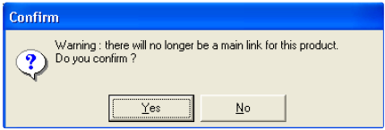

Accessing that functionality requires a specific access right (1600: DEFINE ITEM/PI LINKS). A trace is added in Audit trail for this action.

The list of linked PIs is updated if the deletion is confirmed.

***Main:*** from the list of PIs linked to an item, one and only one PI can be defined as being the main PI. Clicking that button will allow defining that PI as the main PI.

Modifying a link is subject to the following checks:

The system checks whether another main link is available. If so, a confirmation request is displayed:

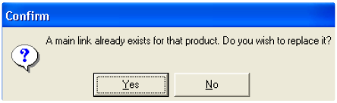

If the user clicks the *Yes* button, the selected PI becomes the main PI and the other one becomes secondary.

264 Sp-EBRDesign-2511

*Managing <PI-Item> Links*

*Managing Links*

Accessing that functionality requires the same access right (i.e. 1600: DEFINE ITEM/PI LINKS). A trace is added in Audit trail for this action.

The list of linked PIs is updated if the deletion is confirmed.

Sp-EBRDesign-2511 265

*Tools to check PIs*

*Coherence Analysis*

# 10 Tools to check PIs

## 10.1 Coherence Analysis

The system enables the user to proceed to a coherence analysis of the workflow when editing it. That analysis enables the user to point out a possible incoherence or to see whether the workflow management rules have been properly followed.

Executing a workflow can be simulated only if that workflow has been analysed as coherent. In the same way, a PI can be signed only if the associated workflow has been analysed as coherent.

The rules to be respected are the following:

### 10.1.1 Starting and Ending Elements

There must be one and only one Starting Manufacturing element per PI;   
 There must be one and only one Ending Manufacturing element per PI.

### 10.1.2 Transition Operations

There cannot be 2 consecutive explicit transitions (at least one element between 2 transitions);   
 There cannot be any transition right before having started to select sequences;

There cannot be any transition right after having started simultaneous sequences;

There cannot be any transition right after having ended to select sequences;

There cannot be any transition right before having ended simultaneous sequences.

### 10.1.3 Paths

Each element needs to have its grey connection points linked.

### 10.1.4 The PI-Text Element

Execution limits have to be defined;

No PI-text element points out headings that have been deleted from the table of contents;

No PI text element must be configured to be executed in between two limits (limits which include an inferior limit that would point out a heading which is right after the one that is pointed out by the superior limit);   
 PI-text elements must not overlap (the system only allow referencing the same PI-text element several times in a PI).

### 10.1.5

The Batch Element – with Batch Operating Text

Batch OTs are taken into account in the analysis of coherence.

266

Sp-EBRDesign-2511

*Tools to check PIs*

*Coherence Analysis*

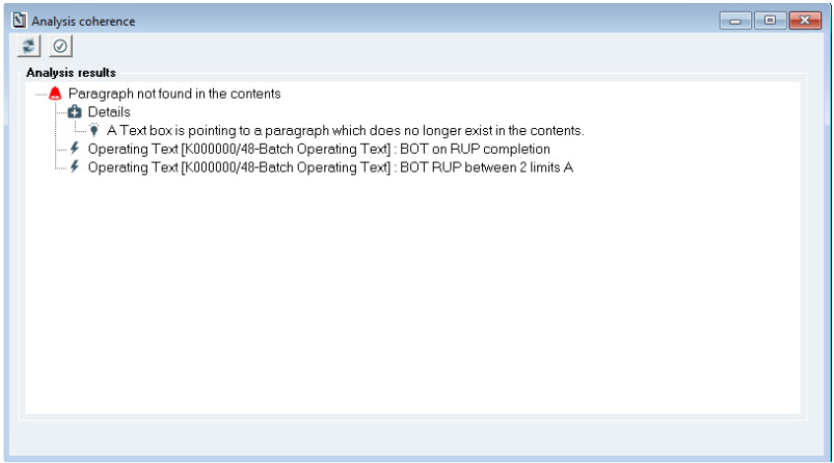

**Batch OT coherence analysis**

Display

The suffix "Batch Operating Text" is added on the Batch Operating Text ID.

Click on Batch Operating Text will select the related batch element in the workflow.

Rules

Each Batch Operating Text follows the same rules defined for PI Text Element (see The PI Text element).

Warning

The coherence analysis is performed globally on all Batch Operating Text and all PI Text Element configurations.

### 10.1.6 PI Element

A coherent called PI must have been chosen for a PI element;

The input and output parameters have to be entirely configured;

The system checks whether the PI hierarchic inclusion rules are respected.

N.B.: When the called PI does not display a coherent status, the coherence analysis of that PI is not automatically activated.

### 10.1.7 Step element

The following elements cannot directly follow each other in the workflow: starting and/or ending sequence selection, starting and/or ending simultaneous sequence. These elements must be separated with a step element.

### 10.1.8

Element title

The title of the elements must be defined (not empty).

Sp-EBRDesign-2511

267

*Tools to check PIs*

*Detailed Documentation*

### 10.1.9 Report & Adjustment

The analysis report is displayed as a tree in a floating window and can include the following icons:

Icons of the list displayed in the tree that includes the analysis report

All the errors of a given type are gathered together.

Precedes the paragraph where the type of error is explained.

Explanations to correct the error.

Precedes the operations that caused the error.

## 10.2

Detailed Documentation

### 10.2.1

Configuring how the Documentation is Generated

A configuration window appears before the detailed documentation is displayed:

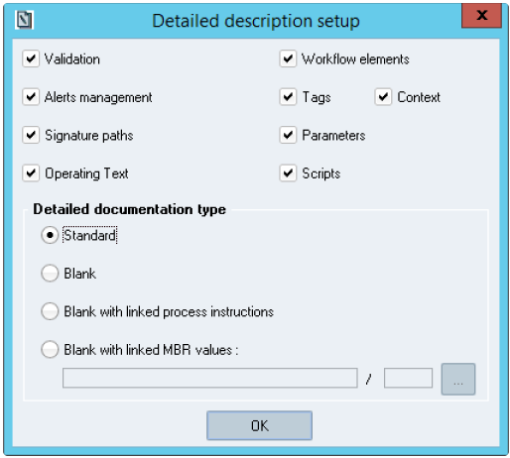

**The *Detailed description setup* window**

**Window description:**

268

Sp-EBRDesign-2511

*Tools to check PIs*

*Detailed Documentation*

That window allows selecting the sections to be displayed in the detailed documentation. By default, all sections are selected. The *Main* section is not displayed as it is always and automatically displayed in the documentation.

Only the sections selected by the operator appear in the table of contents and in the PI details.

N.B.: From a section to another, the references (e.g. tag numbers, names of parameters, etc.) are displayed as links, even if the section that contains the object (to which the link refers to) is not displayed.

This setup window also allows the user to select the type:

***Standard:*** Default configuration. Only the detailed documentation of the current PI will be generated. The

standard detailed documentation shows the names of parameters in the input fields that are included in the Operating Text, but only if the *Operating Text* check box is ticked.

***Blank:*** This option is identical to the generation of the standard documentation in the sense that only the main PI documentation is generated. However, the Operating Text input boxes are empty if the *Operating Text* option was selected.

***Blank with linked process instructions:*** allows printing the blank detailed documentation of the current PI and of all its linked PIs

***Blank with linked MBR values:*** allows printing the detailed documentation of the current PI. Values of PI parameters specified at the MBR level are displayed in the tag instead of the parameter code. For this option, the user must select an MBR (see MBR selection for further information). The MBR selection is mandatory to generate the detailed documentation.

Sp-EBRDesign-2511 269

*Tools to check PIs*

*Detailed Documentation*

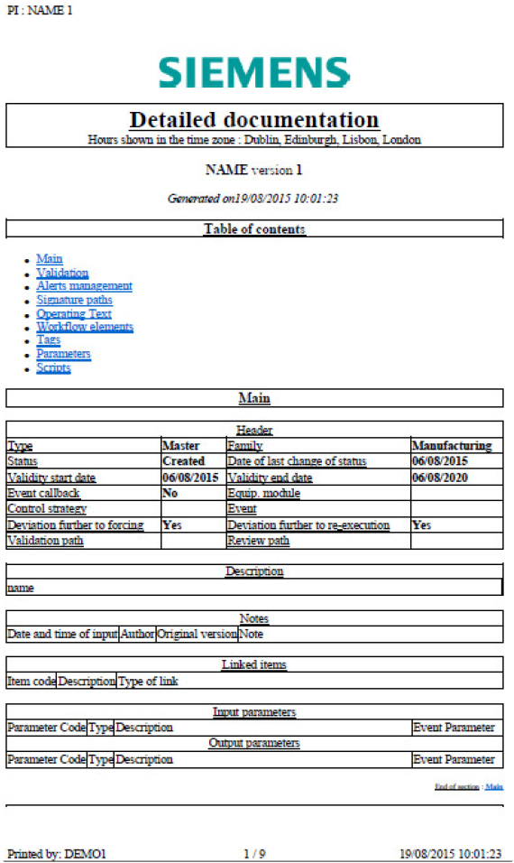

**The blank detailed documentation of the current PI**

Remark:

It's recommended to print the detailed documentation in landscape mode to ensure that all its content is displayed.

### 10.2.2

General Presentation

The detailed documentation of a PI is divided into three sections, which are entitled as follows:

Introduction; Table of contents;

270

Sp-EBRDesign-2511

*Tools to check PIs*

*Detailed Documentation*

PI details.

### 10.2.3

Introduction

It is defined as a brief summary of the main documentation references. It includes the following values:

Time zone in which the date/times are set up

Code and version of the current PI

Date and time when the detailed documentation was generated:

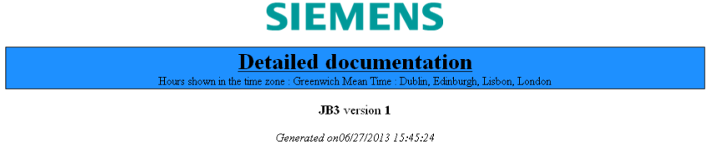

**Introduction of a detailed documentation**

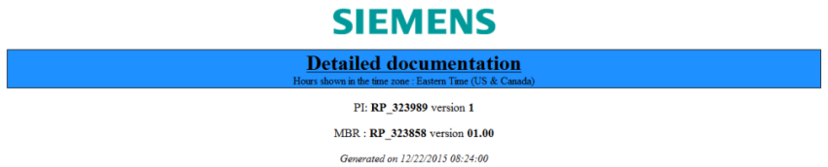

**Introduction of a detailed documentation for "Blank with linked MBR values" option**

### 10.2.4 Table of Contents

It lists all the sections of the document.   
It includes the following entries:

***Master Batch Record*** (only for "Blank with linked MBR values" option)   
 ***Main*** (general Points)

***Validation***

***Alerts Management***

***Signature Paths***

***Operating Text***

***Workflow Elements***

***Tags*** (context data can be displayed)

***Parameters***

***Scripts.***

#### [10.2.4.1](http://10.2.4.1)

Master Batch Record

Note: Display **only for "Blank with linked MBR values" option**.

Sp-EBRDesign-2511

271

*Tools to check PIs*

*Detailed Documentation*

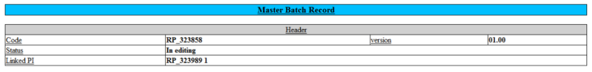

**The Master Batch Record section of a detailed documentation**

**Description of that part of the documentation, for the current PI:** That part of the documentation corresponds to MBR header.

***Code:*** code of the selected MBR.

***Version:*** version of the selected MBR.

***Status:*** status of the selected MBR.

***Linked PI:*** PI occurrence selected to specify the execution context.

#### [10.2.4.2](http://10.2.4.2) Main

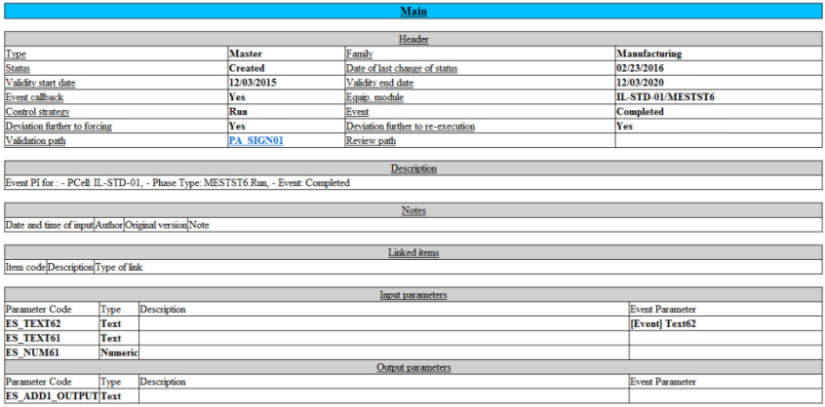

***The* *Main* section of a detailed documentation**

**Description of that part of the documentation, for the current PI:**

***Header:*** that part includes general information about the PI header: its type, family, status, date when the

status has last changed, validity start and end dates, the configuration of the Event PI (if the PI is an Event PI), validation and review path codes (if specified). Both of these paths are a link on which the user can click to access the details (see Signature Paths).

***Description:*** if the text is displayed on more than one line, the lines are displayed one after the other.

***Notes:*** notes associated with the PI. It includes the author of the note, the original version, and the input date/ time.

***Linked items:*** all the items that are linked to the PI are listed with their code, description, and the type of link that has been used (main or secondary; see Definition to know the difference between main and secondary PIs).   
 ***Input/Output parameters:*** each input or output parameter is represented by its code, its type, and its description.

272 Sp-EBRDesign-2511

#### [10.2.4.3](http://10.2.4.3)

*Tools to check PIs*

*Detailed Documentation*

Validation

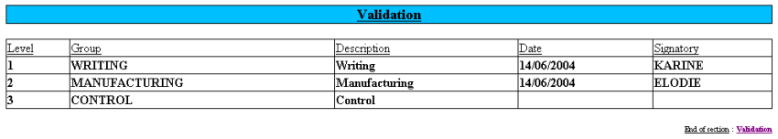

**The *Validation* section of a detailed documentation**

**Description of that part of the documentation, for the current PI:**

That part of the documentation corresponds to the list of validation signatures that have been applied to the PI. Each signature includes the following values:

***Level:*** signature level

***Group:*** expected group (defined in the path)

***Description:*** name of the signature level (defined in the path)   
 ***Date:*** signature date

***Signatory***

#### [10.2.4.4](http://10.2.4.4)

Alerts Management

That section includes all information related to the processing of Remark and Deviation alerts:

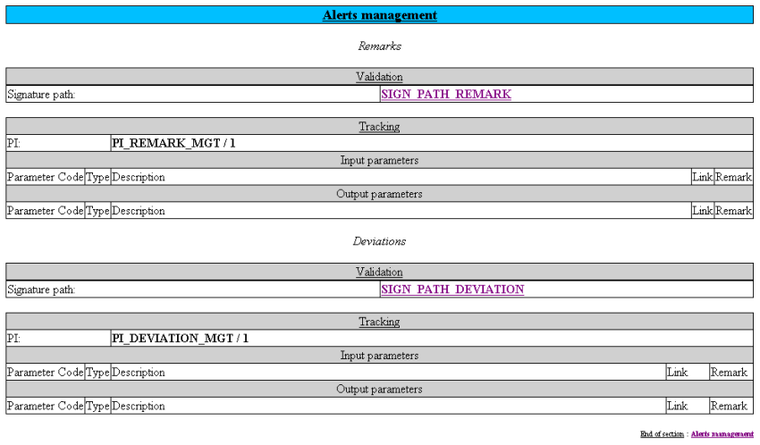

**The *Alerts management* section of a detailed documentation**

**Description of that part of the documentation, for the current PI:**

Sp-EBRDesign-2511

273

*Tools to check PIs*

*Detailed Documentation*

That section includes, for both types of alerts:

A *Validation* sub-section to provide the potential signature path that has been used to validate the alert. That

path code is a link. Clicking on that link enables the user to directly access the path details in the *Signature paths* section.

A *Tracking* sub-section to provide the potential PI associated with the alert. This PI has a code and a version (separated with a "/"). The input and output parameters appear in this section, as well as their potential links.

#### [10.2.4.5](http://10.2.4.5) Signature Paths

That section includes the details of each signature path that is referenced in the PI:

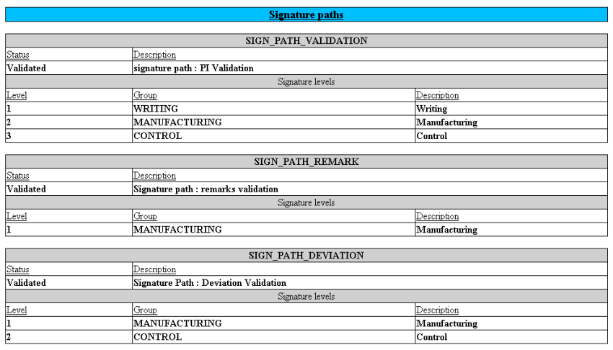

**The *Signature paths* section of a detailed documentation**

**Description of that part of the documentation, for the current PI:** These paths correspond to:

the PI-validation path;

the PI-review path;

the validation path for Remarks;   
 the validation path for Deviations.

The following elements are displayed for each path:

status;

description;

list of expected signatures (level, expected group, and description).

#### [10.2.4.6](http://10.2.4.6)

PI Text

That section includes the whole part of the PI text.

274

Sp-EBRDesign-2511

*Tools to check PIs*

*Detailed Documentation*

A numeric link is displayed on the right hand part of each tag. Clicking that link enables the user to access the tag details.

If the detailed documentation has been generated with "Blank with linked MBR values" option then PI parameter code is replaced by the value specify at the MBR level.

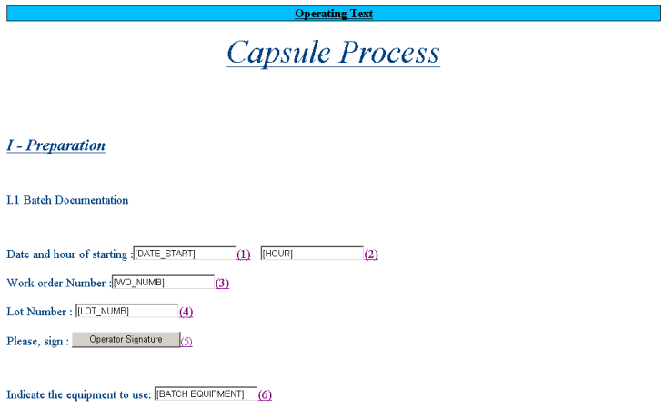

**The *Operating Text* section section of a detailed documentation**

Whatever the visibility configuration, all items are displayed (i.e. items configured as hidden are also displayed with the defined visibility rendering).

#### [10.2.4.7](http://10.2.4.7) Tags

That section includes the details of all the tags that are referenced in the PI text. Context data is displayed if the *Context* option was selected before generating the detailed documentation.

**General Display Rules:**

For each tag, the corresponding details are displayed in a table which lists all the tag properties.   
In that table:

All data that concern tag configuration are referenced in that table.

Each value of property which references a parameter is written in bold and is underlined. If so, the parameter reference gets a code and a version (separated with a "/"). Clicking that reference enables the user to access the details of the referenced parameter.

Each name of property is written in simple and underlined characters.

Each fixed value of property is written in bold and is not underlined.

#### [10.2.4.8](http://10.2.4.8)

Workflow Elements

That section includes the details of each element which make the workflow up. As it is described for tags, each element is displayed in a table which provides all the characteristics of the element.

Sp-EBRDesign-2511

275

*Tools to check PIs*

*Detailed Documentation*

**General Display Rules:**

These elements follow the same rules as those that are applied to the tags (especially the dynamic references to the parameter codes/versions).

In addition, each table includes a list of incoming and outgoing links that enable the user to get easy access to the details of:

All the elements that precede that element in the logical order that has been defined in the workflow (graph);   
 All the elements that follow that element in the logical order that has been defined in the workflow (graph).

If a transition is associated with the link, its expression is displayed on the right. However, if the expression includes references to parameters, it is displayed and the dynamic references to these parameters are not suggested.

When the element heading includes references to parameters, their dynamic links are not suggested.

#### [10.2.4.9](http://10.2.4.9) Parameters

That section includes the details of all parameters that are ***directly*** used by the PI.

If a parameter is actually referenced by another parameter, and if that parameter is not referenced by the PI, that parameter is not included in the detailed documentation.

**General Display Rules:**

These rules are the same as the rules that have been defined for tags and elements.

There are 3 different characteristics to note:

A parameter can appear as a property of another parameter (therefore with a dynamic reference) but its link is still not working. It is not necessarily referenced in the PI.

For function parameters, the expression that contains potential parameters is displayed, but the references to   
these parameters are not suggested.

Notes can be associated with parameters. If so, the list of notes for each parameter appears in the table under the details. The date, author, text, and original version are specified for each note.

#### [10.2.4.10](http://10.2.4.10) Scripts

That section lists the scripts that are used by the PI.   
Script details include four parts:

General data related to the script: the code/ version, status, description.   
 The set of parameters with, for each of them, the code and type.

The script text.

Page breaks divide each section for better printing quality.

### 10.2.5 PI Details

If the *Blank with linked process instructions* check box is ticked, the system performs a recursive search for all the PIs that are used from the current PI.

The following window is opened once the search is complete:

276 Sp-EBRDesign-2511

*Tools to check PIs*

*Detailed Documentation*

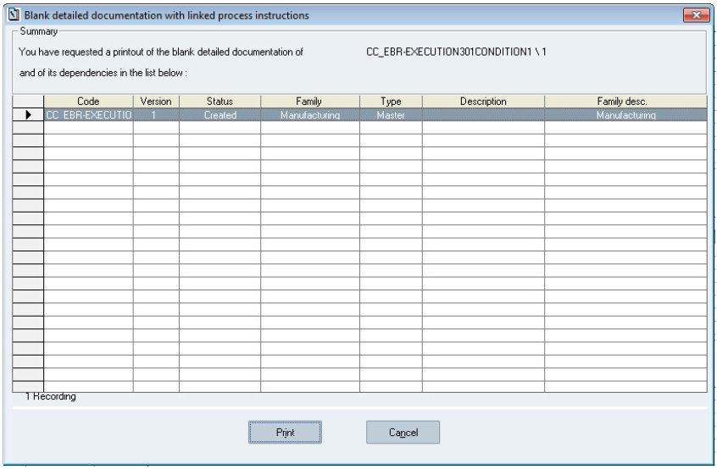

**The Blank detailed documentation with linked Process Instructions window**

**Window description:**

The table displays each linked PI and the main PI, with the following columns: *PI code*, *Version*, *Status*, *Family*, *Type*, *Description*, and *Family desc.* (for "description").

This list sorts the PI codes in the alphabetical order. The detailed documentation of each PI will also be printed in that order, regardless of the order in which the linked PIs appear in the main workflow.

***Print:*** print the blank detailed documentation of all the PIs in the list, after having selected a printer.   
 ***Cancel:***

If the printer has not started printing the document (i.e. the *Print* button is available): the detailed documentation of each PI will not be printed.

If the printer has started printing the document (i.e. the *Print* button is available): the detailed documentation that is being printed will be fully printed but no other PIs will be printed as the corresponding printing order cancelled.

***Progression:*** appears while the document is printed, displays the PI that is being printed, and how many PIs still have to be printed.

Sp-EBRDesign-2511 277

*Tools to check PIs*

*PI text Comparator*

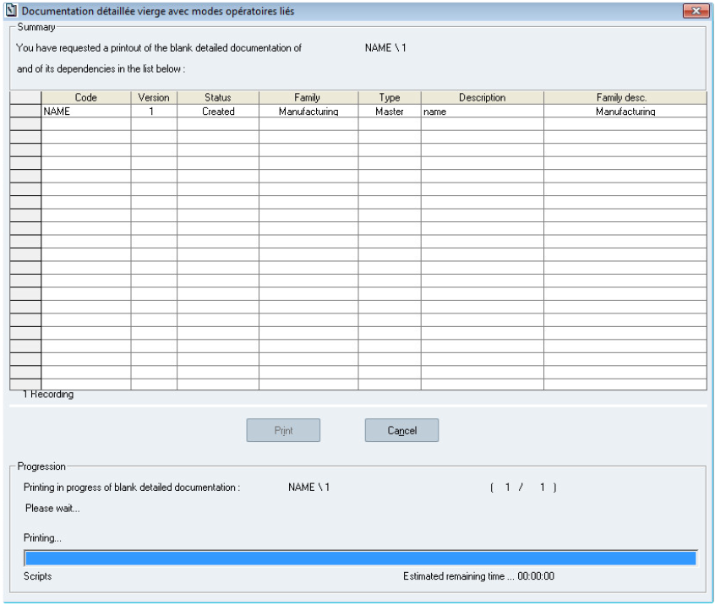

**The Progress bar**

The detailed documentation of each PI will be printed one after the other, as it would have been if the user had printed each PI manually.

### 10.2.6 Translation

The Detailed Documentation is generated based on the language of the locale settings defined in the system (User locale settings if defined, otherwise workstation locale settings if defined, otherwise default locale settings).

**If the PI translation functionality is activated on the PI,** the following content is also translated:

PI Operating Text (instructions and title of tags),

workflow elements descriptions,

parameters possible values and initial value for text parameters. The design value and the related translation are displayed (format: *key* (*translation*))

To generate the detailed documentation in another language, the language defined in the system locale settings must be changed.

## 10.3 PI text Comparator

The PI text comparator compares the tags of a PI text to the tags of another version of the same PI.

278 Sp-EBRDesign-2511

*Tools to check PIs*

*PI text Comparator*

With this functionality, a user is able to see all tag modifications occurred between two versions.

### 10.3.1

Access

The PI text comparator is accessible from tools menu (PI is open):

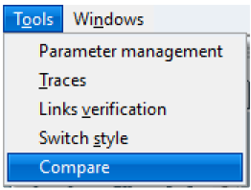

**Access to the comparator**

After click on the menu, the user should select the version of the PI that must be compare to the open PI:

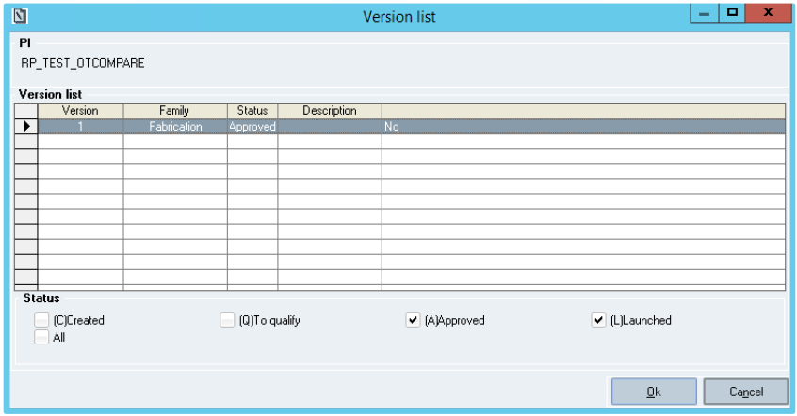

**Selection of PI version**

All non-obsolete versions of the PI (except the current one) are displayed in the list.

After the selection (OK button), the comparator is open in a new window.

Sp-EBRDesign-2511

279

*Tools to check PIs*

*PI text Comparator*

### 10.3.2 Comparator screen

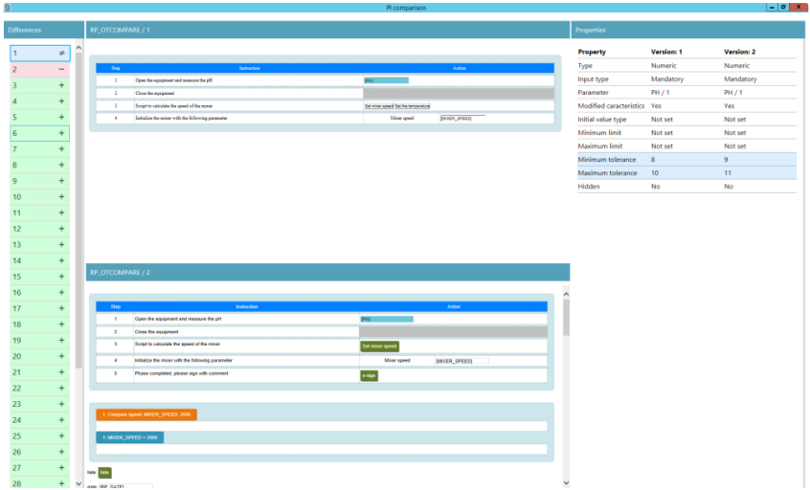

**Comparator screen**   
The OT comparator is a new window split into 4 parts:

List of differences: all differences found by the comparator. The analysis is based on tag differences.   
 PI text 1: text of the PI with the smaller version

PI text 2: text of the PI with the greater version

List of properties: all attributes of the tag which is selected from the tag difference panel.

### 10.3.3

List of tag differences

A summary of the tag differences are available on the left panel of the comparator.

The list is sort by tag location in the PI text with the smaller version.

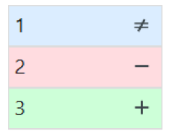

**Example of difference list**

For each difference, following data/style are available:

Number: number of the difference

Type: icon which is refer to the type of difference:

≠: tag has been modified

280

Sp-EBRDesign-2511

*Tools to check PIs*

*PI text Comparator*

+: tag has been added in the OT with greater version   
 -: tag has been deleted in the OT with greater version

Color: set according to the type:

Modification: blue   
 Deletion: red   
 Adding: green

A click on a difference will set the focus on the related PI text tag. For edition, focus will be done on both tags (top side and bottom side). For deletion, the focus will be done on the tag located in the PI text on the top side. For insertion, the focus will be done on the tag located in the PI text on the bottom side.

Moreover, the list of properties is refreshed to display all properties of the tag(s).   
Note: Focus is not set for picture and alert tags.

### 10.3.4

PI text display

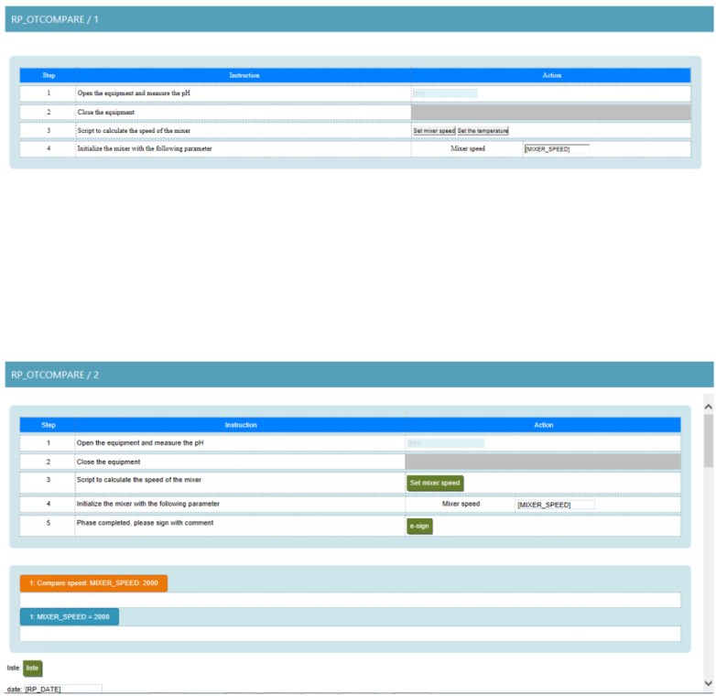

**Display of compared PI texts**

The read only text of the PI with the smaller version is displayed on the top.

The read only text of the PI with the greater version is displayed on the bottom.

Sp-EBRDesign-2511

281

*Tools to check PIs*

*PI text Comparator*

The code of the related PI and the version is displayed on headers of each text. Each panel is independent. The user can scroll on the desired PI text.

### 10.3.5 List of properties

This panel displays the list of tag attributes and the attribute values.

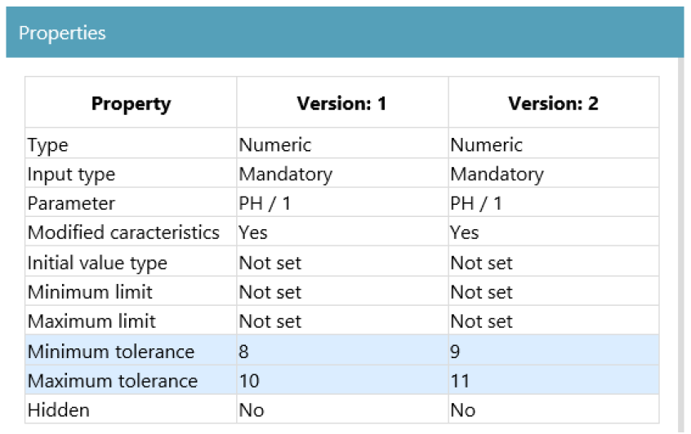

**List of tag attributes with source value and revised value**   
The panel contains a title ("Properties") and a table:

Property: code of the attribute

PI text top value: attribute value of the PI with the smaller version. In case of adding difference, the column is not displayed because the tag does not exist in this version. The header of the column contains the version of the related PI.

PI text bottom value: attribute value of the PI with the greater version. In case of deletion difference, the column is not displayed because the tag does not exist in this version. The header of the column contains the version of the related PI.

To clearly identify a difference between values, the line is colored in blue. The list of attributes display in this panel is the same as detailed documentation.

### 10.3.6 Comparison algorithm

The comparison algorithm is based on the id of the tag set at the insertion time. The system will do a list of tag from the first PI text and another one for the second PI text. Then, the system will take the first tag of the first PI text and will check if a tag with the same id and the same type is found in the second list (and so on).

If a match is found, the system compare the list of attributes.

If a match is not found, the system identify the tag as deletion.

282 Sp-EBRDesign-2511

*Tools to check PIs*

*Simulation*

To find insertion, the same algorithm is applied but with tag from the second list as base.

This algorithm has a limitation. At the insertion of a tag, the id of the tag will be the greater id of PI text tag + 1. It means that a deletion of tags with greater id will decrease the maximum number of ids. So, ids can be reused and new tag can have same id as previous version.

In this case, the algorithm will find a match. There are three possibilities:   
 Tag types are the same and all attributes also => No difference raised   
 Tag types are the same and some attributes are different => Modification raised

The tag type is not the same => 2 differences will be raised. Deletion from the left side and one insertion for the right side.

## 10.4 Simulation

When writing a PI, the user can simulate its execution without having to prepare a WO.   
It allows:

Simulating the sequence of the different actions that have been set in the workflow (to visualise the PI as it will be viewed by the final operator);

Testing how everything is executed ("dynamics");

Validating the flow of operations.

In simulation mode, since there is no WO, the user cannot test the elements as they require a WO (i.e. weighing, combination, reconciliation, some scripts, etc.). It is also possible to view and modify context data from an Operating Text that was tested in Simulation mode (Normal-execution mode, Alert-tracking mode).

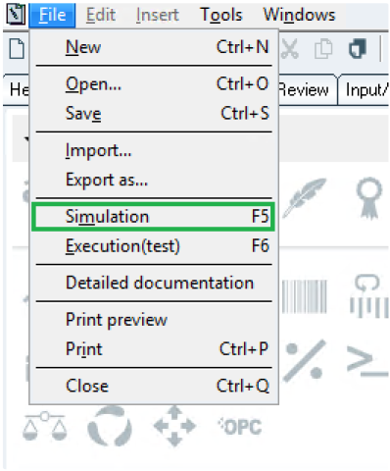

**How to access the *Simulation* function from operating text**

The page setting, the tag inputs, the loops, the documentary links, and the scripts can therefore be tested before approving the PI, without having to create a WO for testing.

**Only for simulation from the workflow**:

Sp-EBRDesign-2511 283

*Tools to check PIs*

*Simulation*

a check is performed on coherence workflow status of main PI and all its linked PIs. The behaviour is this one described for Execution test function, please refer to Accessing the Execution*)*

in case of MBR management (at least one MBR exist), a list of MBR is displayed in order to select the MBR that will be used to initialize PI parameters.

### 10.4.1 MBR selection

The list contains all MBRs except MBRs with *Withdrawn* status and MBRs not linked to a PI.

Besides, to select the MBR/PI execution context (for absolute addressing), all occurrences of the current PI are displayed in a tree view according to the PI linked to the selected MBR.

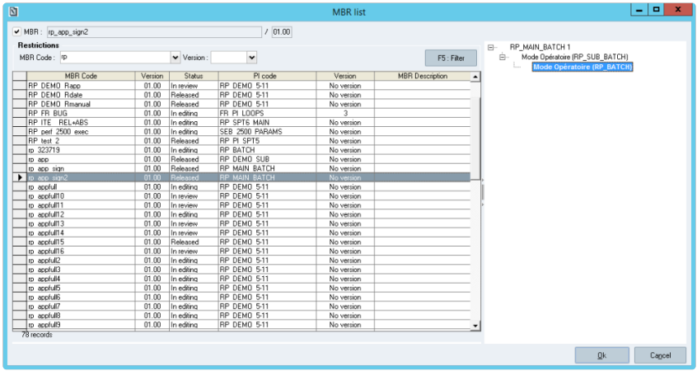

**MBR selection popup**

**Window description:**

***MBR check box:*** checked by default, means that user has to select an MBR and the context of execution of the

simulation inside the MBR.

If the user unchecks the option MBR, then the OK button becomes enabled. In this case, the simulation is launched as in previous version.

***MBR list:*** list of MBR matching constraints listed above. The list of columns is:

MBR code

MBR version   
 MBR status

PI code

PI version

MBR description

***PI list:*** list of the future simulated PI occurrences from the PI workflow linked to the MBR

The root node represents the main Process Instruction   
 *Data displayed: -Process Instruction code and version*   
 Each parent node represents a Sub Process Instruction.   
 *Data displayed:*

- Sub PI element title (2) and Sub PI code (1)   
 - Element ID: in a tooltip(3)

284 Sp-EBRDesign-2511

*Tools to check PIs*

*Simulation*

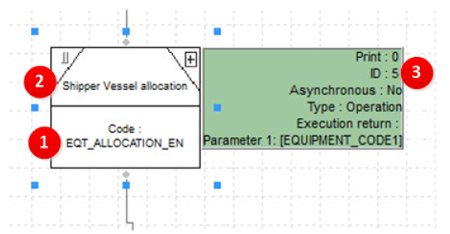

PIs are sorted following alphabetic order

***Cancel:*** allows cancelling the access to the simulation; the user is sent back to the previous window.

***Ok:*** allows validating the MBR and context selection.

The version of Main PI taken into account to display the tree view is the version referred inside the MBR header. If no version is defined, then the version taken into account is the one selected in the MBR configuration design.

The tree view only displays the branches with the same PI code and version as the current PI.   
The tree view also follows following rules:

All the levels of sub PI are developed and displayed until the level of the current PI is reached,

Others branches without the current PI are not displayed,

By default, the first occurrence of current PI is selected,

The Ok button is enabled only if an occurrence of the current PI is selected.

Event PI set into batch element and PI set in "WO launch PI" tag are not taken into account by the tree view.   
 Even if there is no link between MBR and current PI, the tree view displays the current PI in the branches. The PI can be selected.

Current PI can be the Main PI set in the MBR. In this case, the Main PI is selected.

Once a MBR is selected, the following cases are possible:

The selected MBR is linked to a PI and the current PI/version is part of the PI linked to the MBR (i.e: as sub-PI or

alert PI): In this case, user can select any of the occurrences of the current PI displayed and then validate its selection.

The selected MBR is linked to a PI but The current PI / version is not present in the tree of PI linked to the MBR: in this case, the user cannot select an occurrence of the current PI and the button "OK" is disabled. The user can either:

select another MBR linked to current PI

or click on Cancel button, to come back to previous screen which displays previously selected MBR if any.

The selected MBR is not linked to any PI: in this case, the behavior of the tree view is the same as previous case.

### 10.4.2 Execution Rules

The execution rules are the same as those applied in Manufacturing, except for the alert process instructions as they are not created in Simulation.

For simulations from workflow, all parameters linked to an MBR parameter are set with the MBR value. There are no differences between the link types (relative and absolute).

Sp-EBRDesign-2511 285

*Tools to check PIs*

*Execution with a WO*

### 10.4.3 Operator's Actions

The simulation is entirely guided by the operator, who is going to manually decide which operations s/he wants to perform.

S/he can decide to make the workflow progress in two different ways:   
 Either by right-clicking an element and by selecting one menu;

Or by double-clicking an element and by executing it.

The two different ways to make the workflow progress

**Type of operation**

PI Text

Reconciliation, Combination, Weighing, Script, Requisition

**Menus available when right-clicking**

Execute Force View Alert

The element status automatically changes to *Terminated*

**When double-click**

Execute or view the PI according to the element status

Not Available

### 10.4.4

Colour Code

A colour code is assigned to each element, which enables the user to quickly view its advancement status. Each colour corresponds to a status:

Correspondance between colours and statuses

**Statuses of the associated task**

Task to be done

**Meaning**

The operation can start.

**Colour**

Green

Task in progress

Task not generated

Task completed

The operation has started.

The operation pre-requisites have not yet been met.

The operation has been performed.

Blue

Grey

Black

## 10.5

Execution with a WO

That functionality enables the user to test the PI (PI text and/or workflow) before its final validation phase. It enables the user to merge a non-validated PI with a WO, and to later modify that PI if a writing error was detected during the testing phase.

N.B.: Contrary to simulation, that functionality enables the user to really perform the operations. A weighing procedure therefore triggers the uses of lots in the database, generates WO traces, etc. For that reason, we recommend using that functionality with a database that differs from the database used for production.

286 Sp-EBRDesign-2511

*Tools to check PIs*

*Execution with a WO*

The access right 1525 (EXECUTION (TEST) WITH WO) enables the user to test the execution of a WO.

For the moment, the user must meet the following constraints to associate a PI with a WO when merging:

the PI has to be launched;

the WO has to be of P6/D6 type and to display the *Launched* status;   
 there must be a link between the PI and the item of the WO;

the PI validity date must be superior to the current date.

That functionality enables the user to execute a PI with a WO by getting rid of these constraints, which become:

The PI status must be one of the following: *Created*, *To qualify*, *Approved,* or *Launched*;   
 The WO status must be one of the following:

Type P6/D6, P7/D7: *Created* or *Untreated*

Type P5/D5: *Created*, *Untreated,* or *Launched*

Type P4/D4: *Created*, *Untreated*, *Launched*, *Preparation in progress*, *Preparation Terminated.*

The user has the possibility to select an MBR to initialize PI parameter. To be available, MBR must match these constraints:

If a product code is defined on the MBR, this product code must be equal to the product code of the WO previously selected.

If a version is defined on the MBR, the combination Process Instruction / Version is equal to the Process Instruction / Version used for the test execution

If no version defined on the MBR, the Process Instruction of the MBR is equal to the Process Instruction used for the test execution.

### 10.5.1 Accessing the Execution

As it is done for current simulation, two accesses are possible according to the entity to be tested:

The *Execution (test)* function (under the *Simulation* function), accessible from the window that is used to write

the PI text, to test the PI text;

*The Execution (test)* function*,* accessible from the window that is used to write the workflow, to test the workflow.

As it is done for classic simulation, the PI and workflow have to be recorded, and the workflow has to be coherent to launch the test.

Accessing that function, checks the workflow coherence statuses of all its linked PIs:

In case of incoherence in sub-PI having at least level N-2 or in alert PIs (i.e. the main PI is coherent and the incoherence on linked PI has been generated since the last saving of main PI), a popup is raised to list incoherent PIs and to ask to the user if he wants to go on with the WO execution.

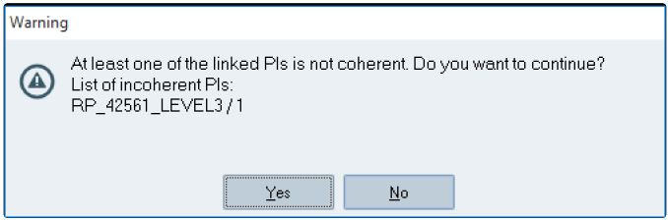

Sp-EBRDesign-2511 287

*Tools to check PIs*

*Execution with a WO*

**Warning raised in case of incoherence**

Only the first 10 incoherent linked PIs (PI name/ PI version) will be displayed in this popup.

Warning: in case of a PI linked to itself (infinite loop), this message will appears depending on existing incoherences or not:

With incoherence =>

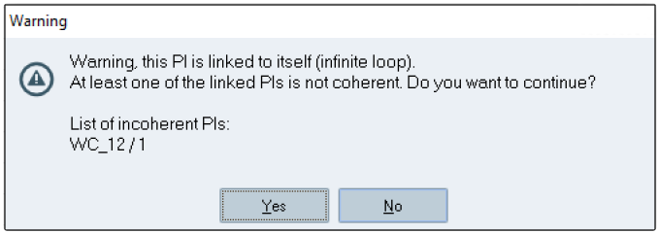

Or without incoherence =>

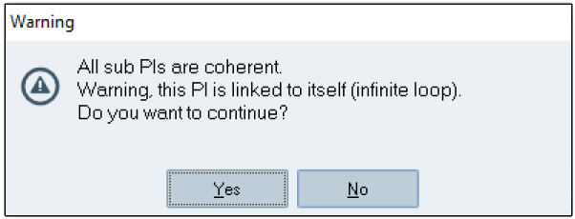

In case of all coherent linked PIs or after validation of incoherence warning, a list of WOs from which the WO to use can be selected is displayed:

288 Sp-EBRDesign-2511

*Tools to check PIs*

*Execution with a WO*

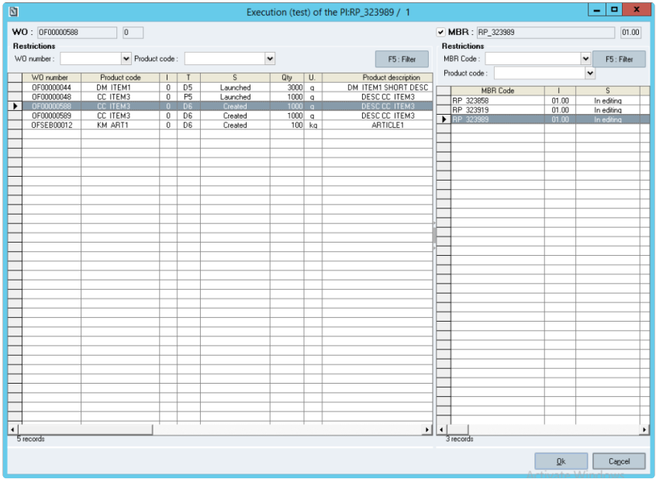

**The *WO list* window**

**Window description:**

***WO list:*** list of WOs matching constraints listed above.

***MBR list:*** list of MBR matching constraints listed above. The list of columns is:

MBR code

MBR version   
 MBR status   
 Product code

PI code

PI version   
 Formula code   
 Formula version   
 Batch size min   
 Batch size max   
 Batch unit

***Cancel:*** allows cancelling the access to the execution; the user is sent back to the previous window.

***Ok:*** allows validating the WO selection. The WO is checked after validation, and a message is displayed if not compliant. The user must then choose another WO or cancel the execution. If an MBR is selected, the MBR will be used for WO merging

The "MBR" checkbox allows enable/disable the selection of an MBR. It is disabled and not editable if the MBR list is empty.

If only one MBR has a batch size which corresponds to the quantity to produce of the order, this MBR is selected by default. If there's more than one MBR which corresponds, no MBR is selected by default.

Sp-EBRDesign-2511 289

*Tools to check PIs*

*Checking Links*

### 10.5.2 Preparation Phase before Execution

If the WO that has been selected by the user is approved by the system, it is submitted to a two-stage preparation phase:

Its status changes to *Ready for Manufacturing*, whatever its original status. It then follows its usual lifecycle;   
 If it has not been assigned a work centre, the work centre that is linked to the workstation requesting the execution is allocated.

### 10.5.3 How the Test Execution is Processed

Once the execution has been launched, later processing is performed exactly the same way as it is done for the   
work order in Real manufacturing (as opposed to what is done during simulation):

The execution is managed by the PI service, which must therefore absolutely be launched;   
 Possibility to simultaneously carry out the actions of execution from several client workstations.   
 WO executed from the PI execution module (i.e. "PIProcess.exe").

## 10.6 Checking Links

The *Links verification* function is available from the PI Management module (PI Management > *Access to PIs* > *Tools* > *Links verification*). This tool enables the user to check whether all the links that are applicable to the current PI – when it has been created from an import/export or a copied/pasted procedure – are included.

If there are links that are missing or obsolete links, a window details those links before updating the PI. This check is automatically launched when signing the PI.

## 10.7 Checking Alerts

The *Alerts verification* function is available from the PI Management module (PI Management > *Access to PIs* > *Tools* > *Alerts verification*). This menu enables the user to check the potentially lost of Alerts links during the design steps in the PIManagement module. When it's the case, the following message is raised:

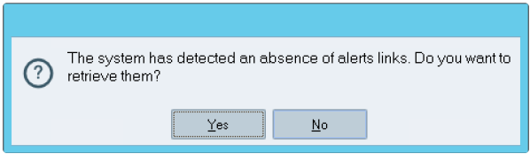

The user can validate this message to retrieve the last saved Alerts links.   
This check is automatically launched when signing the PI.

## 10.8 Checking Input output

The *Input/output verification* function is available from the PI Management module (PI Management > *Access to PIs* > *Tools* > *Input/output verification*). This menu enables the user to check the potentially lost of Input/output links during the design steps in the PIManagement module. When it's the case, the following message is raised:

290 Sp-EBRDesign-2511

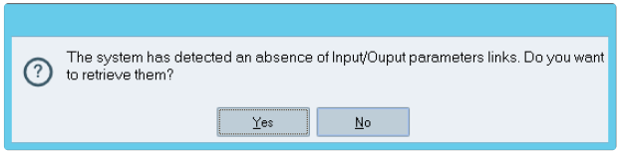

The user can validate this message to retrieve the last saved Input/output links.

This check is automatically launched when signing the PI.

Sp-EBRDesign-2511

*Tools to check PIs*

*Checking Input output*

291

*PI Management*

*PI Lifecycle*

# 11 PI Management

Each time a window is opened, it consumes GDI objects. As the complexity of the window increases, because of additional features such as buttons and images, the use of its GDI object also increases. When too many objects are used, Windows® is unable to draw any more GDI objects. As a consequence, the software can slow down the computer, but also freeze or crash.

To avoid this problem, the MAX_OPENED_MDI_CHILD_WINDOWS parameter limits the number of windows that can be opened at the same time (by default, its value is set to 3).

If the user tries to open more than the maximum number of windows (defined in this parameter), the following message informs the user about it: "*Too many opened windows*."

E.g.: if the value equals to 3, it is possible to open up to 3 PIs, or 2 PIs and 1 workflow.   
**N.B. The minimum screen resolution of PI Management is increased to 1280*1024.**

## 11.1 PI Lifecycle

The following diagram displays the different stages and associated changes of status that lead to PI validation (and then to its launch):

292 Sp-EBRDesign-2511

## 11.2

*PI Management*

*Accessing PIs*

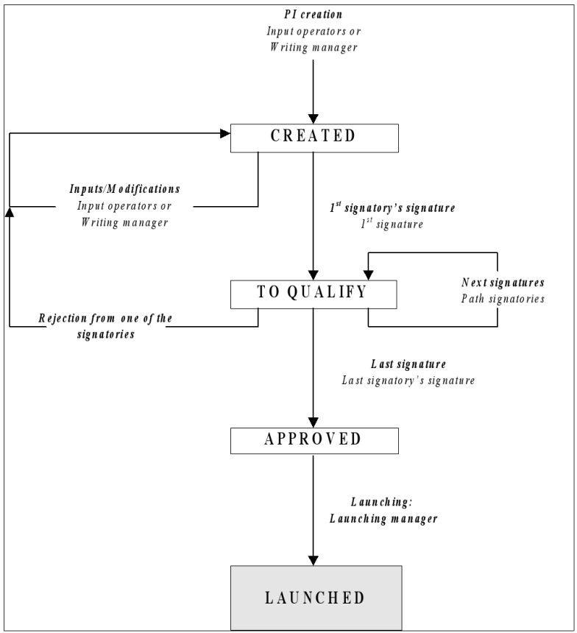

**PI Lifecycle**

Accessing PIs

The user can access the list of process instructions from the *PI Management* tab:

Sp-EBRDesign-2511 293

*PI Management*

*Copying PIs*

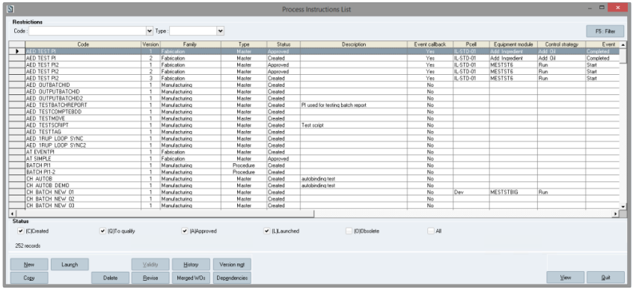

**The *Process instruction List* window**

**Window description:**

That list of PIs available from the system enables the user to access the following functionalities:

***New:*** allows creating a new PI.

***Launch:*** allows launching the selected PI.

***Validity:*** allows modifying the start and end validity dates of the selected PI when it displays the *Launched* status.

***History:*** allows accessing the history of the versions for the selected PI.

***Version mgt*** (for "management")***:*** allows accessing the upgrade of a new version.

***Copy:*** allows copying the selected PI (see Copying PIs for further information about copying PIs).

***Delete:*** allows deleting the selected PI.

***Revise:*** allows revising the selected PI (see Revising PIs for further information about copying PIs).

***Merged WOs:*** allows accessing the list of WOs that have been merged with the selected PI.

***Dependencies:*** allows accessing the dependencies of the selected PI.

***Edit/View:*** allows either editing or only viewing the selected PI.

***Quit:*** allows closing the list of PIs

## 11.3 Copying PIs

Copying a PI enables the user to get a new PI to rename that is identical to the original and that can be modified. Copying a PI requires a specific access right (1100: PI CREATION).

The button is always available when the list is completed (i.e. no matter which PI has been selected from the list), but is not when the list is empty. When copying a PI, a new code has to be assigned. The type, family, start and end validity dates, and description can be modified:

294 Sp-EBRDesign-2511

*PI Management*

*Copying PIs*

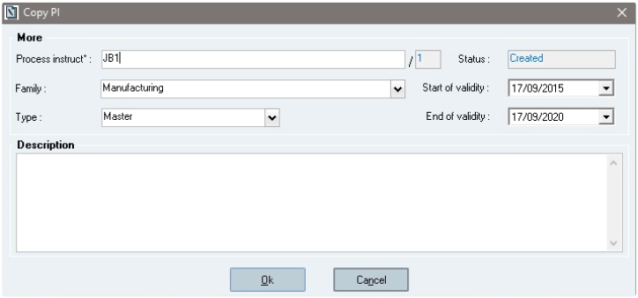

**The *Copy PI* window**

**PI-Copy Attributes:**

The copied PI is exactly identical to the original PI.

The index of a PI copy (which is after the "/" character) is always initialised to **1** by the system.

A PI copy is always initialised to the ***Created*** status.

The signature path of the new PI is identical to the signature path of the original PI. Nevertheless, **all signatures** **are cancelled** (i.e. blank path).

Other data are identical4 to the original PI (e.g. *workflow*, *notes*, *alerts management*, etc.).

4The copy of a PI defined as an Event PI does not save the Event PI configuration.

**Particular case of PIs designed in version prior to 2205.0000.0000 (PIs not supporting instructions identification):**

When such a PI is copied, a "Migration" section appears in the Copy window and proposes to the operator to enable instructions identification functionality on the copied PI:

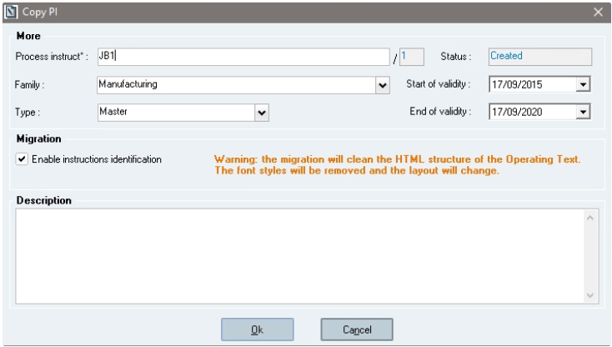

**The *Copy PI* window**

Sp-EBRDesign-2511 295

*PI Management*

*Revising PIs*

If the instructions identification is enabled for the copy, this has the following consequences on the new PI:

The Operating Text html structure of the new PI is "cleaned" (old font styles are removed): only the layout is

modified not the content,

The instructions are identified,

If the translation is enabled by the system, the new PI will support translation *(refer to* PI Translation*).*

If the instructions identification checkbox is unchecked for the copy, the new PI will not support instructions identification functionality (and, as a consequence, PI translation).

## 11.4 Revising PIs

### 11.4.1 Introduction

The button is always available when the list is completed (i.e. no matter which PI has been selected from the list). Revising a PI requires a specific access right (1120: PI REVISION).

The rules when revising PIs are the following:

Only the last non-obsolete version of a PI can be revised.

The PI to be revised has to display the ***Approved*** or ***Launched*** status.

Revising a PI creates a new version of that PI.

### 11.4.2 The PI Revision Process

Clicking the *Revise* button (or the Alt+R shortcut) displays the following message which requires confirmation from the user for revising the PI:

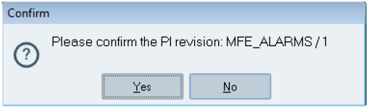

Clicking the *No* button makes the confirmation window disappear and sends the user back to the list of PIs (since no PI has to be revised).

Clicking the *Yes* button allows displaying the window which enables the user to enter the characteristics of the PI that has to be revised

296 Sp-EBRDesign-2511

*PI Management*

*Revising PIs*

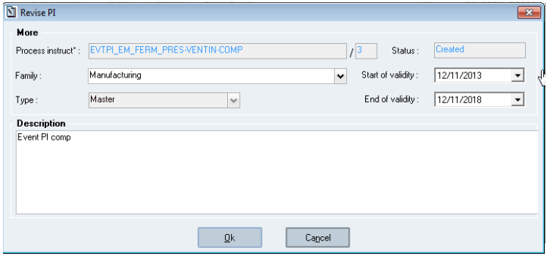

**The *Revise PI* window**

The Type field cannot be modified.

The Family, Start of validity, End of validity, and Description fields can be modified.

### 11.4.3 PI-Revision Attributes

The copied PI is exactly identical to the original PI.

The PI index is incremented.

The new index is initialised to the ***Created*** status.

The signature path of the new index is identical to the signature path of the original index. Nevertheless, **all** **signatures are cancelled** (i.e. blank path).

Other data are identical to the original PI (e.g. *workflow*, *notes*, *alerts management*, etc.).

### 11.4.4

Revision of a PI designed in version prior to 2205.0000.0000 (PIs not supporting instructions identification)

When such a PI is revised, the PI revision process and the PI-Revision attributes are exactly the ones described previously.

The only difference is a "Migration" section which appears in the Revise window and proposes to the operator to enable instructions identification functionality on the revised PI:

Sp-EBRDesign-2511

297

*PI Management*

*Validating PIs*

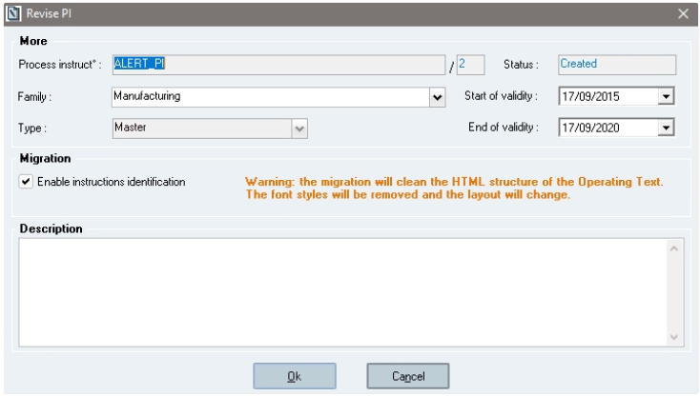

**The *Revise PI* window**

If the instructions identification is enabled for the revision, this has the following consequences on the new PI:   
 The Operating Text html structure of the new PI is "cleaned" (old font styles are removed): only the layout is

modified not the content,

The instructions are identified,

If the translation is enabled by the system, the new PI will support translation *(refer to* PI Translation*).*

If the instructions identification checkbox is unchecked for the revision, the new PI will not support instructions identification functionality (and, as a consequence, PI translation).

## 11.5 Validating PIs

Once written, and translated if managed, the PI has to follow a signature path to be validated.

The *Signatures* tab includes the signature path description. The *Sign* button enables the user to sign the 1st level that has not been signed yet.

The user must always be part of the expected group of signatories.

The signatures take place in the order that is imposed in the path tree. Each signatory must belong to the group that is specified at each level of the tree.

### 11.5.1 Signing PIs

When the user activates the first PI signature, the PI is analysed to update the list of parameters, scripts, and PIs that are used:

If a parameter, a script, or a PI is being used, but is not displayed in the list, that entity is inserted into the list of links and the last available version is considered as being the version;

If a parameter or a PI that is referenced in the list is no longer used in the PI, this entity is deleted from the list of links.

The new updated list of links is then subject to the following checks: **For linked PIs:**

298 Sp-EBRDesign-2511

*PI Management*

*Validating PIs*

All the PIs and parameters that are referenced in the list is available (the non-available entities point out a null version). If not, an error message that blocks the signature is displayed;

The statuses of all the used PIs are either set to *Approved* or *Launched*. If not, a blocking error message is displayed, which lists the PIs that do not display these statuses. No signature can be appended.

**For linked parameters:**

None of the used parameter displays the *Obsolete* status or not existing (point out a null version). If not, a

blocking error message is displayed, which lists all the parameters that have been used but that are obsolete or not existing (and therefore unusable). No signature can be appended;

All the parameters that are used are validated. If not (at least one parameter is *Created*), the list of created parameters is displayed to allow validating these parameters:

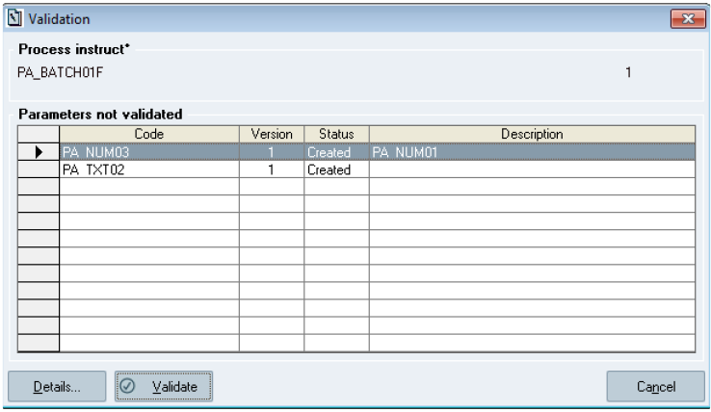

**The *Validation* window**

**Window description:**

***Details…:*** allows displaying the details of the selected parameter;

***Validate:*** allows validating the selected parameter/s by performing the same procedure as the one that has been used to validate a parameter from the *Parameter management* window (i.e. "PIManagement.exe" > *PI Management* > *Parameter Management*);

***Cancel:*** allows cancelling that step, which also cancels the PI signature.

**For linked scripts:**

All the scripts that are referenced in the list are stored in the system (scripts that do not point out null versions).

Otherwise, a message that blocks the signature appears.

No used script displays the *Obsolete* or *Created* status. Otherwise, a **blocking** **error message** appears and it lists all the scripts that cannot be used (as their status has been set to *Obsolete* or *Created*). No signature can be appended. Scripts must be validated from the *List of scripts* window.

**For Alert PI links:**

The system checks if Alerts PI links are lost or have been deleted. If a difference is found, the system raises a

message asking the user to continue or not the signature process.

Sp-EBRDesign-2511 299

*PI Management*

*Launching PIs*

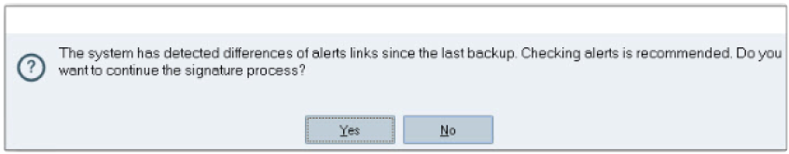

**Warning message during PI signature for Alert links**

**For Input/output links:**

The system checks if Input/output parameters links are lost or have been deleted. If a difference is found, the system raises a message asking the user to continue or not the signature process.

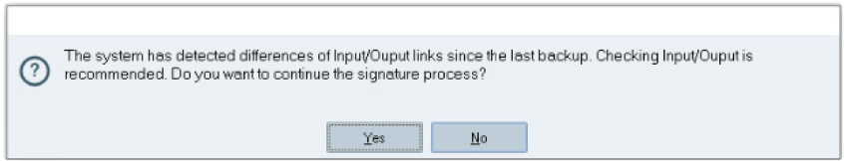

**Warning message during Pi signature for Input/output links**

Once the first signature of the path has been applied (the PI consequently displays the *Approved* or *To qualify*

status), the definitive links are created. These links can no longer be modified, unless the PI is rejected. The last signature of the PI makes the PI status change into *Approved.*

### 11.5.2 Rejecting PIs

At each signature stage, and as long as the PI has not been approved, the signatories can also reject the PI. That PI becomes modifiable again and the previous signatures are cancelled. The entire signature path must be followed again to approve the PI.

The operators that are authorised to reject a PI are those who are allowed to sign it. To reject a PI, an operator must therefore be part of the authorised signatories.

## 11.6 Launching PIs

The last stage before starting the PI in Production is called ***Launch.***

That stage consists in providing the PI start and end of validity dates, and in changing its status.

A check is carried out to make sure that all called PIs have been launched and that their validity ranges are included within the validity range of the calling PI.

The launch is performed from the list of PIs.

This operation requires a specific access right (1350: LAUNCH A PI).

300 Sp-EBRDesign-2511

*PI Management*

*Launching PIs*

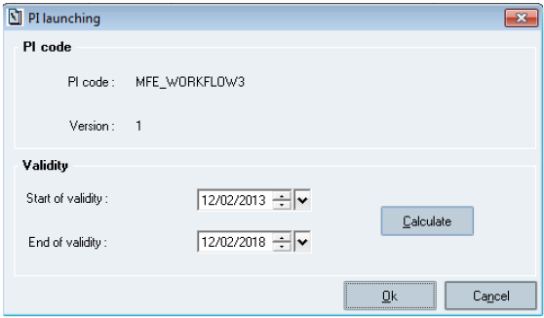

**The *PI launching* window**

The PI_INITIAL_VALIDITY_START_DATE parameter determines how the start validity date of a PI is initialised:

If it is set to 0: Its start validity date is initialised to the date when it has been created.

If it is set to 1: Its start validity date is initialised to the date when it has been launched.

When launching the PI, the system checks that all the linked PIs are launched and that the start and end validity dates meet the following rules:

**Rule for the verification of the validity start date:**

The start validity date of a PI is correct if superior or equal to the highest start validity date of its linked PIs.

**Rule for the verification of the validity end date:**

The end validity date of a PI is correct if inferior or equal to the smallest end validity date of its linked PIs.

The system checks whether these rules have been followed for each linked PI of the PI to launch.

If these rules are not followed, the system warns the user that it is impossible to launch the PI. The gaps are then listed PI by PI. The text cannot be edited, but can be selected to be copied/pasted to eventually correct the incriminated validity dates:

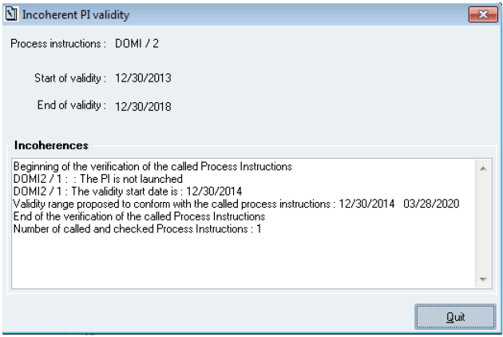

**The *Incoherent PI validity* window**

Sp-EBRDesign-2511

301

*PI Management*

*Modifying the Validity Dates of a PI*

**Window description:**

***Calculate:*** enables the user to correctly initialise the start and end validity dates according to the validity dates of all the linked PIs.

## 11.7 Modifying the Validity Dates of a PI

The start and end validity dates of a PI can be modified from the list of PIs (when the PI displays the *Launched* status) by clicking the *Validity* button:

The user enters the start and end validity dates from that window:

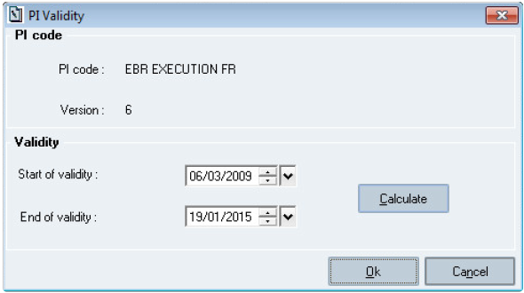

**The *PI Validity* window**

**Window description:**

The user validates the modifications by clicking the *Ok* button*.* The system then activates the algorithm to check whether the date rules have been followed and provides a report if a gap is found (see Launching PIs).

Here, and as opposed to the launch of a PI where the system only applies the rules to the linked PIs, the system activates the algorithm both downwards and upwards (i.e. for **all** the called and calling linked PIs).

Modifying the validity dates of a launched PI is traced. This operation requires a specific access right (1351: MODIF PI VALIDITY).

## 11.8 Deleting PIs

Deleting a PI consists in changing its status to *Obsolete*. This enables the user who is archiving PIs to take it into account.

This operation requires a specific access right (1305: DELETE PI).   
To be deleted, the PI must follow the rules:

Not used by a WO (i.e. a WO that is neither closed nor cancelled) or be referenced in another non-obsolete PI.   
 Not used by an MBR with status other than *Withdrawn* (if the MBR is not linked to a specific PI version, a non- obsolete version of the PI must exist).

302 Sp-EBRDesign-2511

## 11.9

*PI Management*

*Revision control of PIs*

Revision control of PIs

PIs can be upgraded by clicking the *Version mgt* button from the *Process Instructions List* window.

The upgrade is not available for Event PIs. In this case the "Upgrade", "Select all" and "Unselect all" buttons are always disabled.

Revision control is performed from the following window:

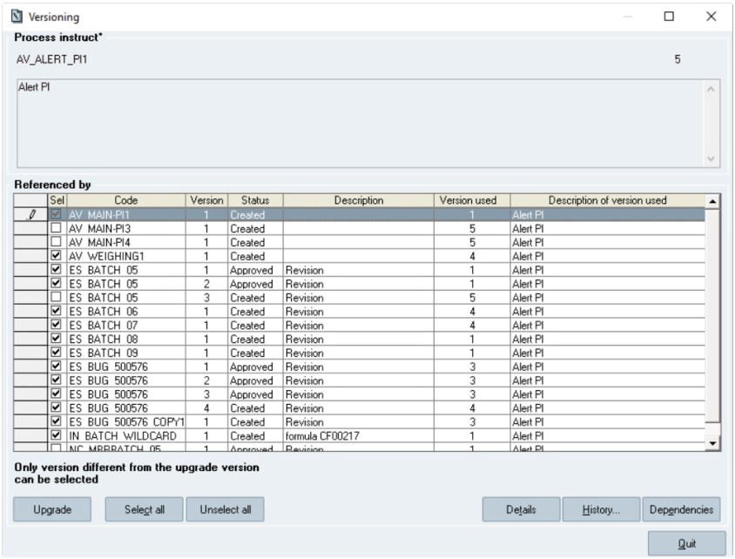

**The *Versioning* window**

**Window description:**

The list stores all the non-obsolete PIs that use the selected PI.

The window indicates that only version that are different from the used PI version can be selected.

***Upgrade:*** allows the user to modify the used version (as it is the case for revision control of parameters; see the description below the *Versioning* window). It requires a specific access right (1352: PI UPGRADE).

It has to follow these rules:

If the PI to be upgraded displays the status *Created* or *To qualify*, only the process instructions displaying the

status *Created* can be upgraded;

If the PI to upgrade displays the *Approved* status:

If the PI_VERSIONING_IMPACT parameter is set to 1:

All the PIs which display the *Created*, *To qualify*, or *Approved* status can be upgraded. The PI does not have to be revised.

If the PI_VERSIONING_IMPACT parameter is set to 0:

Sp-EBRDesign-2511 303

*PI Management*

*PI-Version History*

Only the PIs which display the *Created* status can be upgraded. An upgrade cannot be performed for the PIs which display the *To qualify* and *Approved* statuses. These PIs have to be revised. An upgrade can then be applied to that revision.

N.B.: A launched PI cannot be upgraded with an approved PI, whatever the value of the PI_VERSIONING_IMPACT parameter.

If the PI to be upgraded displays the *Launched* status:

If the PI_VERSIONING_IMPACT parameter is set to 1:

All the non-obsolete PIs can be upgraded. The PI does not have to be revised.

Moreover, if there is an impact because of a launched PI, the system checks that the validity interval of the version of the replaced PI is included within the validity interval of the version of the replacing PI.

If the PI_VERSIONING_IMPACT parameter is set to 0:

Only the PIs displaying the *Created* status can be upgraded. An upgrade cannot be performed for the PIs which

display the *To qualify, Approved,* and *Launched* statuses. These PIs have to be revised. An upgrade can then be applied to that revision.

There is no impact on the PIs that are being modified by another user.

The system also checks the concordance between the input and output parameters of the version to be replaced and of the replacing version (the version is ignored). More precisely, any parameter code that is included in the set of input parameters of the replacing version has to be included in the set of input parameters of the replaced version. The same rule is applied to the output parameters. If not, the upgrade is rejected.

The ***Select all***, ***Unselect all****,* ***Details***, ***History…***, and ***Dependencies…*** buttons allows accessing the same functions as those set for revision control of parameters (see the description below the *Versioning* window).

## 11.10

PI-Version History

The history of PI versions is available from the *Process Instructions List* window.

Clicking the *History* button allows displaying the following window.

304

Sp-EBRDesign-2511

*PI Management*

*PI-Version History*

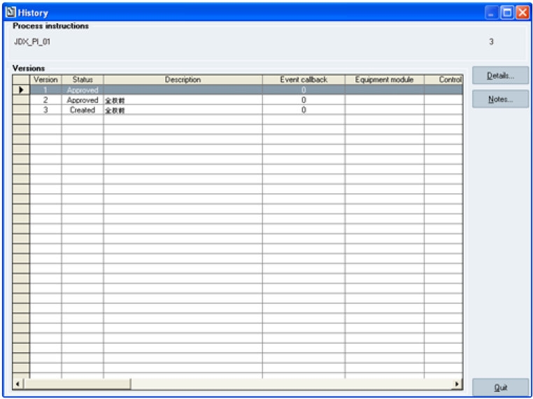

**The *History* window**

**Window description:**

***Details:*** enables the user to access the PI detailed documentation. That detailed documentation includes all the PIs where the viewed version is used.

***Notes:*** enables the user to access the list of notes that concern that PI in Read-only mode. The window which displays that list is the window when the *Notes* tab has been selected.

Sp-EBRDesign-2511 305

*PI, Script, and Parameter Dependencies*

*Introduction*

# 12 PI, Script, and Parameter Dependencies

## 12.1 Introduction

The dependencies that are available between PIs and parameters or between PIs and scripts are displayed in a graph which includes all the elements and the links between them.

## 12.2 Accessing the Function

PI dependencies can be accessed from:

The list of PIs, by clicking the *Dependencies* button;

The window that is used to upgrade a PI, by clicking the *Dependencies* button.

Parameter dependencies can be accessed:

From the list of parameters, by clicking the *Dependencies* button.

When validating a parameter, available when signing a PI (if so, only the "direct" dependency links will be displayed; i.e. only the parameters used by the parameter which is being validated will be displayed).

When validating a parameter, available when signing a PI (only the "child" dependency links are displayed; i.e. only the parameters used by the parameter that is being validated are displayed).

Script dependencies can be accessed from:

The list of scripts, by clicking the *Dependencies* button;

When appending the signature of a PI if there are scripts that are not validated;   
 When upgrading a PI, by clicking the *Dependencies* button.

306 Sp-EBRDesign-2511

## 12.3

*PI, Script, and Parameter Dependencies*

*Window Description*

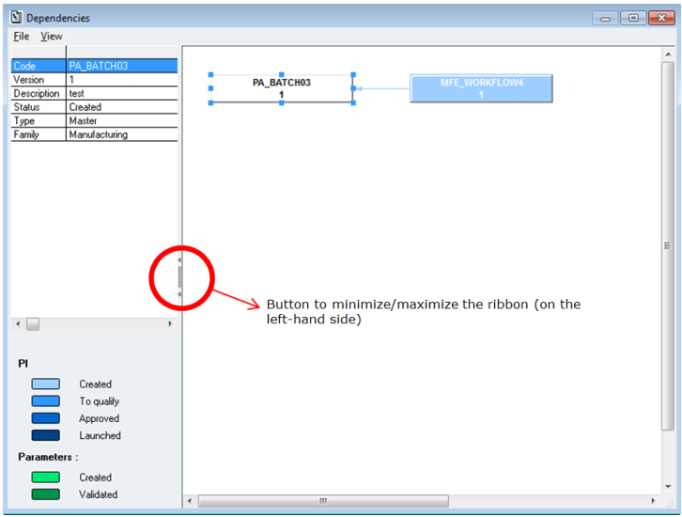Window Description

**The *Dependencies* window (for using PA_BATCH03 version 1)**   
The window which displays dependencies is divided into two sections:

The left-hand part lists all data of the header for the selected element, for a parameter or a PI:   
 Code

Version

Description

Status

Type

Family

The right-hand part displays a graph of all the PIs which use, directly or indirectly, the PI – script – or parameter for which its dependencies have been requested, identified by its code and version.

The display format follows the following rules:

The PI for which its dependencies have been requested is displayed in a different colour, in order to identify it

easily. Moreover, when displaying the window, it is displayed as selected and is centred.

The colour of the elements differs according to the status of the corresponding entity (i.e. Created and Validated for parameters or scripts; Created, To qualify, Approved, and Launched for PIs).

The shape of the elements differs according to their type (i.e. PI or parameter/script).

The entities (PI, parameter, or script) which display the Obsolete status do not appear on the graph. Moreover, the user can modify that part of the window, so that s/he can reorganise the elements that make up the graph as required (e.g. to make it more readable before printing).

Sp-EBRDesign-2511 307

*PI, Script, and Parameter Dependencies*

*Window Description*

The size of both sections can be modified by using the vertical scroll bar or the button to minimize/maximize the ribbon in the middle of that bar.

From that graph, the user can:

Print the dependencies window as displayed on that window. The paper document includes the code and

version of the entity (PI or parameter) for which its dependencies have been requested, the date and time when the document was printed, and the page number.

Export the graph of dependencies to a file. The generated file will be a picture file, with the EMF format.

Zoom in/out the graph. In addition to the pre-defined zooms, a customised zoom is available, for precisely using this tool:

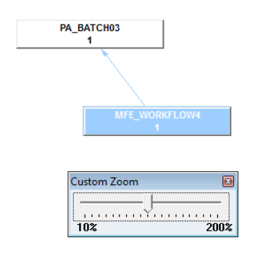

**Customised zoom**

308 Sp-EBRDesign-2511

# 13

*Traces*

*Accessing Traces*

Traces

## 13.1

Accessing Traces

These traces will be available AuditTrail module:

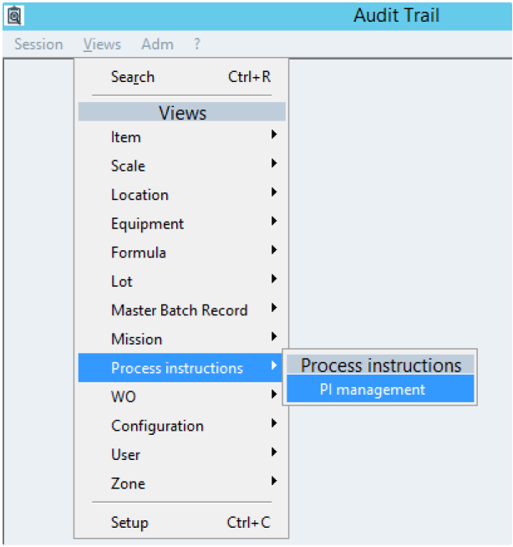

**Access to PI design traces** See ***Sp-AuditTrail-i.pdf*** for further information.

## 13.2

Traced Actions

The following actions are traced:

**Traced Actions**

- PI creation (initial or through copying)

- PI revision

Sp-EBRDesign-2511

**Function (to be associated with the corresponding trace)**

CREATE PI

PI REVISION

309

*Traces*

*Traced Actions*

**Traced Actions**

- PI deletion

- PI launch

- Validity date modification

- Sign PI

- PI rejection

- PI upgrade, via a new parameter or PI version

- Parameter creation (initial or through copying)

- Parameter revision

- Parameter validation

- Parameter deletion

- Script creation (initial or from a copy)

- Script revision

- Script validation

- Script deletion

- Script upgrade

310

**Function (to be associated with the corresponding trace)**

DELETE PI

LAUNCH A PI

MODIF PI VALIDITY

SIGN PI

REJECT PI

PI UPGRADE

CREATE PARAMETER

REVISE PARAMETER

VALIDATE PARAMETER

DELETE PARAMETER

SCRIPT CREATION

SCRIPT REVISION

SCRIPT VALIDATION

SCRIPT DELETION

SCRIPT UPGRADE

 Sp-EBRDesign-2511

**Context tab**

**PI tab**

**Parameter tab**

*Traces*

*Traced Actions*

**Script tab**

**Func** **tion**

CRE

ATE

PI

PI

REVI SION

DELE TE PI

LAU

NCH

A PI

MOD IF PI VALI DITY

SIGN

PI

**Message**

Creation of PI xxxx, version x

Creation of PI xxxx, version x by copying PI xxxx, version x

Creation of PI xxxx, version x by copying PI xxxx, version x and enabling instruction identification

Creation of PI xxxx, version x by revising PI xxxx, version x

Deletion of PI xxxx, version x

PI launch xxxx,

version x

Modification of the validity date of PI xxxx, version x. New date: xxx

PI signature: specify the name of the selected level

**PI**

**code**



Code of the create d PI



Code of the create d PI

**PI**

**versio**

**n**



Versio n of the create d PI



Versio n of the create d PI

**PI**

**status** **after action**



Create

d



Create

d

**Para** **meter** **code**

**Param** **eter versio**

**n**

**Para** **mete**

**r**

**statu**

**s**

**after** **actio**

**n**

**Scri** **pt cod**

**e**

**Scrip**

**t**

**versi** **on**

**Scri** **pt stat** **us**

**afte**

**r**

**acti** **on**

Sp-EBRDesign-2511

311

*Traces*

*Traced Actions*

**Context tab**

**PI tab**

**Parameter tab**

**Script tab**

**Func** **tion**

REJE CT PI

PI

UPG

RAD

E

PI

UPG

RAD

E

CRE

ATE

PAR

AME

TER

REVI

SE

PAR

AME

TER

**Message**

PI rejection

Modification of the version of the parameter used   
old version => new version

Modification of the parameter version used

old version => new version

Creation of parameter xxxx,

version x

Creation of parameter xxxx,

version x by copying parameter xxxx,

version x

Creation of parameter xxxx,

version x by revising parameter xxxx,

version x

**PI**

**code**







Impac ted PI

**PI**

**versio**

**n**







Impac ted PI

**PI**

**status** **after action**







Impact ed PI



Code of the create

d

param eter



Code of the create

d

param eter

**Para** **meter** **code**





Code of the create

d

param eter



Code of the create

d

param eter

**Param** **eter versio**

**n**





Versio n of the create

d

param eter



Versio n of the create

d

param eter

**Para** **mete**

**r**

**statu**

**s**

**after** **actio**

**n**

**Scri** **pt cod**

**e**

**Scrip**

**t**

**versi** **on**

**Scri** **pt stat** **us**

**afte**

**r**

**acti** **on**

312

Sp-EBRDesign-2511

**Context tab**

**PI tab**

**Parameter tab**

*Traces*

*Traced Actions*

**Script tab**

**Func** **tion**

VALI

DAT

E

PAR

AME

TER

DELE

TE

PAR

AME

TER

SCRI PT CRE ATIO

N

SCRI PT REVI SION

**Message**

Validation of parameter xxx, version x

Deletion of parameter xxxx,

version x

Creation of script xxxx, version x

Creation of script xxxx, version x from a copy of parameter xxxx, version x

Creation of script xxxx, version x by revising script xxxx,

version x

**PI**

**code**

**PI**

**versio**

**n**

**PI**

**status** **after action**

**Para** **meter** **code**

**Param** **eter versio**

**n**

**Para** **mete**

**r**

**statu**

**s**

**after** **actio**

**n**

**Scri** **pt cod**

**e**



Cod   
e of the crea ted scrip

t



Cod   
e of the crea ted scrip

t

**Scrip**

**t**

**versi** **on**



Versi on of the

creat ed scrip

t



Versi on of the

creat ed scrip

t

**Scri** **pt stat** **us**

**afte**

**r**

**acti** **on**

Sp-EBRDesign-2511

313

*Traces*

*Traced Actions*

**Context tab**

**PI tab**

**Parameter tab**

**Script tab**

**Func** **tion**

SCRI PT VALI DATI ON

SCRI PT DELE TION

SCRI

PT

UPG

RAD

E

**Message**

Validation of script xxxx, version x

Deletion of script xxxx, version x

Modification of the script version used xxxx: x => y

**PI**

**code**

**PI**

**versio**

**n**

**PI**

**status** **after action**

**Para** **meter** **code**

**Param** **eter versio**

**n**

**Para** **mete**

**r**

**statu**

**s**

**after** **actio**

**n**

**Scri** **pt cod**

**e**

**Scrip**

**t**

**versi** **on**

**Scri** **pt stat** **us**

**afte**

**r**

**acti** **on**

314

Sp-EBRDesign-2511

# 14

*Known Issues*

*Traced Actions*

Known Issues

When using cyclic operations, system will allow the user to choose different PI versions of an Open PI, but it is recommended to use the same version of PI and Parameter in the same PI workflow.

Sp-EBRDesign-2511

315